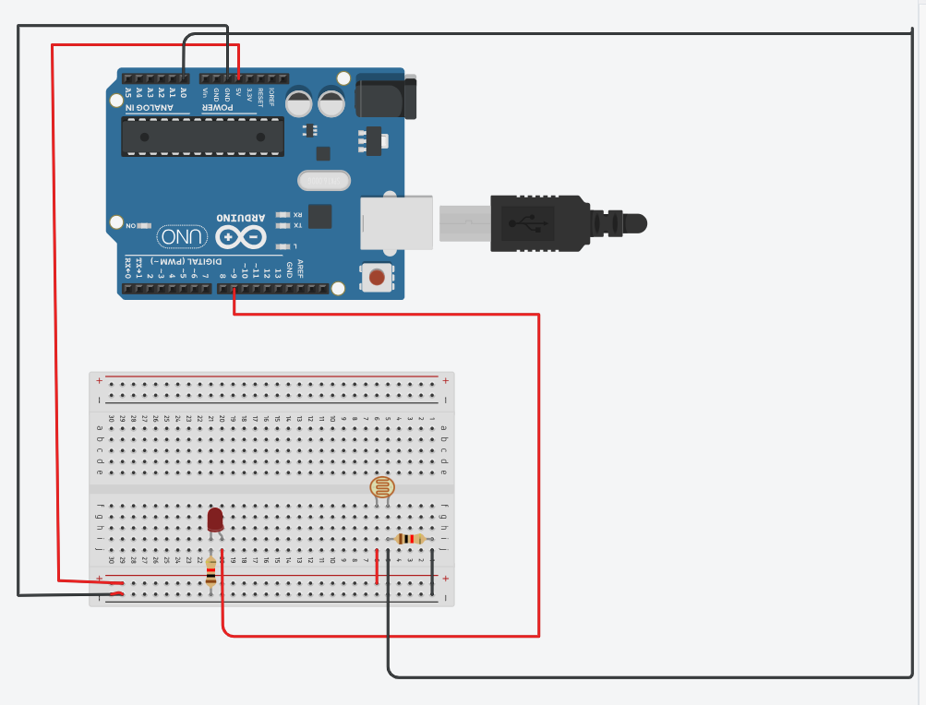

const int ldrPin= A0;
const int ledPin = 9;
int ldrValue = 0;
int threshold = 500;

void setup() {
pinMode(ledPin, OUTPUT);
Serial.begin(9600);
}

void loop() {
ldrValue = analogRead(ldrPin);

Serial.print("LDR Value: ");
Serial.println(ldrValue);

if (ldrValue < threshold) {
digitalWrite(ledPin, HIGH);
Serial.println("Environment: DARK LED ON");
} else {
digitalWrite(ledPin, LOW);
Serial.println("Environment: DARK LED OFF");
}
delay(300); // Wait half a second before next reading
}

Observation : As light intensity increases , the LDR’s resistance decreases, and the Arduino reads a higher analog value

