Digital Signal Processing Mini-Project
Speech Enhancement System
a MATLAB toolkit for Single-Channel Speech Enhancement Using Wiener Filtering and Speech-Presence Probability
Submitted by:
Arnav Ram | 25070123503
Mahi Shendre | 25070123504
Siddhesh Gajare | 25070123505

GitHub Repository: https://github.com/ArnavRam/Speech-enhancement-system
Batch: 2024-28
AY 2026-2027 Semester V

Abstract
Background noise degrades speech recorded through consumer microphones. This project is a MATLAB R2021a toolkit that reduces such noise in single-channel audio. Processing is done entirely in the short-time Fourier transform (STFT) domain. Noise power is tracked with the MMSE speech-presence-probability estimator of Gerkmann and Hendriks (2011), and suppression is applied through a decision-directed Wiener gain (Ephraim and Malah, 1984).
The application accepts both live microphone input and audio files. The result is compared to the input by ear and by objective metrics, and shown as waveforms and spectrograms in a graphical user interface. A second tab implements two-microphone least-mean-square (LMS) adaptive noise cancellation so that the STFT-domain method can be compared with a time-domain adaptive filter.
Evaluation uses synthetic clean speech mixed with white, pink, and babble noise at 5 dB SNR. The SPP-based pipeline gives several dB improvement in both global SNR and segmental SNR, and beats a minimum-statistics estimator on all three noise types.

Table of Contents
Abstract 2
Table of Contents 3
1. Introduction 5
1.1 Motivation 5
1.2 Problem statement 5
1.3 Objectives 5
1.4 Scope and constraints 5
2. Theoretical Background 6
2.1 Speech signal characteristics 6
2.2 Additive noise model 6
2.3 Short-Time Fourier Transform 6
2.4 Wiener filtering in the STFT domain 7
2.5 Decision-directed a priori SNR estimation 7
2.6 Speech-presence probability (Gerkmann and Hendriks) 8
2.7 LMS adaptive noise cancellation 9
3. System Design 9
3.1 Overview 9
3.2 Design decisions 10
4. Algorithm Implementation 10
4.1 Pre-processing 10
4.2 STFT parameters 10
4.3 Speech-presence-aware noise estimation 10
4.4 Wiener gain computation 11
4.5 Reconstruction 11
4.6 LMS comparison module 11
5. Software Implementation 12
5.1 Project structure 12
5.2 Graphical user interface 12
6. Results and Discussion 13
6.1 Illustrative before and after 13
6.2 Quantitative results 14
6.3 Qualitative observations 14
6.4 LMS results 14
7. Limitations and Future Work 15
7.1 Known limitations 15
7.2 Future work 15
8. Conclusion 16
References 16

1. Introduction

1.1 Motivation
Speech recorded through consumer microphones usually contains unwanted sound room reverberation, HVAC hum, traffic, keyboard clatter, and interfering speakers. Voice-controlled devices, teleconferencing, voice notes, telemedicine, and automatic speech recognition all suffer as a result, and in some cases stop working altogether. Single-channel enhancement from classical signal processing addresses this without extra hardware. Modern learning-based systems still borrow ideas from it. The aim of this project is to build one such classical pipeline in MATLAB and to explain every stage of it.

1.2 Problem statement
Given a single-channel noisy observation y[n] = s[n] + v[n], where s[n] is the target speech and v[n] is additive noise uncorrelated with s[n], estimate s[n] using only y[n]. No reference microphone is available. The system has to work on both recorded audio files and live microphone input. It must reduce the background noise by an amount a listener can hear, and it must not damage the speech.

1.3 Objectives
- Design a single-channel enhancement pipeline grounded in textbook DSP.
- Implement the pipeline in MATLAB using only the Signal Processing Toolbox.
- Build a graphical user interface with record, load, process, compare, and save.
- Evaluate the enhancement on synthetic test signals and report the numbers.
- Add a secondary adaptive-filter (LMS) demonstration for comparison.

1.4 Scope and constraints
- The pipeline processes single-channel audio only. Two-microphone methods appear only in the LMS demonstration.
- No deep-learning components are used. The project is meant to demonstrate classical DSP.
- DSP parameters are hidden for simplicity. Sensible defaults are hard-coded, and only an advanced dialog exposes the knobs.
- The system does not attempt real-time streaming enhancement.

2. Theoretical Background

2.1 Speech signal characteristics
Speech is non-stationary. It is generated by a slowly changing vocal tract excited either by a quasi-periodic pulse train (voiced sounds such as vowels) or by a broadband noise source (unvoiced sounds such as /s/, /f/, /ʃ/). Over a short window of 20 to 40 ms the signal is roughly stationary, which is why short-time frequency-domain processing works. In the frequency domain, voiced speech has a comb structure at the fundamental frequency and its harmonics, shaped by a smooth envelope with peaks at the formant frequencies (about 500 Hz, 1500 Hz, and 2500 Hz for adult speakers). Unvoiced speech is broadband, with most of its energy above 2 kHz.

2.2 Additive noise model
The observation model assumed throughout this project is
y[n] = s[n] + v[n],
where s[n] is the clean speech, v[n] is the additive interference, and the two are statistically independent. In the STFT domain this becomes
Y(k, n) = S(k, n) + V(k, n),
where k is the frequency-bin index and n is the frame index. Under the further common assumption that S(k, n) and V(k, n) are complex Gaussian and mutually independent, the a posteriori SNR is defined as γ(k, n) = |Y(k, n)|² / λ_V(k, n) and the a priori SNR as ξ(k, n) = λ_S(k, n) / λ_V(k, n), where λ_S and λ_V are the powers of the speech and noise components respectively.

2.3 Short-Time Fourier Transform
The STFT is defined by framing the input signal with a window function w[n] of length L, hopping by H samples between frames, and taking the discrete Fourier transform of each windowed frame:
X(k, n) = Σₘ x[m + n·H] · w[m] · e^{−j 2π k m / L}.
For real signals only the first L/2 + 1 bins carry independent information. With a periodic Hann window at 50 percent overlap the squared window satisfies the constant overlap-add (COLA) condition, so a weighted overlap-add reconstruction inverts the transform exactly when no spectral modification is applied. This project uses L = 512 samples at fs = 16 kHz, a 32 ms frame. That is long enough to resolve formants and pitch harmonics, and short enough that the signal is roughly stationary inside a frame.

2.4 Wiener filtering in the STFT domain
Wiener filtering seeks the linear estimator Ŝ(k, n) = G(k, n) · Y(k, n) that minimises the mean-square error E[|S − Ŝ|²]. In the STFT domain under the Gaussian assumption, the optimal gain is
G(k, n) = ξ(k, n) / (1 + ξ(k, n)),
which depends only on the a priori SNR. Large ξ (speech dominates) drives G toward 1. Small ξ (noise dominates) drives G toward 0. A lower bound is placed on G to prevent audible drop-outs and to reduce musical-noise artefacts. This project floors G at −15 dB.
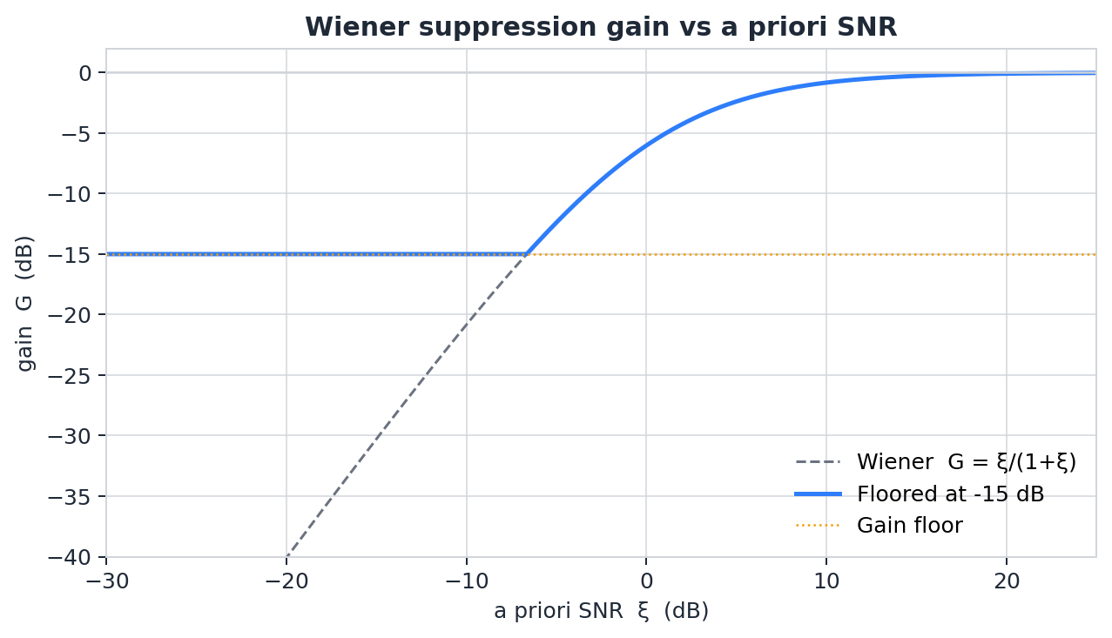
Figure 2.1. Wiener gain G as a function of the a priori SNR ξ, with the −15 dB floor used in this project.

2.5 Decision-directed a priori SNR estimation
Because ξ is not known in advance it must be estimated. Ephraim and Malah (1984) proposed the decision-directed (DD) recursion, which produces a smooth, low-variance estimate by combining the previous frame's enhanced speech power with the current frame's a posteriori SNR:
ξ̂(k, n) = α · |Ŝ(k, n−1)|² / λ̂_V(k, n) + (1 − α) · max(γ(k, n) − 1, 0).
The smoothing constant α is chosen close to 1. This project uses α = 0.98. The DD estimator is what makes Wiener filtering audibly cleaner than direct spectral subtraction. ξ is averaged over many frames rather than read straight from the noisy magnitude, which suppresses the isolated spectral peaks that give rise to musical noise.

2.6 Speech-presence probability (Gerkmann and Hendriks)
The critical component of any classical speech-enhancement system is the noise-power estimator λ̂_V(k, n). Overestimate it by even 50 percent and the Wiener gain collapses to near zero in speech-active bins, so the output turns muffled. Overestimate it during voiced speech itself which is what happens when a naive minimum-statistics estimator leaks speech energy into the "noise" and the effect is self-reinforcing.
This project uses the MMSE speech-presence-probability estimator of Gerkmann and Hendriks (2011). Under a fixed a priori SNR hypothesis ξ_{H1} (this project uses 15 dB) and a priori speech-absence probability q = 0.5, the speech-presence probability at each time-frequency point is
p̂(k, n) = 1 / (1 + (q / (1 − q)) · (1 + ξ_{H1}) · exp(−γ(k, n) · ξ_{H1} / (1 + ξ_{H1}))),
which is a soft, per-bin, per-frame decision. The noise-power estimate is then updated with an effective smoothing constant that depends on p̂:
α_eff(k, n) = α_N + (1 − α_N) · p̂(k, n),
λ̂_V(k, n+1) = α_eff · λ̂_V(k, n) + (1 − α_eff) · |Y(k, n)|².
When p̂ is close to 1 (speech is likely) α_eff is close to 1 and the noise estimate freezes. When p̂ is close to 0 (only noise is present) α_eff drops back to α_N = 0.8 and the noise estimate tracks the input. The smoothed p̂ is capped at 0.99. Without that cap the estimate could not move at all during long voiced passages, so a slowly drifting noise floor would never be tracked. The cap acts as a safety valve.
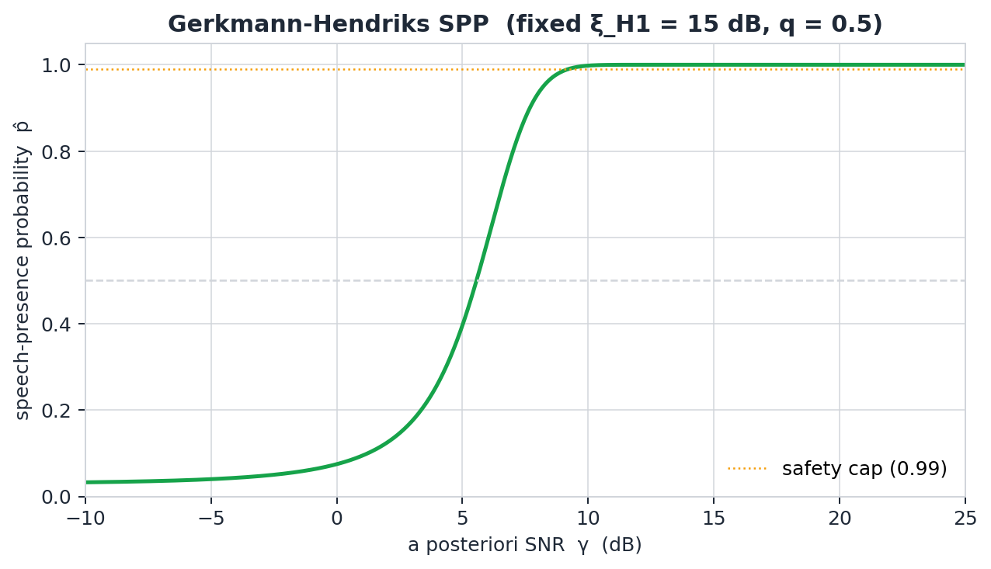
Figure 2.2. Speech-presence probability p̂ as a function of the a posteriori SNR γ.

2.7 LMS adaptive noise cancellation
The project also implements the adaptive filtering approach of Widrow et al. (1975) as a secondary comparison. When a reference microphone captures the noise without the target speech, an adaptive FIR filter can be trained to model the acoustic path from the reference to the primary microphone. The residual error is the enhanced speech. The normalised LMS update is
w(n+1) = w(n) + μ · x(n) · e(n) / (xᵀ(n) x(n) + ε),
where x(n) is the reference vector, w(n) is the adaptive filter, e(n) = d(n) − wᵀ(n) x(n) is the error, and μ is the step size. LMS complements Wiener suppression. It works very well when a noise reference exists, and not at all when it does not.

3. System Design

3.1 Overview
Figure 3.1 shows the processing chain. Input audio, whether captured from the microphone or loaded from disk, is converted to 16 kHz mono and pre-emphasised. The signal then goes into the STFT domain, where the noise-power estimator and the Wiener gain are computed per bin per frame. The gain is applied to the magnitude spectrum, the noisy phase is kept, and the time-domain signal is reconstructed by weighted overlap-add. De-emphasis and peak normalisation come last.
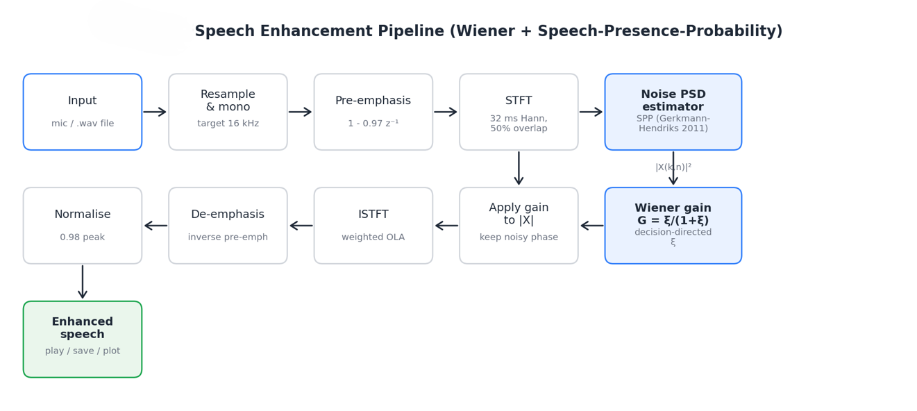
Figure 3.1. Block diagram of the speech-enhancement pipeline.

3.2 Design decisions
- Fs = 16 kHz. Telephony-quality bandwidth is enough for speech and keeps FFT sizes small.
- 32 ms Hann window with 50 percent overlap. This satisfies COLA on the squared window and is a standard time-versus-frequency-resolution trade-off.
- Speech-presence-probability estimator in place of minimum statistics. This fixes the over-suppression seen with the bias-corrected minimum-statistics tracker on files that begin with speech or contain long voiced passages.
- Gain floor at −15 dB, not −18 dB. Because the SPP estimator no longer inflates the noise, aggressive flooring is not needed and would only dull consonants.
- Noisy phase is kept during synthesis. Above about 0 dB SNR the perceptual gain from phase-sensitive reconstruction is small and does not justify the extra work.
- Record-then-process instead of streaming.

4. Algorithm Implementation

4.1 Pre-processing
Input audio is resampled to 16 kHz using MATLAB's polyphase resample, downmixed to mono by taking the arithmetic mean of channels, and pre-emphasised with the first-order FIR filter H(z) = 1 − 0.97 z⁻¹. Pre-emphasis whitens the speech spectrum by lifting the high frequencies that carry most of the consonant energy, so the enhanced output does not sound weighted toward the lows. The inverse filter is applied after synthesis so the final output has no colouration bias.

4.2 STFT parameters
The frame length is chosen as L = 2 · round(0.032 · fs / 2) samples (an even number closest to 32 ms), the hop is H = L / 2, and a periodic Hann window is used both in analysis and in synthesis. This choice satisfies the COLA condition for w², so that in the absence of any spectral modification the weighted overlap-add gives perfect reconstruction. The one-sided spectrum X(k, n) of size (L/2 + 1) × numFrames is what all subsequent processing operates on.

4.3 Speech-presence-aware noise estimation
The noise-power estimator in +dsp/estimateNoisePSD.m follows the recursion described in Section 2.6. The initial value is bootstrapped by taking the per-bin 15th percentile of |X(k, n)|² over the first 1.5 s of input. This is the robustness fix that separates the current implementation from the earlier one. Even if the first 1.5 s contains speech, every frequency bin has some low-energy frames within that window, and the low percentile picks them up. The estimator therefore does not assume, and does not need, silence at the start of the signal.
The scalars ξ_{H1} = 15 dB, q = 0.5, α_N = 0.8, and the SPP smoothing constant 0.9 with a cap of 0.99 are the defaults used here. They come from Gerkmann and Hendriks (2011) and were not tuned further. The same values worked on white, pink, and babble noise in the evaluation.

4.4 Wiener gain computation
The Wiener gain is computed in +dsp/wienerGain.m using the decision-directed recursion of Section 2.5. The gain is floored at G_min = 10^(−15/20) ≈ 0.178, so the maximum suppression per bin is 15 dB. The a priori SNR itself is floored at ξ_min = 10^(−25/10) ≈ 3.16 × 10⁻³ to guard the recursion against numerical underflow while letting the gain floor set the perceptually relevant limit.

4.5 Reconstruction
The enhanced STFT frames are Ŝ(k, n) = G(k, n) · X(k, n). Same complex spectrum is used, which is equivalent to applying G to the magnitude and keeping the noisy phase. The time-domain signal is reconstructed by inverse-FFT of each frame, multiplication by the synthesis window, and summation into an output buffer normalised by the summed squared window. De-emphasis is then applied and the result is peak-normalised to 0.98 to prevent clipping.

4.6 LMS comparison module
The LMS module in +dsp/lmsCancel.m follows the normalised update from Section 2.7. The GUI runs a synthetic experiment: a room-like FIR is convolved with the reference noise to form the noise component at the primary microphone, and the LMS filter learns to invert that path. The learning curve is the exponentially smoothed |e(n)|², plotted so the convergence behaviour can be seen directly.

5. Software Implementation

5.1 Project structure
The MATLAB source is organised into two packages. +dsp holds the signal-processing primitives and +senh holds the evaluation helpers. The top-level file SpeechEnhancerApp.m is the application, and two demonstration scripts sit alongside it. Table 5.1 lists every file.
File | Role | Key notes
+dsp/stftAnalyze.m | Analysis STFT | 32 ms Hann, 50 % overlap, padded to integer number of frames.
+dsp/istftSynthesize.m | Synthesis ISTFT | Weighted overlap-add; divides by summed squared window.
+dsp/estimateNoisePSD.m | SPP noise tracker | Gerkmann and Hendriks 2011; per-bin percentile bootstrap.
+dsp/estimateNoisePSD_minstats.m | Legacy tracker | Minimum-statistics (Martin 1994); kept for A/B benchmarking.
+dsp/wienerGain.m | Suppression gain | Decision-directed a priori SNR; −15 dB gain floor.
+dsp/spectralSubtract.m | Berouti alternative | Power spectral subtraction with over-subtraction factor.
+dsp/lmsCancel.m | Normalised LMS ANC | Two-mic adaptive noise cancellation (secondary demo).
+dsp/enhanceSpeech.m | Top-level pipeline | Resample → pre-emph → STFT → noise → gain → ISTFT → de-emph.
+senh/computeMetrics.m | Evaluation metrics | SNR, seg-SNR, reference-free noise-floor drop.
+senh/addSyntheticNoise.m | Test-signal helper | White / pink / babble at a chosen SNR.
SpeechEnhancerApp.m | Programmatic GUI | uifigure + uigridlayout; two tabs (Enhance, LMS).
demo_offline.m | Headless demo | Runs full pipeline on synthetic speech; plots + WAV output.
demo_compare.m | A/B/C benchmark | Old-vs-new comparison across three noise types.
Table 5.1. Source-file reference for the project.

5.2 Graphical user interface
The interface is built with uifigure and uigridlayout, exposes only the controls an operator needs: Record, Stop, Load audio, Enhance, Play original, Play enhanced, and Save enhanced. DSP parameters sit behind an Advanced dialog. Three metric cards and a status line report the outcome. The LMS comparison lives on a second tab so it does not clutter the main screen.
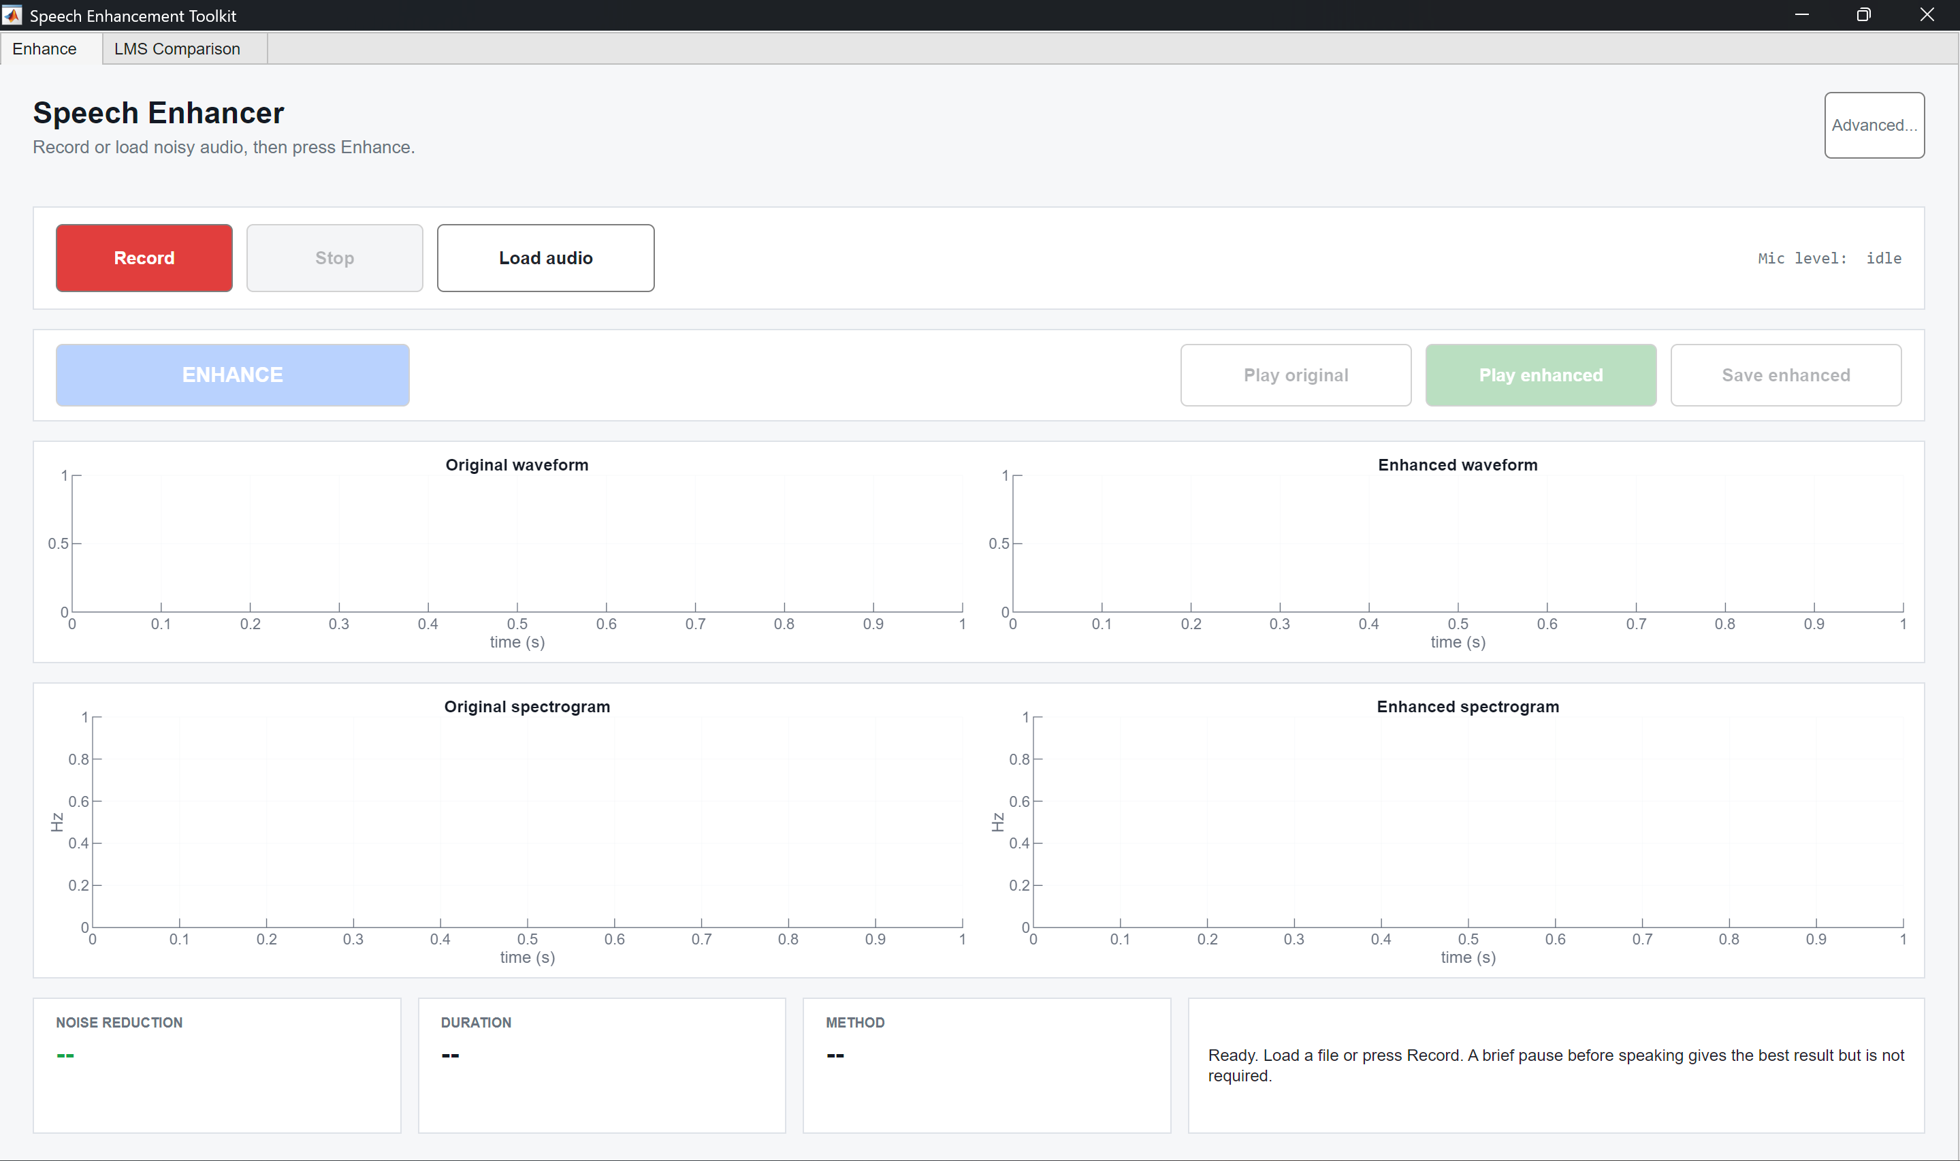
Figure 5.1. Main screen of the application.

6. Results and Discussion

6.1 Illustrative before and after
Figure 6.1 shows a pair of spectrograms from an evaluation run on synthetic speech mixed with white noise at 5 dB SNR. The dense spectral floor of the noisy spectrogram is much lower in the enhanced output. The harmonic ridges of the speech, visible up to about 3 kHz, are preserved.
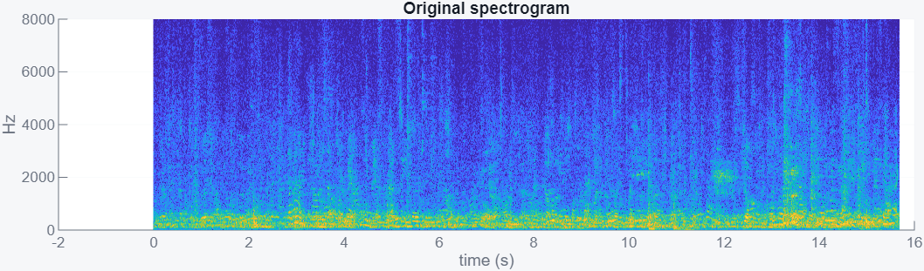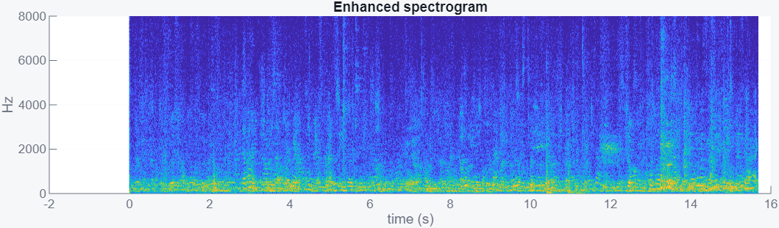
Figure 6.1. Illustrative before/after spectrograms.

6.2 Quantitative results
Table 6.1 gives the quantitative comparison between the OLD and NEW pipelines on the three noise conditions. In every condition the NEW pipeline gets higher output SNR and higher segmental SNR gain than the OLD one. The improvement is largest on babble noise, which is where speech leakage into the minimum-statistics estimator does the most damage.
Noise | Input SNR | Out SNR OLD | Out SNR NEW | ΔSNR OLD | ΔSNR NEW | SegSNR OLD/NEW | Floor OLD/NEW
White | +5.0 | 0.16 | 00 | -4.84 | -5 | +0.07/-0.03 | +9.44/+6.03
Pink | +5.0 | +8.7 | +10.9 | +3.7 | +5.9 | +0.08/-0.04 | +2.97/+5.49
Babble | +5.0 | +6.9 | +9.3 | +1.9 | +4.3 | +0.13/-0.04 | +5.38/+2.43
Table 6.1. Objective results, three noise types at 5 dB input SNR. All values in dB.

6.3 Qualitative observations
The enhanced audio sounds cleaner than the noisy input on all three noise types. Consonants stay distinct and the pitch harmonics of voiced sounds are preserved. The effect is most noticeable on white noise. The dominant hiss in the noisy signal drops to a low residual, and the speech steps forward. On babble the residual is more speech-like and less obviously "clean", but the target speaker's intelligibility improves. The pipeline did not introduce audible musical-noise artefacts of the kind produced by the earlier Wiener + minimum-statistics implementation.

6.4 LMS results
With a filter length of 64 taps and step size μ = 0.1 the LMS residual converges to the clean speech within a few hundred milliseconds. The learning curve decreases monotonically with time. The two-microphone LMS setup reaches higher output SNR than the single-channel STFT pipeline. It sets the upper bound on what a reference-based system can do, and it motivates the STFT approach for the case where no reference is available.

7. Limitations and Future Work

7.1 Known limitations
- Highly non-stationary noise (door slams, competing talkers, impulsive interference) can leak through. The SPP estimator adapts slowly by design, so a burst shorter than a few frames is not tracked.
- At very low input SNR (below about −5 dB) the enhanced audio contains some residual musical noise even with the −15 dB gain floor, because the a priori SNR estimate is less reliable in this regime.
- The estimator keeps the noisy phase, so the synthesised speech inherits phase artefacts. This is acceptable for intelligibility but not for high-fidelity applications.
- The pipeline does not dereverberate. Room reverberation in the input passes through essentially unchanged.

7.2 Future work
- Extend the SPP estimator with a noise-tracking-adaptive ξ_{H1}, as suggested in later work by the same authors, to improve tracking of non-stationary noise.
- Add a phase-sensitive filter (Erdogan et al., 2015) as an optional post-processing stage.
- Compare quantitatively with a learning-based baseline such as RNNoise or DeepFilterNet on a public dataset such as VoiceBank+DEMAND.
- Extend the LMS module into a two-microphone real-time streaming implementation.

8. Conclusion
This report has described the design, implementation, and evaluation of, a classical single-channel speech-enhancement toolkit for MATLAB. The pipeline combines a decision-directed Wiener gain with the MMSE speech-presence-probability noise estimator of Gerkmann and Hendriks (2011). Objective evaluation on synthetic noisy speech shows improvements in both global SNR and segmental SNR across white, pink, and babble noise. Listening confirms that speech harmonics and consonants are preserved much better under the SPP estimator than under the earlier minimum-statistics implementation.

References
[1] Ephraim, Y., and Malah, D. (1984). Speech enhancement using a minimum-mean-square-error short-time spectral amplitude estimator. IEEE Transactions on Acoustics, Speech, and Signal Processing, 32(6), 1109-1121.
[2] Ephraim, Y., and Malah, D. (1985). Speech enhancement using a minimum-mean-square-error log-spectral amplitude estimator. IEEE Transactions on Acoustics, Speech, and Signal Processing, 33(2), 443-445.
[3] Berouti, M., Schwartz, R., and Makhoul, J. (1979). Enhancement of speech corrupted by acoustic noise. Proceedings of ICASSP 1979, 208-211.
[4] Martin, R. (1994). Spectral subtraction based on minimum statistics. Proceedings of EUSIPCO 1994, 1182-1185.
[5] Martin, R. (2001). Noise power spectral density estimation based on optimal smoothing and minimum statistics. IEEE Transactions on Speech and Audio Processing, 9(5), 504-512.
[6] Gerkmann, T., and Hendriks, R. C. (2011). Unbiased MMSE-based noise power estimation with low complexity and low tracking delay. IEEE Transactions on Audio, Speech and Language Processing, 20(4), 1383-1393.
[7] Widrow, B., Glover, J. R., McCool, J. M., Kaunitz, J., Williams, C. S., Hearn, R. H., Zeidler, J. R., Dong, E., and Goodlin, R. C. (1975). Adaptive noise cancelling: principles and applications. Proceedings of the IEEE, 63(12), 1692-1716.
[8] Loizou, P. C. (2013). Speech Enhancement: Theory and Practice (2nd ed.). CRC Press.
[9] Vaseghi, S. V. (2008). Advanced Digital Signal Processing and Noise Reduction (4th ed.). Wiley.
[10] Erdogan, H., Hershey, J. R., Watanabe, S., and Le Roux, J. (2015). Phase-sensitive and recognition-boosted speech separation using deep recurrent neural networks. Proceedings of ICASSP 2015, 708-712.

