Game Design Document

Fill up the following document

1. Write the title of your project.

Defeat the Zombies

1. What is the goal of the game?

Kill all the zombies

1. Write a brief story of your game.

Our chracter is stuck in a forest full of zombies , you have to save him

1. Which are the playing characters of this game?

* Playing characters are the ones who respond to the user based on the input from the user.
* Cars, monkeys, dinos, wizards, etc., are the playing characters in the game.

|  |  |  |
| --- | --- | --- |
| Number | Character Name | What can this character do? |
| 1 | Knight | Kill zombies |
| 2 | Zombie | Kill knight |
| 3 |  |  |
| 4 |  |  |
| 5 |  |  |
| 6 |  |  |
| 7 |  |  |
| 8 |  |  |

1. Which are the Non-Playing Characters of this game?

* Non-Playing characters are the ones that don't have an action or behavior when the user interacts with the game.
* Hurdles, stones, bananas, coins, etc., are non-playing characters in the game.

|  |  |  |
| --- | --- | --- |
| Number | Character Name | What can this character do? |
| 1 | Weapon | Attack zombies |
| 2 | background | see |
| 3 |  |  |
| 4 |  |  |
| 5 |  |  |
| 6 |  |  |
| 7 |  |  |
| 8 |  |  |

Draw your imagination of this game. What does this game look like?

* Draw the game either on your computer or on paper.
* Add images of the game scenes to show each of the playing and non-playing characters at least once.

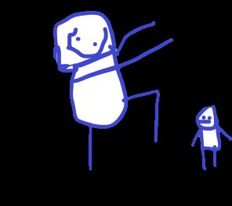

How do you plan to make your game engaging?

By adding weapons