**Criterion B: Design**

**Structure Diagram:**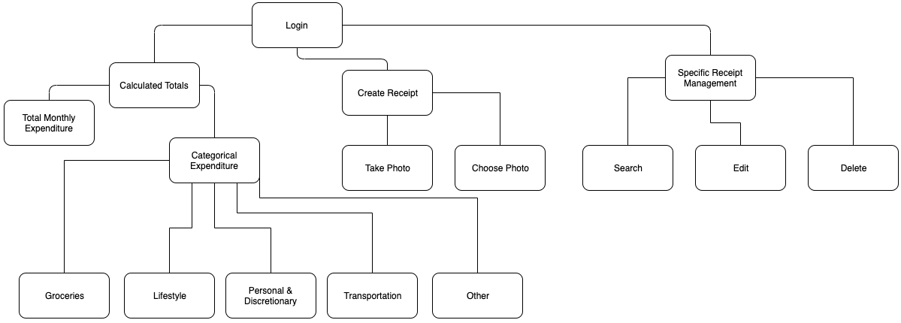

**UML Class Diagram:**

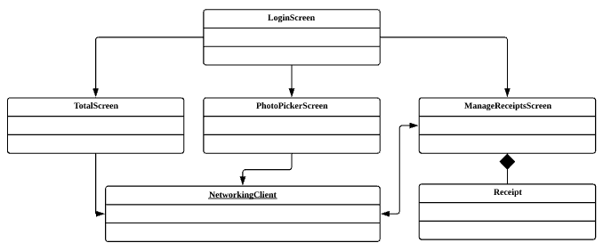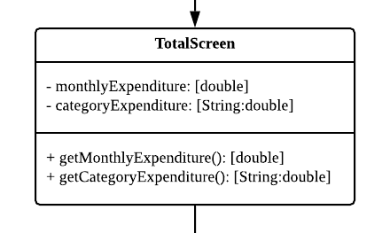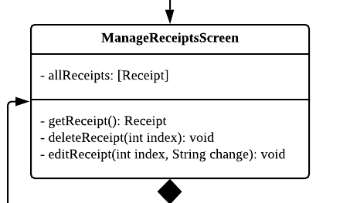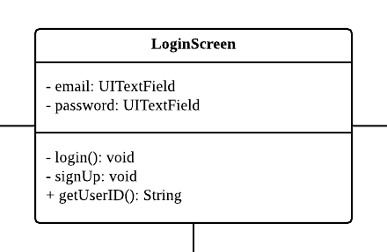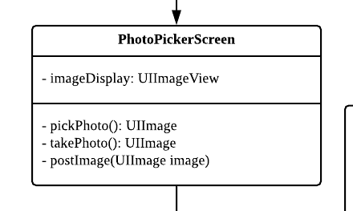

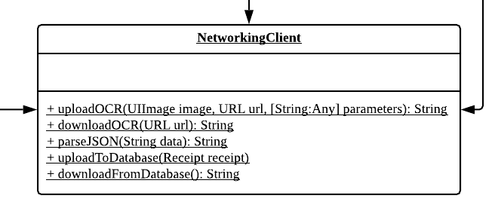

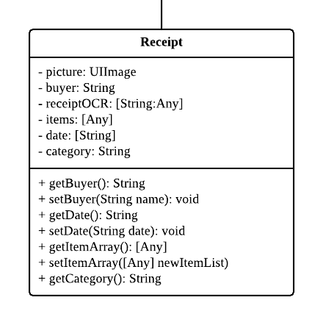

**System Flowchart:**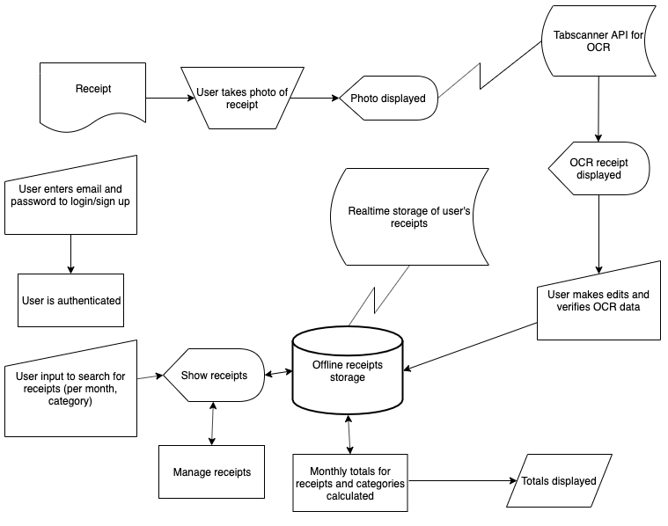

**Program Flowcharts (from important processes in System Flowchart):**

Login:

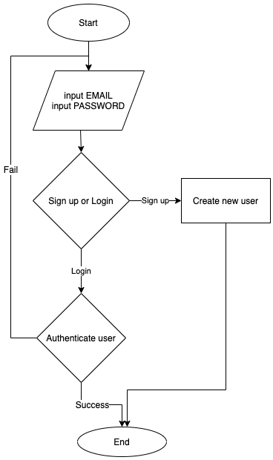

Receipt OCR

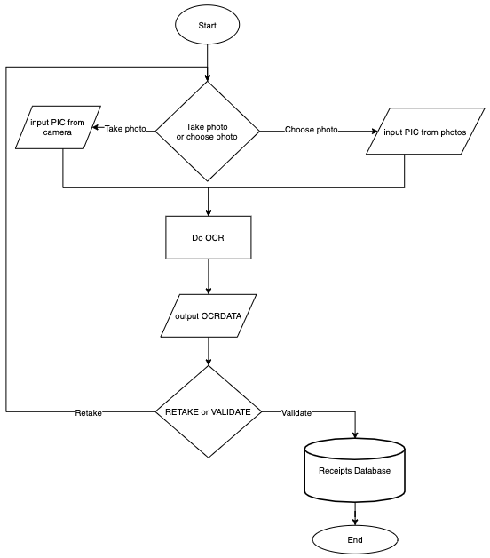

Total Calculation:

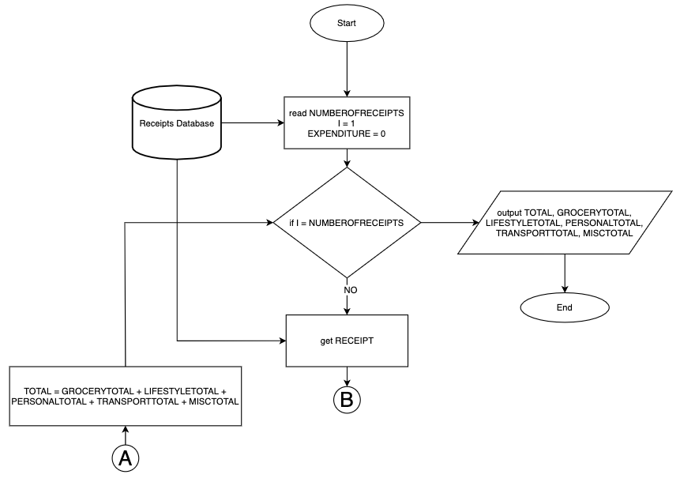

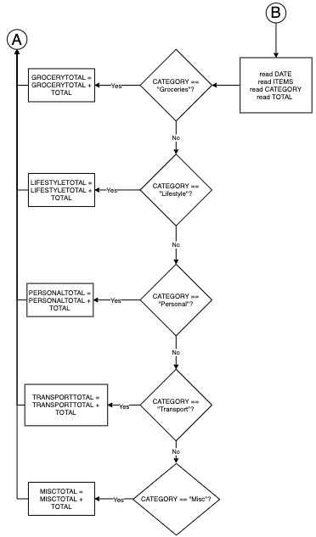

Manage Receipts:

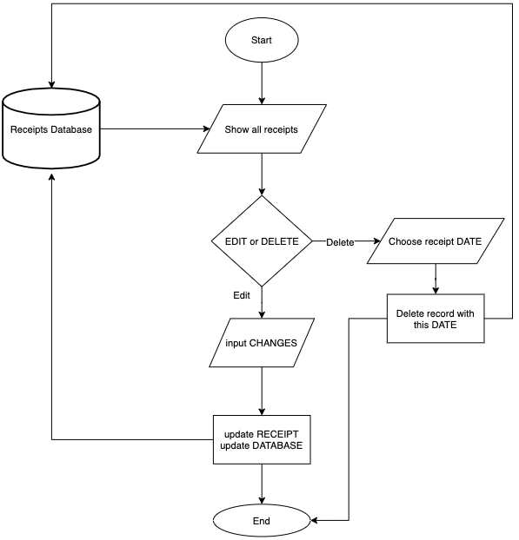

Upload to Tabscanner

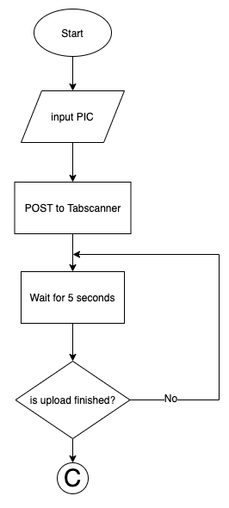

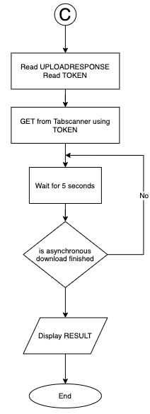

**Database Design:**

Relations:



Table 1 – User

| Field Name | Data Type | Description |
| --- | --- | --- |
| USERID | text, length 15 | Unique ID to identify each record. Primary Key. |
| Email | text |  |
| Password | text |  |

Table 2 – Month Totals

| Field Name | Data Type | Description |
| --- | --- | --- |
| TOTALSID | text, length 15 | Unique ID to identify each record. Primary Key. |
| USERID | text, length 15 | Unique ID to identify each Month Totals is part of one user’s expenditure. Foreign Key. |
| Expenditure | currency | Holds expenditure for that month |
| Grocery Expenditure | currency | Holds grocery expenditure for that month |
| Lifestyle Expenditure | currency | Holds lifestyle expenditure for that month. Lifestyle expenditure includes expenditure on furniture, clothing, and other luxury items |
| Personal & Discretionary Expenditure | currency | Holds personal and discretionary expenditure for that month |
| Transportation Expenditure | currency | Holds expenditure on transport for that month |
| Misc Expenditure | currency | Holds miscellaneous expenditure for that month |

Table 3 – Receipt

| Field Name | Data Type | Description |
| --- | --- | --- |
| RECEIPTID | text, length 15 | Is the token value from the upload to Tabscanner. Unique ID to identify each record. Primary Key. |
| USERID | text, length 15 | Unique ID to identify each Receipt is part of one user’s expenditure. Foreign Key. |
| TOTALSID | text, length 15 | Unique ID to identify each Receipt is part of one Month Totals. Foreign Key. |
| Category | text | Which category the receipt is part of: Groceries,  Lifestyle, Personal & Discretionary, Transportation, Misc. |
| Image | CLOB | Image of the receipt that was uploaded by the user. |
| Buyer | text | Who bought the receipt. |
| ReceiptOCR | text | OCR data of receipt |
| Total | currency | Total amount spent on receipt |

Table 4 – Item

| Field Name | Data Type | Description |
| --- | --- | --- |
| ITEMID | text, length 15 | Unique ID to identify each record. Primary Key. |
| RECEIPTID | text, length 15 | Unique ID to identify each Item is part of one receipt. Foreign Key. |
| Description | text | Contains the name of the item |
| Quantity | float | Contains mass of the item (only valid for groceries) |
| Price | currency |  |

**Screen Designs**

Screen 1: Login Page

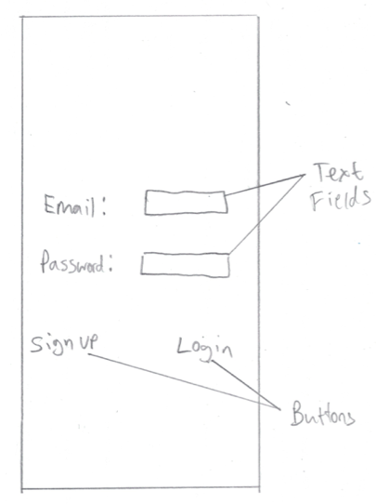

Screen 2: Receipt Image Page

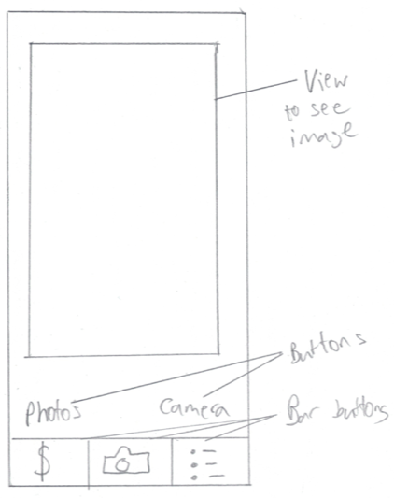

Screen 3: Receipt Data Page

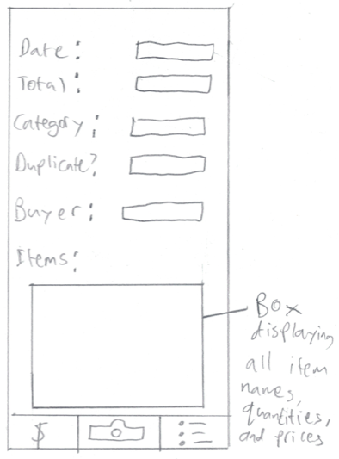

Screen 4: Totals Page

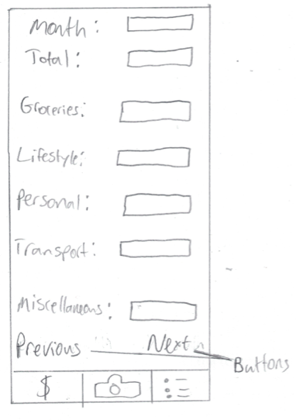

Screen 5: All Receipts Page

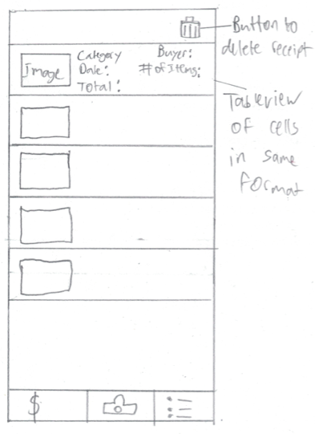

**Updated Screen Designs**

Screen 3: Receipt Data Page

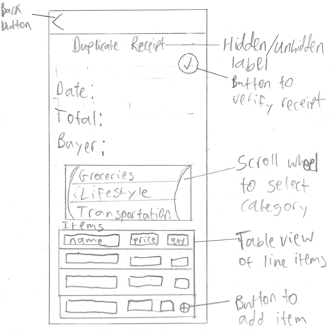

Screen 4: Totals Page

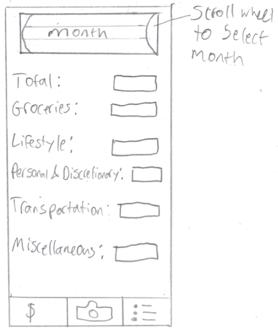

Screen 5: All Receipts Page

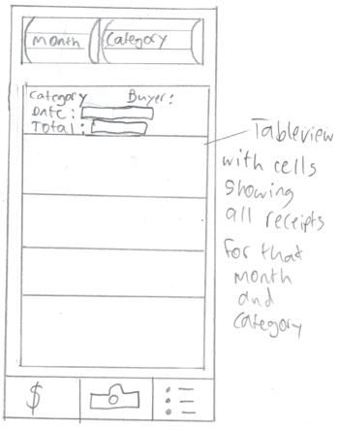

Screen 1: Login Page and Screen 2: Receipt Image Page do not need to be modified

**Test Plan:**

| **Success Criterion** | **Method of Testing** | **Expected Outcome** |
| --- | --- | --- |
| The application should: |  | |
| Run-on an iPhone 8 | Ask my client to use the product on her phone | All features function on my client’s phone, and the layout is properly adjusted for the size specifications. |
| Require login to view any data of purchases and totals | Try logging in, and try signing up. Also, attempt to login using incorrect details | The homepage opens if login is successful. Alerts are shown if details are invalid |
| The homepage should: |  | |
| Display the current month’s totals (including category totals) up to the current date | Run the homepage | All totals are displayed for the current month |
| Have a navigation menu to see receipts (from any month and category) and items bought | Test all the buttons on the homepage which are meant to navigate to other screens | Correct screens are loaded |
| Contain totals of previous months upon user’s request | Attempt to navigate to the menu which shows totals of previous months | Previous month totals are displayed |
| The interface should: |  | |
| Be “simple and intuitive to use” by using buttons and intuitive symbols to improve usability | Run all pages of the product | All buttons are blue, and their icons clearly depict what they do |
| Be navigable and not require many steps to view expenditure | Check if navigating to the expenditure page takes many steps | User is able to go to the expenditure page within 3 button clicks |
| Have consistent placing of buttons | Run all the screens in the program | “Logout” button and the bar buttons for the different screens are in the same place |
| The database should: |  | |
| Store data on purchases made of each item and related values | Add records for several receipts | Database contains the records of the added receipts |
| Have unique identifiers to locate a purchase | Add a record for a receipt and check database | The receipt is identified by a new ID that hasn’t been used previously |
| To manage receipts, the user should be able to: |  | |
| Take a photo of the receipt after purchase, or choose an old photo | Attempt to take a photo of a new receipt, and attempt to choose an old photo | Camera app or Photo app loads and allows the user to take/choose a photo |
| Cancel the upload to the database of a receipt | Choose a receipt photo and try to cancel the upload, then check database | Database shows no record of the receipt |
| View and edit the receipt in an OCR format | Choose a receipt and see if the data is displayed correctly in a digital format. Then try and change each of its data. Check database after edits are made | The receipt’s data is displayed to the user through, for example, text fields. Each value is able to be changed, and the database reflects these changes |
| Delete unwanted receipts | Delete an old receipt and check to see if the database contains it. Also, check that the totals have been changed | The database does not contain the deleted receipt. Totals are updated to exclude the expenditure of the deleted receipt |
| To review expenditure, the program should: |  | |
| Calculate monthly totals for all the categories: Groceries, Lifestyle, Personal, Transportation, Miscellaneous | Add receipts and check if the totals are correct | Expenditure on each receipt from each category sums up to the correct total |
| Calculate the total expenditure in a specific month | Add receipts from different months and check if the total for the current month is correct | Total is the correct sum of all the receipts |
| Allow the user to select who bought a receipt, and then display this data when they are looking at the receipt | Before the receipt is uploaded to the database, specify that another person bought the receipt | Database record shows who bought the receipt. When the receipt is checked on the app, the name of the buyer is shown |