# Teamcenter client installation for ecn-tc13prod

These instructions assume:

* You are connected to the Purdue VPN. This is required to install and run Teamcenter
* You have NX 1926 or newer installed locally or loaded on your system with AppsAnywhere
* You are on a personally-owned PC using an account with administrative privileges

Please contact ECN to request installation on Purdue-owned PCs.

First, type “cmd.exe” in the Start Menu or Windows search. Right-click the search result and “Run as administrator”

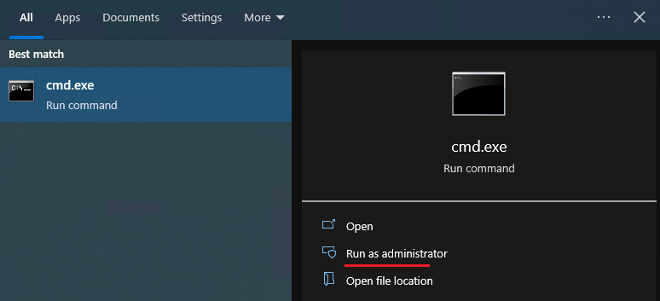

Run this command in the admin command prompt, then enter your career account password:

c

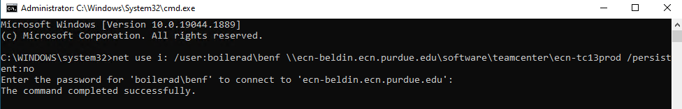

Run this script in your admin command prompt: i:\editsilentxml.bat

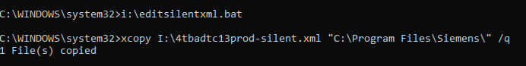

This will open the silent install XML file in Notepad. On line 10, replace "badela" with the username you use to log into your PC. You can see your username under "whoami" in the command prompt.

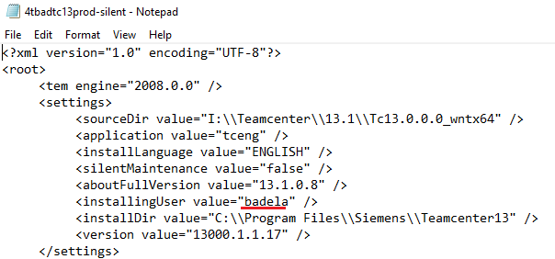

If your NX version is newer than 1946, look in C:\Program Files\Siemens to see which series it's from and replace "NX1926" in line 30.

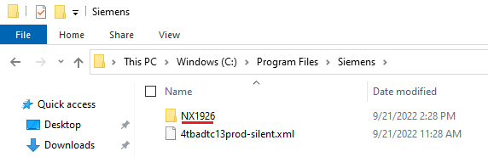



Save the file, close Notepad, and run this in the command prompt: i:\tcinstall.bat

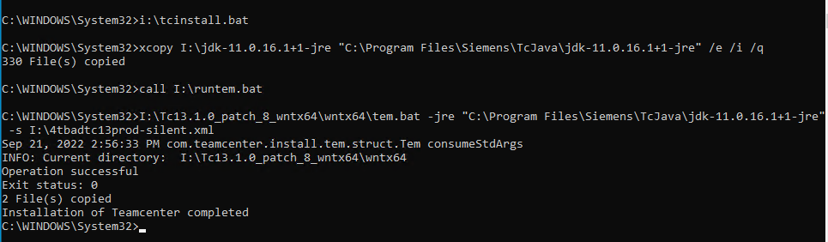

# Using Teamcenter without the Rich Client

If you don’t need the Rich Client, you can access Teamcenter within NX using the “NX with Teamcenter ecn-tc13prod” shortcut:

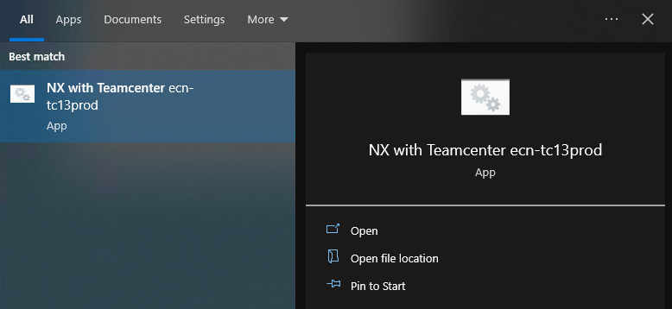

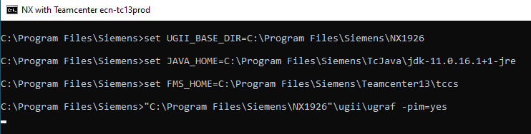

Log in using your career account username and the password you were provided.



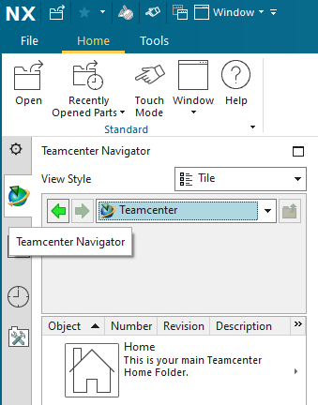

# Using the Teamcenter Rich Client

If you need the Rich Client, launch it using the “Teamcenter 13” shortcut:

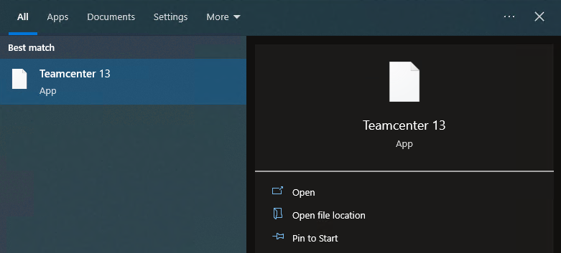

Log in using your career account username and the password you were provided.

