WEEK 2 INTERNSHIP DELIVERABLE
Data Collection, Preprocessing & Cleaning for Agribusiness Analysis
A simulated, reproducible data-preparation workflow for agriculture and agribusiness machine-learning analysis
Prepared for Internship Submission • Week 2
Primary deliverable | Detailed Week 2 data collection and preprocessing report
Selected source domains | Crop production • rainfall/weather • agricultural market prices
Processing approach | Simulated raw → cleaned → feature-engineered → ML-ready
Data integrity statement | Synthetic sample records; public source metadata documented separately

Executive Summary
Week 2 focuses on the practical data-engineering stage between research planning and analysis. The objective is to demonstrate how agricultural datasets can be collected from public sources, profiled, cleaned, transformed and prepared for machine-learning applications. Three source families are used: Government of India crop-production statistics, India Meteorological Department rainfall data published through the Open Government Data platform, and e-NAM market information.
Because the internship task explicitly asks for a simulation, this package includes small synthetic datasets whose schemas resemble the public sources. The simulated data intentionally contain common data-quality problems—missing values, duplicates, inconsistent labels, invalid values and outliers—so the complete cleaning process can be demonstrated and audited without representing fabricated values as official observations.

1. Data Sources & Relevance
Dataset | Publisher | What it provides | Agribusiness relevance | URL
Crop production | Government OGD / Department of Agriculture & Farmers Welfare | District-wise, crop-wise, season-wise and year-wise area/production. | Crop productivity, geographic comparisons and yield modelling. | https://data.gov.in/resource/district-wise-season-wise-crop-production-statistics-1997
Rainfall | Government OGD / IMD | Monthly and seasonal rainfall and departure from normal. | Weather feature for yield/productivity and seasonality analysis. | https://data.gov.in/catalog/rainfall-india
Market prices | e-NAM / SFAC / Ministry of Agriculture & Farmers Welfare | APMC/commodity market and price-discovery information. | Price trends, volatility, arrivals and market modelling. | https://enam.gov.in/
Official crop statistics | ES&E, Department of Agriculture & Farmers Welfare | Current advance/final production estimates and agricultural reports. | Validation/reference source for crop statistics. | https://desagri.gov.in/

2. Data Collection Procedure
- Identify the official dataset and record its publisher, title, URL, update date, coverage and granularity.
- Download/API-extract the data where permitted and retain the original file without modification.
- Create a source metadata record containing access date, dataset version/report date, units, field definitions and known limitations.
- Store raw data separately from processed data so every cleaning decision is reversible.
- Profile row count, column count, data types, missingness, duplicate keys, unique categories and numerical ranges.
- Create a data dictionary before applying transformations.
- Apply cleaning rules, feature engineering and validation checks.
- Export cleaned datasets and an ML-ready analytical table, together with the transformation log.

3. Data Collection Simulation
The package contains three deliberately imperfect datasets. They are synthetic examples designed to reproduce realistic preprocessing issues. They are not official downloaded observations.
- Crop production: 17 raw rows with missing production/area, an extreme production value, inconsistent crop spacing and a duplicate.
- Rainfall: {len(rain_raw)} raw rows with a missing observation, negative rainfall, an extreme value and a duplicate.
- e-NAM-style market data: {len(market_raw)} raw rows with missing modal price, an invalid price relationship, inconsistent commodity spacing and a duplicate.

4. Data Quality Issues Simulated
Issue | Example | Treatment
Missing values | Production, area, rainfall and modal price | Use source validation first; apply justified derivation/imputation only when appropriate.
Duplicates | Repeated natural-key records | Drop only after defining the correct natural key.
Inconsistent labels | Whitespace/capitalization | Trim and map to canonical labels.
Invalid values | Negative rainfall / price ordering | Set invalid values to missing or correct only under documented rules.
Outliers | Extreme production/rainfall/price | Flag with IQR/z-score; investigate before deletion.
Unit consistency | Area, production, yield, price | Standardize units and retain original fields for auditability.

5. Detailed Preprocessing Methodology

5.1 Structural Cleaning
- Normalize column names to lowercase/snake_case.
- Parse dates and numeric fields explicitly.
- Standardize state, district, crop, season, APMC and commodity labels.
- Remove duplicates only after defining a natural key.
- Retain raw source columns where a transformed field is created.

5.2 Missing Values
- Determine why a value is missing; missing does not automatically mean zero.
- Use source re-check before statistical imputation where possible.
- Derive production from area × yield only when units match and the relationship is valid.
- For rainfall in this simulation, state+month median imputation is demonstrated; real data should use meteorological validation first.
- For market prices, source verification/neighboring observations should be preferred to blind imputation.
- Record every imputed value and method in the cleaning log.

5.3 Outlier Handling
- Use IQR, z-score and domain-specific rules for detection.
- Check units and decimal errors first.
- Compare adjacent dates/years and known events.
- Flag suspicious observations instead of automatically deleting them.
- Replace/remove only after source validation or documented domain rules.

5.4 Normalization & Standardization
- Standardize area to hectares and production to tonnes.
- Calculate yield in tonnes/hectare where compatible.
- For ML, fit numerical scalers on training data only.
- Use one-hot or suitable categorical encoding for nominal variables.
- Do not scale targets unless the selected model requires it.

5.5 Feature Engineering
- Yield = production / area.
- Year and month derived from date fields.
- Average rainfall and rainfall variability aggregated to year/state.
- Average modal price, price volatility and arrivals aggregated by market/year/state.
- Price spread = maximum − minimum price.
- Create lags/rolling features only after chronological sorting and leakage checks.

6. Data Cleaning Simulation — Results
Dataset | Issue | Records affected | Treatment
Crop | Duplicates | 1 | Removed exact duplicate based on year+state+district+season+crop
Crop | Missing production | 1 | Derived from area × reported yield / 1000 where inputs available
Crop | Missing area | 1 | Imputed with crop+state median
Crop | Production outlier | 3 | Flagged by global IQR; retained for review and replaced only if source validation fails
Rainfall | Duplicates | 1 | Removed duplicate year+month+state
Rainfall | Negative values | 1 | Set invalid negative rainfall to missing
Rainfall | Missing/invalid | 2 | Median imputation by state+month
Rainfall | Outlier | 1 | IQR flag; retained pending meteorological validation
Market | Duplicates | 1 | Removed duplicate date+state+APMC+commodity
Market | Logical price errors | 1 | Flagged; impute only after checking source
Market | Missing modal price | 1 | Median imputation for simulation; real project should validate source/neighboring observations
Market | Invalid min price | 1 | Replaced with 95% of modal only as simulation rule; real data should be source-validated
Market | Modal-price outlier | 0 | IQR flag; do not delete without source/event validation

7. ML-Ready Dataset Design
The package creates `ml_ready_agri_sample.csv`, joining cleaned crop, rainfall and market features by year and state. This is a demonstration table, not a statistically representative agricultural dataset.
- Candidate target: yield_t_ha.
- Weather predictors: average monthly rainfall and rainfall variability.
- Market predictors: average modal price, average arrivals and price volatility.
- Categorical predictors: state, district, season and crop.
- Temporal predictors: year and season; lagged features only when future leakage is prevented.

8. Validation & Quality Assurance
- Compare row counts before/after each transformation.
- Confirm natural-key duplicates are resolved.
- Check missingness after cleaning.
- Check non-negative ranges for area, production, rainfall, price and arrivals.
- Check logical price ordering: min ≤ modal ≤ max.
- Recalculate derived yield and compare with source-reported yield where available.
- Review random rows against the raw file.
- Check chronological leakage before modelling.
- Save versioned source, data dictionary and cleaning log.

9. Pseudocode
LOAD raw crop, rainfall and market datasets
CAPTURE source metadata and data dictionary
FOR each dataset:
standardize column names and data types
define natural key
remove confirmed duplicate records
inspect missing values
inspect invalid ranges and logical rules
flag outliers using statistical + domain checks
apply only documented corrections/imputation
standardize units and category labels
create derived features
validate transformed dataset
JOIN compatible features by common time/geography keys
CHECK for leakage and incompatible definitions
EXPORT cleaned datasets + ML-ready dataset
SAVE cleaning log + data dictionary + source register

10. Workflow Diagram
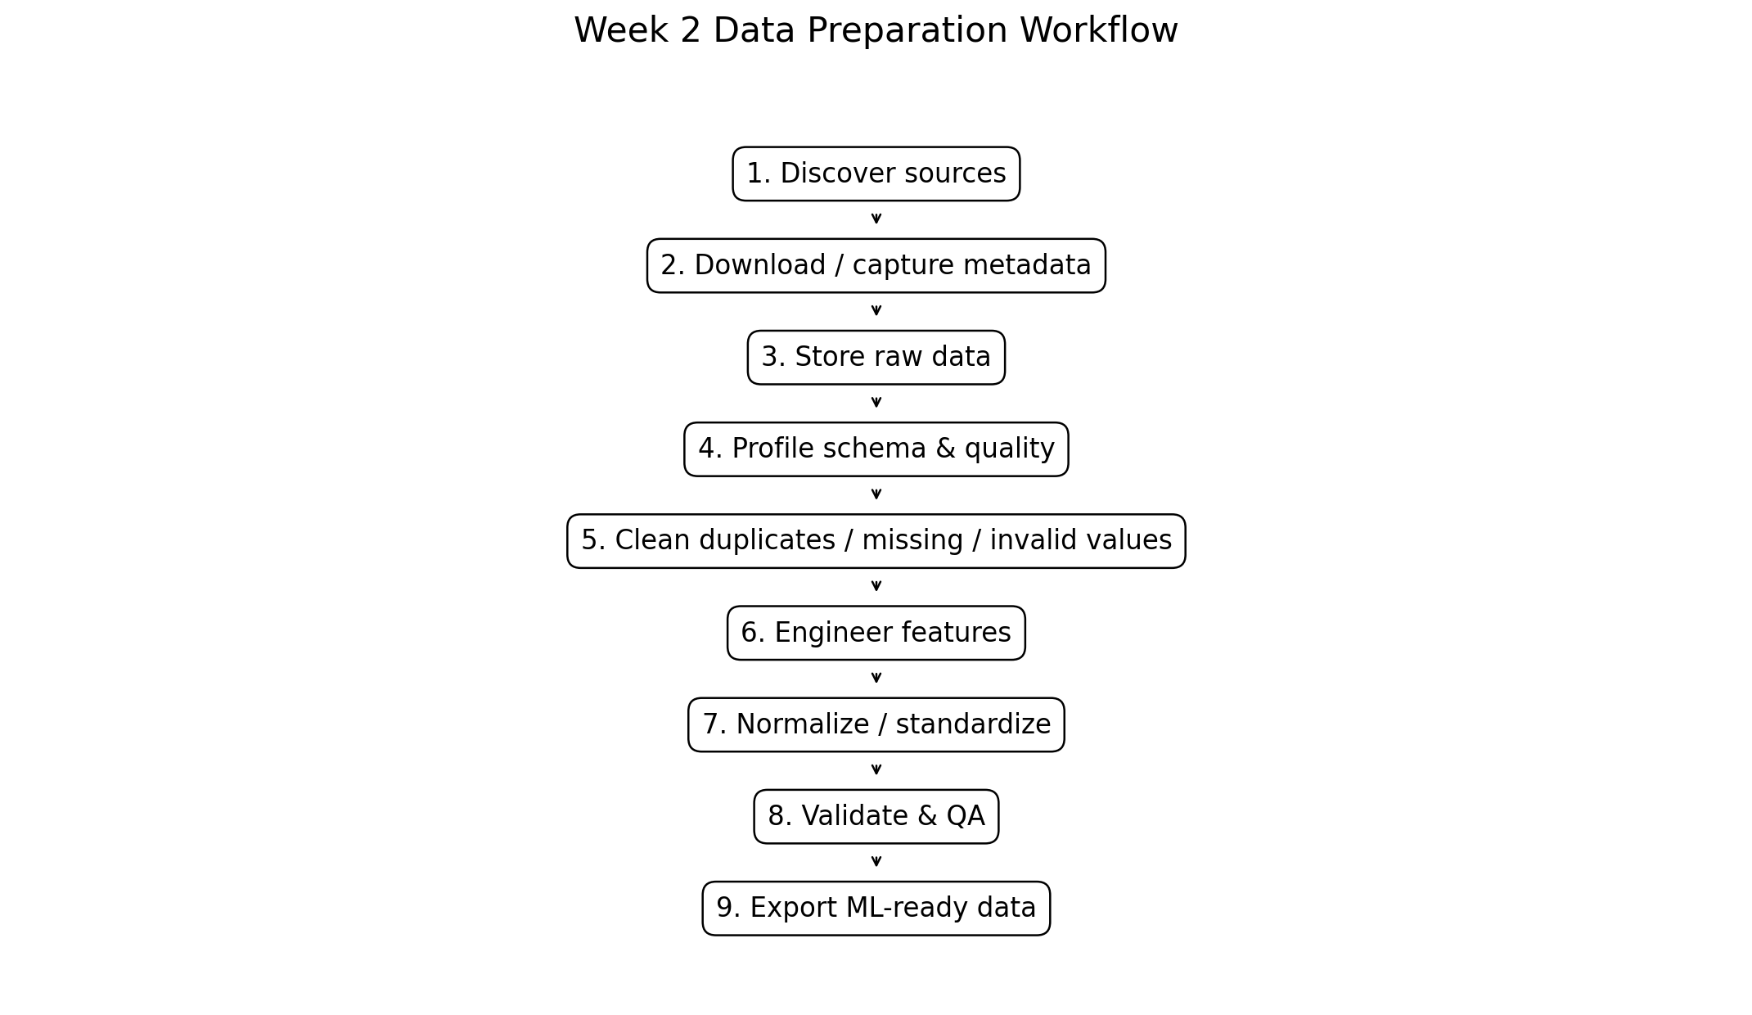

11. Visual QA Outputs

11. Visual QA Outputs
Crop yield trend
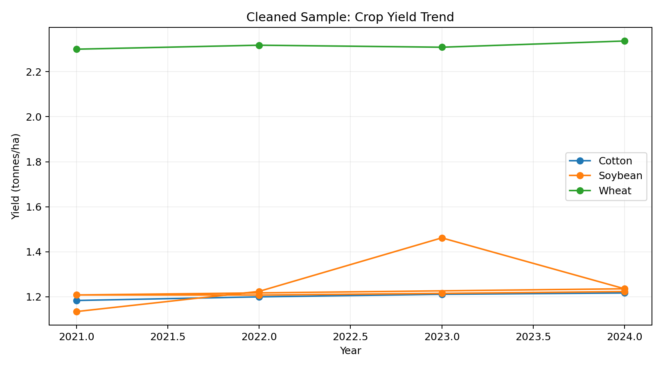
Market modal-price trend
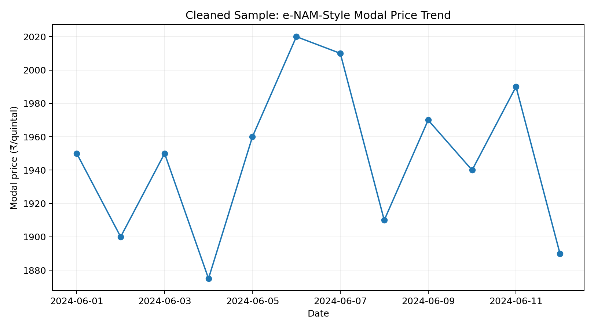
Rainfall–yield simulation
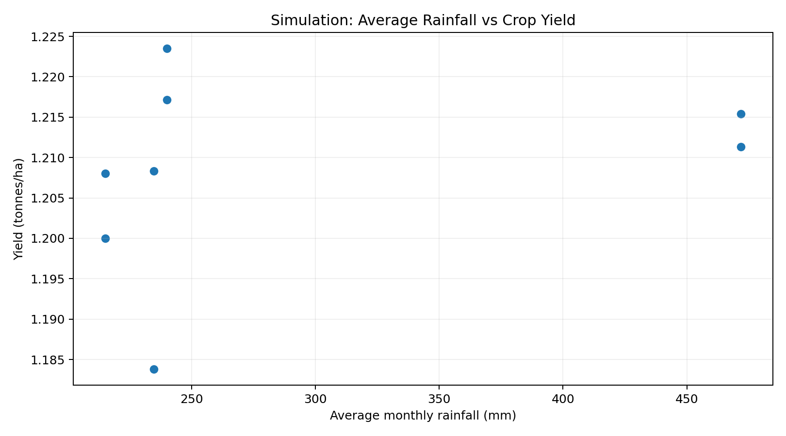

12. Data Dictionary
Field | Description | Type | Role | Validation
year | Year | Integer | Time index | Valid year
state | State/UT | Categorical | Geography | Controlled spelling
district | District | Categorical | Crop geography | Controlled spelling
season | Agricultural season | Categorical | Crop season | Standardized label
crop | Crop name | Categorical | Target/entity | Trim and canonicalize
area_ha | Area cultivated | Numeric | Crop scale | Non-negative
production_tonnes | Production | Numeric | Target/predictor | Non-negative
yield_t_ha | Yield | Numeric | Target KPI | Production divided by area
rainfall_mm | Rainfall | Numeric | Weather feature | Non-negative
modal_price_rs_quintal | Modal market price | Numeric | Market feature | Check min <= modal <= max
arrival_tonnes | Market arrivals | Numeric | Supply feature | Non-negative

13. Practical ML Considerations
- Avoid data leakage: preprocessing parameters must be learned from training data only.
- Use chronological validation for forecasting tasks.
- Correlation does not establish causation.
- Preserve geography and crop categories carefully.
- Check target/class imbalance if the problem becomes categorical.
- Track feature provenance from source to model input.

14. Limitations
- Included CSV observations are synthetic simulation data, not official government observations.
- Public datasets can differ in definitions, coverage periods, revision status and units.
- Rainfall and crop production may have different spatial/temporal granularities; joins require aggregation and validation.
- Market coverage can differ across commodities/APMCs.
- Simulation imputation rules must not be applied blindly to real data.

15. Conclusion
The Week 2 workflow demonstrates a complete and auditable path from public agricultural data sources to cleaned, feature-engineered and ML-ready data. The central principle is that preprocessing is not simply deleting bad rows: every change should be justified by source metadata, domain logic or a transparent statistical rule. The package therefore preserves raw data, cleaned outputs, a data dictionary, cleaning log, code and visual QA evidence.

References & Source Evidence
- Government OGD — District-wise, season-wise crop production: https://data.gov.in/resource/district-wise-season-wise-crop-production-statistics-1997
- Government OGD — Rainfall in India: https://data.gov.in/catalog/rainfall-india
- e-NAM — National Agriculture Market: https://enam.gov.in/
- ES&E / Department of Agriculture & Farmers Welfare: https://desagri.gov.in/
Public source pages were reviewed on 30 September 2026. Recheck dataset metadata and update dates when downloading actual production files.

