WEEK 3 INTERNSHIP DELIVERABLE
Exploratory Data Analysis & Visualization in Agricultural Contexts
Crop performance, production trends, geographic variation and agricultural relationships
Prepared for Internship Submission • Week 3
Primary dataset | Government of India OGD crop-production dataset schema
Analytical scope | 2015–2024 • 4 states • 3 crops
EDA methods | Univariate, bivariate, trend, correlation and distribution analysis
Data integrity | Synthetic analytical sample; public source documented separately

Executive Summary
This Week 3 analysis explores agricultural crop performance using the Government of India Open Government Data crop-production resource as the source framework. The resource is district-wise, crop-wise, season-wise and year-wise and is suitable for studying production scale, productivity, time trends and geographic variation.
For data integrity, the numerical records analyzed here are a synthetic sample modeled on that public schema. They demonstrate the requested EDA workflow without presenting fabricated values as official statistics.
The analysis uses descriptive statistics, distributions, crop/state comparisons, time-series trends, scatter plots, a correlation heatmap and a crop-level boxplot. The main descriptive findings are that crop and geography matter materially, production scale is closely linked to cultivated area, and productivity should be evaluated separately from total output.

1. Dataset Selection & Relevance
The selected public source is the Government of India OGD resource “District-wise, season-wise crop production statistics from 1997.” It is published by the Ministry of Agriculture and Farmers Welfare / Department of Agriculture and Farmers Welfare. The resource page reports annual granularity and an update on 16 October 2024. citeturn0search0
- Direct agricultural relevance: area and production are core crop-performance measures.
- Time dimension: supports historical trend exploration.
- Geographic dimension: supports state/district comparisons.
- Crop and season dimensions: enable segmentation and benchmarking.
- Agribusiness relevance: output and productivity are useful inputs for sourcing, logistics, storage and commodity planning.
- Public official source: transparent metadata and government ownership.
Supporting context: the Government of India's IMD rainfall catalogue contains monthly and seasonal rainfall series and can support a later weather–yield EDA extension. citeturn0search2

2. Analytical Dataset
The cleaned analytical sample contains 119 observations across 10 years (2015–2024), 4 states and 3 crops.
Variable | Type | Meaning | EDA role
year | Integer | Year | Time
state | Categorical | State | Geographic segmentation
crop | Categorical | Crop | Commodity segmentation
area_ha | Numeric | Cultivated area | Scale
production_tonnes | Numeric | Output | Primary performance
yield_t_ha | Numeric | Production/area | Productivity

3. EDA Workflow
- Inspect schema and data types.
- Check missing values and duplicates.
- Standardize category labels and derive compatible missing fields.
- Calculate descriptive statistics.
- Perform univariate distribution analysis.
- Compare crops and states.
- Analyze production and yield trends over time.
- Study area–production and yield–production relationships.
- Calculate a correlation matrix.
- Synthesize descriptive findings and carefully qualified agribusiness implications.

4. Data Preparation Before EDA
- Trimmed inconsistent crop labels.
- Removed one duplicate natural-key record.
- Derived missing production from area × yield where possible.
- Derived missing yield from production ÷ area where possible.
- Used a state+crop median for one missing area value in the demonstration sample.
- Recalculated yield after cleaning.
These are analytical-sample procedures and are not claims about the official source's internal cleaning methodology.

5. Univariate Analysis

5.1 Descriptive Statistics
Metric | Count | Mean | Std. | Min | Max
area_ha | 119 | 9971.65 | 6736.02 | 1170.57 | 23949.49
production_tonnes | 119 | 18837.47 | 18276.28 | 1403.09 | 80222.47
yield_t_ha | 119 | 1.86 | 0.86 | 1.08 | 3.44
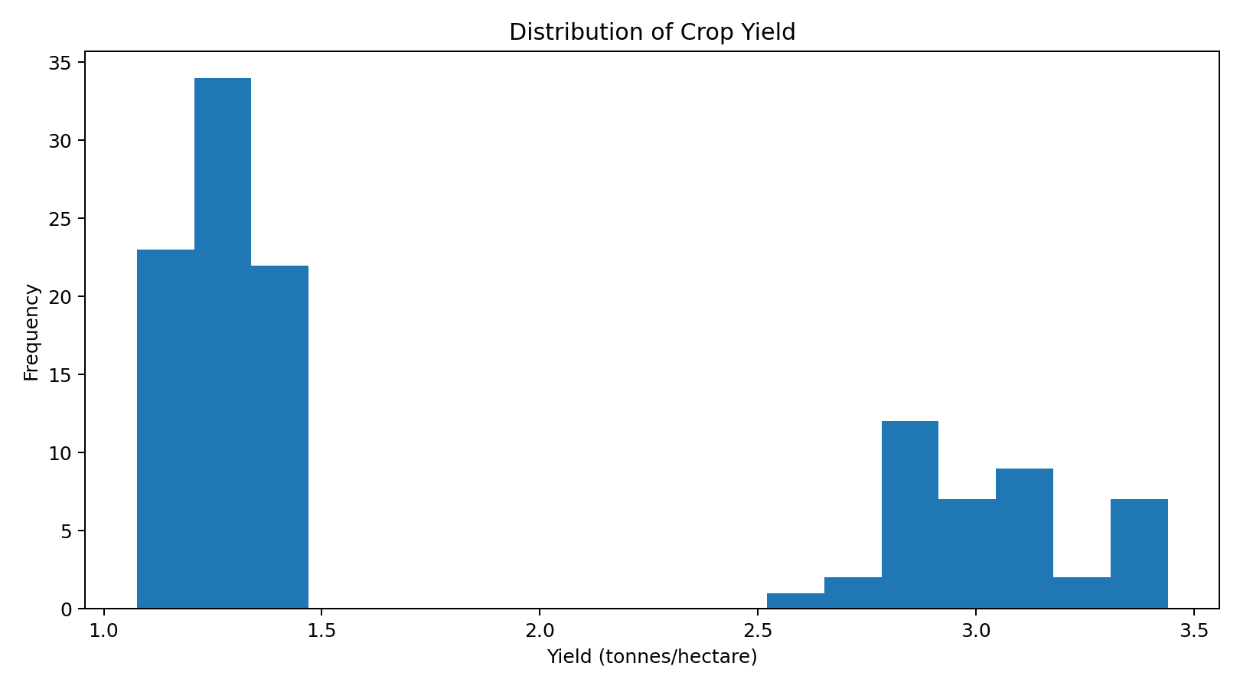
Interpretation: the yield distribution contains crop-specific clusters. Pooling crops into one productivity benchmark can hide meaningful crop differences.

6. Crop and Geographic Comparisons
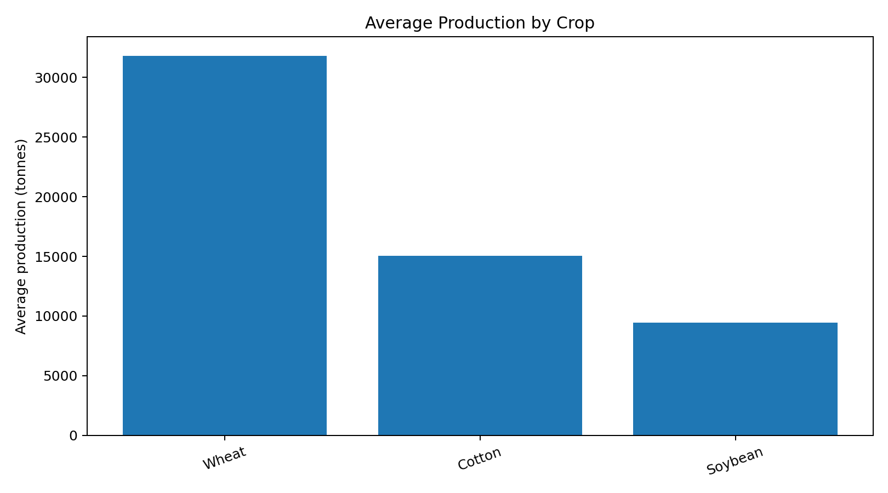
Average production differs across crops. Production volume measures scale and should not be treated as a direct measure of efficiency.
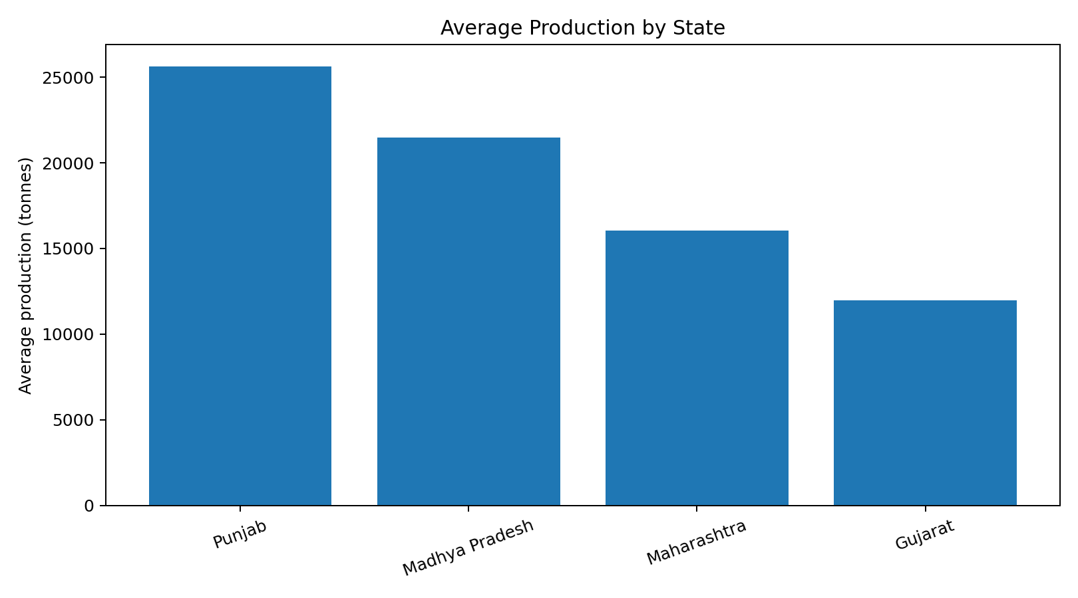
Average output differs across states, reflecting differences in crop mix and cultivated area. Geographic segmentation is therefore important for agribusiness analysis.

7. Time-Series Analysis
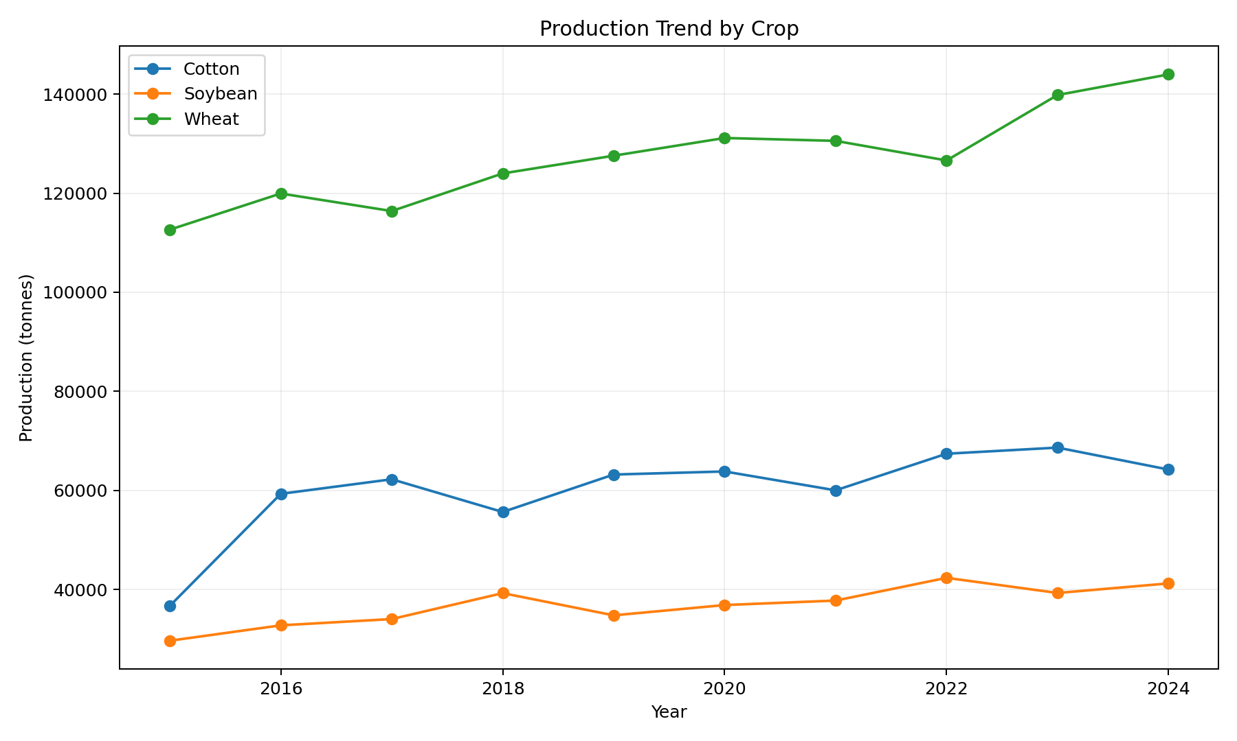
Crop production trajectories are not identical, supporting commodity-specific trend monitoring.
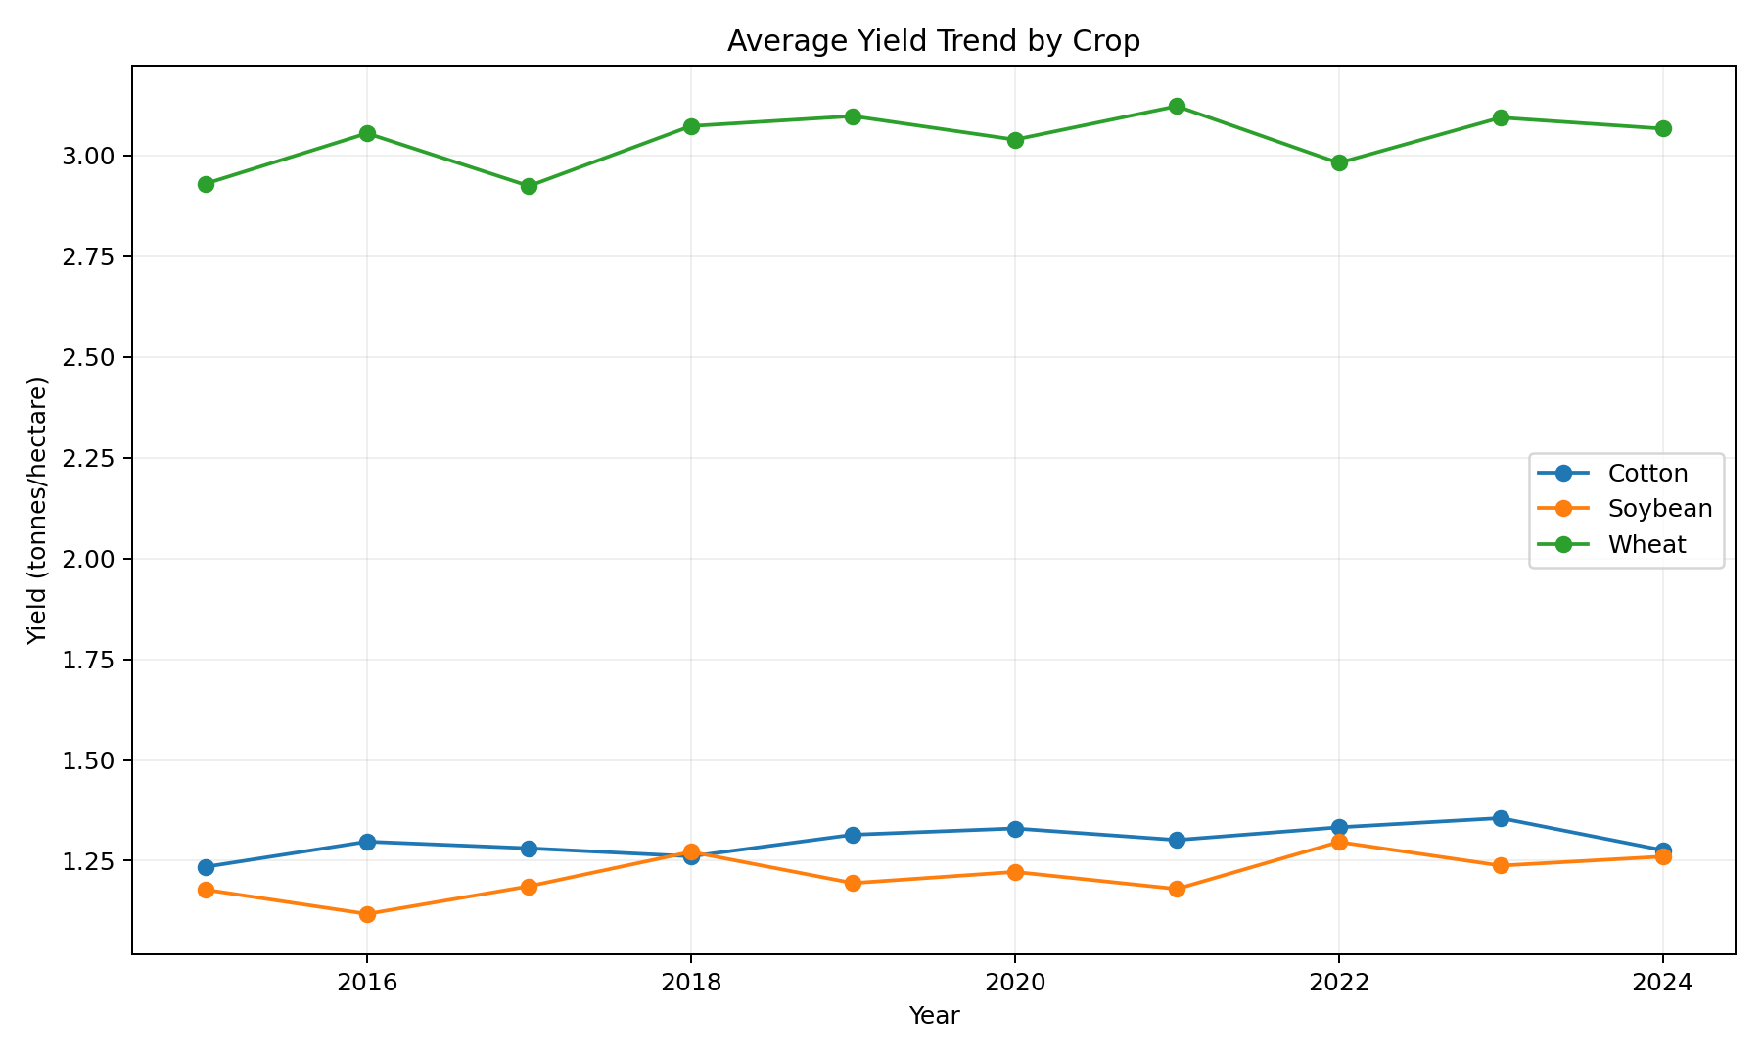
Yield trends complement production trends. Production growth can result from increased area, higher yield, or both.

8. Bivariate Analysis
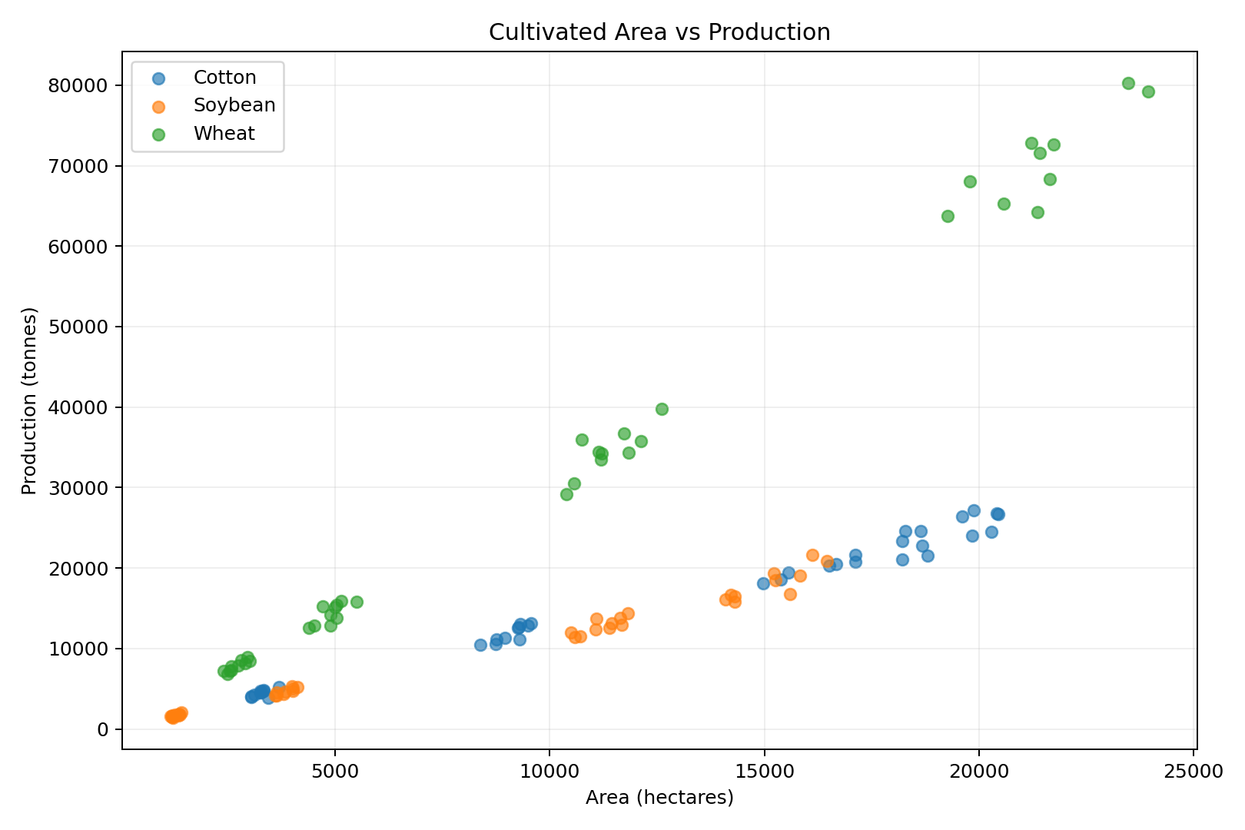
Area and production show a positive association in the analytical sample. This is consistent with production being influenced by cultivated area; it is not a causal estimate.
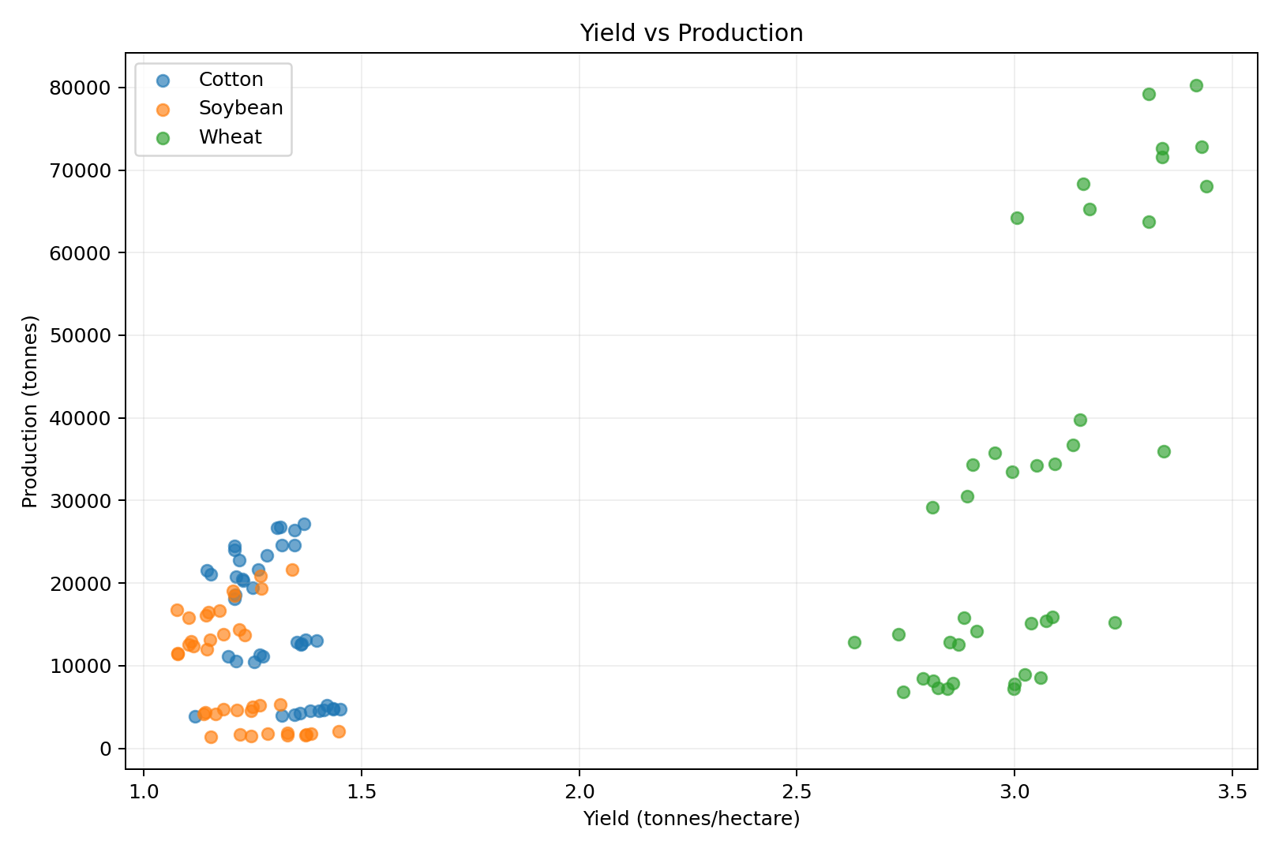
Yield is positively associated with production, but total output also depends on area. Productivity and scale are complementary measures.

9. Correlation Analysis
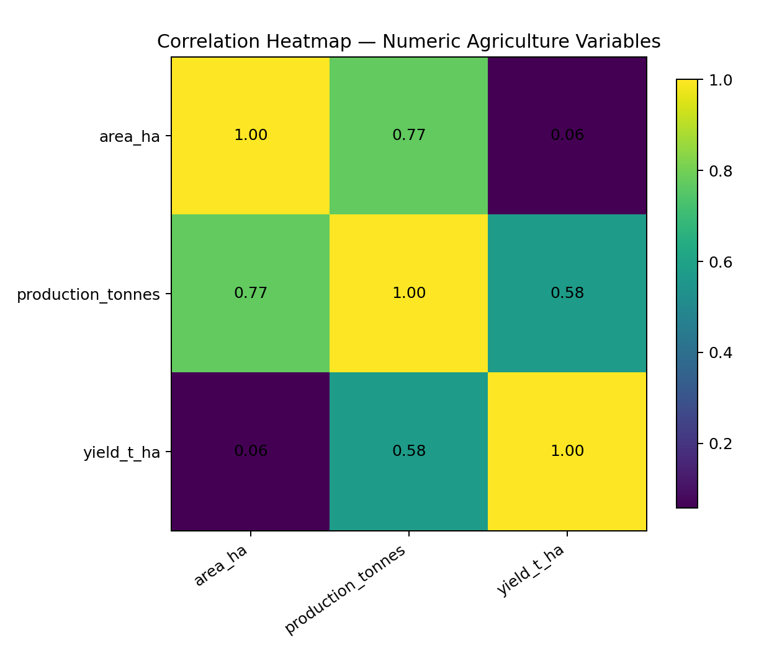
Interpretation: the heatmap summarizes linear associations among area, production and yield. Correlation is descriptive and does not establish causation.

10. Crop-Level Yield Distribution
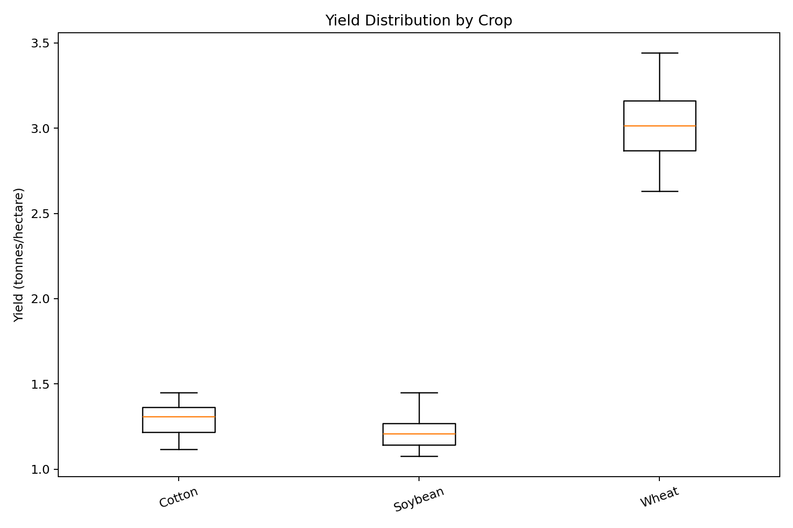
Interpretation: crop-specific yield distributions differ in center and spread, reinforcing the need for crop-level benchmarking.

11. Key Insights
Yield distribution: Yield values form crop-specific clusters. Benchmark productivity at crop level rather than using one pooled threshold.
Crop comparison: Average production differs by crop. Production scale should be separated from productivity.
Geography: Average production differs across states. Crop mix and area make geographic segmentation important.
Time trend: Crop trajectories are not identical. Commodity-specific monitoring is preferable to one aggregate trend.
Area vs production: Positive association is visible. Output reflects both cultivated area and yield.
Yield vs production: Higher yield is associated with higher production in the sample. Productivity and scale should be monitored together.
Correlation: Numeric variables have measurable linear associations. Correlation is descriptive, not causal.
Data quality: Missing, duplicate and inconsistent records were resolved before EDA. Reliable EDA requires documented preprocessing.

12. Agribusiness Implications
- Sourcing: monitor production by crop and geography to understand potential supply concentration.
- Logistics: geographic output differences can inform preliminary storage and transport planning when combined with market and infrastructure data.
- Productivity: track yield alongside production to distinguish area-driven growth from productivity-driven growth.
- Commodity strategy: use crop-specific trend monitoring instead of relying only on an aggregate agriculture indicator.
- Risk analysis: integrate rainfall and market-price data in the next stage; the IMD OGD rainfall catalogue provides long historical rainfall resources. citeturn0search2
- Decision support: EDA provides signals, but operational decisions require current prices, costs, inventories, weather and other business variables.

13. Limitations
- The numerical sample is synthetic and not official observations.
- Only selected states/crops are represented.
- No causal relationship is established.
- Weather and market variables are not joined to the core EDA sample.
- The full official dataset should be used for real-world conclusions, with its definitions, revisions and coverage documented.

14. Reproducibility Files
- Clean analytical CSV
- Python EDA script
- Descriptive statistics and correlation tables
- Nine EDA visualization files
- Structured insight log
- Public-source research note

15. Conclusion
The Week 3 EDA demonstrates a complete exploratory workflow for agricultural data: inspect, validate, summarize, visualize, compare, identify relationships and translate observations into carefully qualified agribusiness implications. The analysis establishes a foundation for integrating weather and market variables and for later predictive or explanatory modelling.

References
- Government of India OGD — District-wise, season-wise crop production: https://data.gov.in/resource/district-wise-season-wise-crop-production-statistics-1997
- Government of India OGD — Rainfall in India / IMD: https://data.gov.in/catalog/rainfall-india
- e-NAM: https://enam.gov.in/
Public source pages reviewed on 30 September 2026.

