FINAL INTERNSHIP TASK — WEEK 6
Strategic Documentation & Presentation
for Future Agribusiness Enhancements
Synthesis of Research, Data Engineering, EDA, Machine Learning & Model Evaluation

Student | Arav Jain
Internship Domain | Agribusiness Analytics / Data & Machine Learning
Scope | Weeks 1–6 integrated strategic proposal
Primary outcome | Future-ready analytics roadmap and decision-support strategy

Executive Summary
The six-week internship progression establishes a complete analytics pathway for agribusiness: strategic research and planning, data collection and cleaning, exploratory analysis, predictive model development, model evaluation and optimization, followed by strategic planning for future enhancements. The central finding is that analytical value does not come from a model alone. It comes from a reliable chain connecting trusted data, reproducible analytical processes, validated predictions, business workflows, and measurable outcomes.
The proposed future direction is therefore a staged agribusiness decision-support capability. The first priority is to strengthen data foundations and governance; the second is to operationalize a small number of high-value forecasting and planning use cases; and the third is to expand into smart technologies, geospatial intelligence, probabilistic forecasting, scenario analysis and optimization.
Public Indian data infrastructure supports this direction. The Government of India OGD Platform provides crop-production data at district/crop/season/year granularity, while the IMD rainfall catalog provides historical rainfall resources. e-NAM provides a digital market infrastructure connecting APMC markets and supporting electronic trade and price discovery. citeturn0search0turn0search2turn0search1

1. Internship Journey: Weeks 1–6
The internship can be viewed as a progression from research to decision intelligence.
Week | Focus | Major work | Strategic finding | Business capability
Week 1 | Strategic research & planning | Defined scope, public data strategy, analytical objectives, methodology and risks. | Established an end-to-end analytics roadmap rather than treating data analysis as an isolated activity. | Data strategy, governance, reproducibility
Week 2 | Data collection, preprocessing & cleaning | Designed public agricultural data inputs and documented missing-value, duplicate and normalization handling. | Data quality is a prerequisite for reliable agribusiness analytics. | Data quality, standardization, auditability
Week 3 | EDA & visualization | Explored crop production, area, yield and regional/time patterns using descriptive analysis and visualizations. | Segment-level and temporal patterns should guide model design and business interpretation. | Dashboards, trend analysis, segmentation
Week 4 | Basic ML model development | Built a crop-yield regression workflow with feature engineering, multiple models and time-aware holdout testing. | ML can convert historical agricultural context into predictive decision-support signals. | Forecasting, prediction, feature engineering
Week 5 | Evaluation & optimization | Compared models using MAE/RMSE/R², time-series CV, error analysis, tuning and regularization. | Model selection must consider accuracy, temporal validity, segment reliability and operational risk. | Model governance, validation, optimization
Week 6 | Strategic enhancement plan | Synthesizes findings into a practical future roadmap for data infrastructure, smart technology and advanced analytics. | Analytics value comes from connecting trustworthy data, models, workflows and business decisions. | Adoption, scale, governance, ROI
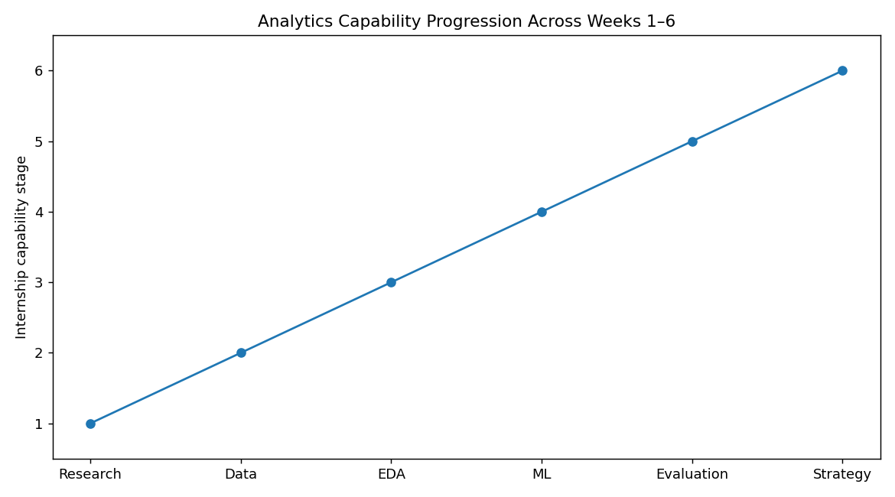

2. Key Findings from Previous Work
Data foundation matters: Agricultural analytics depends on consistent definitions, geographic/time alignment, missing-value handling, duplicate control and reproducible preprocessing.
EDA should guide modeling: Crop, state and temporal patterns provide context for feature selection, segmentation and interpretation.
Prediction can support planning: The Week 4 yield-prediction workflow demonstrates how weather, soil, irrigation, crop and lagged information can be combined in a supervised-learning framework.
Evaluation must be time-aware: Week 5 uses chronological holdout and time-series validation to reduce the risk of future-information leakage.
Accuracy is not enough: Segment-level errors, model bias, operational constraints and monitoring requirements must be considered before deployment.
Business integration is the next step: Forecasts become valuable when they are connected to procurement, storage, logistics, risk and management decisions.

3. Strategic Opportunity
The strategic opportunity is to evolve from periodic spreadsheet/report-based analysis into a connected decision-support system. Such a system would continuously ingest relevant agricultural and market data, validate the data, generate descriptive and predictive analytics, present results through role-specific dashboards, and capture actual outcomes for model and process improvement.
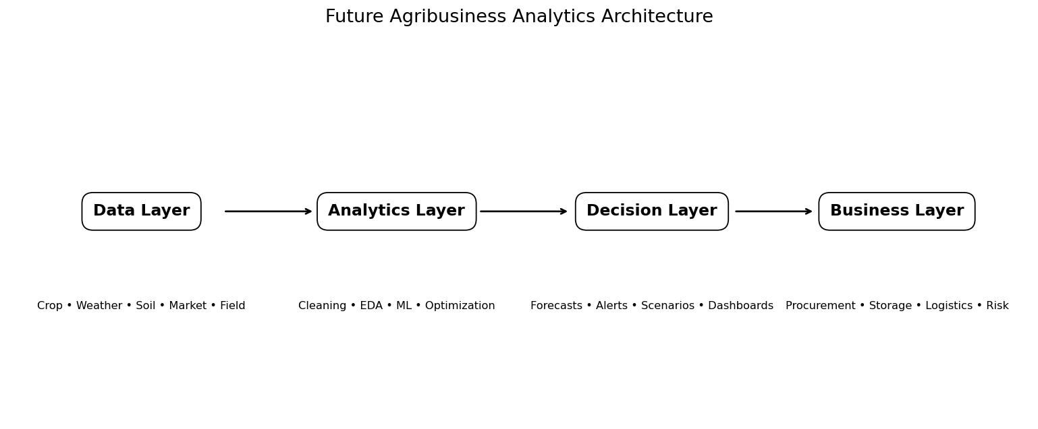

4. Strategic Use Cases for Agribusiness
Use case | Analytical input | Decision supported | Potential value
Crop-yield forecasting | Historical crop production + weather + soil + irrigation | Procurement and supply planning | Earlier and more informed sourcing decisions
Weather-risk monitoring | Rainfall, temperature, anomalies | Seasonal risk planning | Identify potential production stress earlier
Market intelligence | Commodity arrivals, prices, quality/trade information | Buying/selling and market planning | Improve information availability and timing
Storage planning | Yield forecasts + procurement schedule | Warehouse capacity allocation | Reduce mismatch between expected supply and capacity
Logistics planning | Expected volumes + locations + timing | Transport allocation | Improve routing and capacity planning
Regional/crop performance | EDA + forecast errors + outcomes | Portfolio/region prioritization | Target investigation and resources
e-NAM's official platform describes a unified electronic market linking APMC mandis and supporting transparent auction-based price discovery, quality-related trade information and online payment. Its stakeholder material also describes market and transaction information that can support analysis. citeturn0search1turn0search8

5. Technology Enhancement Strategy
Technology | Recommended stage | Purpose | Key consideration
Centralized data repository | Short term | Create a trusted source for analytical datasets. | Ownership and access controls
Automated ETL/ELT pipelines | Short term | Reduce manual data preparation and improve repeatability. | Data-quality tests
BI dashboards | Short term | Make trends, forecasts and KPIs accessible to business users. | Role-specific design
ML model pipeline | Short/medium term | Automate training, validation and inference. | Versioning and monitoring
Geospatial analytics | Medium term | Analyze regional patterns and spatial risk. | Consistent geographic identifiers
Remote sensing | Medium/long term | Add crop condition and land-surface signals. | Calibration and cloud/data availability
IoT / field sensors | Pilot first | Collect localized soil/weather/field observations. | Cost, maintenance and coverage
Probabilistic forecasting | Medium term | Communicate uncertainty instead of point estimates only. | Calibration and interpretation
Optimization / scenario engine | Long term | Translate forecasts into allocation and planning alternatives. | Clear business constraints

6. Recommendations for Agribusiness Stakeholders
Management: Create an analytics governance sponsor and select a small set of measurable business use cases before scaling technology.
Data / IT teams: Build standardized data definitions, validation rules, lineage and secure reusable pipelines.
Agribusiness analysts: Maintain reproducible EDA, model evaluation and reporting templates rather than one-off analyses.
Procurement teams: Pilot yield and supply forecasts alongside existing planning methods and compare forecast-vs-actual outcomes.
Supply-chain teams: Use expected regional volumes to support storage and logistics scenario planning.
Market teams: Combine production forecasts with market information to identify changing supply-demand conditions.
Farm/FPO-facing teams: Use explainable, practical indicators and feedback mechanisms rather than presenting model scores without context.

7. Advanced Analytics Roadmap
- Probabilistic yield forecasting — provide prediction intervals and confidence/uncertainty information.
- Geospatial ML — model district/sub-district patterns and spatial spillovers.
- Remote-sensing analytics — incorporate vegetation indices and crop-condition signals where validated.
- Time-series forecasting — model seasonal and monthly patterns with appropriate temporal validation.
- Scenario simulation — estimate outcomes under alternative rainfall, price or supply assumptions.
- Optimization — connect forecasts to procurement, inventory, transport and resource allocation constraints.
- Anomaly detection — flag unusual production, weather, market or data-quality conditions.
- Explainable AI — provide feature contributions and reason codes suitable for business review.

8. Future Analytics Architecture
The architecture should be modular. New sources should enter through governed data pipelines; analytical models should be independently versioned; dashboards should consume validated outputs; and business outcomes should feed back into evaluation.

9. Implementation Roadmap
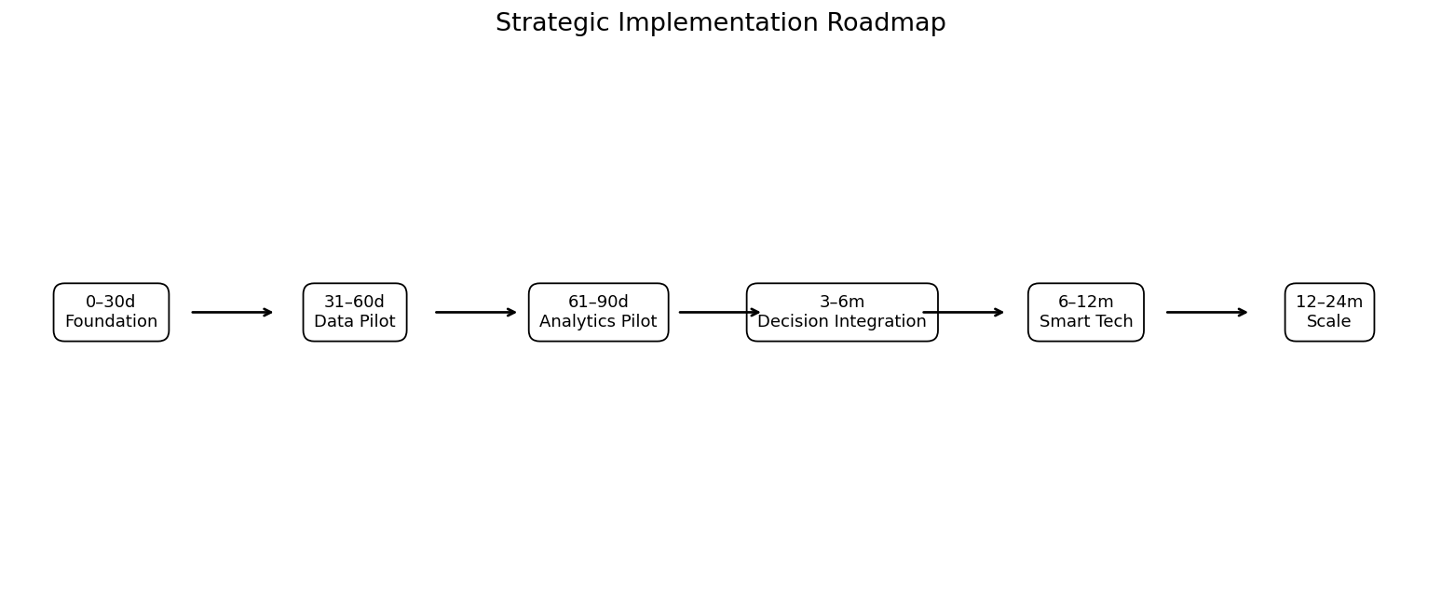
Timeline | Phase | Key actions | Expected outcome
0–30 days | Foundation | Confirm business use cases; appoint owners; finalize data dictionary; define governance; audit current data flows. | Approved scope, owners, baseline KPIs
31–60 days | Data pipeline pilot | Build repeatable ingestion/cleaning for crop and weather data; establish validation checks; create data-quality dashboard. | Reliable pilot dataset and pipeline
61–90 days | Analytics pilot | Build production-style yield model; time-aware validation; segment error analysis; management dashboard prototype. | Validated pilot model and dashboard
3–6 months | Decision integration | Connect forecasts to procurement, storage and logistics workflows; add market-price data; establish alerts. | Forecast-informed operating decisions
6–12 months | Smart agriculture expansion | Add remote sensing, soil and IoT/field data where feasible; improve uncertainty estimates; monitor drift. | Multi-source analytics platform
12–24 months | Scale & advanced analytics | Scenario simulation, probabilistic forecasting, optimization, geospatial intelligence and automated model governance. | Scalable decision-intelligence capability

10. KPI Framework
Success should be measured through both technical and business KPIs. The purpose of the KPI framework is to prevent technology adoption from becoming an activity without measurable decision impact.
Dimension | KPI | Suggested target | Frequency | Owner | Evidence
Data Quality | Missing-value rate | < 2% critical fields | Monthly | Data Engineering Lead | Quality dashboard
Data Quality | Duplicate rate | < 0.5% natural-key duplicates | Monthly | Data Engineering Lead | Data-quality log
Forecasting | MAE (yield) | Set baseline from pilot; target improvement vs baseline | Per model release | ML Lead | Model evaluation report
Forecasting | RMSE (yield) | Track and reduce large-error events | Per model release | ML Lead | Model monitoring
Forecasting | Segment MAE gap | Keep largest crop/state error gap within agreed tolerance | Quarterly | ML + Agribusiness | Segment scorecard
Forecasting | Prediction coverage | > 95% of eligible observations receive valid prediction | Weekly | Analytics Ops | Pipeline dashboard
Adoption | Dashboard active users | Define baseline during pilot; grow usage among target teams | Monthly | Product Owner | Usage analytics
Business | Procurement planning variance | Reduce forecast-vs-actual procurement variance vs baseline | Seasonal | Procurement Head | Planning review
Business | Storage utilization forecast error | Reduce avoidable capacity mismatch | Seasonal | Supply Chain Lead | Warehouse report
Governance | Model drift review completion | 100% scheduled reviews completed | Quarterly | ML Governance | Model card/review log
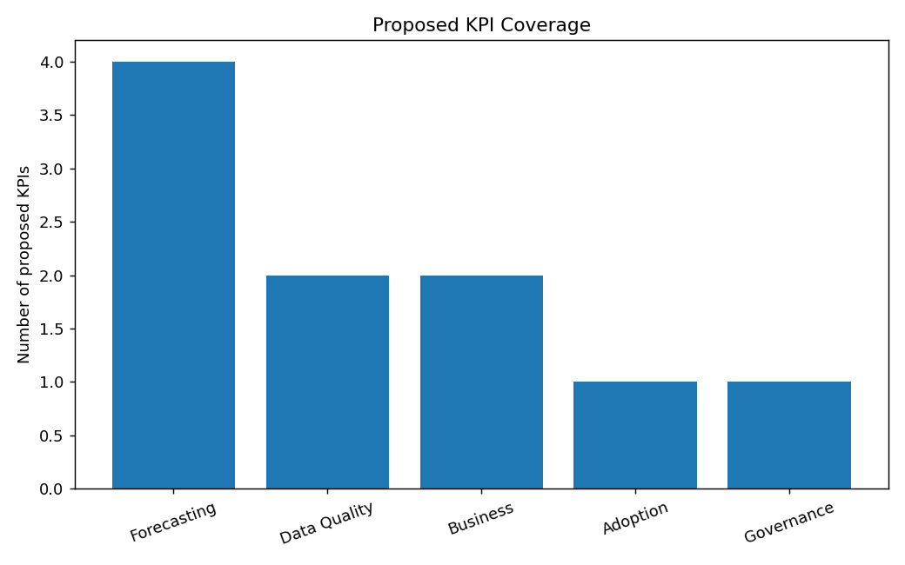

11. Data Governance & Responsible Adoption
- Define ownership for every critical dataset and KPI.
- Maintain a data dictionary and consistent units/geographic identifiers.
- Log transformations and preserve raw-source lineage.
- Apply access controls and protect sensitive farm, customer and transaction information.
- Version models, datasets and feature pipelines.
- Require validation before production deployment.
- Monitor data drift, model drift and segment performance.
- Document limitations and communicate uncertainty to decision-makers.

12. Risk Register
Risk | Description | Likelihood | Impact | Mitigation
Data quality | Missing, inconsistent or delayed data | High | High | Automated validation; data dictionary; ownership; quality SLAs
Temporal leakage | Future information enters model training | High | High | Chronological splits; time-series CV; pipeline controls
Regional bias | Model works better for some crops/states | Medium | High | Segment metrics; regional validation; targeted data collection
Model drift | Relationships change due to weather, technology or markets | High | High | Drift monitoring; scheduled review; retraining triggers
Technology adoption | Users do not integrate forecasts into workflows | Medium | High | Co-design with users; explainability; pilot champions; training
Infrastructure cost | Sensors/cloud/data integration become expensive | Medium | Medium | Stage-gate investment; ROI tracking; prioritize high-value use cases
Cyber/privacy | Unauthorized access or misuse of farm/transaction data | Medium | High | Least privilege; encryption; access logs; data minimization
Synthetic pilot limitation | Pilot performance does not represent real-world accuracy | High | High | Validate with official and operational data before deployment

13. Continuous Decision-Support Loop
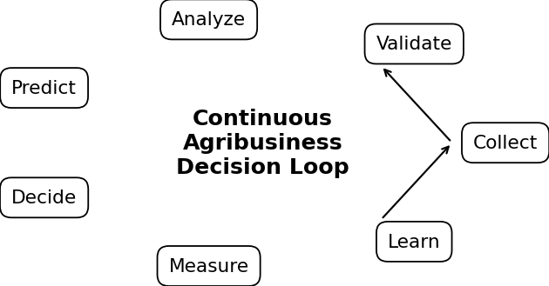
The recommended operating model is a continuous loop: collect data, validate it, analyze patterns, generate predictions, make a business decision, measure the outcome, and learn from the result. This prevents analytics from becoming a static reporting exercise.

14. Presentation Guide
The final report is designed to double as a presentation script. A suggested 18-slide sequence is included.
Slide | Section | Headline | Key content
1 | Title | Future Agribusiness Analytics Enhancement Strategy | Internship synthesis and strategic vision
2 | Executive Summary | What was built across Weeks 1–5 | Research → data → EDA → ML → evaluation
3 | Problem Context | Why agribusiness needs integrated analytics | Weather, production, markets, operational uncertainty
4 | Week 1 | Strategic research foundation | Data sources, scope, methodology, risks
5 | Week 2 | Data engineering foundation | Cleaning, quality, reproducibility
6 | Week 3 | EDA insights | Trends, crop/state differences, relationships
7 | Week 4 | ML model development | Yield prediction, feature engineering, model selection
8 | Week 5 | Evaluation & optimization | MAE/RMSE/R², time-aware validation, error analysis
9 | Strategic Gap | From analysis to decisions | Need integrated pipelines, dashboards, alerts and governance
10 | Future Architecture | Data → analytics → decisions → business | Unified architecture
11 | Priority Use Cases | Procurement, storage, logistics, risk | Actionable applications
12 | Smart Technology | IoT, remote sensing, geospatial analytics | Future data expansion
13 | Advanced Analytics | Probabilistic forecasts, scenarios, optimization | Next-generation analytics
14 | Governance | Data quality, security, model monitoring | Responsible scaling
15 | Roadmap | 0–30 days to 24 months | Stage-gated implementation
16 | KPIs | How success will be measured | Technical + business KPIs
17 | Risks | What can go wrong | Mitigations
18 | Conclusion | Strategic recommendation | Build a measured decision-intelligence capability

15. Recommended Presentation Visuals
- Use the capability progression graphic to show the Week 1–6 journey.
- Use the analytics architecture to explain the future-state system.
- Use the strategic roadmap to communicate phased implementation.
- Use the KPI coverage chart to show balanced technical and business measurement.
- Use the decision loop to explain continuous improvement.
- Use selected Week 3–5 model charts from the supporting evidence folder when presenting the analytical progression.

16. Practical Adoption Strategy
Implementation should use a stage-gated approach rather than attempting a full smart-agriculture platform immediately. Each phase should have a named business owner, a measurable KPI, a defined data requirement, a validation criterion and a decision about whether to scale, revise or stop the initiative.
Gate | Question | Evidence required
Gate 1 — Data readiness | Is the required data sufficiently reliable and available? | Quality report, lineage, missingness and latency metrics
Gate 2 — Model readiness | Does the model outperform an appropriate baseline without leakage? | Time-aware evaluation, error analysis, validation results
Gate 3 — User readiness | Will users incorporate the output into an actual workflow? | Pilot feedback, workflow integration and adoption metrics
Gate 4 — Business value | Does the system improve a measurable decision outcome? | Before/after KPI or controlled pilot evidence
Gate 5 — Scale readiness | Can the process operate reliably across regions/crops? | Monitoring, governance, infrastructure and cost assessment

17. Final Strategic Recommendations
- Prioritize a trusted agricultural data foundation before adding advanced algorithms.
- Pilot yield forecasting and weather-risk analytics because they connect directly to planning decisions.
- Integrate market information progressively so production forecasts can be interpreted in a supply-demand context.
- Use time-aware model evaluation and segment-level monitoring as mandatory ML governance practices.
- Adopt dashboards and alerts designed around decisions rather than around raw datasets.
- Introduce geospatial, remote-sensing and IoT inputs only where their incremental business value can be measured.
- Move from point predictions toward uncertainty-aware forecasting as the analytics capability matures.
- Create a continuous feedback loop between predictions, business actions and realized outcomes.
- Scale only after each stage demonstrates data reliability, model validity, user adoption and measurable business value.

18. Conclusion
The internship work demonstrates a progression from agricultural research and data preparation to exploratory analysis, machine learning, evaluation and strategic planning. The next stage is not simply to build a more complex model; it is to build an integrated analytical capability in which trustworthy data, validated models, business workflows and continuous measurement operate together.
A phased roadmap provides a practical path: establish the foundation, pilot high-value decision use cases, connect analytics to operations, expand data sources and advanced methods, and then scale with governance and monitoring. This approach can make agribusiness analytics more repeatable, measurable and decision-oriented.

19. Supporting Files
- Weekwise synthesis and evidence tables
- Week 4 model-ready agricultural data
- Week 5 model evaluation results and error summaries
- Strategic visualizations
- Implementation roadmap
- KPI framework
- Risk register
- Presentation slide plan
- Public-source research notes
- Submission checklist
End of Week 6 Final Strategic Report

