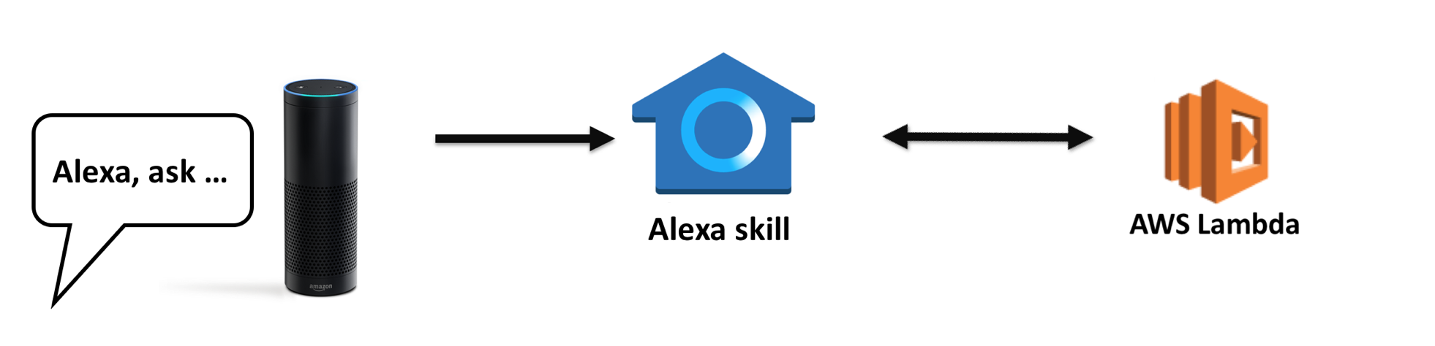

ALEXA SKILL:

In [Amazon developer account](https://developer.amazon.com/) after you logged in go to Alexa > Alexa Skills Kit > Add a new skill

Set up the Skill information with:

* + Skill type: Custom interaction model
  + Language
  + Name
  + Invocation Name
  + copy the *ApplicationID*

Interaction Model

|  |
| --- |
|  |

Configuration:

* The ARN can be obtained in the top right corner in AWS Lambda details page

AWS:

Lambda function:

In AWS > Lambda > function

[Function in N. Virginia](https://console.aws.amazon.com/lambda/home?region=us-east-1#/functions) :

* Set to *Alexa skills Kit*
* Make sure to create the Lambda function in the right AWS region