Taylor Gater

Arne Schöntag

Stefan Rauch

Maximilian Zollbrecht

Christian Linha

Milestone 2: Playtesting

1. Description:

Our group’s term project takes the form of a platforming game by the name of “Splorrt”. In our game, the player controls an unnamed spider through a series of different lands in order to bring the spider back to its family’s home in the forest, from which it was separated from during a large storm. This main goal is accomplished through the completion of singular levels; each new land is composed of at minimum ten levels, with additional bonus levels to be made available upon a certain level of completion in the land. This completion is based off of obtaining all available bug collectibles: a feature which at this point has yet to be implemented.

The basic rules and functions are similar to that of most other platformers. The spider can utilize running and jumping to traverse and overcome chasms, enemies, and other damaging environmental elements. However, the main mechanic that makes our game different from the traditional platformer is the ability to use the spider’s web to assist in overcoming more difficult platforming challenges and trickier enemy scenarios. This web will be able to stick to most substances; however, it will not stick to all materials that the spider will come across. This will allow us as level designers to come up with more interesting and meaningful platforming experiences. For example, in our first world, most materials the spider will come across (rock, dirt, grass) will be available surfaces for the spider’s web to stick to. However, as the player progresses through our game to the more difficult worlds, he or she will have to put their platforming abilities to the test when there are very few surfaces which the web-mechanics can utilize.

The player controls the spider through WASD movement controls and uses the mouse to control web interactions. The mouse is used to point towards a location to which the spider will shoot a web. After clicking the left mouse button, a web is shot out towards the specified location. Upon clicking the left mouse button a second time, the web disappears, and the spider is disconnected from the surface it was previously attached to.

2. Prototype:

Our prototype is primarily frontloaded with the code that will make future development of the game easier for us, while also having a digestible sample for our play-testers to evaluate. For example, we have implemented a system that imports PNG files with a select palette of RGB colors and generates actors in the world based on the PNG level file. This makes it much simpler for our team to generate levels for our game, as we can draw it in editing software such as Photoshop and be able to visualize and generate each level with ease. Our class system for most objects we will implement in our game has been generated, which will make it easy to implement other blocks and enemies down the road as we think of them and complete them. Furthermore, we have created a level selection screen for the player to pick a level, although this feature was not placed in our prototype jar file as it was not needed

We have implemented features such as collision detection, kill floors, gravity and velocity mechanics, and enemy / player interactions. We have a set of completed sprites for over ten types of blocks, our spider, a few enemies, and the level-end portal, among others. Our game has a set of sounds to accompany player interactions and a background track, although these are subject to change. Our generation of enemies in the world is controlled by the PNG color recognition code, which generates an enemy spawner and then the corresponding enemy.

After opening the prototype, you are presented with a colorful introduction screen. Upon pressing a key, you are thrown into our prototype level. From there, you traverse a series of gaps, spikes and enemies in a 2-minute level that exposes you to the basic mechanics of the game. Should you perish, you are presented with a death screen and then are led back to the start of the level. We didn’t want to make the prototype too long so we could maintain playtester attention to detail; we wanted every critique to be fresh in the player’s mind upon completing the level.

Future material that we haven’t completed / implemented yet include a health bar, a web-meter, collectible bugs, bug eating (health / web regeneration) mechanics, and the remaining sprites for the planned environments. Furthermore, we need to create some art to flesh out the story elements; these art frames will be placed in-between level sequences in order to provide the small amount of narrative that gives a platformer some direction. Lastly, we have to create the remainder of levels for all of our planned environments.

3. Playtesting:

The message containing the download link of the jar and the survey were then sent to friends, family and gaming communities together with a few instructions explaining that Java is required to test.

Since our target was to find out which crucial elements of our game are still missing, the instructions given to our testers were kept to a minimum – no information was given about the abilities of the spider, the control, the game’s goal or the story behind the game. As a result, we only expected feedback about our core mechanics and the user’s impression of the game.

We observed several testers playing the game for a duration of 10 to 20 minutes, so we can reasonably assume that most of them played the game for a similar duration of time.

Upon starting the game, the tester found himself as a spider in a world of blocks and only one possible way to explore – to the right. On his left hand side, a cliff and emptiness made sure the player would not try to go there. Once the player reached the first pit of spikes, he was able to get used to the basic movement jumping over it using the jump button (spacebar). Shortly afterwards, these possibilities were not enough anymore to proceed in the level. He encountered a gap being too big to simply jump over so he had to figure out another way to pass. But at this point, the tester had to figure out the spider’s ability to shoot webs. Therefore, we created a simple situation to test how intuitive our controls really are. After crossing the gap by shooting a web, they had to face a new type of challenge. They encountered enemies in form of wasps, followed by the same components of threats until the exit of the level was reached. This was the end of the level though the player was still able to restart the level and try out different approaches.

After that, the testers were asked the following questions:

* **What would you consider yourself? [Non- / Casual- / Hardcore-Gamer]**
* **Did you enjoy the game? [Yes/No]**
* **Would you recommend the game to friends? [Yes/No]**
* **How would you rate the controls? [Scale from 1 to 10]**
* **How would you rate the art style? [Scale from 1 to 10]**
* **How would you rate the ingame sounds? [Scale from 1 to 10]**
* **Did the game feel like it was missing a crucial element? Were there elements that felt extraneous? [Text answer]**
* **Was anything confusing? [Text answer]**
* **We are not done with the game yet, but in your opinion, what needs to be improved? [Text answer]**
* **Now that you have had a chance to play the game, is there any information that would have been useful to you before starting? [Text answer]**
* **What overall rating would you give this game? [Scale from 1 to 10]**
* **What did you like about the game? [Text answer]**
* **What did you dislike about the game? [Text answer]**

4. Evaluation:

During our first playtesting phase, a total of 14 unique players participated in our online survey. Once the playtesting had subsided, we analyzed the results of our questions.

The first question asked the tester what kind of player they were. The results show that most of our testers for our first playtesting phase were casual gamers. However, 35.7% of our testers indicated that they were hardcore gamers, which is no dismissible population.

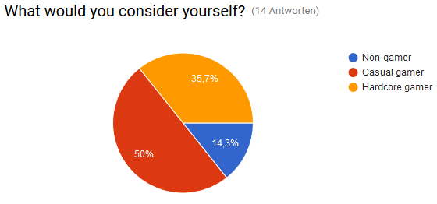

The next questions were concerned with player satisfaction and whether they would recommend it to their friends. Most of them suggested that they enjoyed our game and would also recommend it to their peers.

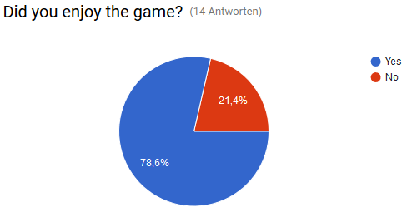

The following set of questions were rating-based for which the players could give ratings between 1 and 10: 10 being the highest possible rating and 1 being the lowest.

The first question in this set asked players how they would rate our controls. The results were quite mixed. Some players were extremely satisfied with the controls and rated them a 9 while noted their dissatisfaction by rating them a 3. We gauged the quality of our art style and in-game sounds by asking the players; most people gave them fairly average ratings between 4 and 8.

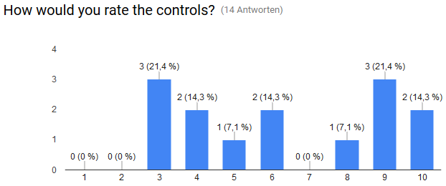

The next questions were text answers where the players could give us detailed feedback. Those are the most important questions because the feedback is much more detailed than the statistical questions.

Players indicated that they longed for collectibles and a story of some kind. Some players also found the web movement to be too slow. A prominent criticism was that there is a lack of information about the game mechanics and keybindings at the beginning of the game and hinted that a tutorial might be necessary.

In the next question the players were asked if there was anything confusing. Many of them mentioned again that there was no information about the controls given. Some also complained that the key binding for the controls was difficult to use.

The next question was maybe the most important. The player should list what things should be improved. As many players complained about the controls in the other questions before, they suggested to improve the yet glitchy controls. One player mentioned to the enemies should be more interactive. Another asked for more audio and visual effects.

Our final question regarding pre-game information yielded the following result; almost everyone complained that they were not introduced to the game mechanics before the first level. A keybindings screen was also requested.

5. Refinement:

After we gathered enough information and analyzed it, we were then able to plan our future changes based on the feedback. Most players were critical of the glitchy controls. As the game is in early development, the controls are unrefined and a bit glitchy at the moment. They will definitely be improved and polished as development continues. Some testers also mentioned that the web movement was too slow. We will talk and perform testing to see if an increased web speed is necessary to maintain the flow of the game.

There are also many aspects of the game that players would like to see which have simply not been implemented yet. Examples of such player desires include collectibles, more enemy interactions, and the inclusion of a story. Furthermore, players also expressed their desire to see improvements in both sound and art style. These features and stylistic improvements are already planned and will be implemented in future releases.

Many players expressed their frustrations with the lack of a tutorial. It is a very difficult decision for the developers if they should add a fleshed-out tutorial considering the differences in the experience of their player base. One one hand, the hardcore players might get bored if there is a tutorial which teaches them mechanics that they’re well aware of and have seen in other games. However, if there is no tutorial, the casual gamers might quickly quit the game in frustration if they don't know how to tackle the game’s opening obstacles. As most of our player base clarified that they fell into the casual player category and most of were frustrated by a lack of awareness of the mechanics , we might add an optional tutorial.