Deep Learning Integration of Convolutional Networks for Automated Terrain Recognition in Satellite Imagery

Term Paper - PC 259
Submitted in partial fulfilment of the
Requirements for the award of the degree
Of
Bachelor of Technology
in
Computer Science and Engineering

By

Athak Mukhija (Enrolment No. 10416403224)
Arnesh Kumar Gupta (Enrolment No. 10616403224)
Under the supervision of
Dr. Raj K. Sharma


UNIVERSITY SCHOOL OF INFORMATION COMMUNICATION AND TECHNOLOGY
Guru Gobind Singh Indraprastha University

Table of Contents

- Abstract …………………………………………………………………………….. 03
- Introduction ………………………………………………………………………… 03
- Literature Review …………………………………………………………………... 06
3.1Research Gap ……………………………………………………………………. 07
- Problem Statement ………………….………………………………………………. 08
- Scope of the Project ………………………………………………………………… 08
- Dataset ……………………………………………………………………………… 09
6.1 Dataset Description ……………………………………………………………... 09
6.2 Data Preprocessing ……………………………………………………………… 09
6.2.1 Black-and-White to Colour Conversion Using pix2pix-CycleGAN ……… 09
- Proposed System Architecture ……………………………………………………... 14
7.1 Overall Flowchart ………………………………………………………………. 14
7.2 CNN Models for Terrain Classification ………..……………………………… 15
7.3 CNN layers ………………………...…………….……………………………… 16
- Implementation Details …………………………………………………………….. 18
- Experimental Results ……………………………………………………………….. 20
- Results and Discussions ………………………..…………………………………… 31
- Conclusion ………………………………………..………………………………… 31
- Future Scope ………………………………………………………………………... 32
References ………………………………………….……………………………….. 33
Appendix A ………………………………………….……………………………… 35
Appendix B ………………………………………….……………………………… 40
Appendix C ………………………………………….……………………………… 42
Appendix D ………………………………………….……………………………… 43
Appendix E …………………………………………………………………………. 44
Appendix F ………………………………………….…………………………….… 45
- Abstract
Recent advancements in deep learning have transformed the analysis of planetary imagery, enabling precise classification of extraterrestrial terrains such as craters, dunes, plains, and rock formations. Traditional image processing methods, which rely on handcrafted features and spectral cues, often fail to capture the complex spatial and textural variations present in Mars surface images. To overcome these limitations, this study proposes a deep learning-based framework that employs Convolutional Neural Networks (CNNs) for automated classification of Mars terrain types. The approach integrates a preprocessing pipeline in which grayscale Mars images are transformed into realistic colour images using a Pix2Pix CycleGAN model, followed by resizing and augmentation to enhance dataset diversity. Three CNN architectures with one, two, and three convolutional layers are implemented and evaluated using different activation functions, including ReLU, LeakyReLU, and ELU, to analyse their impact on feature extraction and classification performance. Comparative experiments on an eight-class Mars terrain dataset demonstrate that deeper CNN models with appropriate activation functions achieve superior accuracy and generalization, particularly under variations in illumination, texture density, and geological patterns. Comprehensive evaluation using accuracy–loss curves, ROC analysis, confusion matrices, and F1-scores highlights the robustness of the proposed system for Mars terrain classification. Overall, this work demonstrates the effectiveness of optimized CNN architectures combined with GAN-based preprocessing for planetary image analysis, offering valuable applications in autonomous navigation, planetary mapping, and scientific exploration.

2.Introduction
The pursuit of space exploration has long captivated human imagination, driving nations to expand the frontiers of scientific and technological knowledge. In India, the foundation for space research was laid in the early 1960s with the formation of the Indian National Committee for Space Research (INCOSPAR) [1] under the guidance of Dr. Vikram Sarabhai. Initially focused on atmospheric studies and small-scale sounding rockets, INCOSPAR sought to establish indigenous capabilities for understanding the upper atmosphere and developing basic rocket technology. These early initiatives provided the technical foundation for the country’s long-term aspirations in space science.
The late 1960s and 1970s marked a critical phase in India’s space journey, culminating in the establishment of the Indian Space Research Organisation (ISRO) in 1969. During this period, India focused on designing and testing the Satellite Launch Vehicle (SLV) [2], which ultimately enabled the country to place satellites into orbit independently. The successful launch of SLV-3 in 1980, carrying the Rohini satellite, established India as the sixth nation capable of indigenous satellite deployment, signalling a major milestone in its space exploration history.
Following this achievement, ISRO expanded its focus from experimental launches to practical applications, emphasizing communication, meteorology, and Earth observation. The INSAT [3] series facilitated advanced telecommunications, broadcasting, and meteorological monitoring, while the IRS (Indian Remote Sensing) satellites provided high-resolution imagery for agriculture, disaster management, and environmental assessment. These initiatives demonstrated the transformative potential of space technology in addressing societal and developmental needs.
The 1980s and 1990s also saw significant advancements in launch vehicle technology with the development of the Augmented Satellite Launch Vehicle (ASLV) and later the Polar Satellite Launch Vehicle (PSLV) [4]. These vehicles offered increased payload capacities, reliability, and flexibility, enabling the launch of both domestic and international satellites. During this period, India established a global reputation for cost-effective and dependable space missions.
Entering the 21st century, ISRO achieved landmark milestones in planetary exploration. The Chandrayaan-1 mission (2008) revealed evidence of water on the Moon, while the Mars Orbiter Mission (Mangalyaan, 2013) [5] successfully entered Martian orbit on its first attempt, showcasing India’s growing capabilities in deep-space missions. Subsequent initiatives, including Chandrayaan-2, Chandrayaan-3, Aditya-L1, and the upcoming Gaganyaan human spaceflight program, reflect the country’s commitment to advancing both scientific knowledge and technological innovation.
Today, India operates a diverse fleet of satellites supporting communication, navigation, Earth observation, and scientific exploration. High-resolution imaging satellites like Cartosat-3 [6] and radar platforms such as RISAT generate large volumes of spatial, spectral, and temporal data. These datasets, when combined with textual mission logs and audio or vibration signals from onboard equipment, constitute complex, heterogeneous sources of information that traditional unimodal analysis methods struggle to fully exploit.
The rapid advancement of Earth observation satellites has led to an exponential increase in the volume and complexity of satellite imagery, making automated terrain recognition a crucial research area. Traditional image processing and handcrafted feature extraction methods often struggle to cope with the scale and diversity of this data. In contrast, deep learning frameworks integrating Convolutional Neural Networks (CNNs) [7] offer a powerful approach to extract spatial and contextual patterns directly from raw imagery, enabling accurate classification and terrain interpretation.
The integration of convolutional and transformer-based architectures enhances both local feature learning and global spatial understanding [8]. CNNs efficiently capture texture and edge-level information, while transformers model long-range dependencies across an image, improving performance in heterogeneous landscapes. This hybrid approach enables robust recognition of terrain types, detection of anomalies, and high-resolution mapping — essential for applications like urban planning, resource monitoring, and environmental surveillance.
With the availability of high-resolution imagery from ISRO’s advanced satellites such as Cartosat-3 and RISAT [9] , deep learning models can now leverage vast datasets to improve generalization across varied terrains and sensor types. The fusion of optical and radar data within deep architectures facilitates comprehensive terrain characterization under diverse illumination and weather conditions. Such developments align with ISRO’s broader objective of incorporating AI-driven automation for intelligent image interpretation and autonomous decision-making in Earth observation missions.
In essence, the integration of carefully designed Convolutional Neural Network architectures with systematic preprocessing and augmentation creates a fully automated and reliable framework for Mars terrain classification. By leveraging hierarchical feature extraction, spatial pattern learning, and progressively deeper convolutional layers, the models efficiently transform raw satellite imagery into meaningful terrain categories with minimal human intervention. This CNN-driven pipeline not only strengthens the accuracy and robustness of classification but also establishes a scalable foundation for future planetary surface analysis and autonomous exploration systems.
Table 1: Insights from Recent Space Research on Big Data and Multimodal Analysis.
Source | Focus Area | Key Findings | Recommendations
NASA 2023 Year in Review [10] | Big Data in Space Science | NASA's Earth System Data Explorer saw over 1 million engagements, indicating high demand for integrated, large-scale datasets. | Enhance data accessibility and integration to support global research efforts.
ISRO 2023 Space Situational Assessment [11] | Space Traffic Management | A record 2,578 operational satellites were added to orbit, highlighting the increasing congestion in space. | Develop and implement robust space traffic management protocols to ensure sustainable operations.
NASA 2023 Space Station Achievements [12] | Climate Monitoring | The ISS collected extensive data on climate change, including the hottest recorded month since 1880. | Expand international collaboration to enhance climate monitoring capabilities.
ISRO 2023 Aditya-L1 Mission [13] | Solar Research | India's first solar observatory began collecting scientific data from the Sun-Earth L1 point. | Continue data collection and analysis to advance understanding of solar phenomena.
NASA 2023 International Space Apps Challenge [14] | Open Science and Data Utilization | The challenge engaged over 57,000 participants from 152 countries, emphasizing the global interest in space data. | Foster open science initiatives to encourage global participation in space research.
ISRO 2023 RESPOND Basket [15] | Academic Collaboration | ISRO's RESPOND program facilitated collaborative research between ISRO and academic institutions. | Strengthen partnerships with academic institutions to drive innovation in space research.

The NASA report specifies the increasing role of big data in space science, emphasizing the use of integrated datasets for Earth observation and climate monitoring. ISRO’s Aditya-L1 mission highlights the collection of solar data, advancing understanding of solar phenomena and space weather. Additionally, NASA’s International Space Apps Challenge demonstrates the global interest in space data, promoting open science and collaborative research initiatives. These findings underscore the growing importance of data-driven approaches and international collaboration in modern space exploration.

3.Literature Review
The research [16] evaluates pre-trained Vision Transformer models for onboard satellite image classification in Earth Observation systems. While traditional CNN and ResNet-based models have been widely used, transformer architectures offer improved accuracy, efficiency, and resilience to noisy inputs. The investigation compares multiple pre-trained models to identify those most suitable for real-time satellite processing. Findings indicate that MobileViTV2 achieves the highest performance on clean validation data, whereas EfficientViT-M2 demonstrates superior robustness under noisy conditions. Overall, EfficientViT-M2 emerges as the optimal model for reliable, accurate, and computationally efficient onboard remote sensing image classification.
The study [17] introduces RAMAN, a robust framework for multimodal anomaly detection in the Mars Science Laboratory (MSL) power subsystem. Traditional anomaly detection approaches often handle only specific anomaly types and rely on human experts for verification, which can introduce bias and limit scalability. RAMAN addresses these issues by combining unsupervised feature extraction with domain knowledge of Martian power systems. The framework applies autoencoder-based thresholding and spline approximations to identify anomalies across various data modalities, including equipment configurations, sensor readings, and telemetry from the Curiosity rover. Evaluation demonstrates strong performance across all modalities, with qualitative validation from field experts. Key advantages of RAMAN include its modular design for subsystem-level anomaly detection, adaptability to other Martian and non-Martian systems, and user-friendly interactive interfaces that facilitate broader usability.
The paper [18] proposes a multi-view sentence matching model based on equal-length interactive attention to improve semantic alignment between sentence pairs. Traditional models rely on stacking multiple attention layers, which can be computationally intensive and sometimes less precise in capturing attention information. The proposed approach introduces multiple equal-length interaction units to more accurately extract high-level features while speeding up processing. Additionally, a residual connection mechanism is employed to mitigate gradient vanishing issues, and a multi-feature spatial information extraction module captures detailed information from underlying features. Experiments on three benchmark datasets—LCQMC, PAWS-ZH, and PAWS-EN—demonstrate the effectiveness of this model, achieving competitive performance in sentence matching tasks.
The paper [19] proposes image-based autonomous navigation to address communication delays and limitations of traditional telemetry and inertial navigation in deep space missions. It shows that spacecraft can achieve high-precision positioning using real-time images of celestial surfaces captured by onboard sensors. Craters are highlighted as key stable terrain features due to their predictable geometry and wide distribution, enabling accurate navigation on the Moon, Mars, and asteroids. The paper proposes surface feature detection methods for precise crater identification and localization, enhancing navigation autonomy. It also discusses overcoming constraints such as limited computing resources and environmental noise, and suggests future directions including intelligent navigation systems, improved perception, hardware advancements, and cross-mission adaptability for multi-body exploration.
The paper [20] proposes a multimodal data fusion framework that combines satellite imagery and social media data to enhance emergency response and decision-making. It highlights the value of artificial intelligence (AI) in processing heterogeneous, distributed, and semantically fragmented Earth Observation data from programs like Copernicus and DIAS. The study emphasizes that social media content, including visual, textual, and spatiotemporal information from citizen observations, provides timely and reliable insights during crisis events. The paper demonstrates how integrating these diverse data sources enables real-time monitoring of emergencies such as floods and extreme weather in polar regions, improving situational awareness and supporting informed decision-making for disaster management.
The study [21] evaluates Vision Transformers for satellite image land cover classification, testing 25 models across multiple datasets. Each image is converted into a feature vector, and a simple classifier assesses backbone performance. Results show that transformers with large receptive fields and advanced attention achieve the best accuracy, while smaller models train faster but with slightly lower performance. The work highlights the balance between accuracy and computational efficiency, providing guidance for selecting suitable backbones for Earth Observation tasks.
3.1 Research Gaps While significant progress has been made in applying machine learning and deep learning models to space and Earth observation tasks, several gaps remain. Vision Transformer models and pre-trained architectures have demonstrated improved accuracy, efficiency, and robustness for satellite image classification, yet challenges persist in optimizing model performance under noisy or resource-constrained conditions. Existing anomaly detection frameworks, such as RAMAN, effectively integrate multimodal data for specific subsystems but are often limited in generalization across different mission environments or datasets. Similarly, multimodal data fusion approaches, including the integration of satellite imagery with social media, show promise for real-time decision-making, but scalable, domain-adaptive models for heterogeneous data remain underexplored. In deep space navigation, image-based models leverage stable terrain features for precise positioning, yet their adaptation to limited onboard computation and varying environmental conditions is still a challenge. Overall, there is a need for robust, generalizable, and computationally efficient machine learning models capable of handling diverse modalities, noisy inputs, and real-time constraints in both satellite Earth observation and deep space missions.

4. Problem Statement
Mars terrain classification plays a crucial role in autonomous rover navigation, geological mapping, hazard detection, and scientific exploration. However, satellite images captured by Mars orbiters often suffer from grayscale formats, low contrast, noise, and inconsistent lighting conditions, making automated classification difficult. Furthermore, different terrain types—such as boulders, craters, dunes, plains, and spider formations—often share similar textures, causing traditional feature-based classifiers to perform poorly. The primary challenge addressed in this project is the accurate classification of Mars terrain images into eight distinct categories, using an approach that enhances low-quality grayscale images by converting them into realistic colorized images. Existing labelled datasets are limited and imbalanced, and the image quality varies significantly due to environmental conditions on Mars.
Thus, the problem can be stated as: “To develop a robust deep learning–based classification system that can accurately identify Mars terrain classes using enhanced, colorized images generated from grayscale satellite images.” This includes, using a Pix2pix-CycleGAN model to convert grayscale images into coloured counterparts, applying preprocessing and augmentation techniques to improve model generalization, training multiple CNN architectures with different activation functions (ReLU, LeakyReLU, ELU) and varying depth (1-layer, 2-layer, 3-layer) and comparing classification performance using accuracy, loss, confusion matrix, ROC curve, and F1-score.
5. Scope of the Project
The scope of this work is clearly defined to ensure practical implementation and reliable results.
5.1 Dataset Scope: The dataset consists of eight Mars terrain classes: boulders, bright dune, crater, dark dune, horizon, plain, spider, swiss cheese.
5.2 Preprocessing Scope: This project includes these preprocessing steps before applying CNN model to dataset, first conversion of Grayscale to Colour conversion using pix2pix-CycleGAN, then image resizing to 256×256 and renaming all images to a unified format (img_1 … img_n), lastly data augmentation to increase training variety – 90 degree, 180 degree, 270 degree clockwise rotation, horizontal and vertical flip.
5.3 Modelling Scope: Only custom CNN architectures (1/2/3 layers) are implemented with only three activation functions (ReLU, LeakyReLU, ELU) are compared. Transfer learning models (e.g., ResNet, VGG, EfficientNet) are outside the scope unless considered in future work.
5.4 Evaluation Scope: Epoch-wise accuracy and loss, ROC curves for each class, F1-score and confusion matrix, predictions for each validation image. Not including real-time classification deployment, model optimization for inference speed.
5.5 Computational Scope: Implemented using TensorFlow/Keras, training performed using Python on a local machine and memory and GPU constraints limit the model size to shallow networks (max 3 convolutional layers).
6. Dataset
6.1 Dataset Description
The dataset used for this study consists of satellite images of Martian terrain collected from publicly available Mars mission archives. The dataset contains images representing eight distinct classes, each corresponding to commonly occurring geological structures on the Martian surface:
D₁ – Coloured Satellite images ~ 1000 images [22]
D₂ – Black and white coloured images ~ 2000 images [23]
- Boulders D₂ – 448 images
- Bright Dune D₂ – 246 images
- Crater D₂ – 809 images
- Dark Dune D₂ – 162 images
- Horizon D₁ – 288 images
- Plain D₁ – 628 images
- Spider D₂ – 151 images
- Swiss Cheese D₂ – 283 images

Each class exhibits unique visual and textural characteristics, but some overlap in appearance due to similar surface features, lighting conditions, and camera angles, making classification a non-trivial task. The dataset D2 includes a mixture of grayscale and low-contrast images, which necessitates preprocessing and enhancement for effective model training.
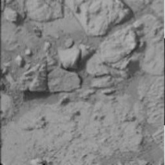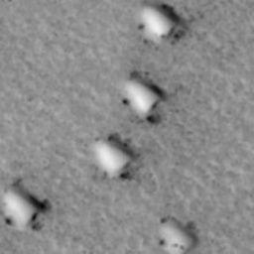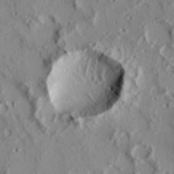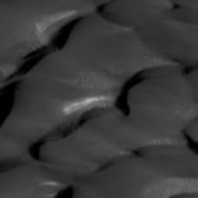
Figure 1.1(Boulders) | Figure 1.2(Bright Dune) | Figure 1.3(Crater) | Figure 1.4(Dark Dune)
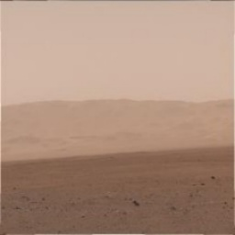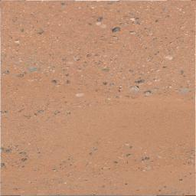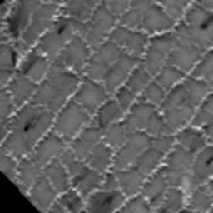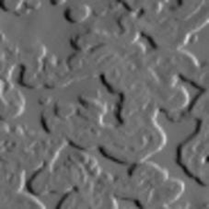
Figure 1.5(Horizon) | Figure 1.6(Plain) | Figure 1.7(Spider) | Figure 1.8(Swiss Cheese)

6.2 Data Preprocessing
To ensure standardized data input and improve the reliability of CNN training, several preprocessing steps were applied sequentially.
6.2.1 Black-and-White to Colour Conversion Using pix2pix-CycleGAN
Many Mars satellite images are originally captured in grayscale or suffer from low colour information. To improve terrain detail and visual richness, the project uses a pix2pix-CycleGAN model to convert grayscale images into realistic, colorized Mars images. pix2pix is a supervised image-to-image translation while CycleGAN is a unsupervised translation using cycle-consistency loss.
Input Image Domain includes $Set A$ being the set of source images (Grayscale Mars images, Dataset D₂) while $Set B$ includes set of target images (Colour Mars images, Dataset D₁). A generator is a neural network that maps images from one domain to another. For pix2pix, generator $G converts A to B$, for CycleGAN, two generators G and F are used where $G converts A to B$ while $F converts B to A$. A discriminator is a classifier that distinguishes real images from generated ones. For pix2pix, $D_{B}$ Determines whether an image is real B or generated by $G\left(A\right).$ For CycleGAN two discriminators are used where $D_{A}$determines real vs fake in domain A while $D_{B}$ determines real vs fake in domain $B$.
6.2.1.1 Pix2Pix: Supervised Image-to-Image Translation
pix2pix requires paired data such that every grayscale image $a$has a corresponding color image $b$. pix2pix uses Generator $G$(U-Net architecture), Discriminator $D$(PatchGAN architecture). The generator tries to convert $a$into a realistic $G\left(a\right)$, matching the ground truth $b$. Mathematically $G:A→B$. Goal of $G$ is to produce $G\left(a\right)$such that $D\left(a,G\left(a\right)\right)≈1$ and minimize L1 distance that is $∥b-G\left(a\right)∥$. The discriminator receives both the input and the output: $D\left(a,b\right)=\text{real pair}$, $D\left(a,G\left(a\right)\right)=\text{fake pair}$.
6.2.1.1.1 Adversarial Loss (GAN Loss): The discriminator tries to maximize its ability to differentiate real from generated images, while the generator tries to minimize it. Eq (1) mathematically demonstrates this Adversarial loss. Eq (2) mathematically represents the min–max optimization objective of the GAN framework, where the generator $G$aims to minimize the adversarial loss while the discriminator $D$simultaneously attempts to maximize it.
$$L_{GAN}\left(G,D\right)=E_{a,b}\left[\log{D\left(a,b\right)}\right]+E_{a,b}\left[\log\left(1-D\left(a,G\left(a\right)\right)\right)\right]$$ | (1)
$$G^{*}=arg⁡\underset{G}{min⁡} arg⁡\underset{D}{max⁡} L_{\text{GAN}}(G,D)$$ | (2)
where , $\log{D\left(a,b\right)}$ is the log probability that (a,b) pair is real , Discriminator tries to maximizes it while $\log\left(1-{D\left(a,G\left(a\right)\right)}\right)$ is the log probability that (a,G(a)) pair is fake , Discriminator tries to maximizes it while Generator wants to minimize it.
6.2.1.1.2 L1 Reconstruction Loss : Ensures generated image is close to the real target image. This reduces blurring and encourages pixel-level accuracy. Eq (3) represents the L1 reconstruction loss, which enforces pixel-wise similarity between the generated output $G\left(a\right)$and the ground-truth target $b$ by minimizing their L1 distance.
$$L_{L1}\left(G\right)=E_{a,b}\left[∥b-G\left(a\right)∥_{1}\right]$$ | (3)
6.2.1.1.3 Total pix2pix Loss : Eq (4) defines the final generator loss, where the adversarial loss and the L1 reconstruction loss are combined, with the weighting factor $λ$controlling the balance between realism and pixel-level accuracy and also controlling the importance of L1 loss (usually 100). Generator G minimizes GAN loss + L1 loss ,while Discriminator D maximizes GAN loss.
$$L_{G}=L_{GAN}\left(G,D\right)+λL_{L1}\left(G\right)$$ | (4)
Generator updates by minimizing Eq (5) while Discriminator improves by minimizing Eq (6)
$$\log\left(1-D\left(a,G\left(a\right)\right)\right)+∥b-G\left(a\right)∥$$ | (5)
$$\log{D\left(a,G\left(a\right)\right)}+\log\left(1-D\left(a,b\right)\right)$$ | (6)
6.2.1.2 CycleGAN: Unsupervised Image-to-Image Translation
CycleGAN does not require paired data. Instead of having a matched pair (a,b), CycleGAN uses two unpaired datasets: domain A (grayscale / low-quality Mars images) and domain B (coloured / enhanced Mars images). Two generators are used, $G$ converts an image from A into B (colorization), and $F$ converts an image from B back into A (grayscale reconstruction). Two discriminators $D_{B}$and $D_{A}$are used. $D_{B}$distinguishes real B images from generated $G\left(a\right)$, and $D_{A}$distinguishes real A images from generated $F\left(b\right)$. The purpose of CycleGAN is not only to make $G\left(a\right)$look like a real B image, but also to ensure that converting it back using F recovers the original image. This property is called cycle-consistency.
6.2.1.2.1 Adversarial Loss for Each Domain: The adversarial loss in CycleGAN follows the standard GAN idea that each generator tries to fool its corresponding discriminator. Eq (7) defines the adversarial loss for generator $G$, which encourages $G\left(a\right)$ to resemble real samples from domain $B$ so that discriminator $D_{B}$ assigns high probability to the generated outputs. Eq (8) represents the adversarial loss for generator $F$, driving it to produce outputs $F\left(b\right)$that closely match real samples in domain $A$, thereby attempting to fool discriminator $D_{A}$.
$$L_{GAN}(G,D_{B})=E_{b∼p_{data}\left(b\right)}[log⁡D_{B}(b)]+E_{a∼p_{data}\left(a\right)}[\log\left(1-D_{B}\left(G\left(a\right)\right)\right]]$$ | (7)
$$L_{GAN}(F,D_{A})=E_{a∼p_{data}\left(a\right)}[log⁡D_{A}(a)]+E_{b∼p_{data}\left(b\right)}[\log\left(1-D_{B}\left(F\left(b\right)\right)\right]]$$ | (8)
Both discriminators $D_{A}$ and $D_{B}$try to maximize these adversarial losses, because a good discriminator gives high probability to real samples and low probability to fake samples. Both generators G and F try to minimize these losses, because a good generator should make $D_{B}\left(G\left(a\right)\right)≈1$and $D_{A}\left(F\left(b\right)\right)≈1$. Eq (9) expresses the combined adversarial objective, where generators $G$and $F$minimize the total loss while discriminators $D_{A}$and $D_{B}$simultaneously maximize it, forming the fundamental min–max game of CycleGAN.
$$G^{*}, F^{*}=arg⁡\underset{G, F}{min⁡} arg⁡\underset{D_{A}, D_{B}}{max⁡}[ L_{\text{GAN}}(G,D_{B})+L_{\text{GAN}}(F,D_{A}) ]$$ | (9)
6.2.1.2.2 Cycle-Consistency Loss : Since there is no paired data, CycleGAN introduces the principle that translating from one domain to another and back should reconstruct the original image. This is called cycle-consistency. Forward cycle in which $a→G\left(a\right)→F\left(G\left(a\right)\right)≈a$ while for Backward cycle $b→F\left(b\right)→G\left(F\left(b\right)\right)≈b$. Eq(10) represents the cycle consistency loss.
$$L_{cyc}\left(G,F\right)=E_{a∼p_{data}\left(a\right)}\left[∥F\left(G\left(a\right)\right)-a∥_{1}\right]+E_{b∼p_{data}\left(b\right)}\left[∥G\left(F\left(b\right)\right)-b∥_{1}\right]$$ | (10)
6.2.1.2.3 Identity Loss : Identity loss is added when translating between colour and grayscale images so that generators preserve colour distribution. For example, if we feed an image already in domain B to generator G (B→B case), the ideal output should be the same. Eq(11) represents the identity loss.
$$L_{identity}\left(G,F\right)=E_{b∼p\left(b\right)}\left[∥G\left(b\right)-b∥_{1}\right]+E_{a∼p\left(a\right)}\left[∥F\left(a\right)-a∥_{1}\right]$$ | (11)
6.2.1.2.4 Total CycleGAN Objective: The full CycleGAN loss includes adversarial loss + cycle consistency loss + identity loss which is represented in Eq (12). $λ_{cyc}=10,λ_{id}=0\text{ or }5$ are most commonly used in Eq (12). The discriminators $D_{A}$and $D_{B }$maximize the adversarial terms while the generators $G$and $F$minimize the entire combined loss.
$$L_{CycleGAN}\left(G,F,D_{A},D_{B}\right)=L_{GAN}\left(G,D_{B}\right)+L_{GAN}\left(F,D_{A}\right)+λ_{cyc}L_{cyc}\left(G,F\right)+λ_{id}L_{identity}\left(G,F\right)$$ | (12)
Generator G minimizes Eqs (13,14,15) by fooling discriminator, reconstructing original image and maintaining identity respectively. Similarly, F minimizes its corresponding terms. Thus, generators try to minimize Eq(16). The discriminators try to maximize their own ability to separate real and fake images. D_{B} maximize Eq(17) while D_{A} maximize Eq(18).
$$\log\left(1-D_{B}\left(G\left(a\right)\right)\right)$$ | (13)
$$∥F\left(G\left(a\right)\right)-a∥_{1}$$ | (14)
$$∥G\left(b\right)-b∥_{1}$$ | (15)
$$\log\left(1-D_{B}\left(G\left(a\right)\right)\right)+\log\left(1-D_{A}\left(F\left(b\right)\right)\right)+λ_{cyc}L_{cyc}+λ_{id}L_{identity}$$ | (16)
$$\log{D_{B}\left(b\right)}+\log\left(1-D_{B}\left(G\left(a\right)\right)\right)$$ | (17)
$$\log{D_{A}\left(a\right)}+\log\left(1-D_{A}\left(F\left(b\right)\right)\right)$$ | (18)
Thus CycleGAN mathematically learns mappings between two domains without requiring paired images, using adversarial supervision plus cycle-consistency.
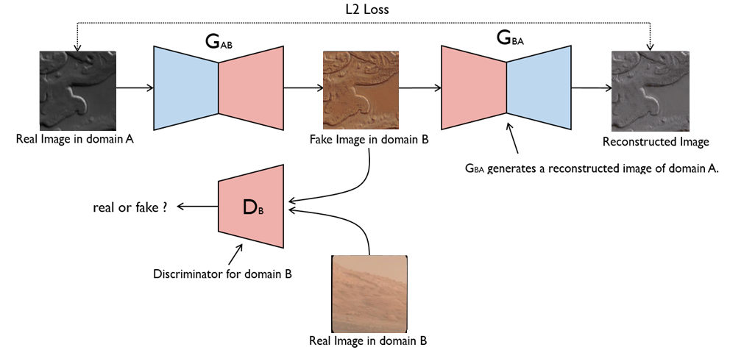
Figure 2: Working of CycleGan Model
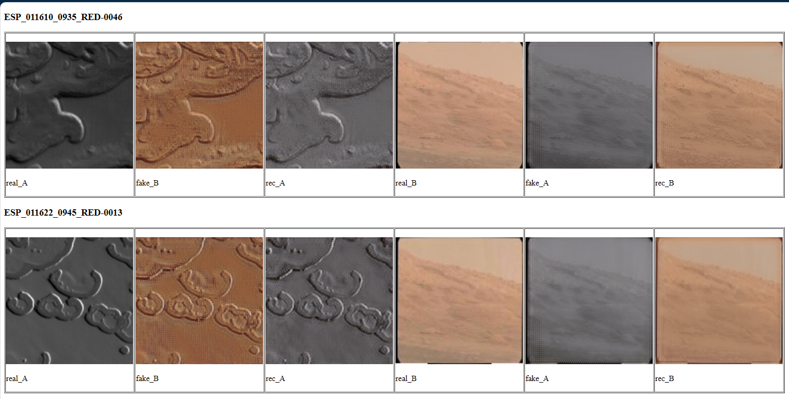
Figure 3: Result of Pix2pix-CycleGan Model
In Figure 3 real_A represents actual image in D₂ dataset , fake_B represents converted image of real_A by generator G and rec_A represents converted image of fake_B by Generator F. Similarly real_B, fake_A , rec_B represents there counterpart from D₁ dataset. This hybrid approach provides Preservation of structural features (dunes, craters, ridges), Enhanced colour gradients, Improved visual cues beneficial for deep learning models. The colorized output images replace the original grayscale images and serve as the final dataset for training.

6.2.2 Image Resizing to 256 × 256, which ensures Computational efficiency, Compatibility with the CNN model input layer, Uniformity across all dataset samples. The resizing is performed using OpenCV to maintain aspect ratio as closely as possible while ensuring fixed dimensions.
6.2.3 Image Renaming Pipeline (img_1 … img_n): To maintain an organized directory structure and prevent filename inconsistencies, all pre-processed images are renamed in a sequential format:
img_1.png, img_2.png, img_3.png, ..., img_n.png
Images are placed in separate folders for each class after renaming.
6.2.4 Data Augmentation Techniques for Satellite Images
Data augmentation is applied to artificially expand the dataset and improve generalization. The following augmentation operations are applied :
a) Rotation 90 degree clockwise
b) Rotation 180 degree clockwise
c) Rotation 270 degree clockwise
d) Horizontal and vertical flips
By applying data augmentation the combined dataset of size 3015 becomes of size 16,974.
6.3 Train–Test Split
A 20% validation split is used to evaluate model performance.This is implemented as Table 2.
Table 2: Train-Test Split of Dataset
validation_split = 0.2
subset="training"
subset="validation"
seed = 123
Thus: 80% of data - Training, 20% of data - Validation
A fixed random seed ensures reproducibility. The dataset is then converted into TensorFlow datasets and optimized using Batch size of 32, Prefetching with AUTOTUNE for faster pipeline performance and Shuffling during training to prevent order bias.

7. Proposed System Architecture
7.1 Overall Flowchart
Figure 4: Flowchart of Proposed Methodology.

7.2 CNN Models for Terrain Classification
A Convolutional Neural Network (CNN) is a deep learning architecture designed to automatically learn spatial patterns from images by applying convolution filters that detect features like edges, textures, shapes, and patterns at increasing levels of complexity. It consists of convolution layers for feature extraction, pooling layers for dimensionality reduction, and fully connected layers for final classification. By learning hierarchical representations directly from raw pixel data, CNNs achieve high accuracy in tasks such as image classification, object detection, and segmentation while requiring fewer parameters than traditional neural networks. Specifically, the paper recommends training a CNN model of an image of mars terrains with dimensions of 256 by 256 by 3. Formulations of the input, filter, and output are shown in Eqs. (19,20,21).
 | $$Input=n_{row}*n_{col}*n_{c}$$ | (19)
 | $$filter =f_{row}*f_{col}*n_{c}$$ | (20)
 | $$Output=\left(\frac{n_{row}+2p-f_{row}}{s}+1\right)*\left(\frac{n_{col}+2p-f_{col}}{s}+1\right)*n_{c}^{'}$$ | (21)
Where $n_{row } \& n_{col}$ are the length and breadth of the image, and $n_{c}$ is the number of channels in the input image. $f_{row} \& f_{col}$ are the length and breadth of the filter. $p,s and n_{c}^{'}$ are padding, stride and the number of filters.
Convolving a filter over the input image adds a bias component to the outputs. The equation for a single forward pass is Eq. (24)/(25)/(26) applied to a ReLU/LeakyRelu/ELu activation function (22,23) to produce activations. The mars image as an input (256 * 256 * 3) is $a_{0}$ and filters (3 * 3 * 3) are the weights $w_{1}$. The output of layer 1 is these activations, which are then sent into layer 2 and so on. Convolutional neural networks' parameter count is constant regardless of input image size. The filtration size plays a role. Consider a set of 32 filters, each of which is 3x3x3..
$$\begin{matrix} & z_{1}=w_{1}*a_{0}+b_{1} & & \end{matrix}$$ | (22)
$$\begin{matrix} & a_{1}=g\left(z_{1}\right) & & \end{matrix}$$ | (23)
Where $a_{0}$ is input image, $w_{1}$is convolution filters, $b_{1}$is bias term, $g\left(⋅\right)$ is activation function
1. Rectified Linear Unit (ReLU)
$$\begin{matrix} & \text{ReLU}\left(x\right)=f\left(x\right)=\left\{\begin{aligned}0, &x<0 \\ x, x≥0\end{aligned}\right. & & \end{matrix}$$ | (24)
2. Leaky ReLU solves the “dying ReLU” problem by allowing a small slope $α$(typically 0.01) for negative inputs.
$$\begin{matrix} & \text{LeakyReLU}\left(x\right)=f\left(x\right)=\left\{\begin{aligned}αx, &x<0 \\ x, x≥0\end{aligned}\right. & & \end{matrix}$$ | (25)
3. Exponential Linear Unit (ELU) introduces exponential behaviour for negative inputs to produce smooth, non-zero gradients.
$$\begin{matrix} & \text{ELU}\left(x\right)=f\left(x\right)= \left\{\begin{aligned}α(e^{x}-1), &x<0 \\ x, x≥0\end{aligned}\right. & & \end{matrix}$$ | (26)
All subsequent CNN layers follow the same form as per Eqs (27,28).
$$z_{k}=w_{k}*a_{k-1}+b_{k}$$ | (27)
$$a_{k}=g\left(z_{k}\right)$$ | (28)
Softmax is used in the final dense layer of multi-class classification CNNs. For an output vector $z=\left[z_{1},z_{2},…,z_{K}\right]$, Softmax converts raw logits into class probabilities as per Eq(29) for $i=1,2,…,K$.
$$f\left(z_{i}\right)=\text{Softmax}\left(z_{i}\right)=\frac{e^{z_{i}}}{\sum_{j=1}^{K}{e^{z_{j}}}}$$ | (29)
7.3 CNN layers (same for each activation)
7.3.1 One layer CNN
TABLE 3: The proposed CNN model's pseudocode with 1 convolutional layer.
Conv2D(32,(3,3),activation= <activation_function>, input_shape=(256,256,3))
MaxPool2D(2,2)
Flatten()
Dense(512,activation= <activation_function>)
Dense(8,activation= 'softmax')
TABLE 3 displays the pseudocode, and FIGURE 5 depicts the proposed CNN model, which has one layer and includes 32 filters in layers 1. Convolutional layer uses the activation function from ReLu/LeakyReLu/ Elu , and the pooling layer is implemented using the MaxPool2D (2,2) approach. The model utilizes a "Dense" layer with 512 units and the activation function from ReLu/LeakyReLu/ Elu after flattening the layer, and the final "Dense" layer with 8 units and a softmax activation function is presented in Eq. (8), producing the classification result, which classifies marsian terrains.
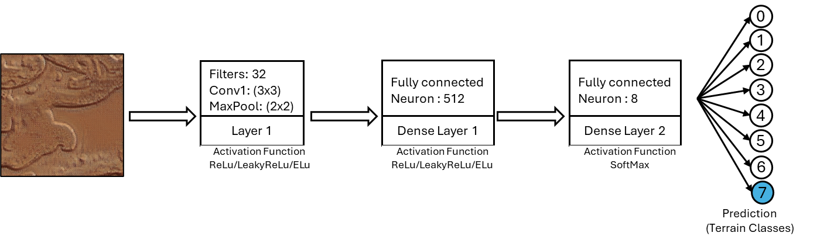
Figure 5: 1 layer CNN model flowchart
7.3.2 Two layer CNN
TABLE 4: The proposed CNN model's pseudocode with 2 convolutional layer.
Conv2D(32,(3,3),activation= <activation_function>, input_shape=(256,256,3))
MaxPool2D(2,2)
Conv2D(64,(3,3),activation= <activation_function>)
MaxPool2D(2,2)
Flatten()
Dense(512,activation= <activation_function>)
Dense(8,activation= 'softmax')
TABLE 4 displays the pseudocode, and FIGURE 6 depicts the proposed CNN model, which has two layer and includes 32 filters in layers 1and 64 in layer 2. Each convolutional layer uses the activation function from ReLu/LeakyReLu/ Elu , and the pooling layer is implemented using the MaxPool2D (2,2) approach. The model utilizes a "Dense" layer with 512 units and the activation function from ReLu/LeakyReLu/ Elu after flattening the layer, and the final "Dense" layer with 8 units and a softmax activation function is presented in Eq. (8), producing the classification result, which classifies marsian terrains.
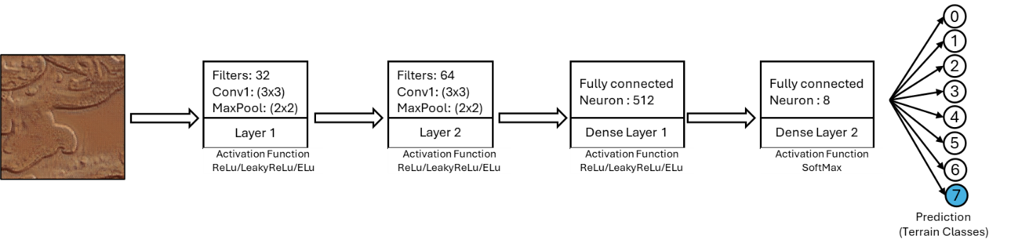
Figure 6: 2 layer CNN model flowchart
7.3.3 Three layer CNN
TABLE 5: The proposed CNN model's pseudocode with 3 convolutional layer.
Conv2D(32,(3,3),activation= <activation_function>, input_shape=(256,256,3))
MaxPool2D(2,2)
Conv2D(64,(3,3),activation= <activation_function>)
MaxPool2D(2,2)
Conv2D(128,(3,3),activation= <activation_function>)
MaxPool2D(2,2)
Flatten()
Dense(512,activation= <activation_function>)
Dense(8,activation= 'softmax')
TABLE 5 displays the pseudocode, and FIGURE 7 depicts the proposed CNN model, which has three layer and includes 32 filters in layers 1, 64 in layer 2 and 128 in layer 3. Each convolutional layer uses the activation function from ReLu/LeakyReLu/ Elu , and the pooling layer is implemented using the MaxPool2D (2,2) approach. The model utilizes a "Dense" layer with 512 units and the activation function from ReLu/LeakyReLu/ Elu after flattening the layer, and the final "Dense" layer with 8 units and a softmax activation function is presented in Eq. (8), producing the classification result, which classifies marsian terrains.
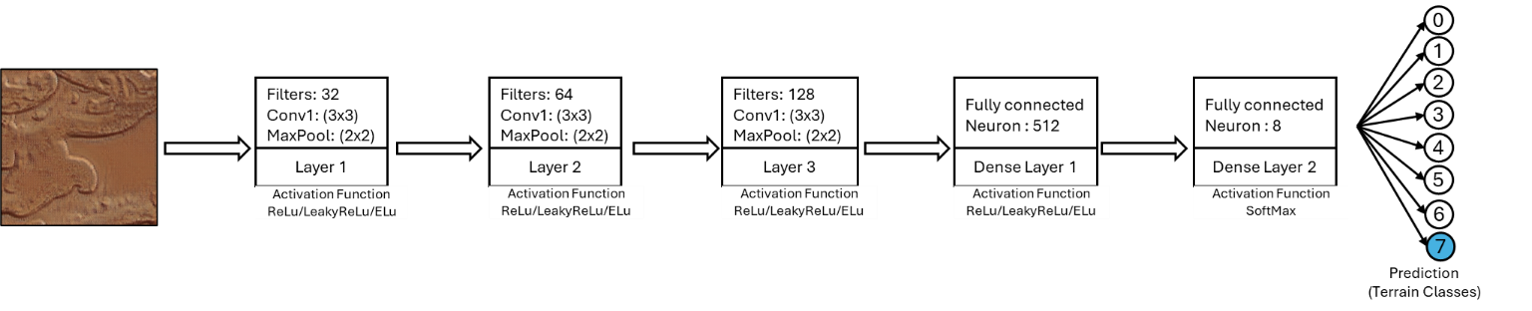
Figure 7: 3 layer CNN model flowchart

8. Implementation Details
8.1 Software and Tools Used : The implementation of the Mars terrain classification system was carried out using the following tools and software components:
- Python 3.11: Primary programming language used for data preprocessing, model development, and evaluation.
- TensorFlow/Keras: Deep learning framework used for building, training, and evaluating the Convolutional Neural Network models.
- NumPy and Pandas: Used for numerical computation, array manipulation, dataset handling, and intermediate preprocessing tasks.
- Local GPU Environment: Used for training the models with GPU acceleration for faster training.
- Matplotlib: Employed for generating accuracy curves, loss curves, and ROC plots.
- scikit-learn: Used for computing performance metrics such as confusion matrix, classification report, and ROC-AUC scores.
- OpenCV (cv2): Utilized for image loading, resizing, and verification during preprocessing.
- IPython Utilities: Used for controlling output streams while saving logs.
- Operating System: Windows environment for local execution and directory-based dataset loading.
8.2 Hyperparameters : A set of predefined hyperparameters was used for training the CNN models. The key hyperparameters are:
- Learning Rate: ReLU and LeakyReLU models used the default learning rate of the Adam optimizer (0.001), ELU models used a manually tuned learning rate of 0.0001 to improve stability.
- Batch Size: A batch size of 32 was used for both training and validation datasets.
- Optimizer: Adam optimizer was selected due to its adaptive learning capability and good convergence behaviour for image classification tasks.
- Number of Epochs: All models were trained for 30 epochs, and epoch-wise performance metrics were recorded.
- Loss Function: Sparse Categorical Crossentropy was used since labels were integer encoded, and the task involved multi-class classification across 8 terrain categories.
These hyperparameters were kept constant across all experiments to maintain a fair comparison between:
(i) different CNN depths (1-layer, 2-layer, 3-layer) and
(ii) different activation functions (ReLU, LeakyReLU, ELU).
8.3 Training Procedure
The procedure followed to train and evaluate each CNN configuration is outlined below:
8.3.1 Model Compilation Each model was compiled using Adam optimizer, Sparse categorical crossentropy loss, Accuracy as the primary evaluation metric. The model architecture varied depending on the number of convolutional layers (1, 2, or 3) and the selected activation function.
8.3.2 Model Training The model was trained for 30 epochs using Training dataset (80% split), Validation dataset (20% split), Prefetching to optimize GPU/CPU pipeline performance. During training, these values for each epoch were recorded Training Accuracy, Validation Accuracy, Training Loss, Validation Loss. These metrics were stored in structured arrays through the Keras training history object.
8.3.3 Saving Epoch Results Epoch-wise results were exported to a text file named results.txt, containing
Epoch | Train_Acc | Val_Acc | Train_Loss | Val_Loss
1 | ...
2 | ...
...
30 | ...
Additionally, final training and validation accuracy/loss values were appended at the end of the file.
8.3.4 Evaluation on Validation Dataset: After training, the model was evaluated using Confusion matrix, Classification report (precision, recall, F1-score), ROC curve and AUC score for each class.
These results were saved to confusion.txt, predictions.txt, ROC.png, ACCURACY.png, LOSS.png
8.3.5 5: Cleanup and Memory Optimization The training function includes Clearing TensorFlow sessions and Garbage collection to free GPU/CPU memory before training the next model.

9. Experimental Results
This section presents the performance evaluation of the Convolutional Neural Network (CNN) models trained on the Mars terrain image dataset. Models with 1, 2, and 3 convolutional layers were trained using three different activation functions: ReLU, LeakyReLU, and ELU. Each model was trained for 30 epochs, and the results were analysed using accuracy–loss curves, confusion matrices, ROC curves, and standard classification metrics.
9.1 Accuracy and Loss Curves: During training, the model generated two important performance indicators:
9.1.1 Training Accuracy vs. Validation Accuracy: The accuracy curves represent how well the model learned the features of the Mars terrain classes over the 30 epochs. An upward trend in training accuracy indicates successful learning. A close alignment between training and validation accuracy indicates good generalization. A large gap typically suggests overfitting.
9.1.2 Training Loss vs. Validation Loss: Loss curves show how effectively the model minimized classification error during training. A decreasing training loss confirms learning progression. Stability in validation loss indicates that the model is not overfitting. Fluctuations or diverging losses suggest learning difficulty for certain architectures.
Both accuracy and loss graphs were saved for each configuration as ACCURACY.png, LOSS.png. These charts provide a visual summary of model behaviour and convergence during training.
9.2 Confusion Matrix: The confusion matrix (generated from Excel output) summarizes the classification performance across all 8 terrain classes: Boulders, Bright Dune, Crater, Dark Dune, Horizon, Plain, Spider, Swiss Cheese. The matrix helps identify which terrain types were most accurately classified, misclassified terrain types, Confusion between visually similar classes (e.g., Crater vs. Plain, Spider vs. Dark Dune). Patterns from the matrix reveal the class-wise strengths and weaknesses of each model.
The confusion matrix and precision , recall , f1-score , recall for each class is stored in Confusion.txt and a separate heatmap of confusion matrix is stored as heatmap.png.
9.3 ROC Curve for Each Class: For each of the eight classes, a Receiver Operating Characteristic (ROC) curve was plotted. From the ROC curve True Positive Rate (TPR) and False Positive Rate (FPR) are analysed and the Area Under the Curve (AUC) measures the model’s discriminative power. Findings typically show high AUC values (~0.90–0.99) for visually distinct classes while lower AUC values for classes with overlapping textures. All ROC curves were stored in ROC.png.
9.4 Performance Metrics: Evaluation metrics were calculated using the validation dataset.
•Accuracy - Percentage of correct predictions made by the model.
$$Accuracy= \frac{TP+TN}{TP+FP+TN+FN}$$ | (30)
• Precision – probability that a predicted class is correct.
$$Precision= \frac{TP}{TP+FP}$$ | (31)
• Recall – ability of the model to correctly identify all instances of a class.
$$Recall= \frac{TP}{TP+FN}$$ | (32)
• F1-Score – harmonic mean of precision and recall.
$$F1-Score= \frac{2}{\frac{1}{Recall}+\frac{1}{Precision}}$$ | (33)
True positive (TP), true negative (TN), false positive (FP), and false negative (FN).
• Support – number of true samples for each class.
Classes with high F1-scores indicate that the model performs strongly in both identifying and distinguishing those terrain categories.

9.5 One Convolutional layer using ReLu Activation Function
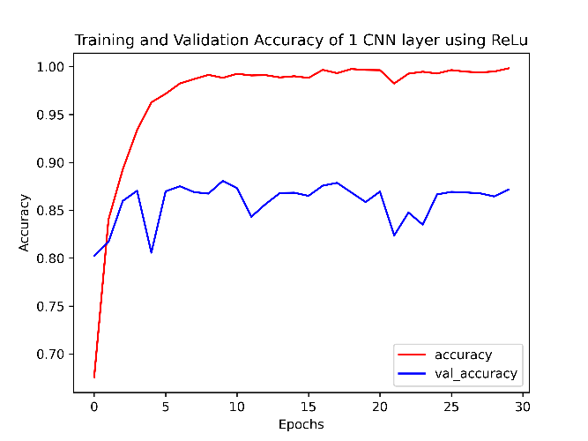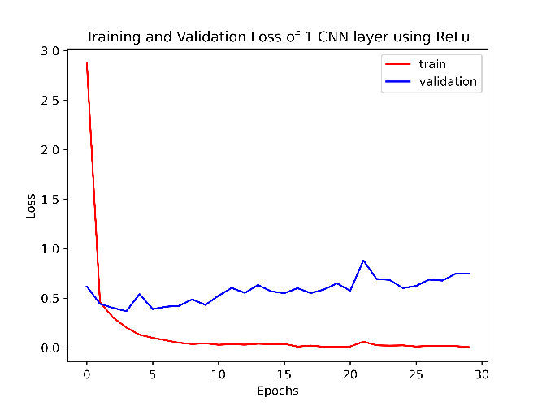
Figure 8.1 Accuracy Plot | Figure 8.2 Loss Plot
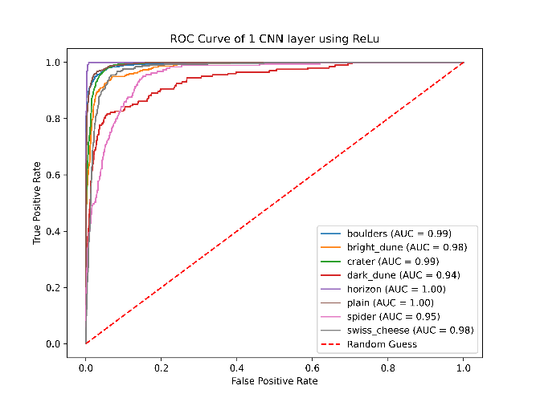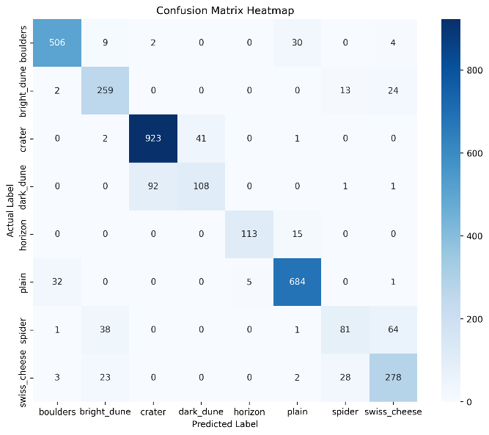
Figure 8.3 ROC curve | Figure 8.4 Confusion Matrix Heatmap
Table 6: Classification Report:
precision recall f1-score support
boulders 0.93 0.92 0.92 551
bright_dune 0.78 0.87 0.82 298
crater 0.91 0.95 0.93 967
dark_dune 0.72 0.53 0.62 202
horizon 0.96 0.88 0.92 128
plain 0.93 0.95 0.94 722
spider 0.66 0.44 0.53 185
swiss_cheese 0.75 0.83 0.79 334

accuracy 0.87 3387
macro avg 0.83 0.80 0.81 3387
weighted avg 0.87 0.87 0.87 3387

9.6 Two Convolutional layer using ReLu Activation Function
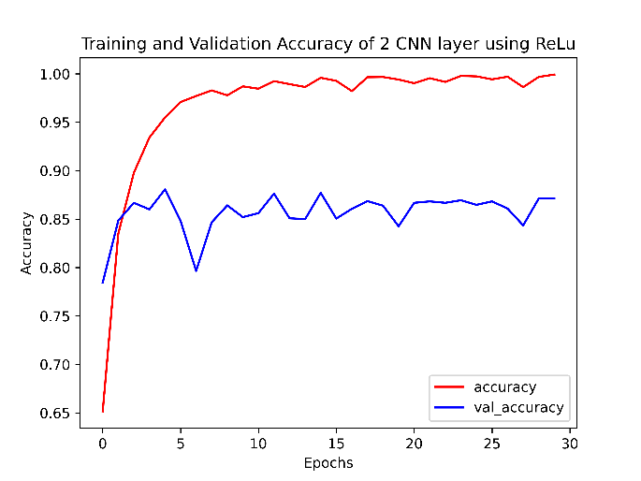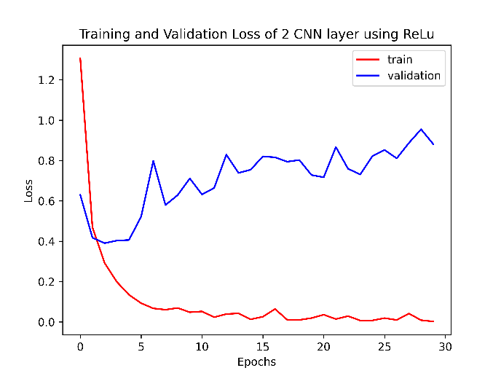
Figure 9.1 Accuracy Plot | Figure 9.2 Loss Plot
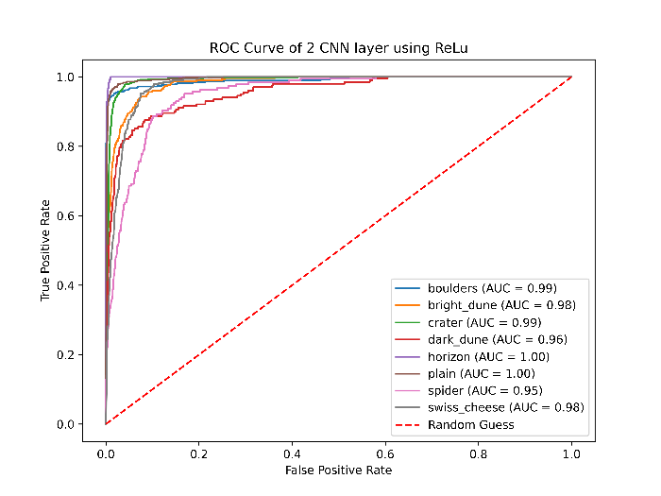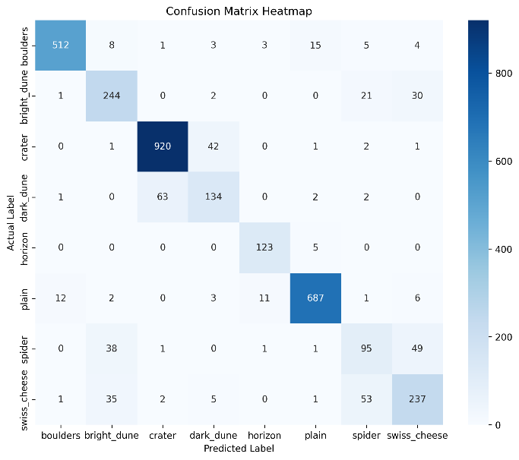
Figure 9.3 ROC curve | Figure 9.4 Confusion Matrix Heatmap
Table 7: Classification Report:
precision recall f1-score support
boulders 0.97 0.93 0.95 551
bright_dune 0.74 0.82 0.78 298
crater 0.93 0.95 0.94 967
dark_dune 0.71 0.66 0.69 202
horizon 0.89 0.96 0.92 128
plain 0.96 0.95 0.96 722
spider 0.53 0.51 0.52 185
swiss_cheese 0.72 0.71 0.72 334

accuracy 0.87 3387
macro avg 0.81 0.81 0.81 3387
weighted avg 0.87 0.87 0.87 3387

9.7 Three Convolutional layer using ReLu Activation Function
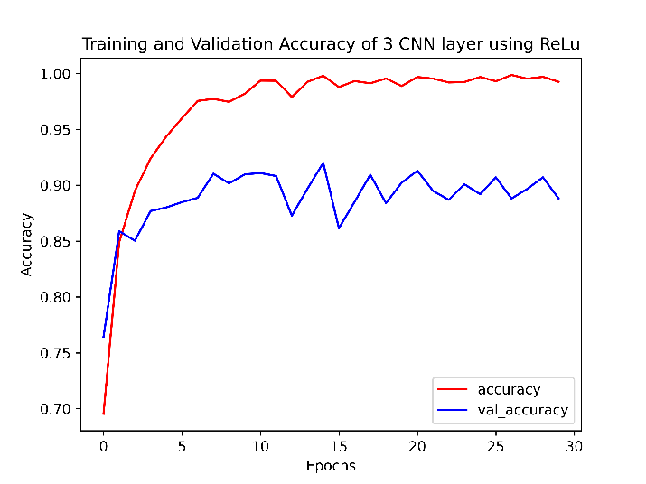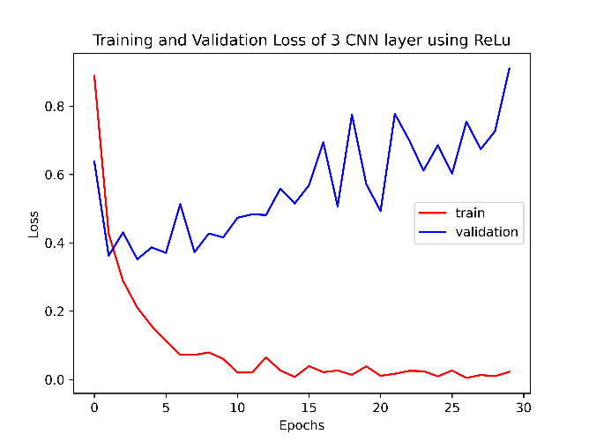
Figure 10.1 Accuracy Plot | Figure 10.2 Loss Plot
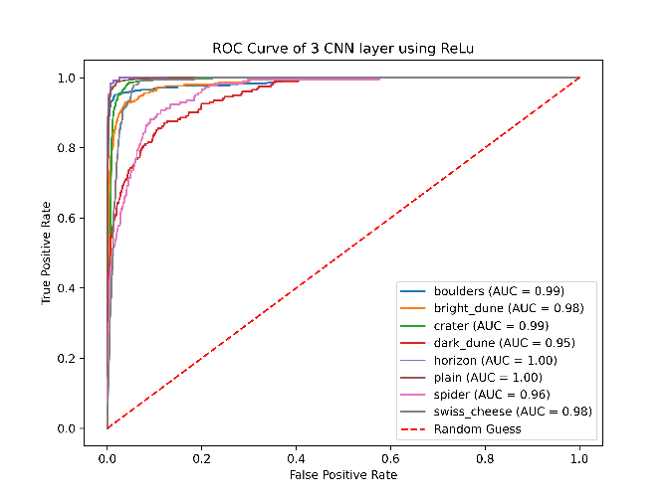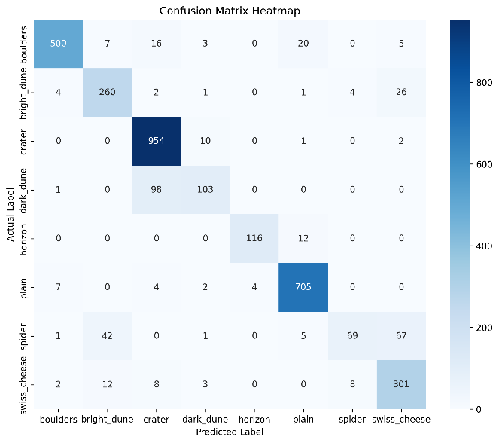
Figure 10.3 ROC curve | Figure 10.4 Confusion Matrix Heatmap
Table 8: Classification Report:
precision recall f1-score support
boulders 0.97 0.91 0.94 551
bright_dune 0.81 0.87 0.84 298
crater 0.88 0.99 0.93 967
dark_dune 0.84 0.51 0.63 202
horizon 0.97 0.91 0.94 128
plain 0.95 0.98 0.96 722
spider 0.85 0.37 0.52 185
swiss_cheese 0.75 0.90 0.82 334

accuracy 0.89 3387
macro avg 0.88 0.80 0.82 3387
weighted avg 0.89 0.89 0.88 3387

9.8 One Convolutional layer using LeakyReLu Activation Function
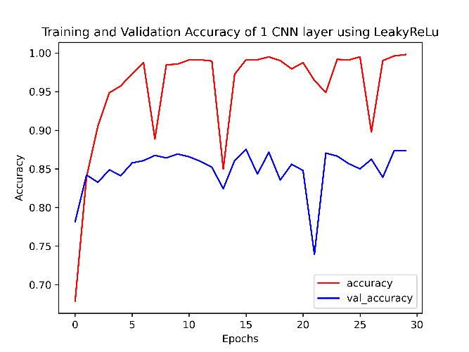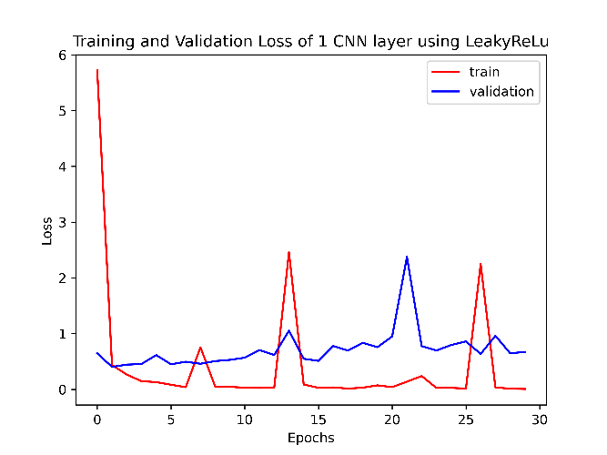
Figure 11.1 Accuracy Plot | Figure 11.2 Loss Plot
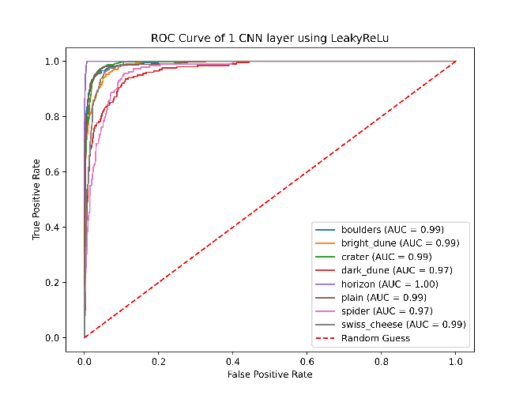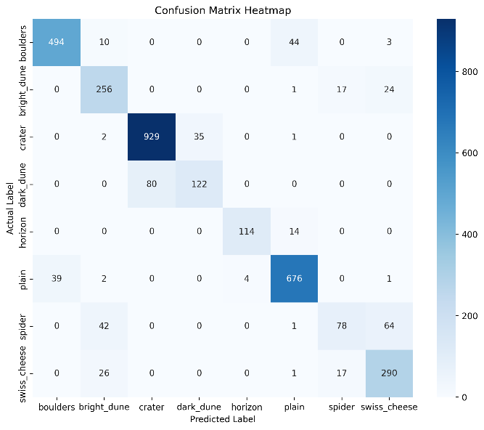
Figure 11.3 ROC curve | Figure 11.4 Confusion Matrix Heatmap
Table 9: Classification Report:
precision recall f1-score support
boulders 0.93 0.90 0.91 551
bright_dune 0.76 0.86 0.81 298
crater 0.92 0.96 0.94 967
dark_dune 0.78 0.60 0.68 202
horizon 0.97 0.89 0.93 128
plain 0.92 0.94 0.93 722
spider 0.70 0.42 0.53 185
swiss_cheese 0.76 0.87 0.81 334

accuracy 0.87 3387
macro avg 0.84 0.80 0.82 3387
weighted avg 0.87 0.87 0.87 3387

9.9 Two Convolutional layer using LeakyReLu Activation Function
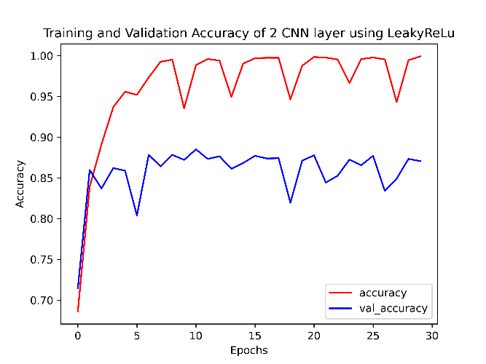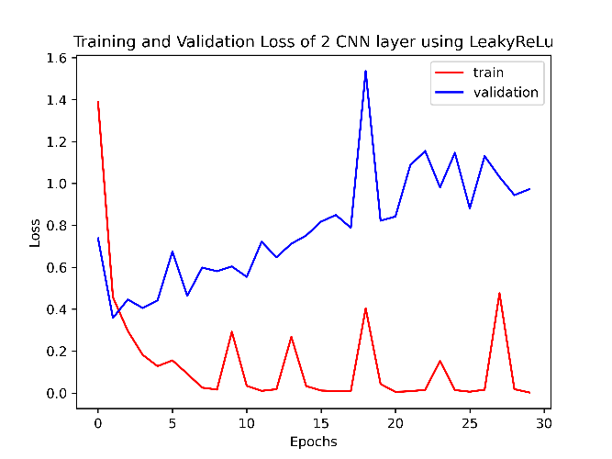
Figure 12.1 Accuracy Plot | Figure 12.2 Loss Plot
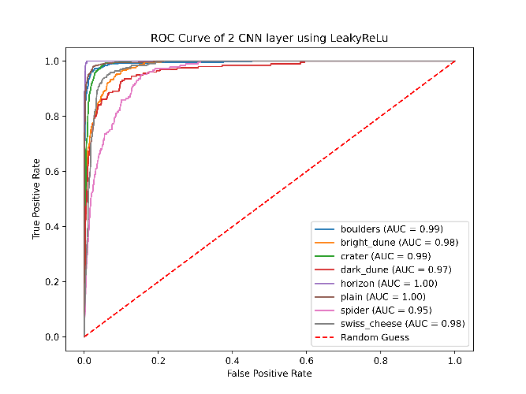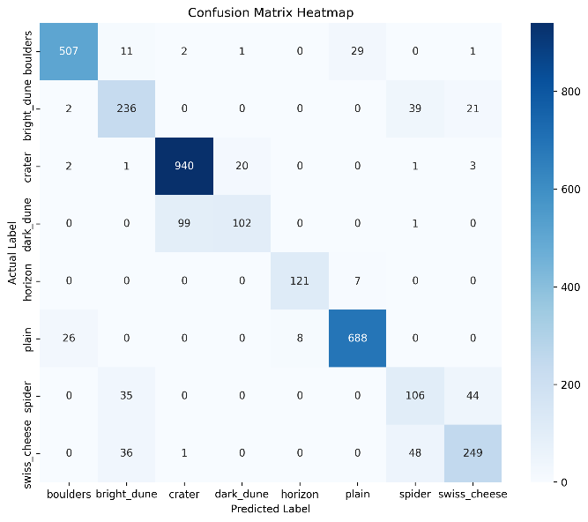
Figure 12.3 ROC curve | Figure 12.4 Confusion Matrix Heatmap
Table 10: Classification Report:
precision recall f1-score support
boulders 0.94 0.92 0.93 551
bright_dune 0.74 0.79 0.76 298
crater 0.90 0.97 0.94 967
dark_dune 0.83 0.50 0.63 202
horizon 0.94 0.95 0.94 128
plain 0.95 0.95 0.95 722
spider 0.54 0.57 0.56 185
swiss_cheese 0.78 0.75 0.76 334

accuracy 0.87 3387
macro avg 0.83 0.80 0.81 3387
weighted avg 0.87 0.87 0.87 3387

9.10 Three Convolutional layer using LeakyReLu Activation Function
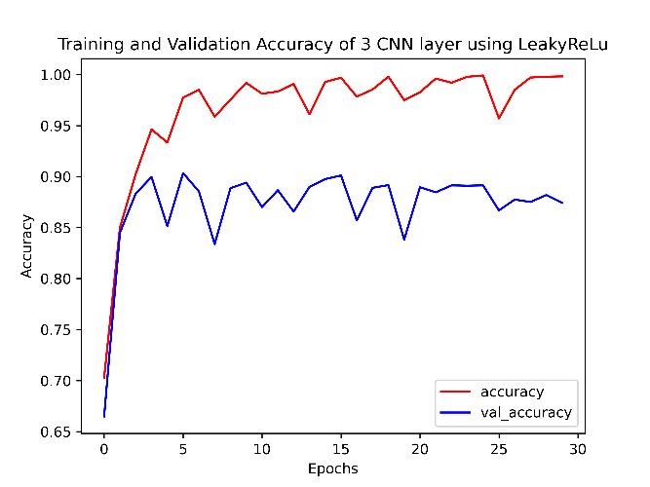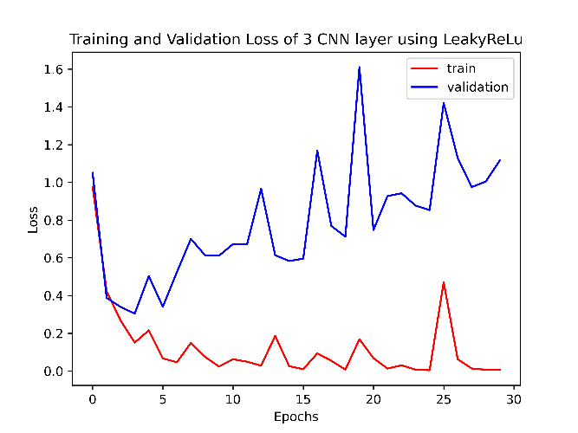
Figure 13.1 Accuracy Plot | Figure 13.2 Loss Plot
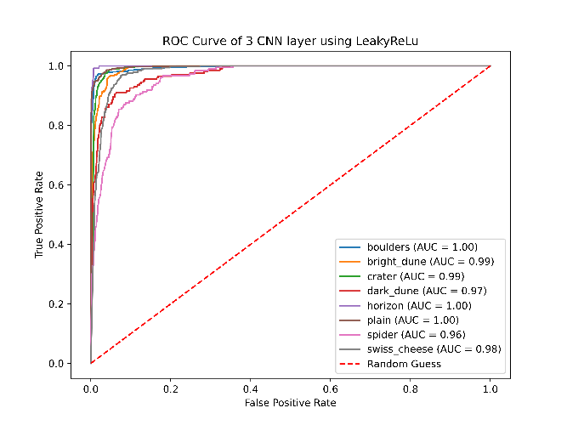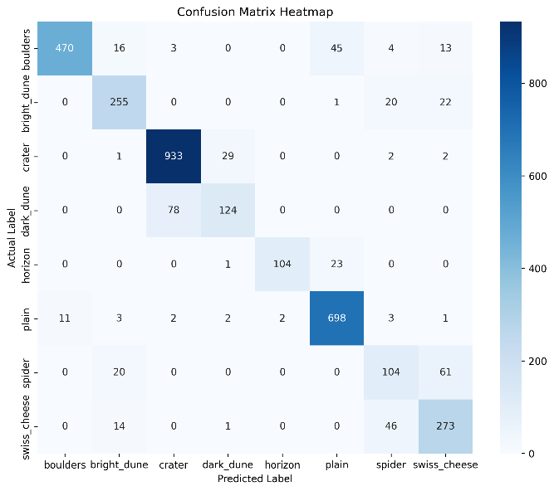
Figure 13.3 ROC curve | Figure 13.4 Confusion Matrix Heatmap
Table 11: Classification Report:
precision recall f1-score support
boulders 0.98 0.85 0.91 551
bright_dune 0.83 0.86 0.84 298
crater 0.92 0.96 0.94 967
dark_dune 0.79 0.61 0.69 202
horizon 0.98 0.81 0.89 128
plain 0.91 0.97 0.94 722
spider 0.58 0.56 0.57 185
swiss_cheese 0.73 0.82 0.77 334

accuracy 0.87 3387
macro avg 0.84 0.81 0.82 3387
weighted avg 0.88 0.87 0.87 3387

9.11 One Convolutional layer using ELu Activation Function
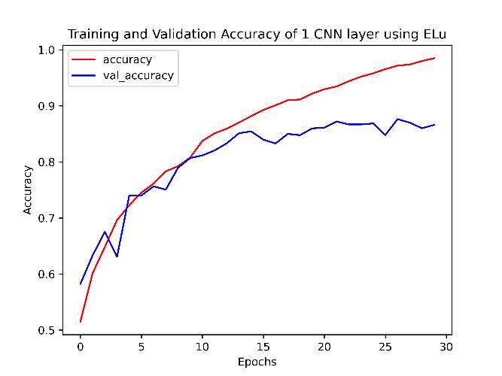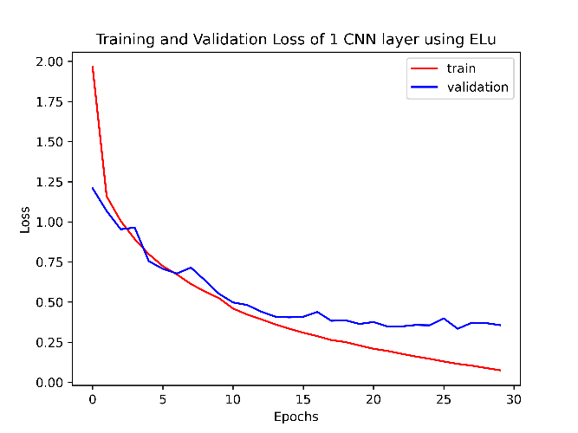
Figure 14.1 Accuracy Plot | Figure 14.2 Loss Plot
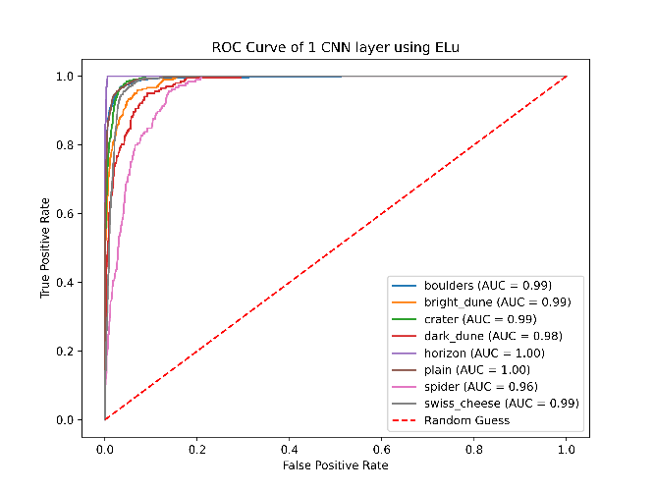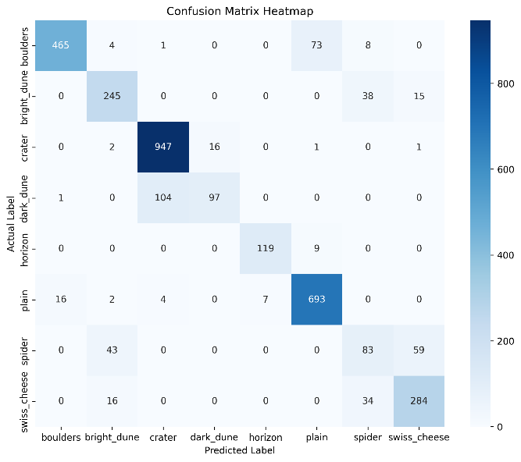
Figure 14.3 ROC curve | Figure 14.4 Confusion Matrix Heatmap
Table 12: Classification Report:
precision recall f1-score support
boulders 0.96 0.84 0.90 551
bright_dune 0.79 0.82 0.80 298
crater 0.90 0.98 0.94 967
dark_dune 0.86 0.48 0.62 202
horizon 0.94 0.93 0.94 128
plain 0.89 0.96 0.93 722
spider 0.51 0.45 0.48 185
swiss_cheese 0.79 0.85 0.82 334

accuracy 0.87 3387
macro avg 0.83 0.79 0.80 3387
weighted avg 0.87 0.87 0.86 3387

9.12 Two Convolutional layer using ELu Activation Function
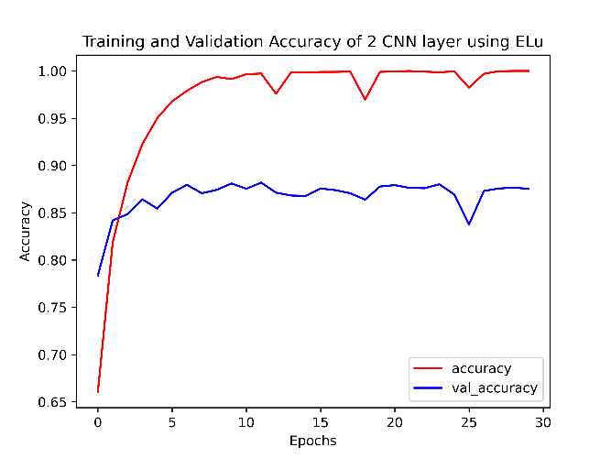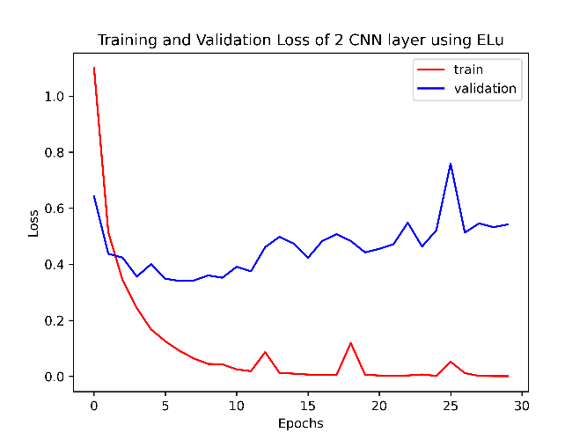
Figure 15.1 Accuracy Plot | Figure 15.2 Loss Plot
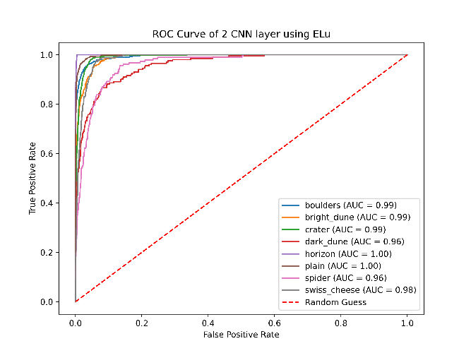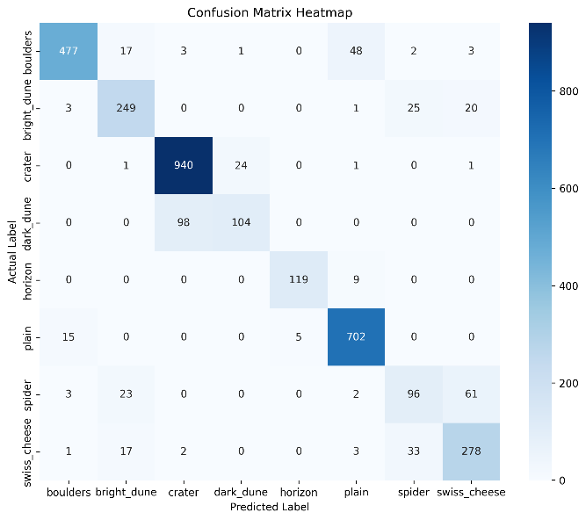
Figure 15.3 ROC curve | Figure 15.4 Confusion Matrix Heatmap
Table 13: Classification Report:
precision recall f1-score support
boulders 0.96 0.87 0.91 551
bright_dune 0.81 0.84 0.82 298
crater 0.90 0.97 0.94 967
dark_dune 0.81 0.51 0.63 202
horizon 0.96 0.93 0.94 128
plain 0.92 0.97 0.94 722
spider 0.62 0.52 0.56 185
swiss_cheese 0.77 0.83 0.80 334

accuracy 0.88 3387
macro avg 0.84 0.81 0.82 3387
weighted avg 0.87 0.88 0.87 3387

9.13 Three Convolutional layer using ELu Activation Function
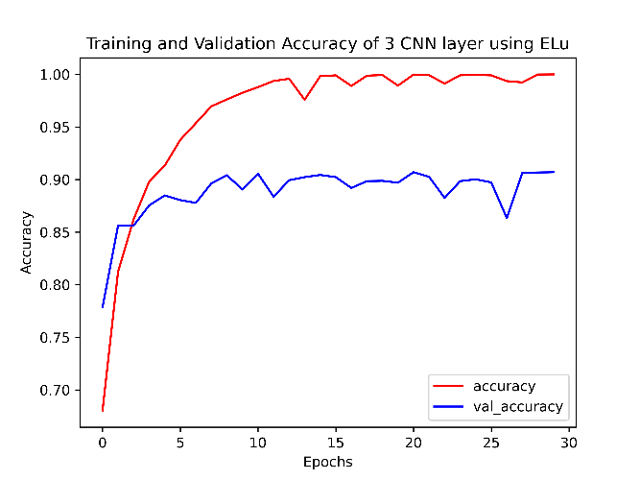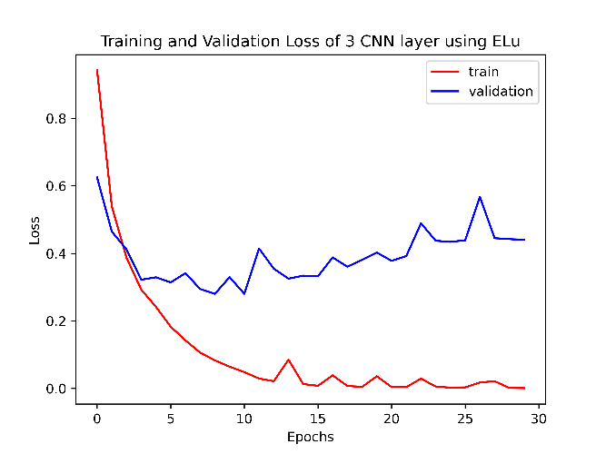
Figure 16.1 Accuracy Plot | Figure 16.2 Loss Plot
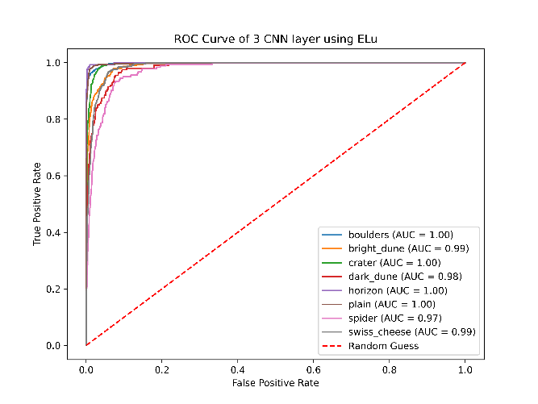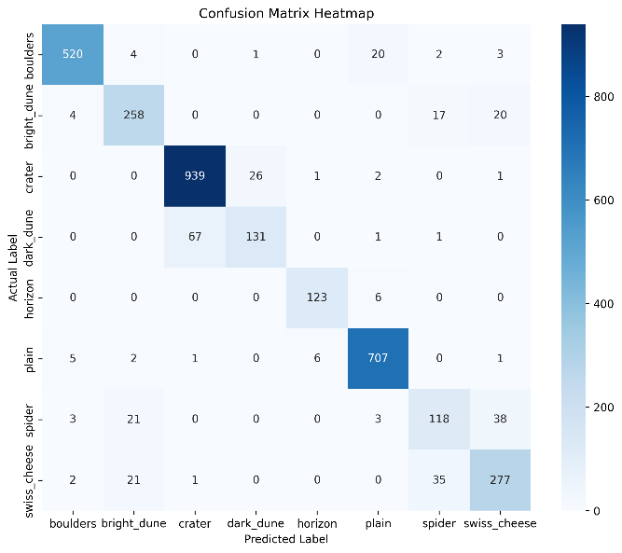
Figure 16.3 ROC curve | Figure 16.4 Confusion Matrix Heatmap

Table 14: Classification Report:
precision recall f1-score support
boulders 0.97 0.95 0.96 550
bright_dune 0.84 0.86 0.85 299
crater 0.93 0.97 0.95 969
dark_dune 0.83 0.66 0.73 200
horizon 0.95 0.95 0.95 129
plain 0.96 0.98 0.97 722
spider 0.68 0.64 0.66 183
swiss_cheese 0.81 0.82 0.82 336

accuracy 0.91 3388
macro avg 0.87 0.85 0.86 3388
weighted avg 0.91 0.91 0.91 3388

10. Results and Discussions
Table 15: Results of each CNN model
Model \ Metrices | Accuracy | Precision (ma) | Recall(ma) | F1 Score(ma) | F1 Score(wa)
1 layer ReLu | 0.87 | 0.83 | 0.80 | 0.81 | 0.87
2 layer ReLu | 0.87 | 0.81 | 0.81 | 0.81 | 0.87
3 layer ReLu | 0.89 | 0.88 | 0.80 | 0.82 | 0.88
1 layer LeakyReLu | 0.87 | 0.84 | 0.80 | 0.82 | 0.87
2 layer LeakyReLu | 0.87 | 0.83 | 0.80 | 0.81 | 0.87
3 layer LeakyReLu | 0.87 | 0.84 | 0.81 | 0.82 | 0.87
1 layer Elu | 0.87 | 0.83 | 0.79 | 0.80 | 0.86
2 layer Elu | 0.88 | 0.84 | 0.81 | 0.82 | 0.87
3 layer ELu | 0.91 | 0.87 | 0.85 | 0.86 | 0.91
(ma – Macro Average, wa Weighted Average)
10.1 Comparison of CNN Layers (1-Layer vs 2-Layer vs 3-Layer): A comparative study across different CNN depths reveals that 1-Layer CNN has lower accuracy due to insufficient feature extraction and works well only for highly separable classes. 2-Layer CNN has significant improvement over 1-layer, better texture extraction and spatial feature learning and good balance of accuracy and computational efficiency. 3-Layer CNN has highest accuracy in most cases due to deeper feature representation, but may risk slight overfitting depending on activation function and dataset. It performs best for complex patterns (e.g., Spider, Swiss Cheese). The results indicate that increasing depth improves classification ability, provided that the model does not overfit.
10.2 Comparison of Activation Functions (ReLU vs LeakyReLU vs ELU) : Each activation function contributed differently to learning like ReLU had fast convergence, performs well on clean features, but may suffer from dying ReLU problem in deeper networks therefore moderate stability. LeakyReLU improves gradient flow, helps avoid dead neurons, is better than ReLU in deeper architectures and therefore good classification for texture-based classes. ELU has best stability among the three, works well with low learning rate, smooth negative output helps gradient updates, produces the most robust accuracy curves and therefore is suitable for noisy or GAN-enhanced datasets. Overall, ELU consistently provided smoother convergence and higher validation accuracy across deeper CNNs.
10.3 Best Model Discussion
Based on all performance indicators—accuracy, loss, ROC curves, and classification reports—the best model is 3-Layer CNN with ELU Activation. It has achieved the most stable and highest accuracy across 30 epochs. ELU avoids exploding or vanishing gradients, giving uniform learning across filters. Most classes achieved AUC values close to 1.00. Indicates both strong precision and recall. Mars terrains involve fine textures (dunes, craters, spiders), and deeper ELU networks excel at such patterns.
11. Conclusion
This project successfully demonstrated the classification of Mars terrain images into eight distinct categories using Convolutional Neural Networks (CNNs). The dataset underwent essential preprocessing steps, including CycleGAN-based colorization, resizing, renaming, and extensive data augmentation tailored for satellite imagery. Multiple CNN architectures with 1, 2, and 3 convolutional layers were trained using ReLU, LeakyReLU, and ELU activation functions. The experimental results show that deeper CNN architectures generally achieved higher accuracy and better generalization, with the best-performing model achieving an overall accuracy of 91%. The classification report, confusion matrix, ROC curves, and evaluation metrics (precision, recall, F1-score) confirm that the model can effectively recognize most terrain categories, especially crater, plain, and boulders. However, certain classes such as spider and dark_dune remain challenging due to their fine-grained texture similarities and limited sample variability. Overall, the study validates the effectiveness of CNN-based deep learning models for automated Mars surface analysis and highlights the potential for enhancing planetary science workflows through machine learning techniques.

12. Future Scope
Although the current model performs well, several enhancements can further improve accuracy, robustness, and real-world deployment potential. Use of Deeper and Advanced Models by integrating architectures like ResNet, EfficientNet, DenseNet, or MobileNet can extract richer hierarchical features, as these models typically outperform basic CNNs due to skip connections, improved feature reuse, and better optimization flow. Improved Data Enhancement using more powerful GAN-based methods such as CycleGAN v2, StyleGAN, or Pix2PixHD can generate higher-quality synthetic training images, where terrain-specific GAN augmentations can help balance under-represented classes like spider and dark_dune. Transfer Learning with pretrained models (trained on ImageNet or remote-sensing datasets) can dramatically boost accuracy with less data, and fine-tuning top layers allows the model to adapt to Mars terrain patterns with minimal computational cost while also enabling cross-planet generalization for terrains from Venus or the icy moons of Jupiter. Real-Time Deployment by optimizing the model using TensorRT, ONNX, or TFLite can enable real-time image classification on embedded devices, on-rover inference during missions, and offline classification in research labs. Cloud-Based Inference Platforms deploying the trained model on services like Google Cloud AI Platform, AWS SageMaker, or Azure ML allows large-scale batch processing, integration with NASA/ESA pipelines, and API-based terrain classification tools for other researchers. More Detailed Terrain Sub-Categorization can introduce richer class hierarchies, such as crater depth, dune morphology, rock density, and geological time indicators, while Explainability and Visualization using Grad-CAM, LIME, or SHAP can help scientists understand the geophysical features influencing classification.
References
- Indian Institute of Remote Sensing (IIRS). (n.d.). About Indian Space Research Organisation (ISRO). Indian Space Research Organisation. https://www.iirs.gov.in/about-indian-space-research-organisation.
- Indian Space Research Organisation (ISRO). (n.d.). Satellite Launch Vehicle (SLV). https://www.isro.gov.in/SLV.html.
- Wikipedia contributors. (n.d.). Indian National Satellite System. In Wikipedia, The Free Encyclopaedia. Retrieved October 2025, from https://en.wikipedia.org/wiki/Indian_National_Satellite_System.
- Bandyopadhyay, S., & Nair, K. (2019). PSLV: The versatile workhorse launches vehicle of India. ResearchGate. https://www.researchgate.net/publication/337023376_PSLV_The_Versatile_Workhorse_Launch_Vehicle_of_India.
- Consulate General of India, Hamburg. (2014). India’s maiden Mars orbiter Mangalyaan successfully enters red planet’s orbit (September 24, 2014). https://cgihamburg.gov.in/pdf/20%20-%20India's%20maiden%20Mars%20orbiter%20Mangalyaan%20successfully%20enters%20red%20planet's%20orbit%20(September%2024,%202014).pdf.
- Indian Space Research Organisation (ISRO). (n.d.). Cartosat-3. Retrieved October 13, 2025, from https://www.isro.gov.in/Cartosat_3.html.
- Zhou, T., & Li, X. (2024). A comparative study of Vision Transformer and Convolutional Neural Network models in geological fault detection. ResearchGate. Retrieved from https://www.researchgate.net/publication/382586426_A_Comparative_Study_of_Vision_Transformer_and_Convolutional_Neural_Network_Models_in_Geological_Fault_Detection.
- Patel, A., & Rao, D. (2024). Leveraging data analytics in multimodal deep learning for predictive maintenance aimed at minimizing rig downtime. ResearchGate. Retrieved from https://www.researchgate.net/publication/380384776_Leveraging_Data_Analytics_in_Multimodal_Deep_Learning_for_Predictive_Maintenance_Aimed_at_Minimizing_Rig_Downtime.
- Indian Space Research Organisation (ISRO). (2025). Research Areas in Space [PDF]. Retrieved October 13, 2025, from https://www.isro.gov.in/media_isro/pdf/programme/Research_Areas_Space_Doc2025.pdf.
- Source APA (7th Edition) Reference NASA 2023 Year in ReviewNational Aeronautics and Space Administration. (2023). NASA's Office of Technology, Policy, and Strategy: A year in review—2023. Retrieved from https://www.nasa.gov/wp-content/uploads/2023/12/otps-annual-report-a-year-in-review-2023-tagged.pdf.
- ISRO 2023 Space Situational Assessment Indian Space Research Organisation. (n.d.). Indian Space Situational Assessment Report (ISSAR) series. Retrieved from https://www.isro.gov.in/ISSAR_2024.html.
- NASA 2023 Space Station Achievements National Aeronautics and Space Administration. (2024). Annual highlights of results from the International Space Station—2023. Retrieved from https://www.nasa.gov/wp-content/uploads/2024/02/annual-highlights-results-iss-2023.pdfI.
- SRO 2023 Aditya-L1 Mission Indian Space Research Organisation. (n.d.). Aditya-L1 mission booklet. Retrieved from https://www.isro.gov.in/media_isro/pdf/Aditya_L1_Booklet.pdf.
- NASA 2023 International Space Apps Challenge National Aeronautics and Space Administration. (2023). Global winners: 2023 NASA International Space Apps Challenge. Retrieved from https://www.spaceappschallenge.org/2023/awards/global-winners/.
- ISRO 2023 RESPOND Basket Indian Space Research Organisation. (2023). RESPOND BASKET—2023. Retrieved from https://www.isro.gov.in/media_isro/pdf/programme/respond_basket_2023.pdf.
- Le, T. D. (2024). On-board satellite image classification for earth observation: A comparative study of pre-trained vision transformer models. arXiv preprint arXiv:2409.03901.
- Ratadiya, P. R., Alimo, R., Kahovec, B., Vatan, F., & Gilbert, W. (2024). Raman: Robust approaches for multimodal anomaly detection in mars rover power systems. In AIAA SCITECH 2024 Forum (p. 1378).
- Zhang, T., Wu, S., & Zhong, L. (2024, October). Multi-View Sentence Matching Model Based on Equal-Length Interactive Attention. In 2024 7th International Conference on Machine Learning and Natural Language Processing (MLNLP) (pp. 1-6). IEEE.
- Lin, X., Li, T., Hua, B., Li, L., & Zhao, C. (2025). A Review of Deep Space Image-Based Navigation Methods. Aerospace (MDPI Publishing), 12(9).
- Gialampoukidis, I., Andreadis, S., Vrochidis, S., & Kompatsiaris, I. (2021, July). Multimodal data fusion of social media and satellite images for emergency response and decision-making. In 2021 IEEE International Geoscience and Remote Sensing Symposium IGARSS (pp. 228-231). IEEE.
- Khan, F. A. (2025). Transforming Earth Observation: An Extensive Evaluation of Vision Transformers for Satellite Images‐Based Land Cover Classification. Expert Systems, 42(7), e70082.
- Wagstaff, K. L., Lu, Y., Stanboli, A., Grimes, K., Gowda, T., & Padams, J. (2017). Mars surface image (Curiosity rover) labeled data set [Data set]. Zenodo. https://doi.org/10.5281/zenodo.1049137
- Doran, G., Dunkel, E., Lu, S., & Wagstaff, K. (2020). Mars orbital image (HiRISE) labeled data set (version 3.2) [Data set]. Zenodo. https://doi.org/10.5281/zenodo.4002935

Appendix A (code for CNN model)
import os
import cv2
import numpy as np
from sklearn.metrics import confusion_matrix, classification_report, roc_curve, roc_auc_score
import tensorflow as tf
from tensorflow.keras import layers, models
from datetime import datetime
import matplotlib.pyplot as plt
from IPython.utils import io
import sys
import gc
import shutil
sys_stdout = sys.stdout
IMAGE_SIZE = (256, 256)
DATA_FOLDER = "C:/Users/Arnesh/Term_Paper_1/dataset"
DIRECTORY = "C:/Users/Arnesh/Term_Paper_1"
BATCH_SIZE = 32
EPOCHES = 30
# Class dictionary
class_dict = {
0: "boulders",
1: "bright_dune",
2: "crater",
3: "dark_dune",
4: "horizon",
5: "plain",
6: "spider",
7: "swiss_cheese",
}
def create_model_relu(layer):
num_classes = len(os.listdir(DATA_FOLDER))
model = models.Sequential()
model.add(layers.Rescaling(1./255, input_shape=(IMAGE_SIZE[0], IMAGE_SIZE[1], 3)))
if layer >= 1:
model.add(layers.Conv2D(32, (3,3), activation='relu', padding='same'))
model.add(layers.MaxPooling2D((2,2)))
if layer >= 2:
model.add(layers.Conv2D(64, (3,3), activation='relu', padding='same'))
model.add(layers.MaxPooling2D((2,2)))
if layer >= 3:
model.add(layers.Conv2D(128, (3,3), activation='relu', padding='same'))
model.add(layers.MaxPooling2D((2,2)))
model.add(layers.Flatten())
model.add(layers.Dense(128, activation='relu'))
model.add(layers.Dense(num_classes, activation='softmax', dtype='float32'))
model.compile(
optimizer='adam',
loss='sparse_categorical_crossentropy',
metrics=['accuracy']
)
return model
def create_model_leakyrelu(layer):
num_classes = len(os.listdir(DATA_FOLDER))
model = models.Sequential()
model.add(layers.Rescaling(1./255, input_shape=(IMAGE_SIZE[0], IMAGE_SIZE[1], 3)))
act = layers.LeakyReLU()
if layer >= 1:
model.add(layers.Conv2D(32, (3,3), activation=act, padding='same'))
model.add(layers.MaxPooling2D((2,2)))
if layer >= 2:
model.add(layers.Conv2D(64, (3,3), activation=act, padding='same'))
model.add(layers.MaxPooling2D((2,2)))
if layer >= 3:
model.add(layers.Conv2D(128, (3,3), activation=act, padding='same'))
model.add(layers.MaxPooling2D((2,2)))
model.add(layers.Flatten())
model.add(layers.Dense(128, activation=act))
model.add(layers.Dense(num_classes, activation='softmax', dtype='float32'))
model.compile(
optimizer='adam',
loss='sparse_categorical_crossentropy',
metrics=['accuracy']
)
return model
def create_model_elu(layer):
num_classes = len(os.listdir(DATA_FOLDER))
model = models.Sequential()
model.add(layers.Rescaling(1./255, input_shape=(IMAGE_SIZE[0], IMAGE_SIZE[1], 3)))
act = layers.ELU()
if layer >= 1:
model.add(layers.Conv2D(32, (3,3), activation=act, padding='same'))
model.add(layers.MaxPooling2D((2,2)))
if layer >= 2:
model.add(layers.Conv2D(64, (3,3), activation=act, padding='same'))
model.add(layers.MaxPooling2D((2,2)))
if layer >= 3:
model.add(layers.Conv2D(128, (3,3), activation=act, padding='same'))
model.add(layers.MaxPooling2D((2,2)))
model.add(layers.Flatten())
model.add(layers.Dense(128, activation=act))
model.add(layers.Dense(num_classes, activation='softmax', dtype='float32'))
optimizer = tf.keras.optimizers.Adam(learning_rate=1e-4)
model.compile(
optimizer=optimizer,
loss='sparse_categorical_crossentropy',
metrics=['accuracy']
)
return model
def imageClassifier(layer, activater):
model_list = {1:create_model_relu,2:create_model_leakyrelu,3:create_model_elu}
model = model_list[activater](layer)
acti = {1: "ReLu", 2: "LeakyReLu", 3: "ELu"}
folder = DIRECTORY + "/CNN" + str(layer) + "_" + acti[activater]
os.makedirs(folder, exist_ok=True)
# ------------------------------
# Load Dataset
# ------------------------------
train_ds = tf.keras.utils.image_dataset_from_directory(
DATA_FOLDER,
validation_split=0.2,
subset="training",
seed=123,
image_size=IMAGE_SIZE,
batch_size=BATCH_SIZE
)
val_ds = tf.keras.utils.image_dataset_from_directory(
DATA_FOLDER,
validation_split=0.2,
subset="validation",
seed=123,
image_size=IMAGE_SIZE,
batch_size=BATCH_SIZE
)
class_names = train_ds.class_names
num_classes = len(class_names)
train_ds = train_ds.prefetch(buffer_size=tf.data.AUTOTUNE)
val_ds = val_ds.prefetch(buffer_size=tf.data.AUTOTUNE)
# ------------------------------
# Train
# ------------------------------
history = model.fit(
train_ds,
validation_data=val_ds,
epochs= EPOCHES
)
# Evaluate model
train_loss, train_acc = model.evaluate(train_ds, verbose=0)
val_loss, val_acc = model.evaluate(val_ds, verbose=0)
# ============================================================
# SAVE EPOCH RESULTS → results.txt
# ============================================================
f = open(f"{folder}/results.txt", "w")
sys.stdout = f
print("Epoch | Train_Acc | Val_Acc | Train_Loss | Val_Loss")
print("------------------------------------------------------")
for ep in range(len(history.history['accuracy'])):
print(
f"{ep+1:3d} | "
f"{history.history['accuracy'][ep]:.4f} | "
f"{history.history['val_accuracy'][ep]:.4f} | "
f"{history.history['loss'][ep]:.4f} | "
f"{history.history['val_loss'][ep]:.4f}"
)
print("\nFinal Results:")
print(f"Train → Loss: {train_loss:.4f}, Acc: {train_acc:.4f}")
print(f"Val → Loss: {val_loss:.4f}, Acc: {val_acc:.4f}")
f.close()
# ============================================================
# confusion.txt
# ============================================================
y_true, y_pred_probs = [], []
for images, labels in val_ds:
preds = model.predict(images, verbose=0)
y_true.extend(labels.numpy())
y_pred_probs.extend(preds)
y_true = np.array(y_true)
y_pred_probs = np.array(y_pred_probs)
y_pred = np.argmax(y_pred_probs, axis=1)
f = open(f"{folder}/confusion.txt", "w")
sys.stdout = f
print("Confusion Matrix:")
print(confusion_matrix(y_true, y_pred))
print("\nClassification Report:")
print(classification_report(y_true, y_pred, target_names=class_names))
f.close()
# ============================================================
# predictions.txt
# ============================================================
all_images, all_labels = [], []
for images, labels in val_ds:
all_images.append(images.numpy())
all_labels.append(labels.numpy())
all_images = np.vstack(all_images)
all_labels = np.concatenate(all_labels)
predictions = model.predict(all_images, verbose=0)
predicted_labels = np.argmax(predictions, axis=1)
f = open(f"{folder}/predictions.txt", "w")
sys.stdout = f
for i in range(len(predicted_labels)):
print(
f"Image {i+1}: Predicted={class_names[predicted_labels[i]]}, "
f"True={class_names[all_labels[i]]}"
)
print(f"Probabilities: {predictions[i]}\n")
f.close()
sys.stdout = sys_stdout
# ==============================
# Plot Accuracy
# ==============================
plt.plot(history.history['accuracy'], color='red', label='accuracy')
plt.plot(history.history['val_accuracy'], color='blue', label='val_accuracy')
plt.title(f"Training and Validation Accuracy of {layer} CNN layer using {acti[activater]}")
plt.xlabel('Epochs')
plt.ylabel('Accuracy')
plt.legend()
location = folder + "/ACCURACY.png"
plt.savefig(location, dpi=600)
plt.close()
# ==============================
# Plot Loss
# ==============================
plt.plot(history.history['loss'], color='red', label='train')
plt.plot(history.history['val_loss'], color='blue', label='validation')
plt.title(f"Training and Validation Loss of {layer} CNN layer using {acti[activater]}")
plt.xlabel('Epochs')
plt.ylabel('Loss')
plt.legend()
location = folder + "/LOSS.png"
plt.savefig(location, dpi=600)
plt.close()
# ==============================
# ROC CURVES
# ==============================
fpr, tpr, roc_auc = {}, {}, {}
for i in range(num_classes):
y_true_bin = (y_true == i).astype(int)
fpr[i], tpr[i], _ = roc_curve(y_true_bin, y_pred_probs[:, i])
roc_auc[i] = roc_auc_score(y_true_bin, y_pred_probs[:, i])
plt.figure(figsize=(8, 6))
for i in range(num_classes):
plt.plot(fpr[i], tpr[i], label=f'{class_names[i]} (AUC = {roc_auc[i]:.2f})')
plt.plot([0, 1], [0, 1], linestyle='--', color='r', label='Random Guess')
plt.title(f"ROC Curve of {layer} CNN layer using {acti[activater]}")
plt.xlabel('False Positive Rate')
plt.ylabel('True Positive Rate')
plt.legend()
location = folder + "/ROC.png"
plt.savefig(location, dpi=600)
plt.close()
# Cleanup
gc.collect()
tf.keras.backend.clear_session()

Appendix B (code for mars image colourization)
The following code was implemented on Google Colab , sample Dataset D₁ and D₂ was saved in google drive and pix2pix-CycleGAN results were also stored in google drive.
from google.colab import drive
drive.mount('/content/drive')
# Commented out IPython magic to ensure Python compatibility.
import os
os.chdir('/content')
# Clone the repo (if not already cloned)
!git clone https://github.com/junyanz/pytorch-CycleGAN-and-pix2pix
# Change into the folder
# %cd /content/pytorch-CycleGAN-and-pix2pix
# this path contains actual model
!ls
!pip install torch torchvision dominate visdom matplotlib Pillow wandb
#content -> datasets -> moon_mars
#moon_mars -> trainA (Black white or images whose olour need to changed)
#moon_mars -> trainB (Coloured mars images)
#moon_mars -> testA (images whose colour are changed)
#moon_mars -> testB (Coloured mars images just a sample)
#content -> drive -> MyDrive (Google Drive)
# !rm -r /<path>/
# !mkdir -p /<path>
# !cp -r /<path from where images are to be copied>/* /<Path where images are copied>/
#model training
import os
print("trainA:", len(os.listdir('/content/datasets/moon_mars/trainA')), "files")
print("trainB:", len(os.listdir('/content/datasets/moon_mars/trainB')), "files")
!python /content/pytorch-CycleGAN-and-pix2pix/train.py \
--dataroot /content/datasets/moon_mars \
--name moon2mars_fast \
--model cycle_gan \
--pool_size 30 \
--batch_size 2 \
--load_size 128 --crop_size 128 \
--netG resnet_6blocks \
--n_epochs 5 \
--n_epochs_decay 5 \
--save_epoch_freq 2
# n_epochs + n_epochs_decay = total epoches
#model testing colours images in test A
!python test.py --dataroot /content/datasets/moon_mars \
--name moon2mars_fast \
--model cycle_gan \
--netG resnet_6blocks \
--direction AtoB \
--dataset_mode unaligned \
--no_dropout \
--serial_batches \
--num_test 200 \
--results_dir ./results/
# num_test must have number >= no of images in test A
# /content/pytorch-CycleGAN-and-pix2pix/results/moon2mars_fast/test_latest/images path where results are stored
# real A - images in test A
# real B - images in test B
# fake A - coloured Test B images as test A
# fake B - coloured Test A images as test B
# rec A - Recoloured images of test A
# rec B - recoloured images of test B
# using cp move result images to google drive
# once model trained it can be stored in google drive and then can be reused again(when replacing model from google drive to collab place in /content/pytorch-CycleGAN-and-pix2pix/)
# Commented out IPython magic to ensure Python compatibility.
# %cd /content/pytorch-CycleGAN-and-pix2pix
A = [ "boulders", "bright_dune", "crater", "dark_dune", "spider", "swiss_cheese"] #looping each class to colour
for i in range(6):
# %cd /content/pytorch-CycleGAN-and-pix2pix # change terminal directory to model always
!rm -r /content/pytorch-CycleGAN-and-pix2pix/results # clear previous result
!rm -r /content/datasets/moon_mars/testA # clear previous testA
!mkdir -p /content/datasets/moon_mars/testA # make new testA folder
!cp -r /content/drive/MyDrive/testing/{A[i]}/* /content/datasets/moon_mars/testA/ # copy its content from drive
B = len(os.listdir('/content/datasets/moon_mars/testA'))
!python test.py --dataroot /content/datasets/moon_mars \
--name moon2mars_fast \
--model cycle_gan \
--netG resnet_6blocks \
--direction AtoB \
--dataset_mode unaligned \
--no_dropout \
--serial_batches \
--num_test {B+10} \ #size of testA +10 for safety
--results_dir ./results/
!mkdir -p /content/drive/MyDrive/light_coloured/Result_{A[i]} #create folder in drive to dtore images
!cp -r /content/pytorch-CycleGAN-and-pix2pix/results/moon2mars_fast/test_latest/* /content/drive/MyDrive/light_coloured/Result_{A[i]}/ # copy images to drive
!cp -r /content/drive/MyDrive/testing/seperatorsss/* /content/drive/MyDrive/light_coloured/Result_{A[i]}/images/ # copy seperator python file to folder having images
# %cd /content/drive/MyDrive/light_coloured/Result_{A[i]}/images/ # change terminal directory to folder having images and python file
!python seperatorsss.py # run this python file to seperate fake A, fake b, real a , real b , rec a , rec b into folders

Appendix C (Epochs result for 1 layer CNN model with ReLu Activation)
imageClassifier(1,1) #1 for 1 layer , 1 for ReLu
Found 16938 files belonging to 8 classes.
Using 13551 files for training.
Found 16938 files belonging to 8 classes.
Using 3387 files for validation.
Epoch 1/30
424/424 ━━━━━━━━━━━━━━━━━━━━ 51s 109ms/step - accuracy: 0.5429 - loss: 9.6805 - val_accuracy: 0.8025 - val_loss: 0.6181
Epoch 2/30
424/424 ━━━━━━━━━━━━━━━━━━━━ 37s 88ms/step - accuracy: 0.8286 - loss: 0.4995 - val_accuracy: 0.8169 - val_loss: 0.4422
Epoch 3/30
424/424 ━━━━━━━━━━━━━━━━━━━━ 39s 82ms/step - accuracy: 0.8821 - loss: 0.3264 - val_accuracy: 0.8598 - val_loss: 0.4008
Epoch 4/30
424/424 ━━━━━━━━━━━━━━━━━━━━ 42s 86ms/step - accuracy: 0.9326 - loss: 0.2090 - val_accuracy: 0.8704 - val_loss: 0.3681
Epoch 5/30
424/424 ━━━━━━━━━━━━━━━━━━━━ 39s 92ms/step - accuracy: 0.9610 - loss: 0.1370 - val_accuracy: 0.8057 - val_loss: 0.5405
Epoch 6/30
424/424 ━━━━━━━━━━━━━━━━━━━━ 35s 83ms/step - accuracy: 0.9668 - loss: 0.1106 - val_accuracy: 0.8698 - val_loss: 0.3898
Epoch 7/30
424/424 ━━━━━━━━━━━━━━━━━━━━ 40s 81ms/step - accuracy: 0.9823 - loss: 0.0791 - val_accuracy: 0.8751 - val_loss: 0.4135
Epoch 8/30
424/424 ━━━━━━━━━━━━━━━━━━━━ 39s 92ms/step - accuracy: 0.9876 - loss: 0.0493 - val_accuracy: 0.8689 - val_loss: 0.4222
Epoch 9/30
424/424 ━━━━━━━━━━━━━━━━━━━━ 36s 85ms/step - accuracy: 0.9918 - loss: 0.0367 - val_accuracy: 0.8674 - val_loss: 0.4873
Epoch 10/30
424/424 ━━━━━━━━━━━━━━━━━━━━ 39s 92ms/step - accuracy: 0.9899 - loss: 0.0380 - val_accuracy: 0.8807 - val_loss: 0.4317
Epoch 11/30
424/424 ━━━━━━━━━━━━━━━━━━━━ 37s 82ms/step - accuracy: 0.9926 - loss: 0.0297 - val_accuracy: 0.8730 - val_loss: 0.5239
Epoch 12/30
424/424 ━━━━━━━━━━━━━━━━━━━━ 37s 86ms/step - accuracy: 0.9937 - loss: 0.0240 - val_accuracy: 0.8432 - val_loss: 0.6032
Epoch 13/30
424/424 ━━━━━━━━━━━━━━━━━━━━ 40s 85ms/step - accuracy: 0.9919 - loss: 0.0314 - val_accuracy: 0.8565 - val_loss: 0.5533
Epoch 14/30
424/424 ━━━━━━━━━━━━━━━━━━━━ 36s 84ms/step - accuracy: 0.9922 - loss: 0.0309 - val_accuracy: 0.8680 - val_loss: 0.6330
Epoch 15/30
424/424 ━━━━━━━━━━━━━━━━━━━━ 41s 85ms/step - accuracy: 0.9891 - loss: 0.0378 - val_accuracy: 0.8683 - val_loss: 0.5686
Epoch 16/30
424/424 ━━━━━━━━━━━━━━━━━━━━ 44s 93ms/step - accuracy: 0.9920 - loss: 0.0241 - val_accuracy: 0.8651 - val_loss: 0.5504
Epoch 17/30
424/424 ━━━━━━━━━━━━━━━━━━━━ 35s 82ms/step - accuracy: 0.9968 - loss: 0.0108 - val_accuracy: 0.8757 - val_loss: 0.6010
Epoch 18/30
424/424 ━━━━━━━━━━━━━━━━━━━━ 45s 92ms/step - accuracy: 0.9925 - loss: 0.0232 - val_accuracy: 0.8787 - val_loss: 0.5505
Epoch 19/30
424/424 ━━━━━━━━━━━━━━━━━━━━ 35s 82ms/step - accuracy: 0.9980 - loss: 0.0074 - val_accuracy: 0.8686 - val_loss: 0.5872
Epoch 20/30
424/424 ━━━━━━━━━━━━━━━━━━━━ 45s 92ms/step - accuracy: 0.9967 - loss: 0.0108 - val_accuracy: 0.8586 - val_loss: 0.6487
Epoch 21/30
424/424 ━━━━━━━━━━━━━━━━━━━━ 41s 92ms/step - accuracy: 0.9952 - loss: 0.0146 - val_accuracy: 0.8695 - val_loss: 0.5744
Epoch 22/30
424/424 ━━━━━━━━━━━━━━━━━━━━ 38s 85ms/step - accuracy: 0.9933 - loss: 0.0236 - val_accuracy: 0.8237 - val_loss: 0.8817
Epoch 23/30
424/424 ━━━━━━━━━━━━━━━━━━━━ 41s 85ms/step - accuracy: 0.9915 - loss: 0.0270 - val_accuracy: 0.8477 - val_loss: 0.6944
Epoch 24/30
424/424 ━━━━━━━━━━━━━━━━━━━━ 35s 81ms/step - accuracy: 0.9909 - loss: 0.0284 - val_accuracy: 0.8350 - val_loss: 0.6841
Epoch 25/30
424/424 ━━━━━━━━━━━━━━━━━━━━ 39s 92ms/step - accuracy: 0.9950 - loss: 0.0177 - val_accuracy: 0.8665 - val_loss: 0.6016
Epoch 26/30
424/424 ━━━━━━━━━━━━━━━━━━━━ 36s 85ms/step - accuracy: 0.9960 - loss: 0.0116 - val_accuracy: 0.8692 - val_loss: 0.6234
Epoch 27/30
424/424 ━━━━━━━━━━━━━━━━━━━━ 41s 85ms/step - accuracy: 0.9960 - loss: 0.0131 - val_accuracy: 0.8686 - val_loss: 0.6867
Epoch 28/30
424/424 ━━━━━━━━━━━━━━━━━━━━ 41s 85ms/step - accuracy: 0.9964 - loss: 0.0122 - val_accuracy: 0.8677 - val_loss: 0.6775
Epoch 29/30
424/424 ━━━━━━━━━━━━━━━━━━━━ 35s 82ms/step - accuracy: 0.9949 - loss: 0.0146 - val_accuracy: 0.8645 - val_loss: 0.7463
Epoch 30/30
424/424 ━━━━━━━━━━━━━━━━━━━━ 41s 81ms/step - accuracy: 0.9987 - loss: 0.0040 - val_accuracy: 0.8716 - val_loss: 0.7470

Appendix D (Epochs result for 2 layer CNN model with LeakyRelu Activation)
imageClassifier(2,2) #2 for 2 Layer, 2 for LeakyReLu
Found 16938 files belonging to 8 classes.
Using 13551 files for training.
Found 16938 files belonging to 8 classes.
Using 3387 files for validation.
Epoch 1/30
424/424 ━━━━━━━━━━━━━━━━━━━━ 52s 116ms/step - accuracy: 0.5731 - loss: 3.4052 - val_accuracy: 0.7148 - val_loss: 0.7385
Epoch 2/30
424/424 ━━━━━━━━━━━━━━━━━━━━ 38s 91ms/step - accuracy: 0.8168 - loss: 0.5305 - val_accuracy: 0.8598 - val_loss: 0.3583
Epoch 3/30
424/424 ━━━━━━━━━━━━━━━━━━━━ 38s 90ms/step - accuracy: 0.8799 - loss: 0.3203 - val_accuracy: 0.8370 - val_loss: 0.4464
Epoch 4/30
424/424 ━━━━━━━━━━━━━━━━━━━━ 40s 89ms/step - accuracy: 0.9342 - loss: 0.1966 - val_accuracy: 0.8621 - val_loss: 0.4061
Epoch 5/30
424/424 ━━━━━━━━━━━━━━━━━━━━ 42s 99ms/step - accuracy: 0.9498 - loss: 0.1481 - val_accuracy: 0.8589 - val_loss: 0.4423
Epoch 6/30
424/424 ━━━━━━━━━━━━━━━━━━━━ 37s 87ms/step - accuracy: 0.9687 - loss: 0.1036 - val_accuracy: 0.8040 - val_loss: 0.6751
Epoch 7/30
424/424 ━━━━━━━━━━━━━━━━━━━━ 42s 99ms/step - accuracy: 0.9484 - loss: 0.1765 - val_accuracy: 0.8784 - val_loss: 0.4641
Epoch 8/30
424/424 ━━━━━━━━━━━━━━━━━━━━ 43s 100ms/step - accuracy: 0.9914 - loss: 0.0304 - val_accuracy: 0.8642 - val_loss: 0.5986
Epoch 9/30
424/424 ━━━━━━━━━━━━━━━━━━━━ 42s 100ms/step - accuracy: 0.9959 - loss: 0.0166 - val_accuracy: 0.8784 - val_loss: 0.5817
Epoch 10/30
424/424 ━━━━━━━━━━━━━━━━━━━━ 41s 97ms/step - accuracy: 0.9551 - loss: 0.2032 - val_accuracy: 0.8722 - val_loss: 0.6041
Epoch 11/30
424/424 ━━━━━━━━━━━━━━━━━━━━ 41s 97ms/step - accuracy: 0.9833 - loss: 0.0486 - val_accuracy: 0.8851 - val_loss: 0.5546
Epoch 12/30
424/424 ━━━━━━━━━━━━━━━━━━━━ 38s 90ms/step - accuracy: 0.9958 - loss: 0.0116 - val_accuracy: 0.8733 - val_loss: 0.7219
Epoch 13/30
424/424 ━━━━━━━━━━━━━━━━━━━━ 40s 88ms/step - accuracy: 0.9960 - loss: 0.0126 - val_accuracy: 0.8766 - val_loss: 0.6480
Epoch 14/30
424/424 ━━━━━━━━━━━━━━━━━━━━ 41s 88ms/step - accuracy: 0.9660 - loss: 0.1897 - val_accuracy: 0.8612 - val_loss: 0.7127
Epoch 15/30
424/424 ━━━━━━━━━━━━━━━━━━━━ 45s 97ms/step - accuracy: 0.9875 - loss: 0.0418 - val_accuracy: 0.8683 - val_loss: 0.7519
Epoch 16/30
424/424 ━━━━━━━━━━━━━━━━━━━━ 39s 92ms/step - accuracy: 0.9966 - loss: 0.0133 - val_accuracy: 0.8772 - val_loss: 0.8181
Epoch 17/30
424/424 ━━━━━━━━━━━━━━━━━━━━ 43s 97ms/step - accuracy: 0.9978 - loss: 0.0079 - val_accuracy: 0.8739 - val_loss: 0.8498
Epoch 18/30
424/424 ━━━━━━━━━━━━━━━━━━━━ 38s 91ms/step - accuracy: 0.9977 - loss: 0.0092 - val_accuracy: 0.8742 - val_loss: 0.7885
Epoch 19/30
424/424 ━━━━━━━━━━━━━━━━━━━━ 41s 98ms/step - accuracy: 0.9808 - loss: 0.1553 - val_accuracy: 0.8196 - val_loss: 1.5361
Epoch 20/30
424/424 ━━━━━━━━━━━━━━━━━━━━ 38s 89ms/step - accuracy: 0.9744 - loss: 0.0968 - val_accuracy: 0.8713 - val_loss: 0.8225
Epoch 21/30
424/424 ━━━━━━━━━━━━━━━━━━━━ 38s 88ms/step - accuracy: 0.9983 - loss: 0.0068 - val_accuracy: 0.8778 - val_loss: 0.8423
Epoch 22/30
424/424 ━━━━━━━━━━━━━━━━━━━━ 45s 98ms/step - accuracy: 0.9987 - loss: 0.0044 - val_accuracy: 0.8444 - val_loss: 1.0872
Epoch 23/30
424/424 ━━━━━━━━━━━━━━━━━━━━ 37s 87ms/step - accuracy: 0.9952 - loss: 0.0191 - val_accuracy: 0.8527 - val_loss: 1.1552
Epoch 24/30
424/424 ━━━━━━━━━━━━━━━━━━━━ 43s 101ms/step - accuracy: 0.9573 - loss: 0.2122 - val_accuracy: 0.8725 - val_loss: 0.9815
Epoch 25/30
424/424 ━━━━━━━━━━━━━━━━━━━━ 38s 89ms/step - accuracy: 0.9961 - loss: 0.0134 - val_accuracy: 0.8657 - val_loss: 1.1466
Epoch 26/30
424/424 ━━━━━━━━━━━━━━━━━━━━ 38s 90ms/step - accuracy: 0.9965 - loss: 0.0099 - val_accuracy: 0.8772 - val_loss: 0.8813
Epoch 27/30
424/424 ━━━━━━━━━━━━━━━━━━━━ 44s 97ms/step - accuracy: 0.9987 - loss: 0.0048 - val_accuracy: 0.8341 - val_loss: 1.1307
Epoch 28/30
424/424 ━━━━━━━━━━━━━━━━━━━━ 41s 98ms/step - accuracy: 0.9248 - loss: 0.6692 - val_accuracy: 0.8491 - val_loss: 1.0312
Epoch 29/30
424/424 ━━━━━━━━━━━━━━━━━━━━ 39s 91ms/step - accuracy: 0.9898 - loss: 0.0366 - val_accuracy: 0.8733 - val_loss: 0.9447
Epoch 30/30
424/424 ━━━━━━━━━━━━━━━━━━━━ 41s 97ms/step - accuracy: 0.9988 - loss: 0.0039 - val_accuracy: 0.8707 - val_loss: 0.9726

Appendix E (Epochs results for 3 layer CNN model with ELu Activation)
imageClassifier(3,3) #3 for 3 layer , 3 for ELu
Found 16941 files belonging to 8 classes.
Using 13553 files for training.
Found 16941 files belonging to 8 classes.
Using 3388 files for validation.
Epoch 1/30
424/424 ━━━━━━━━━━━━━━━━━━━━ 60s 119ms/step - accuracy: 0.5866 - loss: 1.2866 - val_accuracy: 0.7786 - val_loss: 0.6250
Epoch 2/30
424/424 ━━━━━━━━━━━━━━━━━━━━ 66s 100ms/step - accuracy: 0.7922 - loss: 0.5927 - val_accuracy: 0.8563 - val_loss: 0.4647
Epoch 3/30
424/424 ━━━━━━━━━━━━━━━━━━━━ 42s 98ms/step - accuracy: 0.8587 - loss: 0.3993 - val_accuracy: 0.8563 - val_loss: 0.4118
Epoch 4/30
424/424 ━━━━━━━━━━━━━━━━━━━━ 85s 106ms/step - accuracy: 0.8894 - loss: 0.3097 - val_accuracy: 0.8754 - val_loss: 0.3221
Epoch 5/30
424/424 ━━━━━━━━━━━━━━━━━━━━ 83s 108ms/step - accuracy: 0.9115 - loss: 0.2472 - val_accuracy: 0.8849 - val_loss: 0.3293
Epoch 6/30
424/424 ━━━━━━━━━━━━━━━━━━━━ 42s 98ms/step - accuracy: 0.9302 - loss: 0.2008 - val_accuracy: 0.8805 - val_loss: 0.3141
Epoch 7/30
424/424 ━━━━━━━━━━━━━━━━━━━━ 83s 100ms/step - accuracy: 0.9463 - loss: 0.1614 - val_accuracy: 0.8778 - val_loss: 0.3415
Epoch 8/30
424/424 ━━━━━━━━━━━━━━━━━━━━ 85s 106ms/step - accuracy: 0.9691 - loss: 0.1087 - val_accuracy: 0.8964 - val_loss: 0.2946
Epoch 9/30
424/424 ━━━━━━━━━━━━━━━━━━━━ 41s 97ms/step - accuracy: 0.9752 - loss: 0.0873 - val_accuracy: 0.9041 - val_loss: 0.2801
Epoch 10/30
424/424 ━━━━━━━━━━━━━━━━━━━━ 46s 108ms/step - accuracy: 0.9832 - loss: 0.0640 - val_accuracy: 0.8905 - val_loss: 0.3297
Epoch 11/30
424/424 ━━━━━━━━━━━━━━━━━━━━ 78s 98ms/step - accuracy: 0.9860 - loss: 0.0561 - val_accuracy: 0.9055 - val_loss: 0.2803
Epoch 12/30
424/424 ━━━━━━━━━━━━━━━━━━━━ 83s 100ms/step - accuracy: 0.9926 - loss: 0.0312 - val_accuracy: 0.8837 - val_loss: 0.4146
Epoch 13/30
424/424 ━━━━━━━━━━━━━━━━━━━━ 85s 106ms/step - accuracy: 0.9938 - loss: 0.0257 - val_accuracy: 0.8994 - val_loss: 0.3548
Epoch 14/30
424/424 ━━━━━━━━━━━━━━━━━━━━ 41s 96ms/step - accuracy: 0.9724 - loss: 0.0938 - val_accuracy: 0.9023 - val_loss: 0.3253
Epoch 15/30
424/424 ━━━━━━━━━━━━━━━━━━━━ 41s 97ms/step - accuracy: 0.9980 - loss: 0.0145 - val_accuracy: 0.9044 - val_loss: 0.3340
Epoch 16/30
424/424 ━━━━━━━━━━━━━━━━━━━━ 45s 107ms/step - accuracy: 0.9987 - loss: 0.0089 - val_accuracy: 0.9023 - val_loss: 0.3322
Epoch 17/30
424/424 ━━━━━━━━━━━━━━━━━━━━ 42s 98ms/step - accuracy: 0.9915 - loss: 0.0300 - val_accuracy: 0.8920 - val_loss: 0.3881
Epoch 18/30
424/424 ━━━━━━━━━━━━━━━━━━━━ 42s 99ms/step - accuracy: 0.9986 - loss: 0.0091 - val_accuracy: 0.8985 - val_loss: 0.3606
Epoch 19/30
424/424 ━━━━━━━━━━━━━━━━━━━━ 42s 99ms/step - accuracy: 0.9990 - loss: 0.0062 - val_accuracy: 0.8988 - val_loss: 0.3809
Epoch 20/30
424/424 ━━━━━━━━━━━━━━━━━━━━ 42s 99ms/step - accuracy: 0.9944 - loss: 0.0205 - val_accuracy: 0.8970 - val_loss: 0.4026
Epoch 21/30
424/424 ━━━━━━━━━━━━━━━━━━━━ 42s 99ms/step - accuracy: 0.9999 - loss: 0.0057 - val_accuracy: 0.9070 - val_loss: 0.3780
Epoch 22/30
424/424 ━━━━━━━━━━━━━━━━━━━━ 81s 98ms/step - accuracy: 0.9996 - loss: 0.0035 - val_accuracy: 0.9026 - val_loss: 0.3921
Epoch 23/30
424/424 ━━━━━━━━━━━━━━━━━━━━ 41s 97ms/step - accuracy: 0.9957 - loss: 0.0142 - val_accuracy: 0.8825 - val_loss: 0.4893
Epoch 24/30
424/424 ━━━━━━━━━━━━━━━━━━━━ 83s 99ms/step - accuracy: 0.9983 - loss: 0.0086 - val_accuracy: 0.8985 - val_loss: 0.4375
Epoch 25/30
424/424 ━━━━━━━━━━━━━━━━━━━━ 42s 99ms/step - accuracy: 0.9994 - loss: 0.0030 - val_accuracy: 0.9002 - val_loss: 0.4343
Epoch 26/30
424/424 ━━━━━━━━━━━━━━━━━━━━ 82s 99ms/step - accuracy: 0.9991 - loss: 0.0031 - val_accuracy: 0.8973 - val_loss: 0.4389
Epoch 27/30
424/424 ━━━━━━━━━━━━━━━━━━━━ 81s 97ms/step - accuracy: 0.9987 - loss: 0.0042 - val_accuracy: 0.8633 - val_loss: 0.5676
Epoch 28/30
424/424 ━━━━━━━━━━━━━━━━━━━━ 41s 97ms/step - accuracy: 0.9827 - loss: 0.0454 - val_accuracy: 0.9064 - val_loss: 0.4452
Epoch 29/30
424/424 ━━━━━━━━━━━━━━━━━━━━ 46s 108ms/step - accuracy: 0.9999 - loss: 0.0017 - val_accuracy: 0.9067 - val_loss: 0.4424
Epoch 30/30
424/424 ━━━━━━━━━━━━━━━━━━━━ 42s 100ms/step - accuracy: 1.0000 - loss: 7.9066e-04 - val_accuracy: 0.9070 - val_loss: 0.4405

Appendix F (Few Predictions and probabilities by 3 layer CNN model with ELu Activation)
Image 1: Predicted=swiss_cheese, True=swiss_cheese
Probabilities: [2.3702732e-12 1.5845141e-07 1.0301042e-08 1.9462357e-10 7.8876419e-11
2.5599537e-13 2.7538456e-06 9.9999714e-01]

Image 2: Predicted=boulders, True=boulders
Probabilities: [1.0000000e+00 2.8275428e-18 4.4399964e-16 1.4932333e-15 9.2677614e-18
2.9571453e-08 8.8858322e-18 2.2254118e-15]

Image 3: Predicted=swiss_cheese, True=swiss_cheese
Probabilities: [5.0853403e-05 4.6242817e-06 1.1065566e-08 9.3649230e-14 4.4785609e-11
4.2766060e-10 3.1377514e-08 9.9994445e-01]

Image 4: Predicted=crater, True=crater
Probabilities: [4.4497536e-08 6.3968955e-09 9.2211473e-01 7.7703737e-02 1.0422652e-08
7.1604823e-05 2.1715194e-10 1.0992884e-04]

Image 5: Predicted=crater, True=crater
Probabilities: [1.3510622e-09 1.6390550e-07 9.9999988e-01 2.6582181e-10 4.6050350e-09
3.1535448e-11 8.7139314e-14 1.2859060e-10]

Image 6: Predicted=boulders, True=boulders
Probabilities: [9.9999392e-01 4.8415525e-12 2.7231378e-19 3.4165731e-25 3.3942263e-19
2.5055135e-06 3.5608082e-06 1.6751526e-09]

Image 7: Predicted=plain, True=plain
Probabilities: [7.3839814e-09 3.0089561e-06 1.4733729e-08 1.1555755e-11 3.2418626e-07
9.9999654e-01 1.3551262e-07 4.4845628e-08]

Image 8: Predicted=boulders, True=boulders
Probabilities: [1.0000000e+00 3.5623102e-10 1.1487164e-15 1.5089743e-23 2.5440084e-18
4.3918284e-08 9.6273600e-10 7.3657869e-10]

Image 9: Predicted=boulders, True=boulders
Probabilities: [9.99887824e-01 7.53349639e-07 7.38304325e-15 2.83708501e-10
1.03640256e-11 1.11342008e-04 9.97895171e-08 1.00072554e-11]

Image 10: Predicted=plain, True=plain
Probabilities: [2.8333554e-08 3.7887053e-21 1.4723180e-13 3.3503599e-16 3.9144160e-11
1.0000000e+00 5.6735652e-21 6.7891946e-16]

Image 3380: Predicted=dark_dune, True=crater
Probabilities: [4.4103299e-08 2.8495001e-12 6.1009326e-03 9.9389619e-01 1.0522926e-09
1.7195762e-06 1.6928503e-10 1.0344833e-06]

