NLP-Driven Semantic Pathfinding in Large-Scale Hyperlinked Knowledge Graphs

Synopsis
Submitted in partial fulfilment of the
Requirements for the award of the degree
Of
Bachelor of Technology
in
Computer Science and Engineering

By
Arnesh Kumar Gupta (Enrolment No. 10616403224)
Under the supervision of
Prof. Ravindra Kumar Purwar


UNIVERSITY SCHOOL OF INFORMATION COMMUNICATION AND TECHNOLOGY
Guru Gobind Singh Indraprastha University

Table of Contents

- Abstract …………………………………………………………………………….. 1
- Introduction ………………………………………………………………………… 1
- Literature Review …………………………………………………………………... 4
3.1 Research Gap …………………………………………………………………… 5
- Proposed Methodology .…………...……………………….……………………….. 6
4.1 Proposed Semantic Navigation Strategies …………...………………………… 6
4.2 Dataset …………………………………………..……………………………… 7
4.3 Model Architecture and Computational Framework …………………………… 7
4.4 Evaluation Strategy …………………………………………………………….. 8
- Future Work ………………………………………………….……………………... 9

References ………………………………………..……………………………………...… 10
1.Abstract
The rapid expansion of online knowledge repositories such as Wikipedia has created large-scale, dynamically evolving hyperlink networks that represent complex semantic relationships between concepts. Navigating these interconnected structures efficiently poses a significant computational challenge, particularly in tasks such as the Wikipedia Game, where the objective is to reach a target article from a given source article using only internal hyperlinks. Traditional graph traversal algorithms such as Breadth-First Search (BFS) and Depth-First Search (DFS) rely solely on structural connectivity and often fail to incorporate semantic understanding of content, leading to inefficient exploration in large knowledge graphs. This study proposes an NLP-driven framework for intelligent navigation in Wikipedia hyperlink networks using transformer-based semantic representations. The proposed system leverages sentence embedding models to capture contextual meaning from article titles and textual content, enabling semantically guided heuristic search rather than purely structural traversal. Multiple semantic representation strategies are explored, including title-based similarity matching, introductory paragraph embeddings, and keyword-driven destination modelling. Cosine similarity measures are employed to estimate semantic proximity between candidate links and the target concept, guiding iterative navigation toward the destination page. By integrating semantic similarity modelling with hyperlink graph traversal, the proposed approach aims to transform the Wikipedia Game into a knowledge-aware pathfinding problem. This research establishes a foundation for intelligent navigation in large-scale knowledge graphs, with broader applications in information retrieval, question answering systems, recommendation engines, and automated reasoning over hyperlinked data structures.

2.Introduction
Natural Language Processing (NLP) has emerged as one of the most transformative fields within artificial intelligence, aiming to enable machines to understand, interpret, and generate human language. The foundations of NLP can be traced back to early rule-based systems in the mid-20th century, where linguistic rules and handcrafted grammars were employed to perform tasks such as machine translation and syntactic parsing. These early approaches relied heavily on symbolic representations and expert-designed language models, which, although effective in constrained environments, struggled to scale to real-world linguistic complexity.
The evolution of statistical methods in the 1980s and 1990s marked a significant shift in NLP research. Instead of relying solely on manually encoded rules, probabilistic models such as Hidden Markov Models (HMMs) and n-gram language models were introduced to capture language patterns from large corpora. These approaches enabled improvements in speech recognition, part-of-speech tagging, and machine translation. However, statistical methods were still limited in capturing long-range dependencies and contextual nuances inherent in natural language.
The advent of deep learning in the early 2010s revolutionized NLP by introducing neural network architectures capable of learning hierarchical representations directly from data. Recurrent Neural Networks (RNNs), Long Short-Term Memory (LSTM) networks, and later Convolutional Neural Networks (CNNs) for text processing demonstrated superior performance across various language tasks. Word embedding techniques such as Word2Vec and GloVe further enhanced semantic modelling by representing words in continuous vector spaces, enabling machines to capture syntactic and semantic relationships between terms.
A major breakthrough in NLP occurred with the introduction of transformer architectures, particularly models such as BERT (Bidirectional Encoder Representations from Transformers) and its subsequent variants. Transformers leveraged self-attention mechanisms to model global contextual relationships within text, overcoming limitations of sequential architectures. This advancement significantly improved performance in tasks including question answering, semantic similarity estimation, text classification, and information retrieval. Sentence-level embedding models built upon transformer architectures further enabled efficient computation of semantic similarity between larger text units.
With the exponential growth of digital information, large-scale knowledge repositories such as Wikipedia have become critical resources for structured and unstructured knowledge. Wikipedia functions not only as a textual corpus but also as a massive hyperlinked knowledge graph, where each article represents a node and hyperlinks represent semantic relationships between concepts. Navigating such complex networks efficiently presents both computational and semantic challenges, particularly when the objective is to identify meaningful conceptual paths between distant topics.
Traditional approaches to navigating hyperlink networks rely primarily on graph traversal algorithms such as Breadth-First Search (BFS) or Dijkstra’s algorithm. While these methods effectively exploit structural connectivity, they lack semantic awareness and often require exhaustive exploration of large portions of the graph. As knowledge graphs continue to grow in size and complexity, purely structural search methods become computationally expensive and inefficient for intelligent navigation tasks.
In this context, the Wikipedia Game presents an interesting real-world problem that combines graph traversal with semantic reasoning. The objective of the game is to navigate from a source Wikipedia article to a target article using only internal hyperlinks. Although structurally simple, the problem becomes challenging due to the vast scale of Wikipedia’s hyperlink network and the absence of explicit guidance toward semantically relevant intermediate nodes.
Recent advancements in transformer-based sentence embedding models offer a promising direction for addressing this challenge. By representing article titles and textual content as high-dimensional semantic vectors, it becomes possible to estimate conceptual proximity between different Wikipedia pages. Instead of relying solely on structural adjacency, navigation decisions can be guided by semantic similarity, enabling heuristic-driven movement toward the intended destination.
The proposed research builds upon this idea by developing an NLP-driven framework for semantic navigation within Wikipedia hyperlink networks. The system leverages transformer-based sentence embeddings to model both destination representation and candidate link evaluation. Multiple semantic modelling strategies are explored, including title-based similarity estimation, introductory paragraph embeddings, and keyword-driven destination representations, in order to enhance contextual alignment during navigation.
By integrating semantic similarity modelling with iterative hyperlink traversal, this work aims to transform the Wikipedia Game into a knowledge-aware pathfinding problem. The proposed approach seeks to bridge the gap between graph theory and natural language understanding, contributing toward intelligent navigation mechanisms in large-scale knowledge graphs. Beyond the scope of the Wikipedia Game, such methodologies have broader implications in information retrieval, recommendation systems, automated reasoning, and AI-driven exploration of hyperlinked knowledge structures.
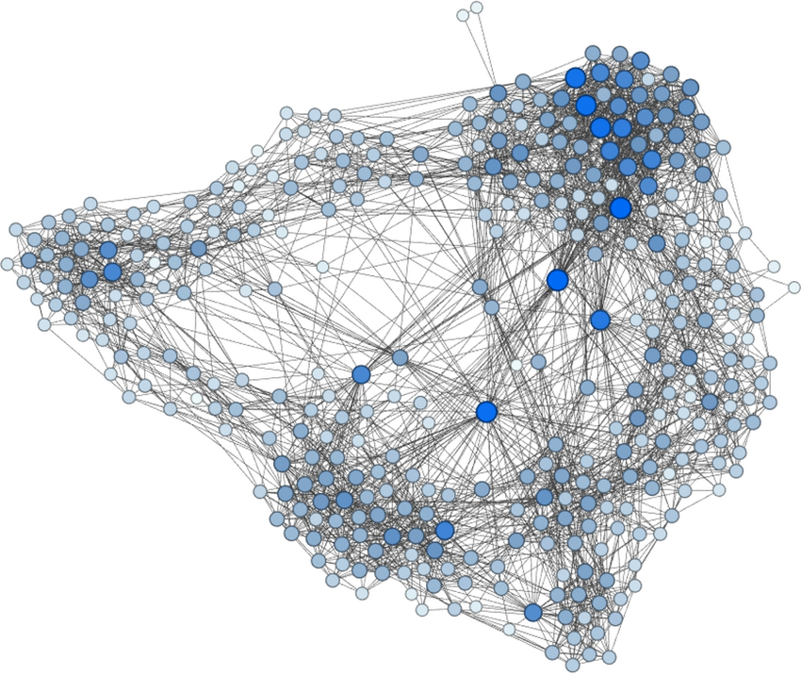
Figure 1: A sample connected web-graph of few Wikipedia pages.

3.Literature Review
The study [1] presents a comprehensive overview of the development of Natural Language Processing, outlining its progression from rule-based systems to statistical and machine learning approaches. The paper emphasizes the interdisciplinary nature of NLP, combining linguistics, computer science, and artificial intelligence. It highlights foundational tasks such as syntactic parsing, semantic analysis, discourse processing, and pragmatic interpretation. The survey explains how early symbolic systems relied on handcrafted linguistic rules, while later statistical approaches enabled more scalable and data-driven solutions. This work provides essential theoretical grounding for understanding how modern NLP systems evolved toward representation learning and contextual modelling.
The work [2] introduces Vector Space Models (VSMs) of semantics, which represent words and documents as mathematical vectors in high-dimensional space. The authors explain how semantic similarity can be computed using geometric measures such as cosine similarity, enabling machines to capture conceptual relationships between textual entities. The study formalizes distributional representations and discusses their application in tasks such as information retrieval, word similarity estimation, and document clustering. This framework forms the mathematical backbone of many modern embedding-based systems and directly supports semantic similarity computation used in navigation and retrieval tasks.
The survey [3] explores the theory of distributional semantics, based on the principle that words appearing in similar contexts tend to have similar meanings. The paper discusses how co-occurrence statistics and contextual patterns can be transformed into vector representations, allowing computational modelling of meaning. It highlights both count-based and predictive models for generating semantic representations and discusses their applications in large-scale corpora. This work establishes the conceptual basis for representing textual units—ranging from words to sentences—as numerical vectors, which is fundamental to transformer-based embedding techniques used in modern NLP systems.
In addition to classical distributional approaches, transformer-based contextual models have significantly advanced semantic representation learning. The study [4] introduces BERT (Bidirectional Encoder Representations from Transformers), which utilizes self-attention mechanisms to capture bidirectional contextual dependencies in text. Unlike earlier static embeddings, BERT generates context-sensitive representations, allowing improved modelling of semantic similarity and language understanding tasks. The introduction of transformer architectures has enabled efficient sentence-level embedding models that are widely used in semantic search, question answering, and information retrieval applications. These advancements provide the technical foundation for leveraging sentence embeddings in hyperlink navigation tasks.

3.1 Research Gaps While foundational studies in NLP and distributional semantics [1], [2], [3] establish robust frameworks for semantic representation, their primary focus lies in word-level or document-level similarity modelling rather than dynamic navigation within large-scale hyperlinked knowledge graphs. Similarly, transformer-based models such as BERT [4] have demonstrated exceptional performance in contextual understanding and semantic similarity tasks, yet their application has largely been concentrated on classification, question answering, and retrieval systems rather than intelligent graph traversal.
Existing research in information retrieval typically treats documents as independent entities, without incorporating the structural topology of hyperlink networks. Conversely, graph traversal algorithms operate on structural connectivity without leveraging semantic understanding. There remains a gap in integrating semantic vector representations with iterative navigation strategies in hyperlinked environments such as Wikipedia. Specifically, limited work has explored heuristic-driven navigation that combines transformer-based sentence embeddings with hyperlink graph exploration to approximate conceptually meaningful paths between distant knowledge nodes.
Therefore, there is a need for a framework that bridges semantic similarity modeling and graph traversal techniques, enabling knowledge-aware navigation in large-scale hyperlink networks. Addressing this gap forms the core motivation of the proposed research.

4. Proposed Methodology
The proposed research aims to develop a semantic-guided navigation framework for solving the Wikipedia Game using transformer-based sentence embeddings and hyperlink graph traversal. Unlike traditional graph search approaches that rely solely on structural connectivity, the proposed system incorporates semantic similarity modelling to guide navigation decisions. The methodology is structured around multiple semantic representation strategies, allowing comparative evaluation of different approaches for knowledge-aware pathfinding.
The system operates iteratively. Given a source Wikipedia page and a target Wikipedia page, hyperlinks are dynamically extracted from the current page. Each candidate link is semantically evaluated against the target representation using cosine similarity between embedding vectors. The link with the highest semantic relevance score is selected as the next navigation step. This process continues until the destination page is reached or no further progress can be made.
To systematically investigate semantic modelling strategies, four distinct methodologies are proposed.

4.1 Proposed Semantic Navigation Strategies
Methodology 1: Title-Based Cosine Similarity Matching
The first approach relies solely on article titles for semantic comparison. In this strategy, the title of the destination Wikipedia page is encoded into a sentence embedding vector using a transformer-based model. For each hyperlink extracted from the current source page, the corresponding article title is converted into an embedding vector. Cosine similarity is computed between each candidate title vector and the destination title vector.
The link with the highest cosine similarity score is selected as the next source node. This method represents a lightweight semantic heuristic, focusing only on surface-level conceptual similarity between article titles. While computationally efficient, it does not incorporate deeper contextual information from article content.

Methodology 2: Introductory Paragraph Embedding Strategy
The second approach enhances semantic modelling by incorporating contextual information from article content. In addition to extracting hyperlinks, the introductory paragraph of each candidate Wikipedia page is scraped and converted into an embedding vector. Similarly, the introductory paragraph of the destination page is encoded into a semantic representation.
Cosine similarity is then computed between candidate introduction embeddings and the destination introduction embedding. This method enables richer semantic comparison, as introductory sections typically summarize the core concept of an article. By leveraging contextual text rather than titles alone, this approach aims to improve conceptual alignment during navigation.

Methodology 3: Keyword-Based Destination Modelling
The third strategy introduces user-guided semantic reinforcement. In addition to the destination title, the user provides a set of descriptive keywords representing the target concept. Each keyword is individually converted into a semantic embedding vector. During navigation, candidate link titles are compared against each keyword vector using cosine similarity.
A combined relevance score is computed by aggregating similarity scores across all keyword vectors. This approach allows domain-specific or culturally significant terms to influence navigation decisions, especially in cases where the destination concept may not be sufficiently represented by its title alone. The method enhances flexibility and enables guided semantic exploration.

Methodology 4: Hybrid Semantic Scoring Strategy
The fourth proposed approach integrates multiple semantic signals into a unified scoring mechanism. In this method, destination title embeddings and keyword-based semantic representations are combined to compute a weighted relevance score for each candidate link. Cosine similarity is calculated separately with respect to title-based and keyword-based representations, and a weighted aggregation function determines the final score.
This hybrid strategy aims to balance structural clarity provided by article titles with contextual reinforcement from user-provided semantic cues. By integrating multiple representation strategies, this method seeks to provide a more robust heuristic for navigating large hyperlink networks.

4.2 Dataset
The primary dataset for this research consists of publicly accessible Wikipedia articles and their associated hyperlink structures. Wikipedia serves as a large-scale, real-world knowledge graph where each article represents a node and internal hyperlinks represent directed edges. The dataset is dynamically constructed during runtime through web scraping of Wikipedia pages.
Hyperlink extraction is performed using HTML parsing techniques to retrieve only internal article links (i.e., links beginning with “/wiki/”) while excluding administrative and non-content pages. Introductory paragraphs are extracted from the main content section of each page for contextual embedding in relevant methodologies.
Since Wikipedia is continuously updated, the dataset reflects a dynamic and evolving knowledge graph, making the navigation problem realistic and scalable.

4.3 Model Architecture and Computational Framework
The proposed system utilizes transformer-based sentence embedding models for semantic representation learning. Pre-trained sentence transformer architectures are employed to generate dense vector embeddings for titles, keywords, and textual content. These embeddings capture contextual meaning and allow computation of semantic proximity using cosine similarity.
The implementation framework is based on Python, incorporating:
- Requests library for HTTP communication and page retrieval
- BeautifulSoup for structured HTML parsing and hyperlink extraction
- SentenceTransformers for transformer-based embedding generation
- NumPy for efficient vector operations and cosine similarity computation
- OS utilities for structured data storage and caching
The cosine similarity function serves as the primary heuristic evaluation metric for navigation decisions. Iterative selection of the highest-scoring candidate link forms the core search mechanism.

4.4 Evaluation Strategy
Since the objective is semantic navigation rather than shortest-path optimization, evaluation focuses on measuring:
- Path convergence toward the destination
- Number of steps required to reach the target
- Semantic relevance consistency across navigation steps
- Computational efficiency of embedding-based scoring
Comparative analysis will be conducted across all four methodologies to assess the impact of different semantic representation strategies on navigation effectiveness. The evaluation will emphasize conceptual alignment and heuristic performance rather than purely structural optimality.

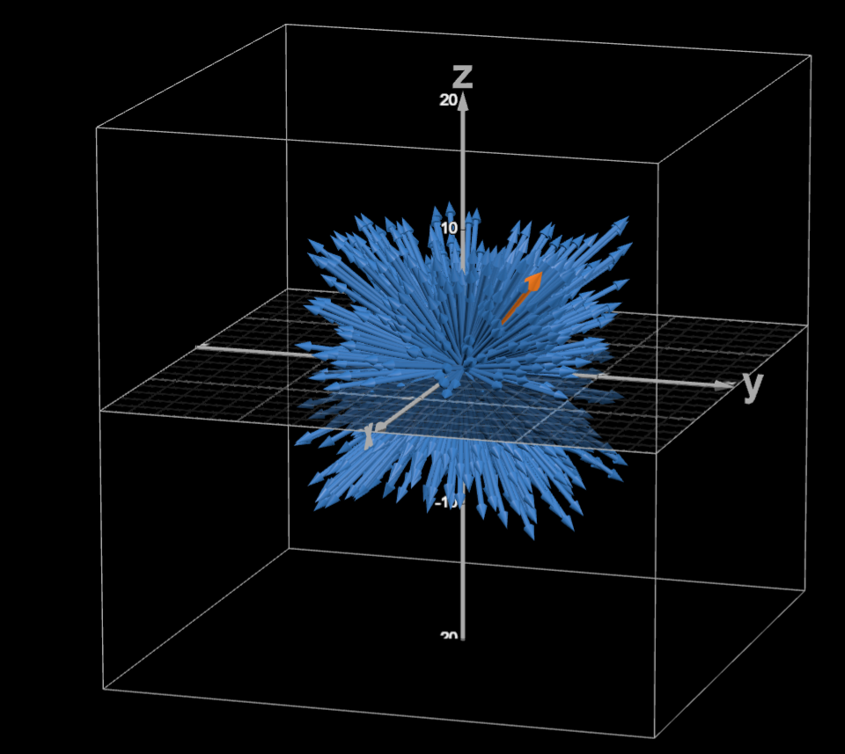
Figure 2 : 3D representation of vector embeddings(orange vector destination wiki title, blue vectors wiki link titles present in source wiki)
5. Future Work
The proposed semantic-guided navigation framework opens multiple directions for further research and enhancement. While the current methodologies focus on title-based and contextual embedding strategies for hyperlink traversal, future work can explore more advanced heuristic search algorithms. Instead of a greedy selection mechanism, algorithms such as Beam Search or A* Search can be integrated with semantic similarity as a heuristic function to improve path optimality and reduce the risk of convergence to local maxima.
Another potential extension involves incorporating full-page content embeddings rather than relying solely on titles or introductory paragraphs. Encoding richer textual representations may improve conceptual understanding and enhance semantic alignment between candidate nodes and the target concept. Additionally, domain-adaptive fine-tuning of transformer models on Wikipedia-specific corpora could further improve embedding quality and relevance estimation.
Scalability is another important area for improvement. As Wikipedia represents a massive and continuously evolving knowledge graph, embedding caching mechanisms and approximate nearest neighbour search techniques such as FAISS can be implemented to reduce computational overhead. Parallel processing and optimization of web scraping pipelines may also enhance efficiency for large-scale navigation tasks.
The framework can further be extended to multilingual Wikipedia navigation, enabling cross-lingual semantic traversal using multilingual transformer models. This would allow navigation between concepts across different language editions of Wikipedia, broadening the applicability of the system.
Finally, the proposed approach can be generalized beyond the Wikipedia Game to real-world applications such as semantic search engines, recommendation systems, automated knowledge graph exploration, and intelligent question-answering systems. By integrating semantic understanding with graph traversal strategies, future research can contribute toward the development of knowledge-aware AI systems capable of navigating complex hyperlinked information networks with minimal human intervention.

References
- [1] Liddy, E. D. (2001). Natural Language Processing. Syracuse University. https://surface.syr.edu/istpub/63/
- [2] Turney, P. D., & Pantel, P. (2010). From Frequency to Meaning: Vector Space Models of Semantics. Journal of Artificial Intelligence Research, 37, 141–188. https://arxiv.org/abs/1003.1141
- [3] Sahlgren, M. (2008). The Distributional Hypothesis. Italian Journal of Linguistics, 20(1), 33–54. https://www.ling.su.se/polopoly_fs/1.37111.1295448412!/distributional_semantics.pdf
- [4] Devlin, J., Chang, M. W., Lee, K., & Toutanova, K. (2019). BERT: Pre-training of Deep Bidirectional Transformers for Language Understanding. Proceedings of NAACL-HLT.
https://arxiv.org/abs/1810.04805
- Rutten, Philip & Lees, Michael & Klous, Sander & Heesterbeek, Hans & Sloot, Peter. (2022). Modelling the dynamic relationship between spread of infection and observed crowd movement patterns at large scale events. Scientific Reports. 12. 10.1038/s41598-022-19081-z.
https://www.researchgate.net/publication/363209041_Modelling_the_dynamic_relationship_between_spread_of_infection_and_observed_crowd_movement_patterns_at_large_scale_events?_tp=eyJjb250ZXh0Ijp7ImZpcnN0UGFnZSI6Il9kaXJlY3QiLCJwYWdlIjoiX2RpcmVjdCJ9fQ

