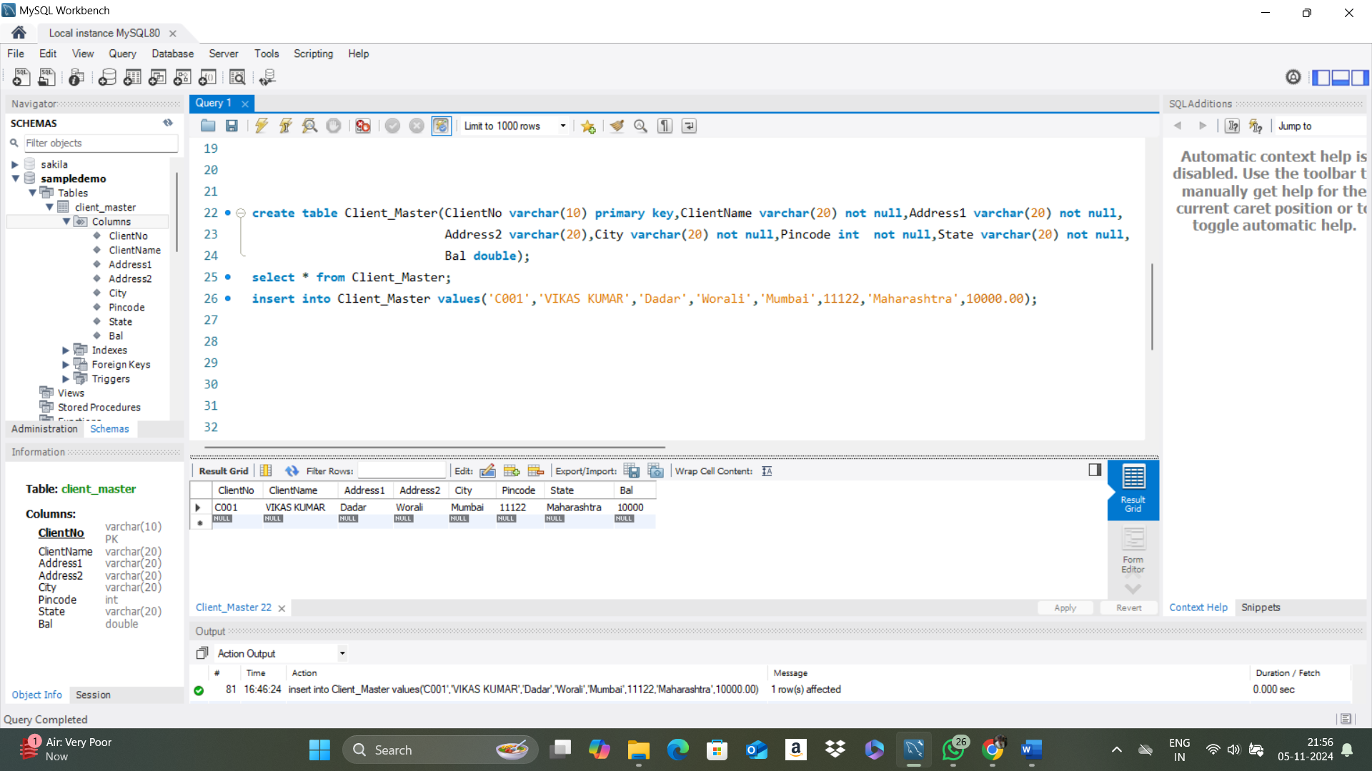

**CODE:**

create table Client_Master(ClientNo varchar(10) primary key,ClientName varchar(20) not null,Address1 varchar(20)

not null, Address2 varchar(20),City varchar(20) not null,Pincode int not null,State varchar(20) not

null, Bal double);

select * from Client_Master;

insert into Client_Master values('C001','VIKAS KUMAR','Dadar','Worali','Mumbai',11122,'Maharashtra',10000.00);