**Increased Ih after enhanced activity increases CA1 excitability during theta stimulation.**

A.R. Boender, D.N. Yousef Yengej & W.J. Wadman

Center for Neuroscience, Swammerdam Institute for Life Sciences, University of Amsterdam, Amsterdam, The Netherlands

**ABSTRACT**

**INTRODUCTION**

Hippocampal theta rhythm provides a mechanism to mediate temporal coding and decoding of neuronal input (G. Buzsáki, 2002). To maintain oscillatory firing patterns the networks needs to have the ability to discharge in an organized and synchronous manner. The neuronal excitability underlying these oscillations are plastic and are thought to be regulated by a combination of synapse specific mechanisms and intrinsic cellular properties (Beck & Yaari, 2008; Wierenga & Wadman, 2003). These intrinsic properties are dynamic and depend (among others) on the composition and abundance of ion channels in the membrane. One of these channels is the hyperpolarization-activated cyclic nucleotide-gated (HCN) channel which carries hyperpolarization-activated currents (Ih). This current contributes to rhythmic changes in subthreshold membrane potential which helps to determine the neuronal response to a given input (Lubenov & Siapas, 2009). In the late 1970s, it was first described as “funny” or “queer” current because of its unusual biophysical properties (Brown, DiFrancesco, & Noble, 1979). At physiological conditions Ih carries an inwardly directed cationic Na+ and K+ current which is activated upon hyperpolarizing voltage steps from potentials negative to -55 mV with a reversal potential around -20 mV. This results in a depolarizing effect on the membrane potential at physiological conditions (Brown et al., 1979; Moosmang, Biel, Hofmann, & Ludwig, 1999). Four distinct HCN channels (HCN1-4) have been found in mammals and they are predominantly expressed in the heart and nervous system (Biel, Wahl-Schott, Michalakis, & Zong, 2009). These channels have opening kinetics that normally range within tens of milliseconds to several seconds with a typical S-shape that can be fit using Boltzmann functions and do not display voltage dependent inactivation (Mccormick & Papet, 1990). The foremost suggested property of Ih is its role as the regulator of the “pacemaker current” of the heart beat (Brown et al., 1979). It has also been suggested to have a role of Ih in the generation of characteristic firing patterns that arise in single thalamocortical cells (Mccormick & Papet, 1990). For hippocampal CA1 pyramidal neurons Ih mediates several biophysical properties regarding the electrical responsiveness and excitability of neuronal cells (Biel et al., 2009). Partially opened HCN channels lower the membrane resistance (Rm) and are thought to function as slow “voltage clamp” by counteracting neuronal input (Jeffrey C Magee, 1998). Enhanced synaptic activity results in a change in intrinsic excitability, which is not merely caused by the potentiated input. Elevated HCN expression is considered to be a contributing factor in chancing neuronal excitability after enhanced synaptic activity (Fan et al., 2005; Noam et al., 2010; van Welie, van Hooft, & Wadman, 2004). The lowered membrane resistance after increased HCN expression is usually considered to have a dampening effect on neuronal excitability (Frick, Magee, & Johnston, 2004). Here we describe how population spikes in the CA1 stratum pyramidalis of the mouse hippocampus increase during theta stimulation after enhanced synaptic activity. Adding of HCN channel blocker ZD7288 results in a decrease of population spike amplitude during a short theta stimulation. This suggests that when exposed to a low frequency input Ih can support the network to synchronize its output and fire in oscillatory rhythms.

**MATERIALS AND METHODS**

**Slice Preparation and imaging.** Horizontal hippocampal slices (300 μm) were prepared from 28- to 42-day-old male Black Six mice (Harlan Netherlands BV, Horst). Experiments were conducted according to the ethics committee guidelines for animal experimentation of the University of Amsterdam and were in accordance with European guidelines. After decapitation, the brain was rapidly removed and placed in ice-cold artificial cerebrospinal fluid (ACSF) containing 120 mM CholineCl, 3.5 mM KCl, 0.5 mM CaCl2, 5 mM MgSO4, 1.25 M NaH2PO4, 10 mM glucose, and 25 mM NaHCO3, equilibrated with 95% O2 and 5% CO2 (pH 7.4). Subsequently, were cut by using a VT1200S vibratome (Leica Biosystems, Nussloch, Germany) after which they were placed in a holding chamber on a membrane (MilliPore LCR membrane filter, FHLC02500, Polytetrafluoroethylene hydrophilic membrane with 0.45 µm pore size, Millipore, Billerica, NA, USA) and allowed to recover for 20 min at 31°C in ACSF containing 120 mM NaCl and without CholineCl. After 20 min the heater was turned off and temperature slowly decreased to room temperature. After 1 hour slices were placed in the recording chamber mounted on a microscope (Axioskop FS, Zeiss, Germany) and perfused with oxygenated ACSF of 32◦C at a rate of 2.5 ml/min. CA1 pyramidal neurons were visualized with an upright Zeiss Axioskop with Hoffman modulation contrast optics and a Qimaging Rolera Bolt CMOS device camera couples with Qcapture software (Scientifica, Uckfield, United Kingdom).ZD7288 was obtained from Tocris Cookson (Bristol, UK) and diluted from stock solutions in water to a concentration of 20 μM.

**Field potentials.** EPSPs were evoked by Schaffer Collateral stimulation using a DS4 Bi-phasic Stimulus Isolator (Digitimer, Ltd.; Welwyn Garden City, UK;) connected to a bipolar stimulation electrode (60 µm diameter isolated stainless steel wire) with a tip separation of 50 µm. The stimulating electrode was placed in stratum radiatum at the CA1–CA3 border to elicit EPSPs (Fig 1 A.). 1-2.5 MΩ recording pipets were pulled using a (P-87 micropipette puller, Sutter Instruments Co.) from borosilicate glass capillaries (Science Products) and filled with ACSF. The recording pipet was placed in the CA1 stratum pyramidalis under visual guidance of a 5x objective (Fig 1 A.). data was collected using an EXT 10-2F extracellular amplifier and processed using custom-made software in MatLab (MathWorks, Natick, MA, USA). Slices were stimulated with 6 trains of 21 pulses at 5 Hz (theta) with current steps of 100 from 250 -750 μA (Fig 1.C). After this theta stimulation a Theta Burst protocol was used to enhance synaptic activity and upregulate HCN channel expression (Fan et al., 2005; J C Magee & Johnston, 1997). The Theta burst stimulation (TBS) consisted of a train consisting of ten bursts given at 5 Hz. Each burst was composed of six stimuli at 100 Hz. The train was repeated 5 times at current steps of 100 starting at 250 μA up to 750 μA (Fig 1D). Every 10 minutes both the theta stimulation and TBS were given again up to 40 minutes. In the experimental condition 20 μM ZD7288 was washed in after the TBS at 20 min.

**CA1 pyramidal Patches.** Patch pipettes were pulled from borosilicate glass and had a resistance of 3 – 4.5 MΩ when filled with 140 mM potassium gluconate, 10 mM Hepes, 5 mM EGTA, 0.5 mM CaCl2, 2 mM Mg-ATP, 10mMsucrose and 2 mg/ml Biocytin (pH 7.4 with KOH). Current signals in voltage clamp were filtered at 10.000 Hz and sampled by using an Axopatch 200A amplifier and Neuron software. Pyramidal cells were visualized by using a 40x water immersion objective and a whole-cell configuration was established (Fig1. B.). Ih currents was elicited in voltage clamp by 600 ms-long hyperpolarizing voltage steps from a holding potential of−40 mV to the range of −60 to −140 mV, in 20 mV steps. After the Ih recording the amplifier was put in current clamp and the impedance profile and subthreshold resonance properties of each cell were recorded by injecting a sinusoidal current waveform of linearly changing frequency between 0.2-20 Hz (chirp). Both the amplitude and the phase of the voltage response of the cell were determined. A TBS was given in a similar protocol as the field recordings to increase HCN-channel membrane expression and potentiate cells.

**Biocytin imaging.** After the recordings the hippocampal slices were fixed in 4% PFA (45 min at room temperature) and then stored at 4 °C in phosphate buffered saline (PBS). Cells were permeabilized with 0.25% Triton X-100 for 30 min and incubated overnight at 4C with 0.5% Alexa 488 (Invitrogen), followed by rigorous washes in PBS. Slices were mounted in VectaShield (Vector Laboratories, Burlingame, CA, USA) on glass slides and stored at 4 C. Cells were visualized using an 4x objective (Zeiss) after 470nm excitation (Fig1 E).

**Analysis.** Analysis of the data was performed using custom-made software in MatLab (MathWorks, Natick, MA, USA).Field potential recordings were amplified (100x) and low pass filtered at 1KHz and sampled at 20 KHz. Evoked responses Population spike- amplitude, width at half max of the amplitude, peak time and the EPSP slope (Fig 1F.). All 21 evoked potentials were averaged to create a mean trace per stimulus intensity. To examine how Evoked potentials behave during a theta stimulation the correlation coefficient *r* was calculated per parameter and a line was fitted. The Fisher r-to-z transformation was used to assess the significance of the difference between two correlation coefficients.

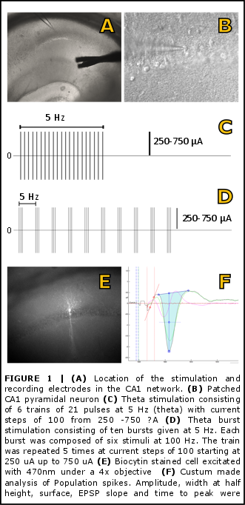

**RESULTS**

The aim of this study was to elucidate on the role of Ih plasticity in the CA1 network by studying the excitatory output evoked after Schaffer collateral stimulation. After Schaffer-Commissural pathway stimulation, several parameters of the field postsynaptic potential (field PSP) and population spike (PS) were measured. The field PSP results from current flowing into the postsynaptic cells in stratum radiatum. The population spike is the extra-cellular reflection of all action potentials of many (near- )synchronously firing pyramidal cells. Subsequently we made whole-cell voltage-clamp recordings of individual pyramidal cells in the same region.

**Theta Burst stimulation.** The mean evoked potential of an intensity was plotted for every time point. TBS was given two minutes after theta stimulation was initiated. To test whether TBS stimulation was sufficient to change population spike output the mean recorded potential was plotted for every time point. To test whether the observed changes in potentials were caused by TBS we repeated the protocol without the TBS stimulation after the first two theta stimulations (Fig 2.). The figures show the mean recording per 10 minute interval after stimulation with 21 pulses of 450 μA at 5 Hz. TBS shows an enhancement of the population spike which is directly measurable in the following theta stimulation. When TBS is no changes in population spike can be seen. When TBS is induced after the third theta stimulation the effects still occurs. To test whether the TBS also enhanced Ih, whole-cell patch recordings were used to measure the properties of the sag after hyperpolarizing voltage steps (Fig 2.). 15 minutes after the initial TBS an increase of x was observed in sag amplitude. Application of 20 μM of the HCN-channel blocker ZD7288 completely abolished the Ih-current (Fig3.).

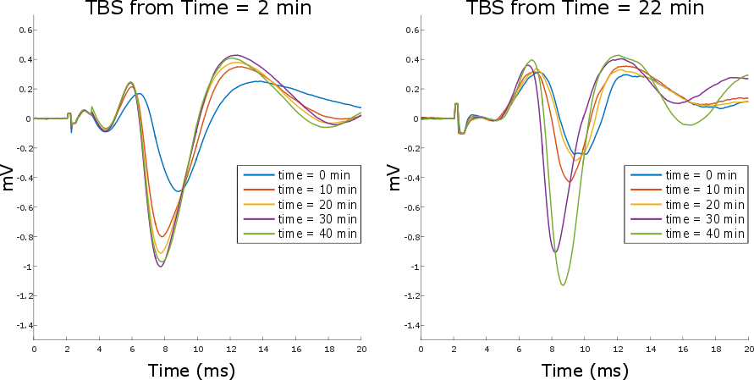

**FIGURE 2 | Theta Burst stimulation effect.** Every ten minutes a theta stimulus was given of 450 μA. The mean field potential for every time point is plotted. A TBS was given after every Theta stimulus in the left graph. In the Right a TBS was given after every theta stimulus after 20 min.

|  |  |  |
| --- | --- | --- |
| **Amplitude (pA)** | | |
|  | control | ZD7288 |
| 0 min | 275 | 134 |
| 20 min | 456 | 0 |
| 40 min | 366 |  |

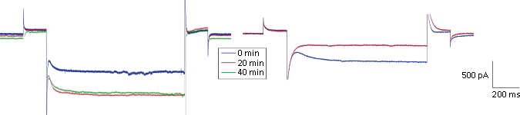 TBS stimulation ZD7288 wash in

**FIGURE 3 | Ih-current amplitude.** Ih was elicited by 800 ms-long hyperpolarizing voltage step from a holding potential of −40 mV to −140 mV. Current traces recorded before and after TBS stimulation, in the right figure 20 µM ZD7288 was washed in after the recording at 0 min.

**Theta stimulation.** To study the network output during a theta stimulus a recording pipet was placed in CA1 pyramidal stratum pyramidalis to measure local field potentials. Schaffer collateral stimulation produce an EPSP in the dendrites and, if sufficiently strong, an action potential in the soma. The Field potential in the dendrites corresponding to the EPSP is called the population EPSP (pEPSP) and the potential corresponding to the action potential is the population spike (PS) (Johnston & Wu, 1995). Rough data was analyzed and pEPSP slope, PS amplitude, PS width and the time between the stimulation and PS peak in amplitude were measured after each of the 21 stimulations given at a certain intensity every 10 minutes. Subsequently the data of these parameters were plotted and a correlation line was fitted over all point within a theta stimulation (Figure 4). The change in offset of each parameter is most likely caused by synaptic potentiation after TBS. Population spikes show a larger amplitude while the width at half max amplitude has decreased. This indicates that single units within the population spike are firing more synchronous with each other. A increase in pEPSP offset is also observed, confirming the potentiation after TBS, this is also likely to explain the decrease in PS peak time. The correlation coefficient shows that during the 21 pulses at theta stimulation the amplitude of the PS has a slightly positive direction in control condition both before and after potentiation. Adding 20 μM of the HCN channel blocker ZD7288 changes the amplitude to a negative direction during the stimulation. We also noted that the correlation coefficient of the PS width becomes more positive after ZD7288 application.

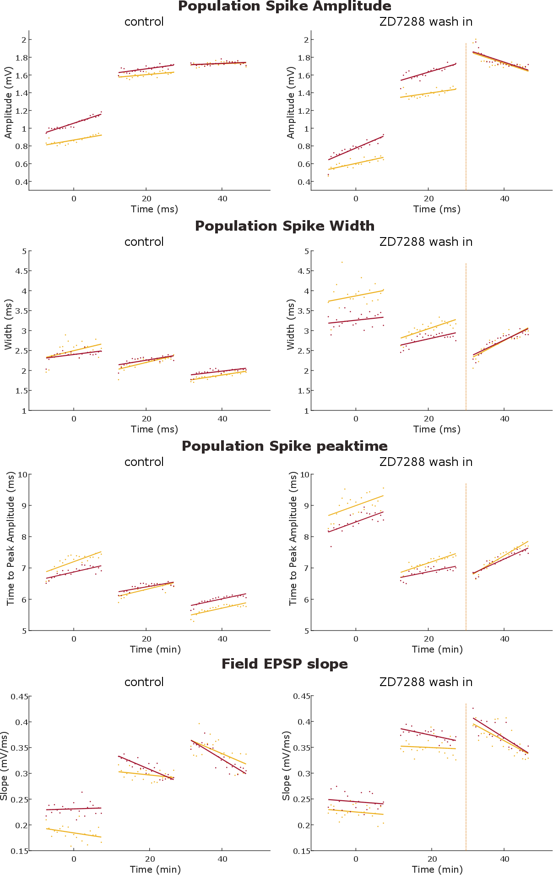 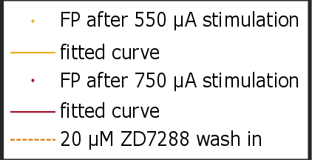

**FIGURE 4 | Population spike parameters**

|  |  |  |  |  |  |  |  |  |
| --- | --- | --- | --- | --- | --- | --- | --- | --- |
| Amplitude | | | | | | | | |
|  | 0 min | |  | 20 min | |  | 40 min | |
|  | control | ZD7288 |  | control | ZD7288 |  | control | ZD7288 |
| Slope |  |  |  |  |  |  |  |  |
| intensity 4 | -0,0012 | 0.0074 |  | 0,0158 | 0.0058 |  | 2,86E-04 | -0,0062 |
| intensity 6 | 0.0044 | 0,0115 |  | 0.0036 | 0.0114 |  | 0.0052 | -0,0079 |
| R |  |  |  |  |  |  |  |  |
| intensity 4 | -0,2014 | 0.7510 |  | 0,80583 | 0.6854 |  | 0,0667 | -0,5368 |
| intensity 6 | 0.6356 | 0.8130 |  | 0.2805 | 0.8114 |  | 0.7613 | -0,07472 |

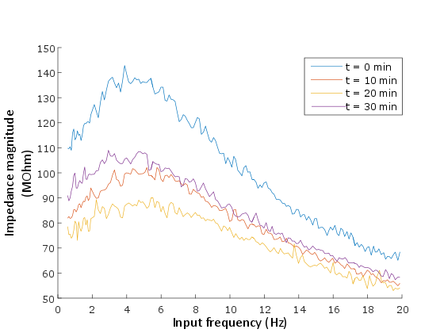**FIGURE 5 | IMPEDANCE PROFILE.** the magnitude of the impedance as a function of input frequency (0.5 – 20 Hz) measured at −70 mV in control conditions. Note that after theta burst stimulation the magnitude phase profiles changed substantially.

**DISCUSSION**

**REFERENCES**

Beck, H., & Yaari, Y. (2008). Plasticity of intrinsic neuronal properties in CNS disorders. *Nature Reviews. Neuroscience*, *9*(5), 357–69. http://doi.org/10.1038/nrn2371

Biel, M., Wahl-Schott, C., Michalakis, S., & Zong, X. (2009). Hyperpolarization-Activated Cation Channels: From Genes to Function, 847–885. http://doi.org/10.1152/physrev.00029.2008.

Brown, H. F., DiFrancesco, D., & Noble, S. J. (1979). How does adrenaline accelerate the heart? *Nature*. http://doi.org/10.1038/280235a0

Fan, Y., Fricker, D., Brager, D. H., Chen, X., Lu, H.-C., Chitwood, R. A., & Johnston, D. (2005). Activity-dependent decrease of excitability in rat hippocampal neurons through increases in Ih. *Nature Neuroscience*, *8*(11), 1542–1551. http://doi.org/10.1038/nn1568

Frick, A., Magee, J., & Johnston, D. (2004). LTP is accompanied by an enhanced local excitability of pyramidal neuron dendrites. *Nature Neuroscience*, *7*(2), 126–135. http://doi.org/10.1038/nn1178

G. Buzsáki. (2002). Theta Oscillations in the Hippocampus. *Neuron*, *33*, 325–340. http://doi.org/10.1016/S0896-6273(02)00586-X

Johnston, & Wu. (1995). *Foundations of cellular neurophysiology*. *Foundations of Cellular Neurophysiology*. http://doi.org/10.1097/00004691-199703000-00009

Lubenov, E. V, & Siapas, A. G. (2009). Hippocampal theta oscillations are travelling waves. *Nature*, *459*(7246), 534–539. http://doi.org/10.1038/nature08010

Magee, J. C. (1998). Dendritic Hyperpolarization-Activated Currents Modify the Integrative Properties of Hippocampal CA1 Pyramidal Neurons, *18*(19), 7613–7624.

Magee, J. C., & Johnston, D. (1997). A synaptically controlled, associative signal for Hebbian plasticity in hippocampal neurons. *Science (New York, N.Y.)*, *275*(5297), 209–213. http://doi.org/10.1126/science.275.5297.209

Mccormick, B. Y. D. A., & Papet, H. (1990). Properties of a hyperpolarization- activated cation current and its role in rhythmic oscillation in thalamic relay neurones., 291–318.

Moosmang, S., Biel, M., Hofmann, F., & Ludwig, A. (1999). Differential Distribution of Four Hyperpolarization-Activated Cation Channels in Mouse Brain, *380*(August), 975–980.

Noam, Y., Zha, Q., Phan, L., Wu, R.-L. L., Chetkovich, D. M., Wadman, W. J., & Baram, T. Z. (2010). Trafficking and surface expression of hyperpolarization-activated cyclic nucleotide-gated channels in hippocampal neurons. *The Journal of Biological Chemistry*, *285*(19), 14724–36. http://doi.org/10.1074/jbc.M109.070391

van Welie, I., van Hooft, J. a, & Wadman, W. J. (2004). Homeostatic scaling of neuronal excitability by synaptic modulation of somatic hyperpolarization-activated Ih channels. *Proceedings of the National Academy of Sciences of the United States of America*, *101*(14), 5123–5128.

Wierenga, C. J., & Wadman, W. J. (2003). Functional relation between interneuron input and population activity in the rat hippocampal cornu ammonis 1 area. *Neuroscience*, *118*(4), 1129–1139. http://doi.org/10.1016/S0306-4522(03)00060-5