* Approach:

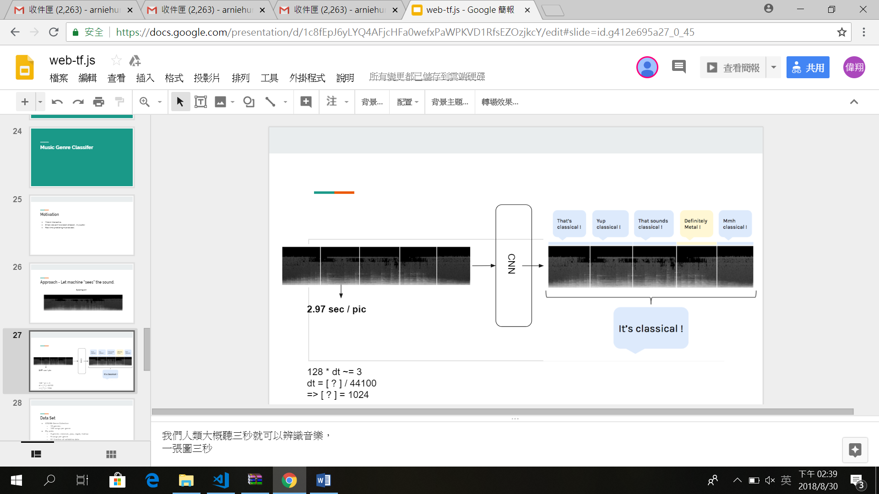

* Web audio:
  + Buffer source

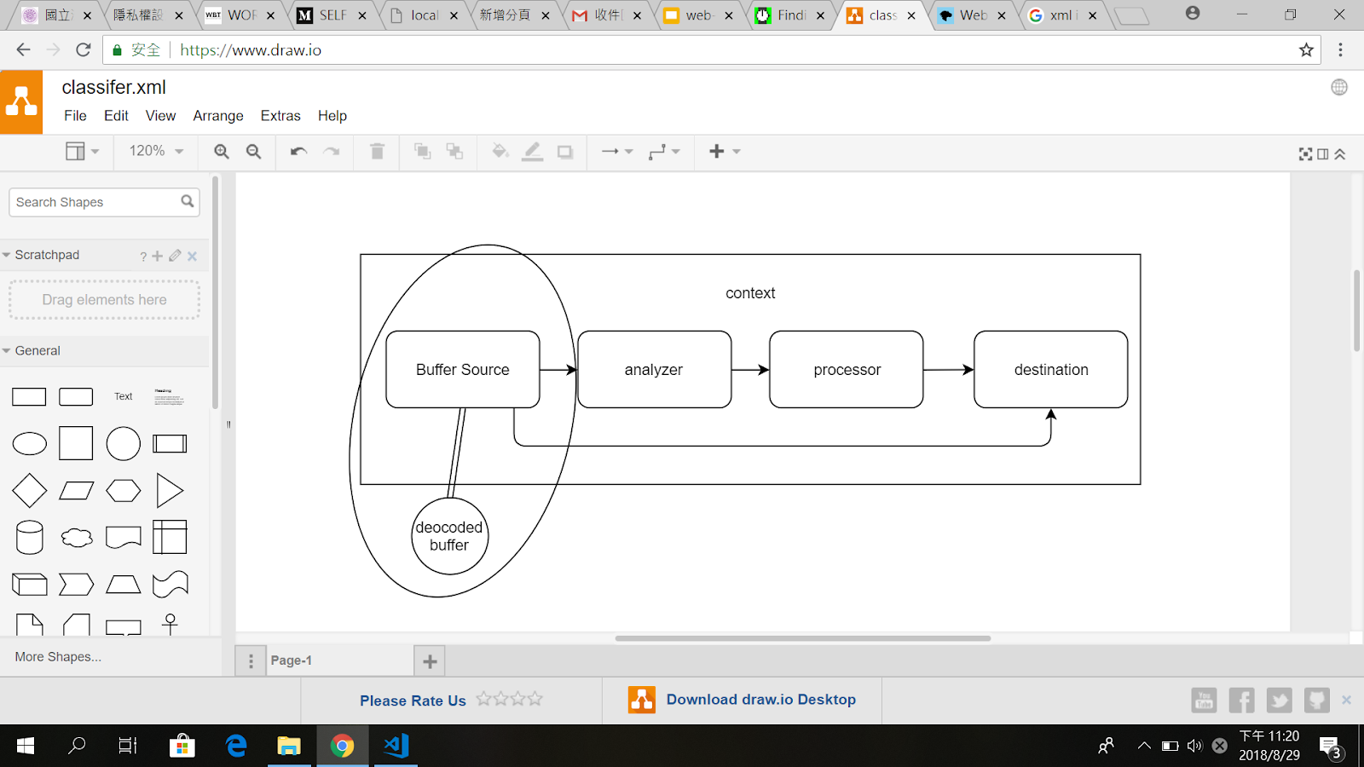

* + Stream

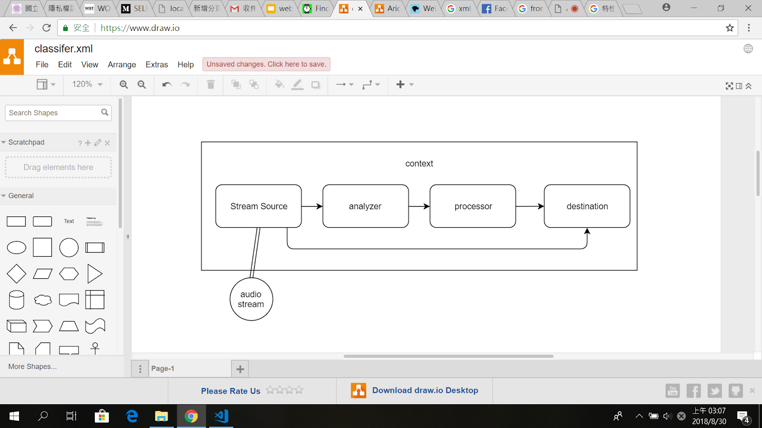

* Data set:
  + GTZAN Genre Collection
  + My picks
  + 4 genres: classical, jazz, ragae, hiphop
  + 9 songs per genre
  + 0.1 fraction of validating data
* Model
  + MobileNet v1 (128) conv_13_relu  + 256 unit FC(relu,  varianceScaling)

+  4 unit FC (varianceScaling, softmax)

* + Loss function:  Crossentropy
  + Hyper parameters: Learning rate: 0.00001, Batch size: 5, Epoch: 10
* Software Architecture

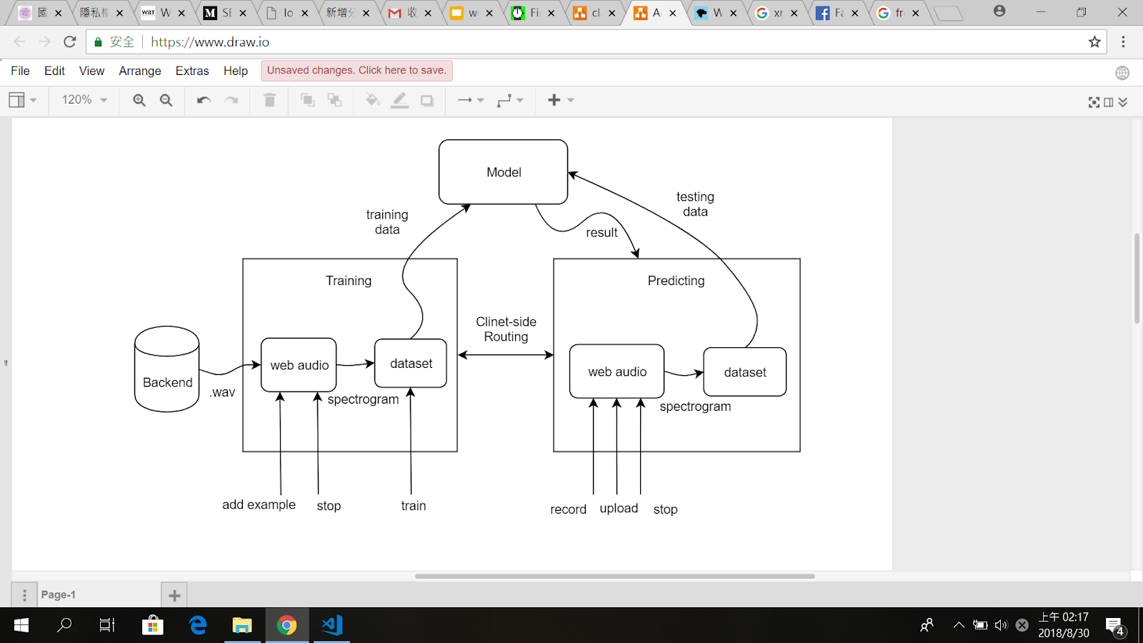

* References:

[1] Deep Image Features in Music Information Retrieval Grzegorz Gwardys an Daniel Grzywczak

[2] https://hackernoon.com/finding-the-genre-of-a-song-with-deep-learning-da8f59a61194