ABSTRACT

Breast cancer is the second most prevalent form of cancer worldwide. In this research paper we have proposed a computer aided predictive model based on supervised artificial neural network that can assist medical professionals in determination of breast cancer from results of fine needle aspirate (FNA) test on breast mass of patients. The proposed approach was evaluated on a dataset made available by the University of Wisconsin and our model achieved a significant predictive accuracy **97.54%** on the same.

INTRODUCTION

Breast cancer is the second most prevalent form of cancer worldwide. In 2018 alone, there were more than 2 million new cases of breast cancer reported worldwide (as per data from World Cancer Research Fund). One of the most critical test in determination of breast cancer in a patient is a fine needle aspirate (FNA) of the patient's breast mass. A hollow needle attached to a syringe is used to withdraw the required amount of tissue from the area of suspicion. Features are subsequently computed from a digitized image of the sample. These features describes various characteristics of the cell nuclei present in the image in a 3-dimensional space. In this research paper we have focused on developing a computer-aided model based on multi-layered artificial neural network that is capable of conducting analysis of the prior mentioned features and predict malignancy with high degree of accuracy. This will assist medical professionals and minimize decisional errors that can be critical to human life.

DATASET

The dataset used for this research was obtained from [UCI Machine Learning Repository](https://archive.ics.uci.edu/ml/datasets/Breast+Cancer+Wisconsin+%28Diagnostic%29). The dataset comprises of numerous parameters calculated from digitized image obtained after conducting fine needle aspirate (FNA) test on 569 patients. Each of the record in turn is labelled as either 'B' or 'M' standing for ‘Benign’ and ‘Malignant’ respectively.

LITERATURE REVIEW

A sizeable amount of research has been done till date on machine learning aided breast cancer detection and the associated literature consists of a number of astonishing works. **Guo, H. and Nandi, A.K.** (2006) in their paper had proposed a **Multilayer Perceptron (MLP)** model with retro propagation of error algorithm which attained an accuracy of **96.21%**. **Christobel, A. and Sivaprakasam, Y.** (2011) compared the performance several classification algorithms and was able to achieve **96.99%** predictive accuracy with the **SVM (Support Vector Machine)** model. **Karabatak, M. and Ince, M.C. 2009** developed a diagnosis system based on Neural Networks (NNs) and Association Rules (AR) which was able to achieve classification accuracy of **97.4%**. **Shahnaz, C., Hossain, J., Fattah, S.A., Ghosh, S. and Khan, A.I. 2017** was able to obtain an astonishing predictive accuracy of **98.06%** with their proposed Convolutional Neural Network model. **In our research, we were able to attain a median accuracy of 97.54%** (on a training and test split of 50% each) **with a neural network featured with adaptive learning capabilities.**

DATA ANALYSIS

We found that there are 357 records with an outcome of ‘B’ (stands for ‘Benign’) whereas 212 records have ‘M’ (stands for ‘Malignant’) as outcome.

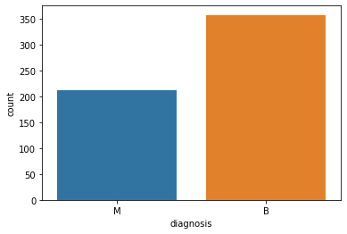

Figure 1 : Distribution of output class

Thus, the distribution of the output data are slightly skewed in favour of ‘’Benign outcomes.

We subsequently analysed the distribution of the mean of each independent variable in the dataset and it was clear that there were a couple of features that has much higher range of values compared to the others.

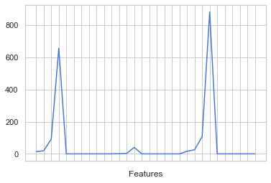

Figure 2 : Mean of individual features

This necessitated a statistical normalization to be conducted on the set of independent variables.

$$X_{normalized}=\frac{\left(X- X_{minimum}\right)}{\left(X_{maximum}- X_{minimum}\right)}$$

Equation 1 : Statistical Normalization

For which we used **min-max normalization** technique as our preferred method.

FEATURE SELECTION

**Principle Component Analysis** : After the normalization of the independent features was completed, we conducted a principle component analysis (PCA) on the feature set to understand the variance explained by each of them.

The test was conducted with increasing test set concentration (starting from 10% to 50% with a step of 5% in between) and in every single instance we found that around 99% of the variance in the data was explained by 15 of the 30 features in feature set.

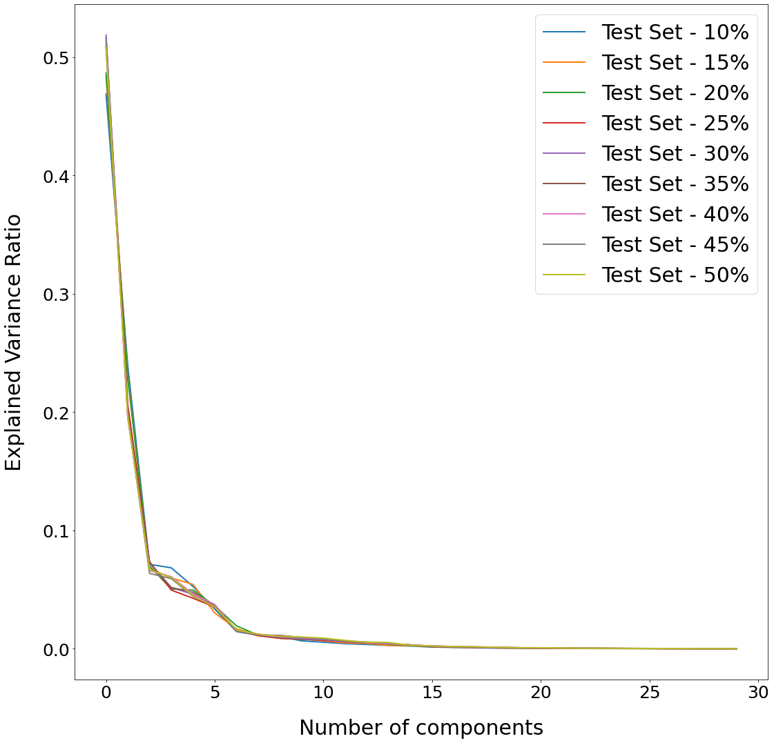

Figure 3 : Result of Principle Component Analysis

Despite the observation we made in our PCA test, we decided to execute an analysis of variance (ANOVA) test on the feature set.

This decision was taken as the principle component analysis test only measures the extent of variance explained by the independent variables. It however does not consider the interaction between the independent variables and the output variable.

|  |  |  |
| --- | --- | --- |
|  |  |  |
|  |  |  |
|  |  |  |

Figure 4 : Result of ANOVA F-Statistics Test

We conducted this test with increasing test set concentration (starting from 10% to 50% with a step of 5% in between) as well.

We observed that the ANOVA F-Statistics test concluded around 25 of the 30 features to be useful. Though the extent of their usefulness was largely different as made clear by the range of scores obtained by the different variables.

As the main idea behind our feature selection process was to identify the features that had almost negligible impact on the outcome, the result we obtained from the ANOVA F-Statistics Test made it possible. Hence, we decided to eliminate the 5 independent variables from the dataset and use the remaining 25 for our models in the subsequent section.

**MODELS :**

In this section, we have first performed a comparative analysis of the prediction accuracy achieved on the Wisconsin Breast Cancer Diagnosis dataset by the various classification models. Followed by that we introduced a deep learning model and recorded the prediction accuracy it achieved on the same dataset.

**Model Training** : In our study, each model was first trained on a portion of the entire dataset. Then, we used the remaining portion of the dataset as the holdout set on which the predictive accuracy of the model was measured.

The portion of the dataset on which the models were trained was steadily decreased in each case from an initial value of 90% of the dataset (meaning the holdout set contained the remaining 10% of the data) to a minimum of 50% (meaning the remaining 50% was used for the holdout set) and the decrement followed a step of 5% in between.

In the case of the deep learning models, in addition to the procedure described above, we also tested them with decreasing batch sizes. Starting with a maximum value of 32 and subsequently decreasing it to a minimum of 1.

In addition, as deep learning models can sometimes be susceptible to volatile performances and can yield varying predictive accuracies (even with the same set of circumstances), we thus recorded the median accuracy obtained by these models over 100 separate iterations in each scenario outlined above.

**Classification Models** : The classification models we used for this analysis are Naïve Bayes (NB), Logistic Regression (LR), K-Nearest Neighbors (KNN), Support Vector Machine (SVM) and Random Forest (RF). We used the default set hyperparameters for each of these models.

We also created an ensemble model (denoted by EN) consisting of the classification models mentioned above and recorded the prediction accuracy obtained by it.

|  |  |  |  |  |  |  |  |
| --- | --- | --- | --- | --- | --- | --- | --- |
| Train | Test | NB | LR | KNN | SVM | RF | EN |
| 90% | 10% | 89.47% | 98.25% | 96.49% | 100.00% | 94.74% | 98.25% |
| 85% | 15% | 91.86% | 97.67% | 97.67% | 100.00% | 96.51% | 98.84% |
| 80% | 20% | 91.23% | 96.49% | 97.37% | 97.37% | 96.49% | 96.49% |
| 75% | 25% | 91.61% | 96.50% | 95.80% | 96.50% | 96.50% | 95.80% |
| 70% | 30% | 90.64% | 95.32% | 96.49% | 97.66% | 97.66% | 96.49% |
| 65% | 35% | 91.00% | 95.00% | 96.50% | 97.50% | 95.50% | 97.00% |
| 60% | 40% | 91.23% | 94.30% | 96.05% | 96.93% | 94.30% | 96.93% |
| 55% | 45% | 92.22% | 94.16% | 95.33% | 96.50% | 94.16% | 97.28% |
| 50% | 50% | 93.33% | 95.09% | 95.79% | 97.19% | 95.09% | 96.84% |

Table : Comparative Analysis of Classification Models

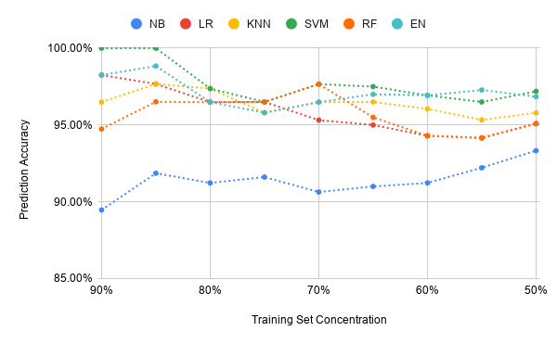

Figure 5 : Predictive Accuracy vs Training Set Concentration

We observed that the SVM model consistently outperformed all the other classification models. Eventually delivering a 97.19% predictive accuracy for the most extreme test condition (50% training and test set split). This observation was in line to the one made by **Christobel, A. and Sivaprakasam, Y.** (2011).

**Deep Learning Models** : In our analysis of deep learning models, we first tested the neural network model we developed with a couple of well-known optimizers (**RMSProp** and **Adam** respectively) from the Keras library. In both cases, we used the hyper-parameters enlisted in Table - 2.

|  |  |  |
| --- | --- | --- |
| Parameter | Description | |
| Kernel Initializer | Uniform | |
| Loss | Binary Crossentropy | |
| Activation Functions | 1st Hidden Layer | ReLU |
| Output Layer | Sigmoid |

Table : List of Hyper-parameters

In Table – 3 and 4, we recorded the predictive accuracy obtained by the models described above. Whereas in Table – 6 and 7, the number of epochs needed for the model to converge is recorded.

|  |  |  |  |  |  |  |  |
| --- | --- | --- | --- | --- | --- | --- | --- |
| Train | Test | BS = 32 | BS = 16 | BS = 8 | BS = 4 | BS = 2 | BS = 1 |
| 90% | 10% | 100.00% | 100.00% | 100.00% | 100.00% | 100.00% | 100.00% |
| 85% | 15% | 100.00% | 100.00% | 100.00% | 100.00% | 100.00% | 99.42% |
| 80% | 20% | 97.37% | 97.37% | 97.37% | 97.37% | 97.37% | 97.37% |
| 75% | 25% | 97.20% | 97.20% | 97.20% | 97.20% | 97.90% | 97.90% |
| 70% | 30% | 97.08% | 97.08% | 97.08% | 97.08% | 96.49% | 97.08% |
| 65% | 35% | 97.50% | 97.50% | 97.50% | 97.50% | 97.50% | 97.50% |
| 60% | 40% | 97.81% | 97.81% | 97.81% | 97.81% | 97.37% | 96.93% |
| 55% | 45% | 97.67% | 97.67% | 97.67% | 97.67% | 97.28% | 96.89% |
| 50% | 50% | 97.19% | 97.19% | 97.19% | 97.19% | 96.84% | 96.49% |

Table : Median Accuracy with RMSProp Optimizer

|  |  |  |  |  |  |  |  |
| --- | --- | --- | --- | --- | --- | --- | --- |
| Train | Test | BS = 32 | BS = 16 | BS = 8 | BS = 4 | BS = 2 | BS = 1 |
| 90% | 10% | 100.00% | 100.00% | 100.00% | 100.00% | 100.00% | 100.00% |
| 85% | 15% | 100.00% | 100.00% | 100.00% | 100.00% | 100.00% | 100.00% |
| 80% | 20% | 97.37% | 97.37% | 97.37% | 97.37% | 97.37% | 97.37% |
| 75% | 25% | 97.20% | 97.20% | 97.20% | 97.20% | 97.20% | 97.20% |
| 70% | 30% | 97.08% | 97.08% | 97.08% | 97.08% | 97.08% | 97.08% |
| 65% | 35% | 97.50% | 97.50% | 97.50% | 97.50% | 98.00% | 98.00% |
| 60% | 40% | 97.81% | 97.81% | 97.81% | 97.81% | 98.25% | 97.81% |
| 55% | 45% | 97.67% | 97.67% | 97.67% | 97.67% | 97.28% | 97.28% |
| 50% | 50% | 97.19% | 97.19% | 97.19% | 97.19% | 97.19% | 96.84% |

Table : Median Accuracy with Adam Optimizer

|  |  |  |  |  |  |  |  |
| --- | --- | --- | --- | --- | --- | --- | --- |
| Train | Test | BS = 32 | BS = 16 | BS = 8 | BS = 4 | BS = 2 | BS = 1 |
| 90% | 10% | 160 | 125 | 102 | 92 | 81 | 80 |
| 85% | 15% | 172 | 134 | 110 | 99 | 91 | 83 |
| 80% | 20% | 154 | 108 | 80 | 64 | 52 | 43 |
| 75% | 25% | 131 | 92 | 70 | 56 | 48 | 43 |
| 70% | 30% | 180 | 127 | 96 | 77 | 64 | 55 |
| 65% | 35% | 220 | 164 | 121 | 98 | 86 | 71 |
| 60% | 40% | 258 | 189 | 143 | 113 | 94 | 73 |
| 55% | 45% | 282 | 203 | 151 | 121 | 100 | 71 |
| 50% | 50% | 270 | 211 | 164 | 132 | 95 | 67 |

Table : Median Epoch Count with RMSProp Optimizer

|  |  |  |  |  |  |  |  |
| --- | --- | --- | --- | --- | --- | --- | --- |
| Train | Test | BS = 32 | BS = 16 | BS = 8 | BS = 4 | BS = 2 | BS = 1 |
| 90% | 10% | 124 | 105 | 87 | 82 | 74 | 76 |
| 85% | 15% | 120 | 111 | 90 | 83 | 78 | 75 |
| 80% | 20% | 102 | 81 | 67 | 56 | 47 | 39 |
| 75% | 25% | 76 | 60 | 49 | 42 | 37 | 32 |
| 70% | 30% | 118 | 93 | 75 | 61 | 52 | 45 |
| 65% | 35% | 145 | 140 | 94 | 77 | 61 | 53 |
| 60% | 40% | 178 | 142 | 112 | 91 | 72 | 61 |
| 55% | 45% | 190 | 151 | 119 | 98 | 81 | 65 |
| 50% | 50% | 185 | 149 | 124 | 108 | 86 | 72 |

Table : Median Epoch Count with Adam Optimizer

**Step Decay Model** : We have developed a model, which starts its training process with a relatively high learning rate of 0.1 and then as the training progresses, the learning rate continues to attenuate in a step-wise manner. Becoming half after every 10 epochs.

The benefit of this approach is that the model can learn the optimal weights relatively early in its training process as it is capable of making comparatively larger adjustments to them. Then in the later phases, it will only be fine-tuning the weights (by making smaller adjustments) till no more optimization can be done.

The model we have developed uses the same set of hyper-parameters described in Table - 2. However, the optimizer it uses is Stochastic Gradient Descent (SGD).

In Table – 7 we have recorded the median predictive accuracies obtained by the model in different scenarios. Whereas, in Table – 8 the median number of epochs needed by the model to converge is recorded.

|  |  |  |  |  |  |  |  |
| --- | --- | --- | --- | --- | --- | --- | --- |
| Train | Test | BS = 32 | BS = 16 | BS = 8 | BS = 4 | BS = 2 | BS = 1 |
| 90% | 10% | 94.74% | 98.25% | 100.00% | 100.00% | 100.00% | 100.00% |
| 85% | 15% | 95.35% | 97.67% | 100.00% | 100.00% | 100.00% | 100.00% |
| 80% | 20% | 94.74% | 96.49% | 96.49% | 96.49% | 97.37% | 97.37% |
| 75% | 25% | 94.41% | 96.50% | 97.20% | 97.20% | 97.20% | 96.50% |
| 70% | 30% | 92.98% | 94.15% | 97.08% | 97.66% | 97.66% | 97.66% |
| 65% | 35% | 92.50% | 93.50% | 96.50% | 97.00% | 98.00% | 98.00% |
| 60% | 40% | 92.54% | 92.54% | 95.61% | 97.37% | 97.81% | 97.81% |
| 55% | 45% | 93.00% | 93.00% | 94.94% | 96.50% | 97.67% | 97.67% |
| 50% | 50% | 94.04% | 93.33% | 95.44% | 96.84% | 97.19% | 97.54% |

Table : Step Decay Model

|  |  |  |  |  |  |  |  |
| --- | --- | --- | --- | --- | --- | --- | --- |
| Train | Test | BS = 32 | BS = 16 | BS = 8 | BS = 4 | BS = 2 | BS = 1 |
| 90% | 10% | 203 | 209 | 179 | 47 | 41 | 39 |
| 85% | 15% | 205 | 211 | 179 | 49 | 44 | 44 |
| 80% | 20% | 203 | 208 | 189 | 169 | 36 | 27 |
| 75% | 25% | 205 | 200 | 154 | 52 | 27 | 22 |
| 70% | 30% | 206 | 203 | 180 | 59 | 35 | 26 |
| 65% | 35% | 206 | 208 | 192 | 170 | 65 | 31 |
| 60% | 40% | 208 | 209 | 215 | 220 | 180 | 50 |
| 55% | 45% | 208 | 208 | 215 | 224 | 228 | 68 |
| 50% | 50% | 209 | 206 | 198 | 178 | 66 | 57 |

Table : Epoch Count Step Decay Model

|  |  |
| --- | --- |
| **C:\Users\Arnab\Downloads\chart.png** | **C:\Users\Arnab\Downloads\chart (1).png** |

Figure : Comparison of Predictive Accuracy and Epochs

As we can see, our model was able to achieve a median accuracy of **97.54%** for the most extreme test condition (50% training and test set split). Further bettering the predictive accuracy of **97.19%** achieved by SVM and the other two Deep Learning models in our study.

**CONCLUSION**

In this study, we aimed to build an efficient predictive model capable of diagnosing breast cancer with a high degree of accuracy and in the process contribute to the noble research work that is being conducted worldwide to combat this fatal disease.

In our analysis with the Wisconsin Breast Cancer Diagnosis dataset, we found deep learning methodologies to be very effective in achieving the goal.

However, we observed that the time taken by the deep learning models to converge was significantly greater in comparison to the classification models. Furthermore, with decreasing batch size the convergence time taken by a model tended to increase for the same training set concentration.

While this additional time cost incurred often resulted in greater predictive accuracy, in a real-life scenario, however, this can turn out to be a trade-off, especially if time is in limited availability. Thus, we believe that there is scope for future improvement in this area with the development of even more efficient predictive models.

**ACKNOWLEDGMENT**

I would like to dedicate this work to my father, who left us too soon at the age of 54 owing to pancreatic cancer. He would have to see me complete this work had he been alive today.