Cabs Online Taxi booking system

By Nikkolas Diehl - 16945724

List of all items in the system:

Note – To follow the submission requirements, the assign2 file on cmslamp14 is filled with non-sub directory files. Each are linked to each other with no sub-directory taken into account. However, to keep my sanity and to make it look really nice, my zip submission folder uses sub-directories and file linking inside my code is slightly different to work as such.

Files:

* Config
  + Database_config_inc.php
    - File is php and contains the log in and database details for the MySQL database – 8 lines
* Images
  + TitlePage.png
  + TitlePage2.png
    - Two different title pages. For ease of marking and use, the code actually links to an online version but I attached the raw images just in case
* Javascript
  + adminFunctions.js
    - JavaScript file that controls most of the functions on the admin page. Also contains the XHR function – 96 lines
  + bookingFunctions.js
    - JavaScript file that controls most of the functions on the booking page. Also contains the XHR function – 44 lines
  + createTable.js
    - JavaScript file that generates the HTML output for all the unassigned bookings. The function is run from the adminFunctions.js file – 65 lines
  + dateFunction.js
    - JavaScript file used to generate the HTML output for the current date and time for both the admin and booking page – 33 lines
  + googleLocation.js
    - JavaScript file used to initiate and link to google API and run the auto complete input bars in the booking page – 9 lines
  + scaling.js
    - JavaScript file used to control the scaling of the admin page for mobile and computer scaling – 16 lines
  + validator.js
    - JavaScript file used to validate and control the inputs on the booking and admin pages. Run from both the booking and admin pages. – 166 lines
  + Xhr.js
    - JavaScript file used to set up an XHR request – 11 lines
* phpFiles
  + actionAssign.php
    - php file used to control the assigning of a booking number. Run from adminProcess.php – 37 lines
  + actionView.php
    - php file used to control the viewing of all the unassigned bookings. Run from adminProcess.php – 46 lines
  + adminProcess.php
    - php file used to control most of the functionality of the admin page and data – 88 lines
  + bookingProcess.php
    - php file used to control most of the functionality of the booking page and data – 83 lines
  + toXml.php
    - php file used to control the output and conversion of the SQL output into an xml object. Functions are called from the adminProcess.php – 74 lines
* admin.html
  + admin page for assigning bookings and showing all bookings
* booking.html
  + booking page for inputting a new booking

Instructions:

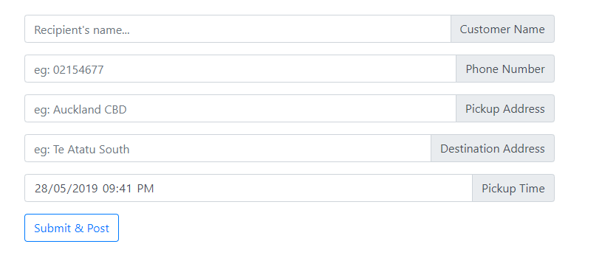

On the booking page you will see 5 inputs and a button.

* The customer name input must use conventional naming format with letters dashes and spaces allowed.
* The Phone number MUST begin with a 0 and then anywhere from 8-12 numbers making up a total of a 9-13-digit long phone number
* The pickup address is allowed any input to a certain extent due to an address being able to contain many different characters.
* The same for the destination address
* The pickup time MUST be at least 1 minute forward in time from the current time and cannot be older than the current time. It also must follow the date time convention of day/month/year hour:minute. The pick up time field is also automatically set to the exact current time on loading of the page

The page will warn you of any issues that it has with your inputs and will not let you continue if you don’t correct your mistakes. Once you have everything inputted correctly, click the submit & post button and the page will give you feedback on your inputs and tell you that it has saved the booking.

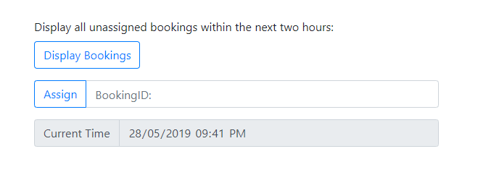

On the admin page you will see 2 buttons, a text field and a current time box to let you know what the time is.

* The display bookings button, when clicked will; on the right side of the page; display all currently unassigned bookings within the next 2 hours. If no unassigned bookings within the next two hours are found it will notify you and not display anything.
* The assign button; when clicked will grab whatever booking number you put into the booking ID field and try and assign that to you. If the booking ID is incorrectly formatted like a letter, it will fail and notify you with an error bellow the buttons. If the booking ID does not exist in the database then it will also fail and let you know what you did wrong bellow the buttons.
* If you correctly put in an existing and unassigned booking ID, a message will pop up bellow the buttons letting you know that it has assigned the booking ID to you and that the table on the right side will reload (or display if not already loaded in which case it will either display the table or if there are no more unassigned bookings within the next 2 hours and you assigned the last one, it will let you know that no more bookings are ready to be assigned at the current moment.)

I; Nikkolas James Diehl; hereby declare that this assignment is my own individual work. I have not worked collaboratively nor have I copied from any other student's work or from any other source. This entire web development assignment was built and written by me; Nikkolas James Diehl - 16945724