XHTML & Web Design
Report Workbook


Assignment Assessment Overview

Each Group should complete the following in relation to the Group work process and submit as part of your project.

Group Report and Logbook | 20%
Online Logbook – There should be at least one progress-report entry posted each week by each Group | 3%
Template 1 – Roles & Responsibilities | See below
Template 2 – Understanding the Problem | 1%
Template 3 – Exploring Ideas | 2%
Template 4 – Group Action Plan | 2%
Template 5 – Individual Action Plan | 3%
Template 6 – Individual Reflection | 3%
Template 7 – Bibliography | 1%
Template 8 – Peer Review | 5%

Template 1 Roles & Responsibilities

Roles & Responsabilities


In order for the group to work effectively it is necessary for members to take responsibility for specific tasks. Assign a group member to each of the roles. If a group member is not performing their role this must be managed within the group. If this cannot be addressed within the group please contact one of your Project lecturers as soon as possible.

Role | Responsibility | Team Member
Chairperson | Ensures each member remains on task and ensures that all members have a voice | Mark Murphy
Time Keeper | Ensures that all tasks are completed on schedule and that meeting time is used appropriately | Barry mc Gettigan
Record Keeper | Ensures that all ideas are documented and templates are completed | Arnis Lupiks

Template 2 Understanding the Problem


INTERPRET THE PROBLEM

Using the headings below, discuss the details of the assignment amongst group members and fill out the template.

- Define the problem. What are you being asked to do? Have you finalised on your subject area for your website?

The group is tasked with creating a fully functional and validated Web-Site. The Web-Site should have at least 6 pages of XHTML, styles controlled by at least one CSS and we should show an example of some JavaScript. We are expected to work efficiently as a team, by delegating different tasks to each member of the group. We are also expected to track our progress by filling out an online Log-Book, with weekly entries that will monitor the progress of our Web-Page. In addition to the Log-Book we are also asked to fill out a project Workbook.

The subject of our Web-Site will be entertainment. Each member of the team will be responsible for creating a page that they have a personal interest in, whether it be in Music, Sport or Technology. We also have a home page that will contain news headlines, the weather and the latest Sports results. This page will be the navigation page that will have links to the Music page, the Sports page and the Technology pages. The home page may change toward the end, depending on how our project takes shape.

- List the different XHTML concepts & Web design considerations that will need to be understood in order to complete this assignment.

- The group will need to understand how links work as we are planning on using videos and pictures to add to the appearance of our Web-Site.

- We will need to understand the basics in how to layout and structure our Web Pages. CSS and tables will help us to do this correctly.

- In order for our Web-Pages to efficiently run on all browsers we will need to be able to validate our web-site.

- We will need to have a basic understanding of CSS. CSS will help us style our web-pages so that they all have a similar look and feel. It will also save us time as we won`t have to keep re-typing different tags.

- We will need to understand the concepts of Java-Script. Java-Script will give our web-pages a very professional look and feel.

- What approach will be taken to implement the website e.g. CSS/tables? Explain your reasons for decisions taken.

- The group plans to implement CSS styling into our Web-Site so that each page has a similar look to it. Once this is done, each member will add their own variations to their page that they are responsible for.

- The group also plans to create a form, so that visitors can subscribe to our Web-Site if they want to. The group plans to create the form inside a table, this will help align all the different fields contained in our form.

- Possibly for the music section of our site, we might use tables to display the top ten artists in the charts and for sports, we will maybe use tables to show the top teams in the premier league.

- We will also use tables to help space out our content in our pages.

Project requirements

List the requirements that you have for your website
- What is the overall goal of your website?

  - We plan for our web-site to be fun and entertaining, with plenty of pictures and videos. We also hope to provide updated information on music, sports and movie reviews.

  - We hope to be able to add some java into some of our pages. We hope to display a rotating image function on the sidebars of our site.

  - We plan on asking the user if they would like to sub-scribe to our web-site, if they say yes then they will be linked to a form that they will have to fill in.

  - We want our web-site to look as good as possible so we will spend plenty of time discussing what colour’s we will use and testing out different lay-outs and structures. Hopefully the web-page will look as good as something you would find on-line.

- What are the functional requirements for your site? What will the site do?

- The site will give the latest information on different forms of entertainment. For example, on the music page we will display what are the top selling singles and albums in the charts that week.

- For the sports section we will show all the latest stories and ask the users their opinions with the popular stories

- We want to use some java-script to display something like DVD latest releases in the sidebar. We will use a rotating image function that will show the different covers of films. If you click on this you will link to a site where you can purchase the items.

- We want the user to be able to subscribe to our site also.

- The movies page will have a video review of the film that we are covering.

- The music page will display a video of the band that we are discussing.

- What are the non-functional requirements of your site? Do you have a preference for the look and feel of the site?

- We want the site to have the same look and feel as any other entertainment site you will find on-line. Each page will have an individual header relating to the page in question. For Example: The sports page header will probably display images of the latest sports stars and the technology page will display images of I-pads and i-pods.

- We hope to be able to display links to other web-sites that are similar to ours. In our site we will be reviewing a movie so we will probably have links that will lead the user to a different site that has an interview with the film`s stars.

- What other requirements do you want to achieve in your site?

We want the visitor to enjoy their time on the site and to check out all the pages we have. We are required as designers to make the pages interesting and not boring to look at. Videos and pictures will be a good way of doing this.

Template 3 Exploring Ideas

Exploring ideas – What will the user interface look like?


Discuss possible designs for your website. Once the group decides on a design use Microsoft Word or a Balsamique Mockup to demonstrate the chosen design and layout of website.

Exploring ideas – What will the user interface look like?

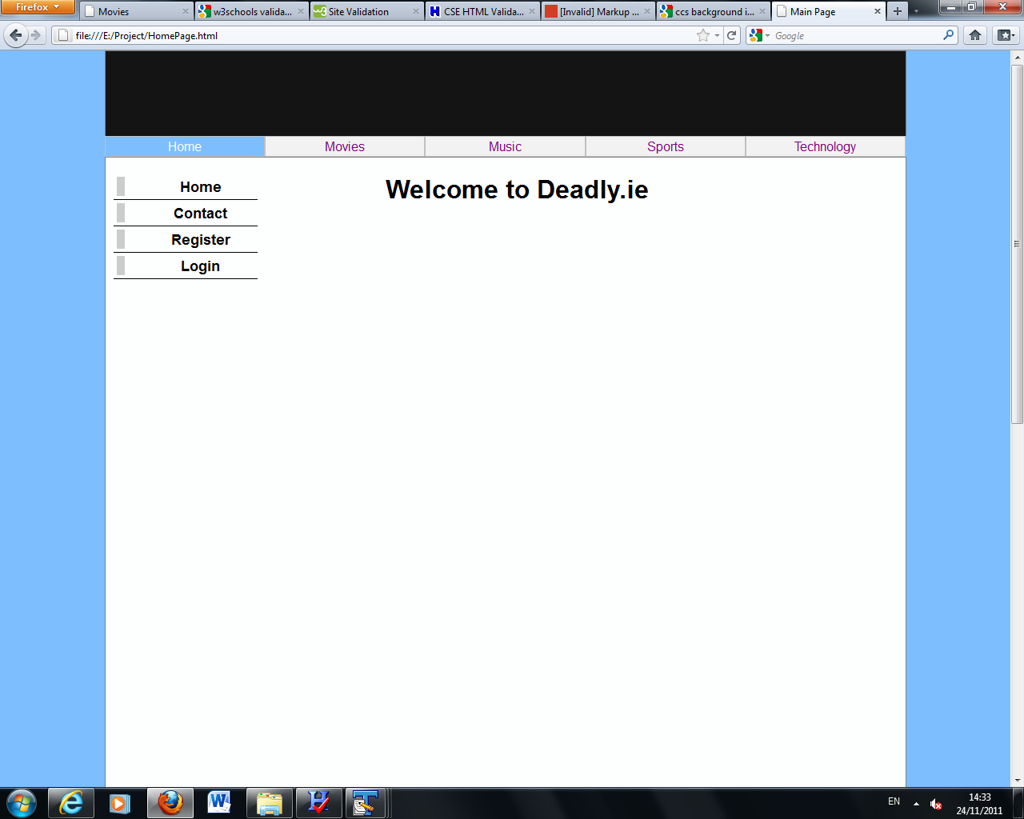
Template 4 Group Action Plan

Group Action Plan
List the tasks your group needs to complete
Assign tasks to each group member and agree on appropriate timelines

Action Plan:
No. | Action | Responsibility | Completed
1 | Arnis is responsible for completing the technology page for our site. | Arnis Lupiks | 17/11/2011
2 | Barry is responsible for completing the Music page for our site. | Barry mc Gettigan | 19/11/2011
3 | Mark is responsible for completing the Sports page for our site. | Mark Murphy | 20/11/2011
4 | Barry is to find a way to implement some Java-Script onto our site and what it is going to do. | Barry mc Gettigan | 20/11/2011
5 | Arnis is responsible for The CSS styling of our Site. He will feedback information to the group when he thinks he has a suitable style and layout. | Arnis Lupiks | 15/11/2011
6 | Barry is responsible for doing a movie review on the film Tower Heist. | Barry mc Gettigan | 21/11/2011
7 | Arnis is in charge of creating the home page and the navigation features of the sit. | Arnis Lupiks | 20/11/2011
8 | Arnis is responsible for filling out the work-book. | Arnis Lupiks | 24/11/2011
9 | Mark is responsible for researching interesting colours and fonts for the site. | Mark Murphy | 18/11/2011
10 | Barry is responsible for completing the weekly Forum. | Barry mc Gettigan | 24/11/2011

Template 5 Individual Action Plan
Group member 1 should fill in this page


Individual Action Plan
Based on the task(s) assigned to you – record and synopsise your findings under the headings below.
Student Details: Student Name: Mark Murphy Student Number: X11558997

- What task(s) have you been assigned?
I was given the roll to design a webpage based on different sports. I covered the areas of contact sports, non-contact sports and individual sports

- What information did you find out from your research?
I found out that there seems to be a lot more non-contact sports than contact but contact sports are much more popular.

- Explain how this information may be useful in the development of the website.
Maybe you could write more about contact sports because people would be more interested in it rather than noncontact sports.

- What are you going to feedback to the group?
I will feedback a lot of information on sports. The other webpages consist of music and electronics so sports would be different in an interesting way.

- Reference the information you have found.
http://www.google.ie/
http://www.google.ie/imghp?hl=en&tab=wi
http://www.wikipedia.org/
Displayed above are some of the most straight forward websites I could think of to collect information for my webpage. I got all my images from Google Images and most of the information from Wikipedia.
Individual Action Plan
Group Member 2 should fill in this page

Individual Action Plan
Based on the task(s) assigned to you – record and synopsise your findings under the headings below.
Student Details: Barry mc Gettigan Student Number: x11103701

- What task(s) have you been assigned?
- I have been tasked with creating a music page. I hope to be able to give up to date information in the music that interests me. Hopefully I will be able to display some of my favourite albums as a suggestion for the user to buy.
- I`m also required to do a movie review on a film that I have recently seen. I am going to display a video review of that particular film. I also plan to create links to different sites to have interviews with the film’s stars.
- I have been tasked with creating a CSS Style sheet for my pages. This will give us an idea of how the rest of our site will look.
- I am responsible for implementing some Java-Script into our site. I hope to put Rotating images of some of my favourite films in the side-bar of my movie page and also to put Rotating images of some of my favourite cd`s in my music page.

- What information did you find out from your research?
I found out how to lay-out a web page professionally, using CSS. I basically had a header, a menu bar, a content section and a side-bar. I had to learn how to space out the margins, so that everything fitted correctly. After I had the structure of the page set-up, it was just up to me to add my content and make sure that fitted in well. I had pictures and text beside one another; it was very cramped together so using the style and table tags, I was able to make it more spacious and easier on the eye to look at.
I also found out that by using Java-Script I could add a very professional look to my pages. Using a Rotating images function I was able to display some of my favourite album covers in the side-bar menu.

- Explain how this information may be useful in the development of the website.
Without using CSS we would have had to re-type different tags over and over again. CSS helped lay out our pages so they all had a similar look to each other. By using the table and style tags my content was a lot easier for the user to read. Once this was done the web-pages really started to take shape and gave us the confidence to try different things to add a bit style to the pages.

- What are you going to feedback to the group?
I will basically show the group the first draft of my web-pages and discuss the different plans that I have in the future for them. I will suggest to each member to use Java-Script on each page. I felt the style and table tags helped make my content look really well so I will advise my teammates to use these tags in their pages.

- Reference the information you have found.
- I found lots of information on CSS and Tables by visiting the site: http://www.w3schools.com/.
- “Mastering the Internet, xhtml and javascript 2nd edition” by Ibrahim Zeid.
- I watched the following video on YouTube: http://www.youtube.com/watch?v=fGP7CjWnVww&feature=channel_video_title
- I found information on Java-Script by visiting the site: http://www.dummies.com/how-to/content/javascript-and-html.html

Individual Action Plan
Group Member 3 should fill in this page

Individual Action Plan
Based on the task(s) assigned to you – record and synopsise your findings under the headings below.
Student Details: Student Name Arnis Lupiks Student Number: x11103621
- What task(s) have you been assigned?
- I have been assigned to make Technology site
- Main page of the project
- Design of the Main page and other pages
- Compail all pages in one HTML
- What information did you find out from your research?
In a begining it was challengin, but with better research I understand how CSS class works and with it help is much esear to complete variable tasks in HTML.

- Explain how this information may be useful in the development of the website.
The CSS class is very usefull for developing a web pages. Without CSS it would be more complecated, more writing and retyping differet tags. As I had made a Main page it become more esear to develope other link pages.

- What are you going to feedback to the group?
At the begining i will draw the scrach of the main web page how it will look. I will explain my ideas how CSS class could help us build esear way a Web page.
- Reference the information you have found.
Found usefull information in http://w3schools.com/ website
Researched a http://www.youtube.com/ for help

Template 6 Reflection
Group Member 1 should fill in this page


REFLECTION
It is important for the group to reflect on how they arrived at the solution and the solution itself and to identify what could be improved on next time. (Students should complete about 500 words reflection)
Student Details: Student Name: Mark Murphy Student Number: X11558997

It was different. It was my first time doing a project in a team, but I enjoyed it. A lot more ideas and opinions came to mind which was definitely a good thing. Also, if someone was stuck on a certain part, the other team members could give a hand.

- What have been the most positive parts?

One positive would definitely be the HTML part of it. I was struggling with it before the project was started but now I am fully aware of most tags I need to know of and any other little niggles.

- What could be improved on next time?
Maybe next time we could put more thought into the subject we make the webpages for. We could have probably done one big subject and made several pages on that, rather than different ideas such as music, sport, technology etc.

Template 6 Reflection
Group Member 2 should fill in this page

REFLECTION
It is important for the group to reflect on how they arrived at the solution and the solution itself and to identify what could be improved on next time. (Students should complete about 500 words reflection)
Student Details: Student Name: Barry mc Gettigan Student Number: x11103701

- Overall what has the experience been like working as part of a project team?
I found the overall experience to be extremely challenging but also very rewarding. It was the most entertaining project I have ever been involved and I am really proud of the site that we have created. The skills I have learned has encouraged me to continue designing sites in my spare time. I have learned a lot of new skills and it was very interesting to see myself improve throughout the project. My people skills have also improved greatly and this was due to the fact I had to work closely with others.

- What have been the most positive parts?
The most positive parts for me were seeing that I had the capabilities to create web-pages. I also ran into problems along the way and I was surprised at how I was able to deal with them, by having patience and discussing them with my teammates and working them out together. Delegating different responsibilities to each other and seeing them completed in time was very rewarding to see.

- What could be improved on next time?
Our time-keeping was a little bit sloppy at times. Sometimes each member went over their deadlines and this created one or two problems, but nothing too serious. I would also have liked to have spent a little bit more time learning Java-Script and plan to learn it in more detail in the future.

Template 6 Reflection
Group Member 3 should fill in this page

REFLECTION
It is important for the group to reflect on how they arrived at the solution and the solution itself and to identify what could be improved on next time. (Students should complete about 500 words reflection)
Student Details: Student Name Arnis Lupiks Student Number x11103621

- Overall what has the experience been like working as part of a project team?
From the beginning it was hard to come with the idie of the site we will design, but after a talk with the group we came to conclusions that we will make Entertainmnet site. Working in the group is much esear than working on your own, becouse there will be the group members with who you can discuss and sort the problems you have on the given tasks.

- What have been the most positive parts?
The most positive parts of this project was that i have achieved better knowlege of HTML and CSS. Understand the probems in which I have been involved and creating nice webpage which i never would think that I will made.

- What could be improved on next time?
From the my opinion our group wasn’t really working as team should work. There was fue parts that we didn’t agree to the end, that made some isues at the end of the date of project. There was bad timing isues, which lead the project not realy how i was imagening it, but from the other hand it was good result after all.
From my personal I would like to improve my personal skills and knowlege in HTML and CSS for better results in future.

Template 7 Bibliography

Referencing
You must reference any books, articles, or web pages which you used to create your web pages. This might include content for your site or resources on how to use a piece of JavaScript code. You must use the Harvard Referencing Style. There are resources on Moodle to help you with this style.

- The Image on the movies web-page was taken from the site: http://teaser-trailer.com/movie/tower-heist/.
- The content from the movies web-page was taken from a review which can be found at: http://twitchfilm.com/reviews/2011/11/tower-heist-review.php.
- The video review that is on the movies page was taken from the YouTube site: http://www.youtube.com/watch?v=2ZdfBD-zjyo&feature=player_embedded
- The images in the side-bar, on the movies page, under top-releases was taken from the site: http://www.movieweb.com/dvd-bluray/2011/week?pg=2
- The image of the “the Neutral Milk Hotel”, found on the music web-page was taken from the site: http://en.wikipedia.org/wiki/Neutral_Milk_Hotel
- The image of the “Pixies”, found on the music web-page was taken from the site: http://shoretap.com/events/pixies-live-at-asbury-park-convention-hall-tonight-102811/
- The video on the music web-page was taken from the YouTube site: http://www.youtube.com/watch?v=s0bxPbWicgc&feature=player_embedded
- The content on the music web-page relating to “Jeff Mangum” was taken from an article found on: http://www.avclub.com/milwaukee/articles/jeff-mangum-announces-new-shows-dates-for-reschedu,64709/
- The content on the music web-page relating to the “Pixies” was taken from an article found on: http://www.punknews.org/article/43324
- The images in the side-bar on the music web-page were taken from:
- Nirvana, Nevermind album cover: http://en.wikipedia.org/wiki/Nevermind
- Radiohead, Ok computer album cover: http://en.wikipedia.org/wiki/OK_Computer
- The Beatles, Sgt. Pepper`s Lonely Hearts Club Band album cover: http://eil.com/shop/moreinfo.asp?catalogid=26567
- Beck, Odelay album cover: http://sleevage.com/beck-odelay/
- Pixies, Doolittle album cover: http://captainsdead.com/pixies-live-in-brussels-10.14.09-doolittle-in-its-entirety.html

- “Mastering the Internet, xhtml and JavaScript 2nd edition” by Ibrahim Zeid.
- We watched the following video on YouTube for tips on CSS: http://www.youtube.com/watch?v=fGP7CjWnVww&feature=channel_video_title
- Found information on CSS and Tables by visiting the site: http://www.w3schools.com/.
- Found information on Java-Script by visiting the site: http://www.dummies.com/how-to/content/javascript-and-html.html

Template 8 Peer Review


PEER REVIEW
When all group members contribute equally it makes sense for everyone to get the same result. However, if group members do not contribute evenly it is only fair that each group member receives the mark that truly reflects their contribution.

Each group member can earn a maximum of 10 marks for their contribution. Group members who made little or no contribution will receive fewer marks. The group must collectively rate each member’s contribution in the grid below by writing the member’s name in the box the group feels is most appropriate.
Main Contributor(s)    10 marks | Secondary Contributor(s)    7 marks | Minimal Contribution    0 marks | No Contribution    0 marks in Assignment
Barry mc Gettigan
Arnis Lupiks
Mark Murphy

I Barry mc Gettigan agree with the marks that have been awarded for my contribution to the assignment.
I Arnis Lupiks agree with the marks that have been awarded for my contribution to the assignment.
I Mark Murphy agree with the marks that have been awarded for my contribution to the assignment.

