**Exp1:-**

**Title of the program:-**

Write a program to convert the temperature reading in Farenheit scale to Celsius & Kelvin scale. Write the flowchart of the program.

**Flowchart:-**

float f,c,k

c=(5*(f-32))/9  
k=c+273

Print c  
Print k

**Program instruction:-**

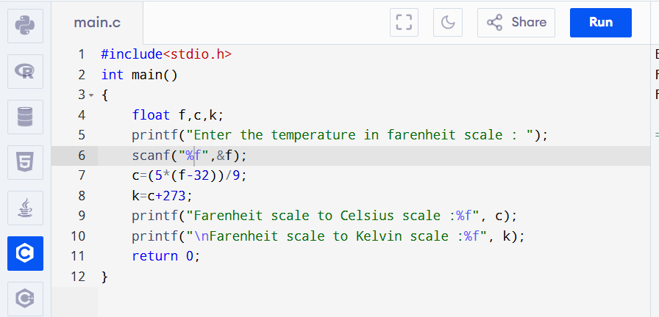

**Output:-**

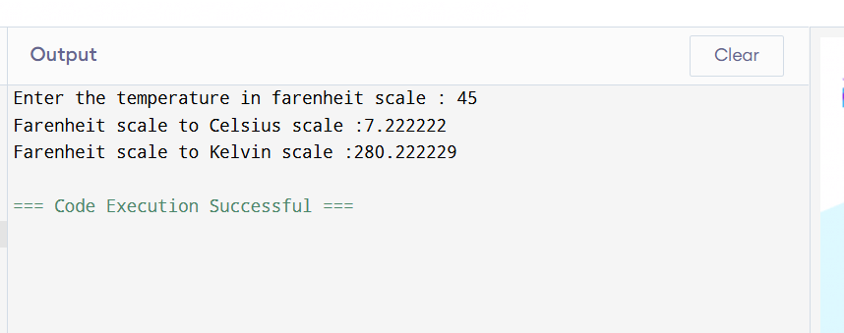

**Exp2:-**

**Title of the program:-**

A student has secured marks in 5 subject (out of 100) write a program to compute the aggregate and if the marks is greater than or equal to 80% then print “Excellent” else print “Average”. Write the flowchart of the program.

**Flowchart:-**

int n,i=0,sum=0,ave

Take the value of n

sum=sum+n

i=i+1

if i<5

ave=sum/5

if

ave<=80

print Excellent

print Average

Yes

No

No

Yes

**Program instruction:-**

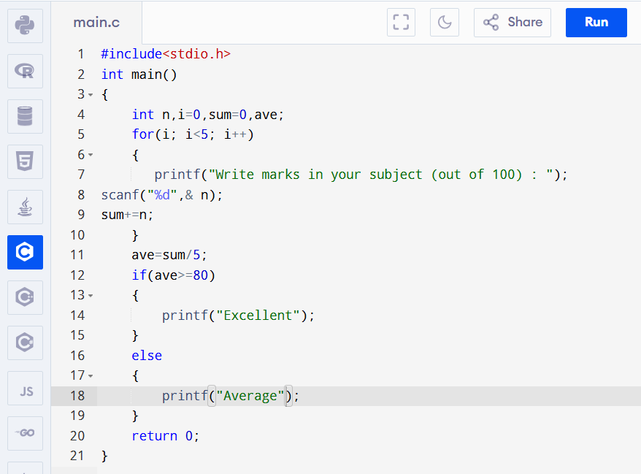

**Output:-**

