**CPE383 Machine Learning: Quiz1**

1. Text

   Description automatically generated10 points. 1.5 hrs. **Template Matching**. Search for the ‘t’ using “t_character.png” as template in the text image “text_image.png”. Use a bounding box to mark where ‘t’ were found. Use the Euclidean norm. You may use OpenCV to only read and write the image, but not to call the template matching routine.

Result:

1. Text

   Description automatically generated**Image Convolution**. Create your own Gaussian Kernel
   1. A picture containing text

      Description automatically generated 10 points. 2 hrs. Using Python, compute and print the matrix for Gaussian kernel with σ=2.5 using kernel size of 15 x 15 (we use width = ceiling (6*σ) ). Print the kernel as output.

* 1. 10 points. 0.5 hrs. Modify the OpenCV code shown in class to show the result of the convolution of your 15 x 15 Gaussian kernel using the Lenna image.

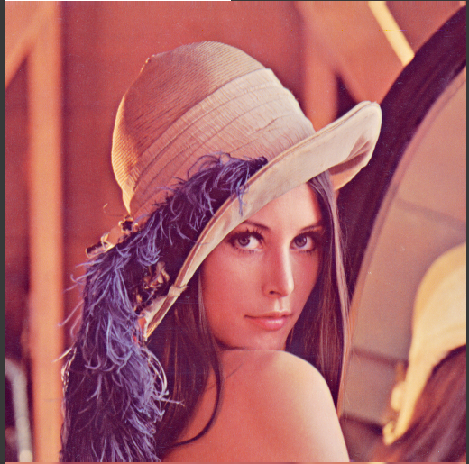

Original image Blurred image

1. Graphical user interface, text

   Description automatically generated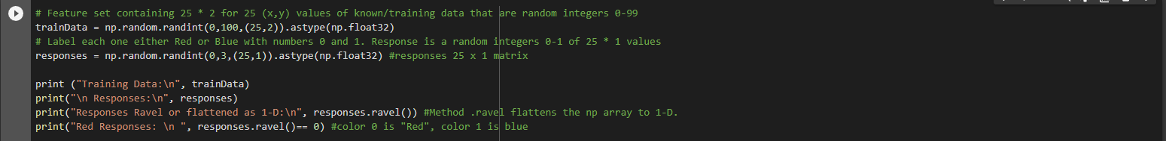10 points. 1 hrs. **KNN (K nearest neighbor) for 3 Classes**. Modify the provided program for KNN with 2 random red/blue classes shown in class to have 3 classes of red/blue/yellow instead. Then use K = 4 to classify a randomly generated sample as red, yellow, or blue.

1. Graphical user interface

   Description automatically generated with medium confidenceText

   Description automatically generated10 points. 0.5 hrs. **Image Matching with KNN**. Try the provided image matching program on a test image of an object you photographed yourself. Then photograph the object in a different environment as a target image. Show your input and output image. Also, show the 2 input images with SIFT features as asked for in the jupyter notebook provided.

