**CPE383 Machine Learning: Quiz 3**

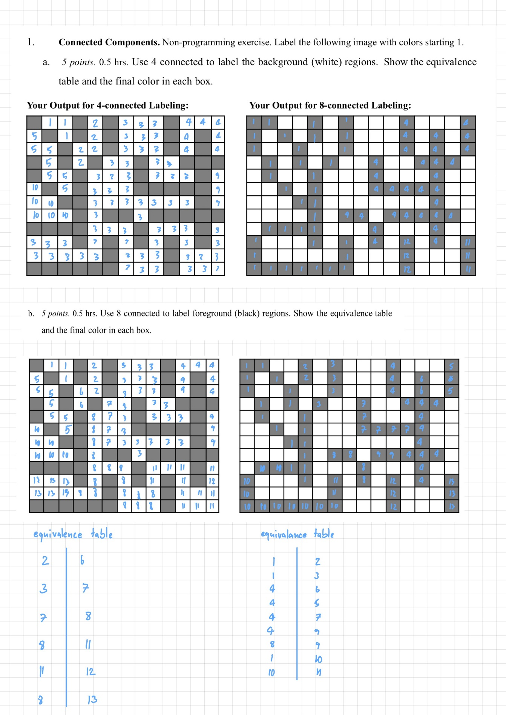

2. Handwritten Digit Recognition. Use the digits.png file as template for digits 0, 1, ..., 9. Write a

python program to cut out each digit as a labeled dataset from 0..9, each of which is 20x20. Note: You

may also use this exact same dataset with 100 samples of each digit 0..9 using 20 x 20 pixels from the

internet along with libraries to read/load the dataset, if it’s easier for you.

Rescale all images from 20 x 20 to 24 x 24. This can be done in memory as a python class data and need

not be stored in a file. Use 80% of the data as the training set, reserving 20% for testing.

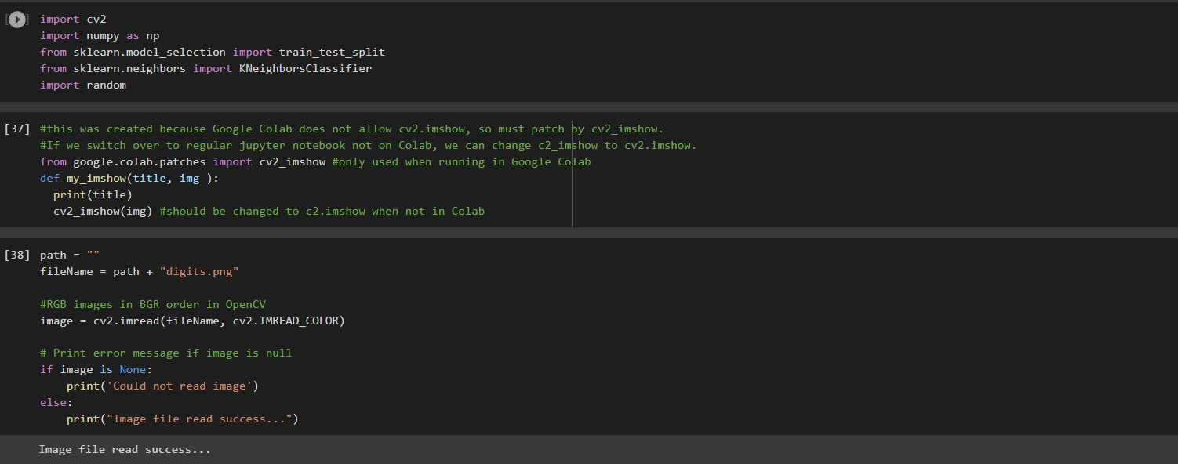

a. 30 pts. 6 hrs. Then try recognition by using test images and report the accuracy percent for these 4

(classifier, feature type) combinations: (KNN K = 5, gray scale features), (KNN K = 5, HOG

features), (KNN K = 1, gray scale features), (KNN K = 1, HOG features). For K = 5, if 2 or more

digits have the same maximum vote count, just report one of them. For HOG, use 20° histogram

orientations of non-directional gradients (ie., 9 bins) with 16 x 16 overlapping pixel windows for

each 24 x 24 digit. Each digit will, thus, have 144 HOG features from 4 x 4 x 9, with 9 histo

values x 4 per 16 x 16 block x 4 such blocks per 24 x 24 image.

b. Use KNN K = 1 with HOG features to report:

i. 5 pts. 1.0 hrs. Result for 2 test images per digit 0..9 cut out from digits.png itself but not

aligned at the original 20 x 20 image, so you may have smaller or bigger sizes. You will

have to rescale each test image to 24 x 24 because HOG must be recalculated after scaling.

ii. 5 pts. 1.0 hrs. Result for 2 test images per digit 0..9 you create in a Paint program to see if

you can find your character. Each test image should be big to start with such as 50x50, but

you should rescale it to 24 x 24 before testing.

iii. 5 pts. 1.0 hrs. Result for 4 test images of digit 5 you create in Paint with white background.

c. 20 pts. 3 hrs. For each 0..9 digit in your dataset of 100 characters, use OpenCV’s auto threshold

and then connected components to find the bounding box. Use that bounding box to cut out each

gray-scale image and resize each back to 24 x 24. This will be your new dataset (training and

testing, combined). Report the accuracy percent for KNN K = 1 using HOG features. Is the result

here better than in problem 2a for KNN = 1 using HOG features?

Ans: No