**CPE383 Machine Learning: Quiz5**

1. Calibrate Camera. 2 hrs. Using the “Calibrate Camera by ChatGPT” program shown in class,

calibrate your laptop or mobile phone camera to find its intrinsic parameters using 10-15

checkerboard images. Make sure you are not using mirror images. If the processing is slow, it

may help to reduce the size of each image to a width of around 1,000.

* 1. 10 points. Report the fx, fy, cx, cy, and lens distortion (k1, k2, k3, p1, p2) parameters

found using left##.jpg, frame-##.png, and your camera’s images.

1.2. 10 points. Show the Original and Undistorted image for one of your checkerboard images.

Draw straight lines across the original image and undistorted image to see if the distortion

has improved.

**Distorted**

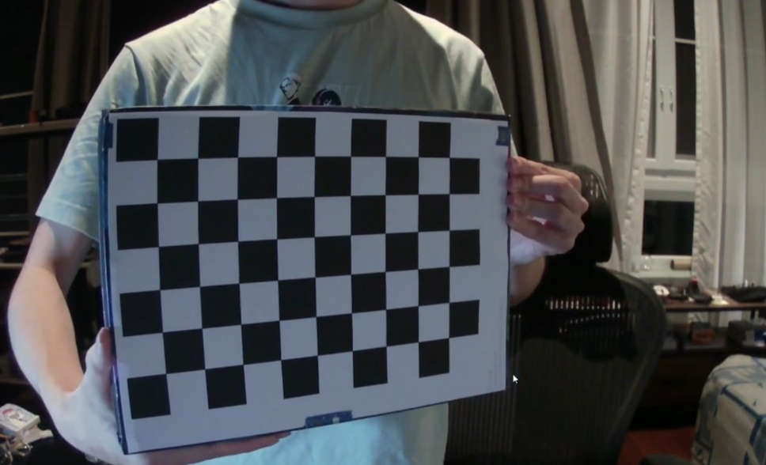

**Undistorted**

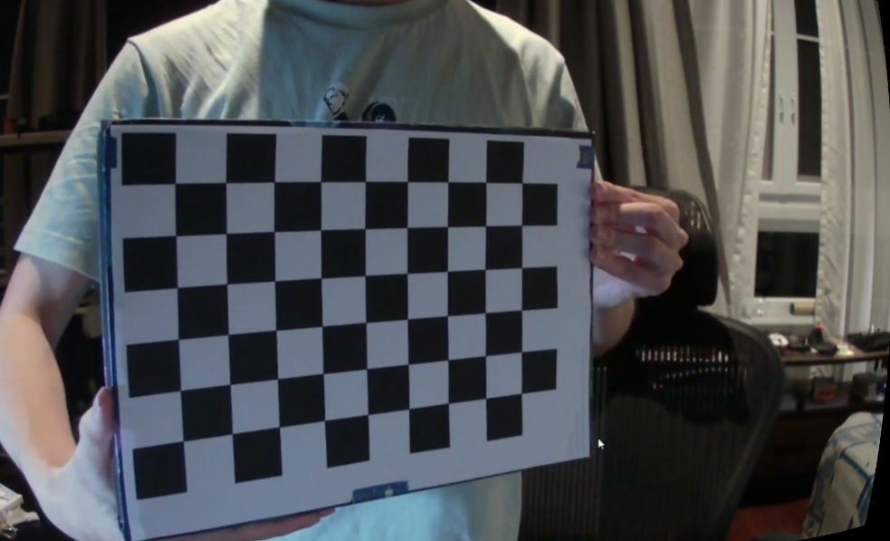

1. Using the Regression on diabetes data example:

* 1. 5 points. 1 hr. Is age highly correlated with total cholesterol / HDL (column ‘S4’)?

**ANS** only a small proportion of the variation in diabetes_s4 can be explained by diabetes_age. Therefore, the correlation between the two variables is weak.

* 1. 5 points. 0.5 hr. Is blood pressure highly correlated with total cholesterol / HDL (column ‘S4’)?

**ANS** only a small proportion of the variation in diabetes_s4 can be explained by diabetes_bp. Therefore, the correlation between the two variables is weak.

2.3. 15 points (4+3+3+5). 1 hr. Report Linear fit results for y = ax + b where x is the blood

sugar level

1. Linear fit coefficients and intercept of the training data

1. Graphical user interface

   Description automatically generatedWhat is the R^2 for the training data?
2. What is the R^2 for the prediction of y based on blood sugar level for the test data?

1. Show a scatter plot of the train set (x, y) as blue circles and predicted (x, y) as green circles. Also show the best fit line in red.

1. 2 hrs. Use the data provided in the shared file gasoline_use.txt to:
   1. 10 points. Show the equation found by fitting the training data: y = f(x1, x2, x3, x4) = a0+ a1x1 + a2x2 + a3x3 + a4x4

**ANS** y = -40.32x1 - 0.08x2 - 0.002x3 + 1464.30x4 + 383.71

3.2. 5 points. What is the R^2 for the prediction of y? Use testing data.

* 1. 5 points. What would happen to gasoline consumption if taxes are increased by $2.00? Use training data.

ANS it’s tell that on average, the model predicts that gasoline consumption will decrease by approximately 76.07 units, but in my opinion tax is not relate to gasoline consumption at all.