Guide to analysis procedure
The MATLAB codes for replicating the results in the paper (DOI?) are in the folder Code2pub.
MasterScript.m contains the whole process using the functions provided.

Edits required for cross validation
The “leave-one-dog-out” crossvalidation method, requires editing the cvpartition class of the Statistics and Machine Learning Toolbox. Following instructions apply to MATLAB Release R2018b.
- Copy cvpartition.m from your matlabroot\toolbox\stats\stats\ to folder Code2pub containing the publication code.
- From matlabroot\toolbox\stats\stats\+internal\+stats copy two functions, cvpartitionImpl.m and cvpartitionInMemoryImpl.m to Code2pub\+internal\+stats
- Add the highlighted rows to function cvpartitionImpl.m. Note, the line numbers refer to the modified file.
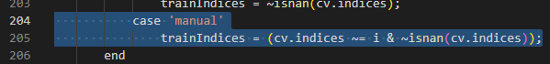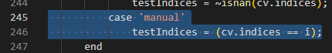
- Add the highlighted parts to function cvpartitionInMemoryImpl.m. Note, the line numbers refer to the modified file.
