I use Ubuntu 18.04, LTS version.
I use Xiphos 4.0.7 (gtk3 webkit1)

When open the program here's what I get. Take note of the “up” and “down” indicators after the book, chapter and verse that are in pairs.

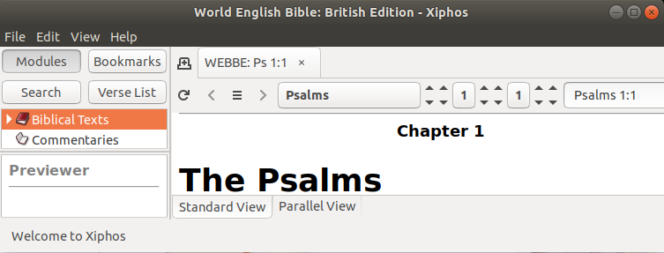
When I move my mouse pointer over any one of the pairs, the pair if immediately replace by single indicator. See the following displays.

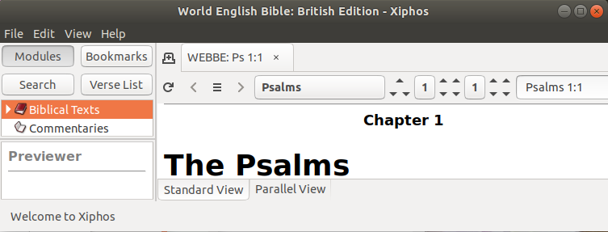

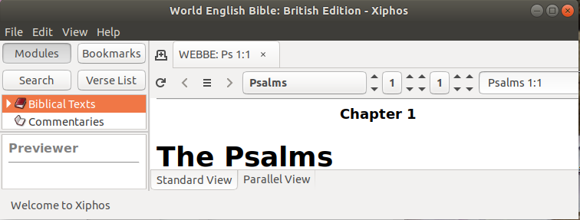

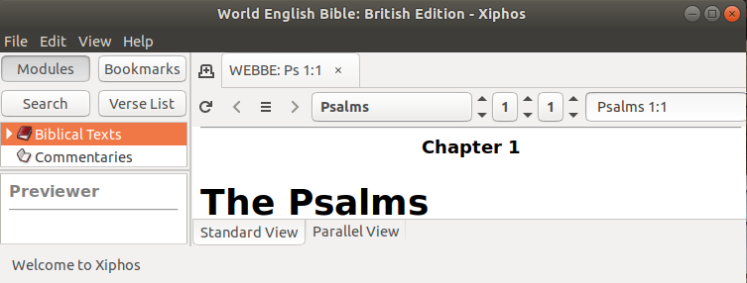
Xiphos otherwise works perfectly. This anomaly has been around for a long time.

Can it be fixed or is it intentional ?

