**DBMS Assignment 1**

**NAME: Arnob Bhakta**

**YEAR: 2nd**

**DEPT: Information Technology**

**SESSION: 2024-2027**

**ROLL NO: 002311001049**

**TABLE CREATION**

**CREATE TABLE EMP**

**( EMPNO NUMBER(4) NOT NULL,**

**ENAME VARCHAR2(10),**

**JOB VARCHAR2(9),**

**MGR NUMBER(4),**

**HIREDATE DATE,**

**SAL NUMBER(7,2),**

**COMM NUMBER(7,2),**

**DEPTNO NUMBER(2),**

**PHONENO NUMBER(10),**

**ADDRESS VARCHAR2(20));**

**INSERT INTO EMP VALUES(7369, 'SMITH', 'CLERK', 7902, '17-DEC-80', 800, NULL , 20,NULL ,NULL );**

**INSERT INTO EMP VALUES(7499, 'ALLEN', 'SALESMAN', 7698, '20-FEB-81', 1600, 300, 30,NULL ,NULL );**

**INSERT INTO EMP VALUES(7521, 'WARD', 'SALESMAN', 7698, '22-FEB-81', 1250, 500, 30,NULL ,NULL );**

**INSERT INTO EMP VALUES(7566, 'JONES', 'MANAGER', 7839, '02-APR-81', 2975, NULL, 20,NULL ,NULL );**

**INSERT INTO EMP VALUES(7654, 'MARTIN' , 'SALESMAN' , 7698, '28-SEP-81', 1250, 1400 ,30,NULL ,NULL );**

**INSERT INTO EMP VALUES(7698, 'BLAKE' , 'MANAGER' , 7839, '01-MAY-81', 2850, NULL,30,NULL ,NULL );**

**INSERT INTO EMP VALUES(7782, 'CLARK', 'MANAGER', 7839, '09-JUN-81', 2450,NULL,10,NULL ,NULL );**

**INSERT INTO EMP VALUES( 7788, 'SCOTT', 'ANALYST', 7566, '19-APR-87', 3000, NULL,20,NULL ,NULL );**

**INSERT INTO EMP VALUES( 7839, 'KING', 'PRESIDENT', null, '17-NOV-81', 5000, NULL, 10,NULL ,NULL );**

**INSERT INTO EMP VALUES(7844, 'TURNER', 'SALESMAN', 7698, '08-SEP-81', 1500 , 0, 30,NULL ,NULL );**

**INSERT INTO EMP VALUES(7876, 'ADAMS', 'CLERK', 7788, '23-MAY-87' , 1100 , NULL, 20,NULL ,NULL );**

**INSERT INTO EMP VALUES(7900, 'JAMES', 'CLERK', 7698, '03-DEC-81', 950,NULL,30,NULL ,NULL );**

**INSERT INTO EMP VALUES(7902, 'FORD', 'ANALYST', 7566, '03-DEC-81', 3000, NULL, 20,NULL ,NULL );**

**INSERT INTO EMP VALUES(7934, 'MILLER', 'CLERK', 7782, '23-JAN-82', 1300 ,NULL,10, NULL ,NULL );**

**create table dept(**

**deptno number(2,0),**

**dname varchar2(14),**

**loc varchar2(13),**

**constraint pk_dept primary key (deptno));**

**insert into dept values(10, 'ACCOUNTING', 'NEW YORK');**

**insert into dept values(20, 'RESEARCH', 'DALLAS');**

**insert into dept values(30, 'SALES', 'CHICAGO');**

**insert into dept values(40, 'OPERATIONS', 'BOSTON');**

**create table salgrade(**

**grade number,**

**losal number,**

**hisal number**

**);**

**insert into salgrade values (1, 700, 1200);**

**insert into salgrade values (2, 1201, 1400);**

**insert into salgrade values (3, 1401, 2000);**

**insert into salgrade values (4, 2001, 3000);**

**insert into salgrade values (5, 3001, 9999);**

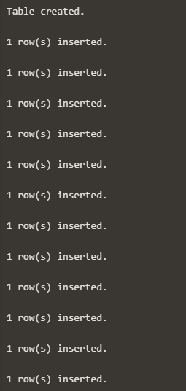

**Queries**

1. Show the details of all employees.

**SELECT * FROM EMP;**

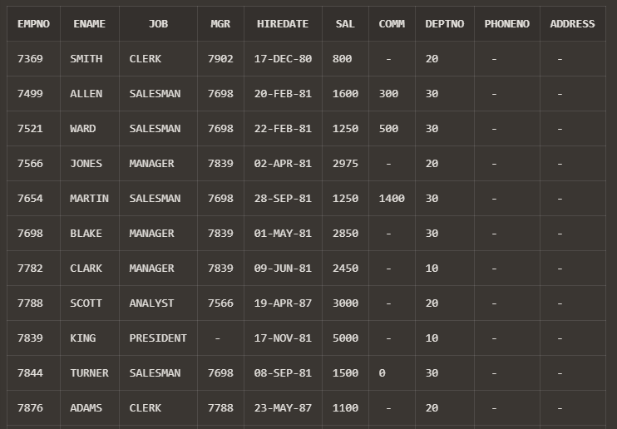

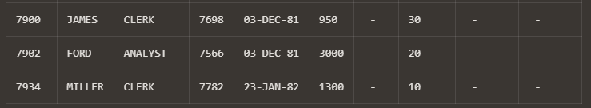

2. Show the department no. and name of all departments.

**SELECT DEPTNO, DNAME FROM DEPT;**

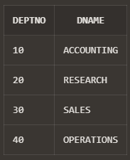

3. Display the employee id, name and department no of all employees whose department no is 20.

**SELECT EMPNO , ENAME , DEPTNO FROM EMP WHERE DEPTNO =20;**

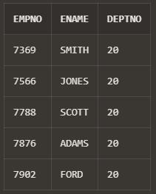

4. Display the details of all employees where department no should be in descending order.

**SELECT * FROM EMP ORDER BY DEPTNO DESC;**

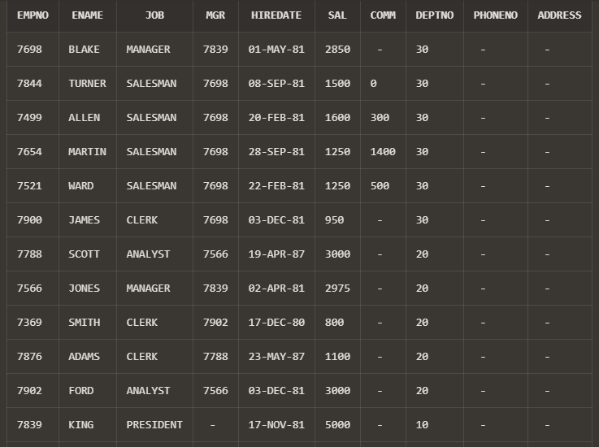

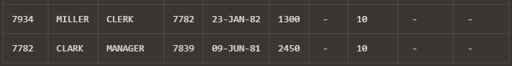

5. Show all available jobs in the employee table.

**SELECT DISTINCT(JOB) AS "AVAILABLE JOBS" FROM EMP ;**

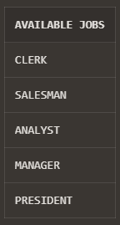

6. Show the name, Annual Salary and department no of employees who works as a clerk in department 20.

**SELECT ENAME,(SAL*12) AS "ANNUAL SAL", DEPTNO FROM EMP WHERE JOB='CLERK' AND DEPTNO=20;**

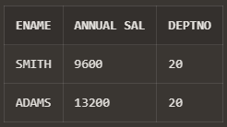

7. Show the name and HIRED date of those employee whose name start with ‘S’ or second character is ‘C’.

**SELECT ENAME,HIREDATE FROM EMP WHERE ENAME LIKE 'S%' OR ENAME LIKE '_C%';** 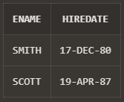

8. Show the name, hire date and salary of those employee who are not a manager.

**SELECT ENAME,HIREDATE,SAL FROM EMP WHERE JOB != 'MANAGER';**

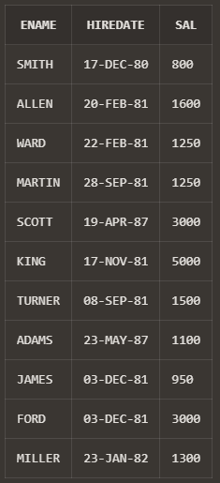

9. Display all employee names in title case and length of the name.

**SELECT INITCAP(ENAME) AS "TITLE CASE NAME", LENGTH(ENAME) AS "NAME LENGTH" FROM EMP ;**

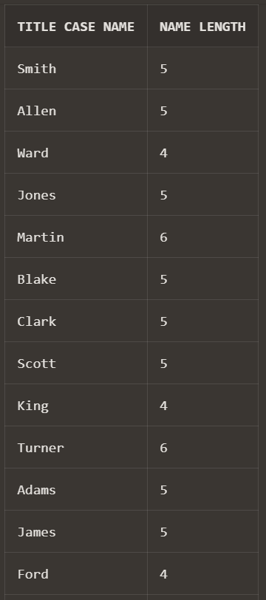

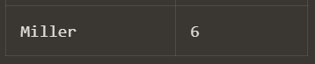

10. Display the name of employee who gets the salary between 4000 to 6000.

**SELECT ENAME FROM EMP WHERE SAL BETWEEN 4000 AND 6000;**

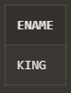ssss