**DBMS Assignment 2**

**NAME: Arnob Bhakta**

**YEAR: 2nd**

**DEPT: Information Technology**

**SESSION: 2024-2027**

**ROLL NO: 002311001049**

**QUERIES**

1. Display the Name, manager Id, and hire date of all employees who are either clerk or works in dept 20. the date should be in the following format: DATE_HIRED Seventeenth December, 1980 Second April, 1981

**SELECT ENAME AS "EMPLOYEE NAME", MGR AS "MANAGER NO",**

**INITCAP(TO_CHAR(HIREDATE,'FMDDSPTH MONTH,YYYY'))**

**AS "DATE_HIRED"**

**FROM EMP WHERE JOB='CLERK' OR DEPTNO=20**

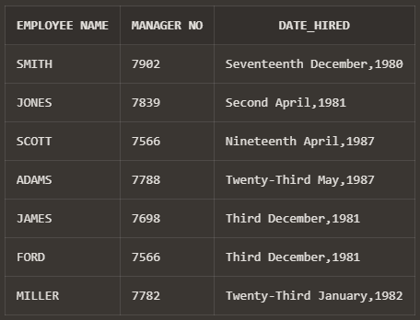

2. List the employee name and old salary and new increased salary by 25% and expressed as a whole number

**SELECT ENAME AS "EMPLOYEE NAME", SAL AS "OLD SAL",**

**ROUND(SAL*0.25 + SAL,0) AS "NEW SAL"**

**FROM EMP;**

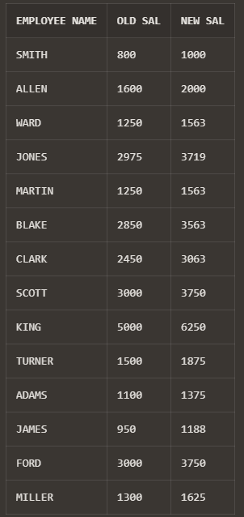

3. List the employee name and salary where name is displayed as left justified and salary with right justified.

**SELECT RPAD(ENAME,LENGTH(ENAME)) AS "NAME" , LPAD(SAL,10) FROM EMP ;**

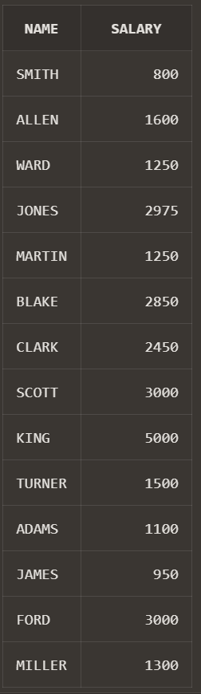

4. Produce the output as follows(for all employees) ROLE OF THE EMPLOYEE Name1 () Name2 () ........ Note: Only first character of Name and job will be in uppercase.

**SELECT INITCAP(ENAME||' ('||JOB||')') AS "ROLE OF THE EMPLOYEE"**

**FROM EMP;**

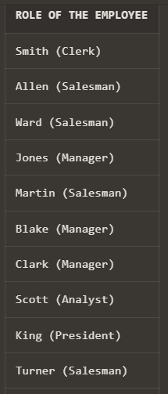



5. Give the details of an employees with job is clerk (enter the job value clerk as input)

**DECLARE**

**jobs varchar(20);**

**CURSOR C_EMP IS**

**SELECT * FROM EMP WHERE JOB = JOBS;**

**ROWREC C_EMP % ROWTYPE;**

**BEGIN**

**JOBS := 'CLERK';**

**DBMS_OUTPUT.PUT_LINE(**

**'EMPNO' || ' ' || 'ENAME' || ' ' || 'JOB' || ' ' || 'MGR ' || ' ' || 'HIREDATE ' || ' ' || 'SAL' || ' ' || 'COMM' || ' ' || 'DEPTNO ' || ' ' || 'PHONENO ' || ' ' || 'ADDRESS'**

**);**

**OPEN C_EMP;**

**LOOP**

**FETCH C_EMP INTO ROWREC;**

**EXIT WHEN C_EMP % NOTFOUND;**

**DBMS_OUTPUT.PUT_LINE(**

**ROWREC.EMPNO || ' ' || ROWREC.ENAME || ' ' || ROWREC.JOB || ' ' || ROWREC.MGR || ' ' || ROWREC.HIREDATE || ' ' || ROWREC.SAL || ' ' || ROWREC.COMM || ' ' || ROWREC.DEPTNO || ' ' || ROWREC.PHONENO || ' ' || ROWREC.ADDRESS**

**);**

**END LOOP;**

**CLOSE C_EMP;**

**END;**

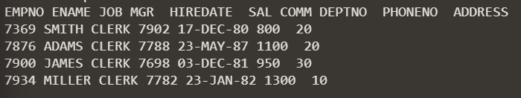

6. Display each employee name with hiredate and salary review date. Assume that date is one year after hiredate. Order the output in ascending review date order.

**SELECT ENAME, HIREDATE, ADD_MONTHS(HIREDATE, 12) AS "SAL REVIEW" FROM EMP ORDER BY ADD_MONTHS(HIREDATE, 12) ASC;**

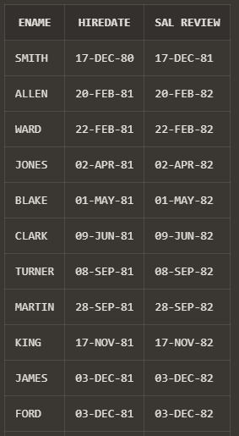

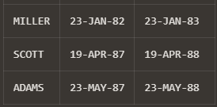

7. Find the employees(s) who earn the highest salary in each job type sort in descending salary order(Use IN operator and subqueries)

**SELECT ENAME, JOB,SAL FROM EMP WHERE SAL IN (**

**SELECT MAX (SAL) FROM EMP GROUP BY JOB**

**) ORDER BY SAL DESC;**

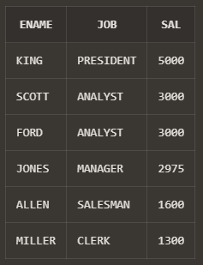

8. Find the most recently hired employee in each department (give number only).

**SELECT ENAME, HIREDATE, DEPTNO FROM EMP WHERE HIREDATE IN (**

**SELECT MAX(HIREDATE) FROM EMP GROUP BY DEPTNO**

**) ORDER BY HIREDATE DESC;**

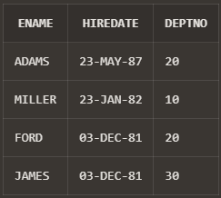

9. Show the name of the department and no of employees who works in that department. Sort in department number.

**SELECT DNAME,COUNT(*) AS "NO OF EMPLOYEES" FROM DEPT,EMP WHERE EMP.DEPTNO=DEPT.DEPTNO GROUP BY DNAME ORDER BY COUNT(*);**

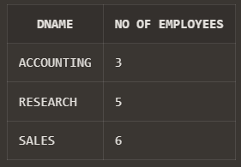

10. Display the Id, name, salary and the salary grade for any employee who earns the maximum salary for their department. Sort in department number.

**SELECT EMPNO,**

**ENAME,**

**SAL,**

**SALGRADE.GRADE AS "SALARY GRADE"**

**FROM EMP,**

**SALGRADE**

**WHERE SAL IN (SELECT MAX(SAL)**

**FROM EMP**

**GROUP BY DEPTNO)**

**AND ( SAL <= HISAL**

**AND SAL >= LOSAL );**

**ORDER BY DEPTNO;**

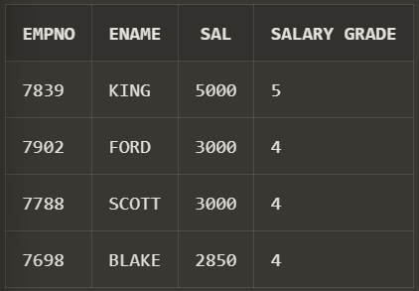

11. In which year did most people join the company? Display the year and number of  employees

select yr as "MOST HIRED YEAR" , COUNT as "NO OF EMPLOYEE"

**SELECT**

**YR AS "MOST HIRED YEAR",**

**COUNT AS "NO OF EMPLOYEE"**

**FROM**

**(**

**SELECT**

**TO_CHAR(HIREDATE, 'yyyy') AS YR,**

**COUNT (*) AS "COUNT",**

**ROW_NUMBER() OVER(ORDER BY COUNT(*) DESC) AS RNK**

**FROM**

**EMP**

**GROUP BY**

**TO_CHAR(HIREDATE, 'yyyy')**

**)**

**WHERE**

**RNK = 1;**

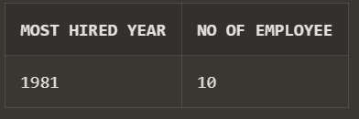

12. Show the every alternate row in employee table.

**select * from**

**(**

**select emp.* ,ROW_NUMBER() over(order by empno) as rnk**

**from emp**

**) where mod(rnk,2)=0;**

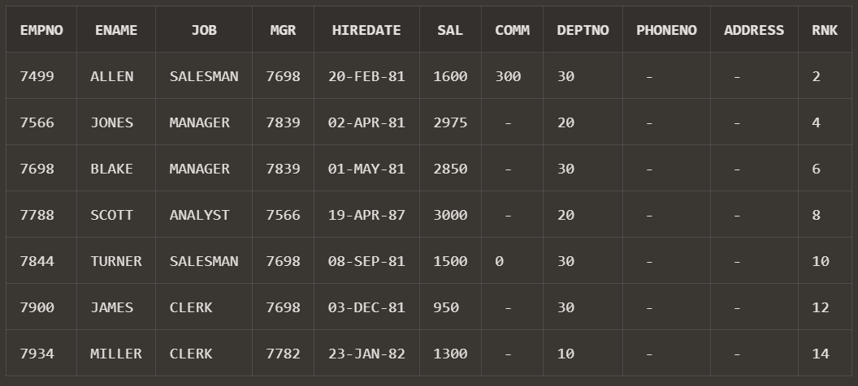

13. Display the total salary of all employees. Total salary = salary + commission.

**SELECT SUM(SAL + NVL(COMM,0)) AS "TOTAL SALARY" FROM EMP ;**

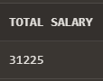

14. Display the department name and available jobs in that department.

**SELECT DNAME, COUNT(DISTINCT JOB) FROM EMP, DEPT WHERE EMP.DEPTNO = DEPT.DEPTNO GROUP BY DNAME ORDER BY COUNT(JOB) DESC;**

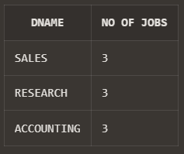

15. Display all the available departments and the employee(s) works under it.

**SELECT DNAME,ENAME**

**FROM EMP**

**NATURAL JOIN DEPT**

**ORDER BY DNAME;**

