Methodology Report
Dual-Scale Fine-Grained PPD Screening with a Score-Free Task-Adaptive Hybrid Framework | Generated March 18, 2026
This methodology report documents the workflow used to develop a postpartum depression screening system from structured clinical and psychosocial survey data. The study uses a Bangladesh-focused cohort of 800 women and addresses two related but different fine-grained classification tasks: PHQ-9 severity prediction with six classes and EPDS severity prediction with three classes.
The methodological contribution is therefore framed around task design rather than a claim of architectural novelty. The attention-based 1D-CNN branch is retained as a solid feature-learning backbone for tabular risk modeling, while the final workflow uses a task-adaptive score-free hybrid strategy that compares the CNN branch against a tuned RBF-SVM decision branch and keeps the stronger validation performer for each task. The more distinctive element is therefore the dual-scale screening formulation, the class granularity, and the unified evaluation of PHQ-9 and EPDS severity from the same structured survey context. The primary notebook configuration used for reporting is score-free, meaning the raw PHQ9 Score and EPDS Score are excluded from prediction. The final workflow therefore uses 46 survey-derived inputs, mode imputation, label encoding, standardization, SMOTE balancing, and a stratified 70/15/15 train, validation, and test protocol.
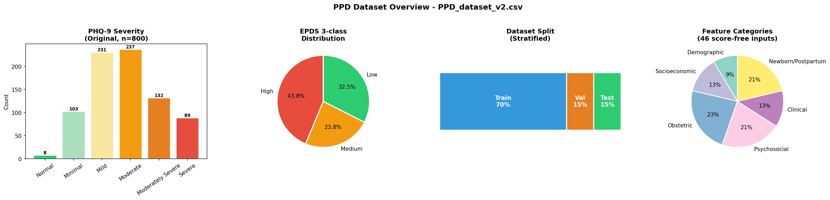
Figure 1. Dataset Description, Class Distribution, and Split Summary.
This figure summarizes the composition of the dataset used throughout the study. The first two panels present the original PHQ-9 and EPDS label distributions, showing that the PHQ-9 problem is notably imbalanced and that the EPDS classes are also unevenly distributed. The third panel presents the stratified train, validation, and test split used after resampling, while the fourth panel groups the predictor variables into demographic, socioeconomic, psychosocial, obstetric, clinical, and postpartum domains. Taken together, these views explain why resampling, class-aware training, and careful evaluation were necessary.

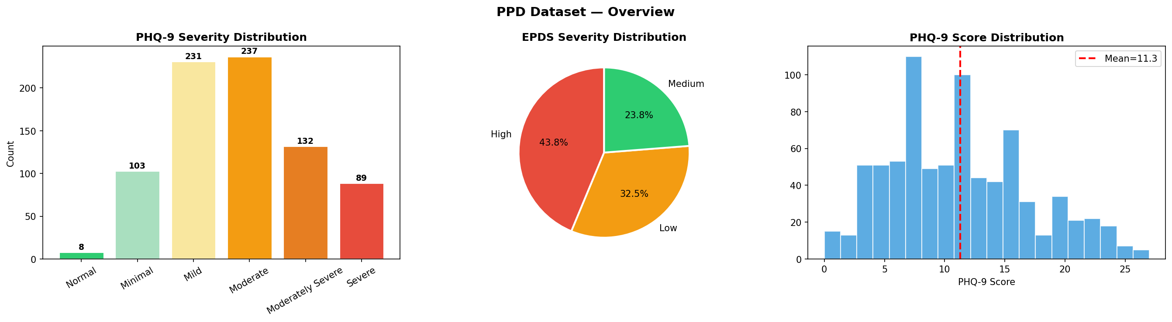
Figure 2. Exploratory Data Analysis Overview for the PPD Cohort.
This exploratory view provides an early statistical profile of the cohort before modeling. The PHQ-9 severity distribution confirms that Moderate and Mild cases are the dominant groups, the EPDS panel shows the relative proportions of High, Low, and Medium risk, and the PHQ-9 score histogram shows where the continuous symptom burden is concentrated. These patterns guided the use of mode-based imputation, standardization, and balancing strategies so that the downstream classifier would not be overly biased toward the majority categories.

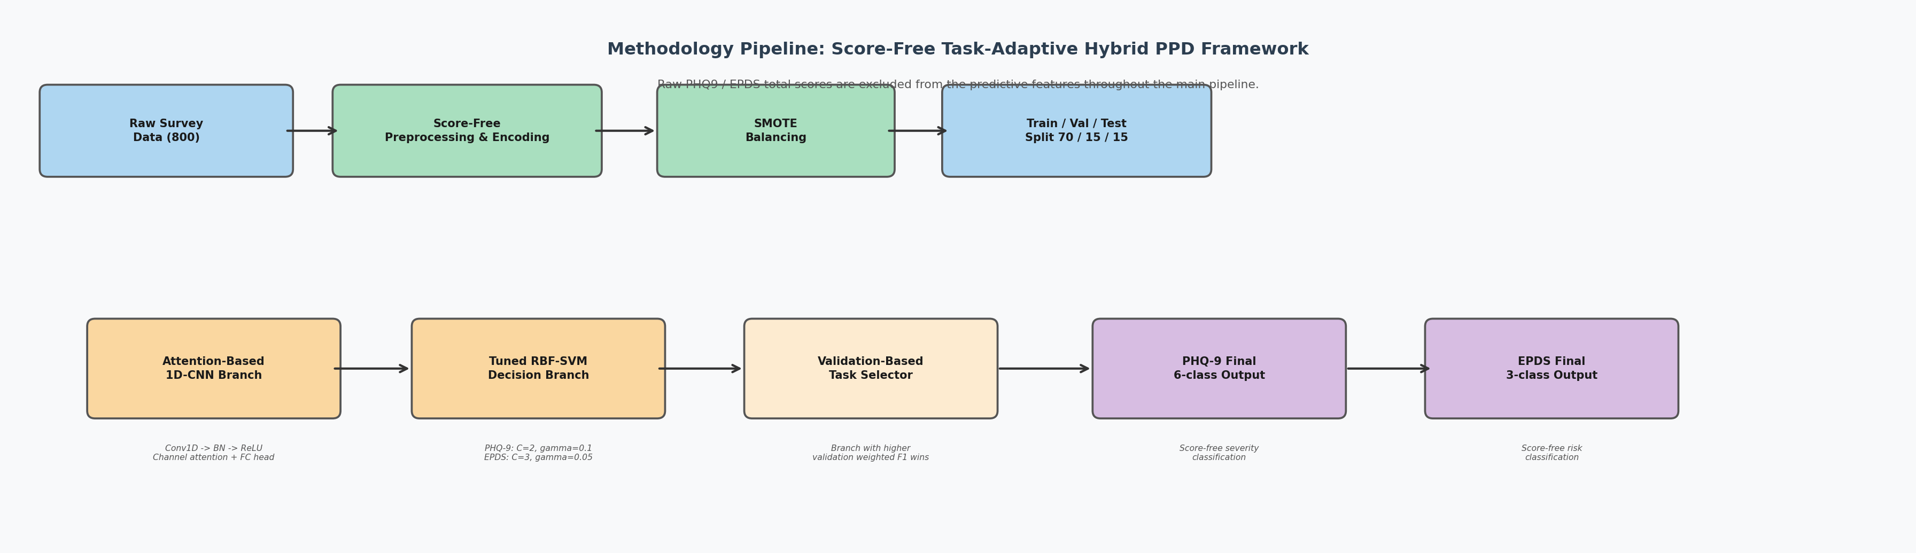
Figure 3. Score-Free Task-Adaptive Hybrid Methodology Pipeline.
The pipeline begins with raw questionnaire data, removes the identifier field and both raw screening score totals, and transforms the remaining survey responses into a standardized numeric sequence of 46 score-free inputs. After SMOTE and stratified splitting, the workflow trains an attention-based 1D-CNN branch and a tuned RBF-SVM decision branch in parallel. The CNN branch still uses three one-dimensional convolution blocks, global average pooling, and a squeeze-excitation style channel-attention gate as a practical feature-learning backbone. The final prediction stage is task-adaptive: for each target, the branch with the higher validation weighted F1 is retained as the deployed model. This keeps the study focused on dual-scale fine-grained screening while improving score-free performance without reintroducing the raw PHQ9 or EPDS scores.

