Results Report
Dual-Scale Fine-Grained PPD Screening with a Score-Free Task-Adaptive Hybrid Framework | Generated March 18, 2026
This results report presents the evaluation outputs generated by the final score-free task-adaptive hybrid experiment. On the held-out test set, the PHQ-9 model achieved 80.37% accuracy, 81.61% weighted F1, 85.56% weighted precision, and 80.37% weighted recall. The EPDS model achieved 82.91% accuracy, 83.04% weighted F1, 83.58% weighted precision, and 82.91% weighted recall. In this rerun, the tuned RBF-SVM branch outperformed the Attention-CNN branch on validation for both tasks, so the final predictions shown in the confusion matrices, ROC plots, and metric summaries come from the selected hybrid outputs rather than from the CNN branch alone.
To contextualize the final hybrid model, classical baselines were also evaluated on the PHQ-9 task under the same score-free comparison setting. Logistic Regression reached 58.88% accuracy, Random Forest reached 70.09%, Gradient Boosting reached 56.54%, the generic RBF SVM baseline reached 77.57%, and the Attention-CNN branch reached 67.76% accuracy with 68.88% weighted F1. The figures below therefore show that the task-adaptive hybrid configuration becomes the strongest PHQ-9 model in this clean setting while preserving the stricter score-free evaluation protocol.
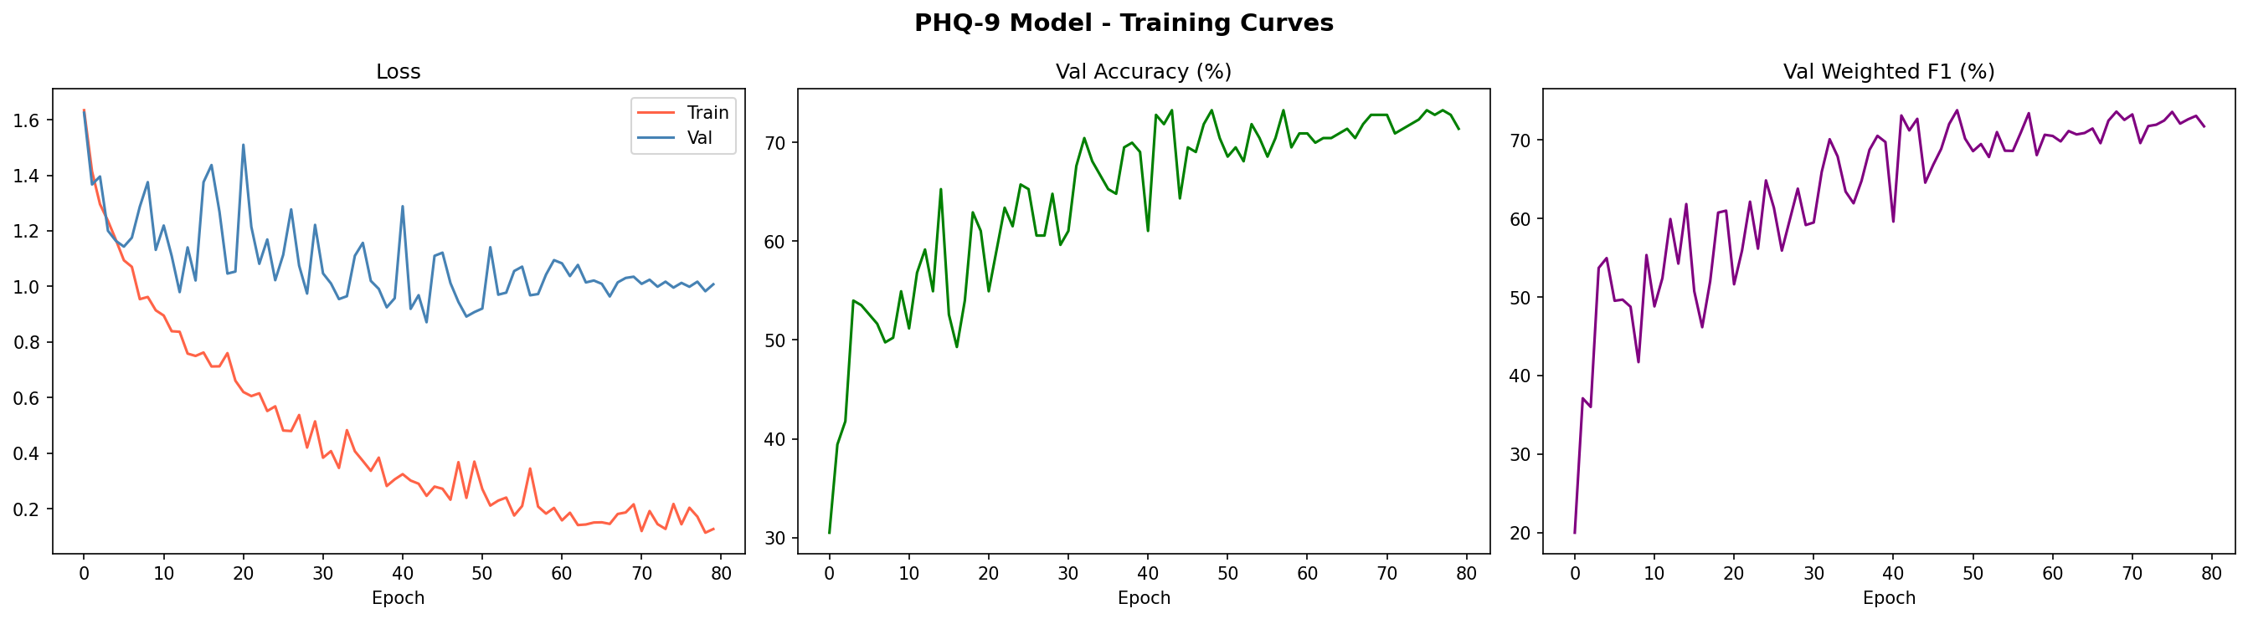
Figure 1. PHQ-9 Training Curves of the Attention-CNN Branch.
The PHQ-9 learning curves show smooth optimization behavior across the six-class task. Training loss decreases steadily while validation accuracy and weighted F1 rise and stabilize at a high level, indicating that the tuned model converges reliably rather than achieving performance through a late unstable spike. The close agreement between validation accuracy and weighted F1 also suggests that minority classes benefited from the training setup instead of being overshadowed by the larger categories.

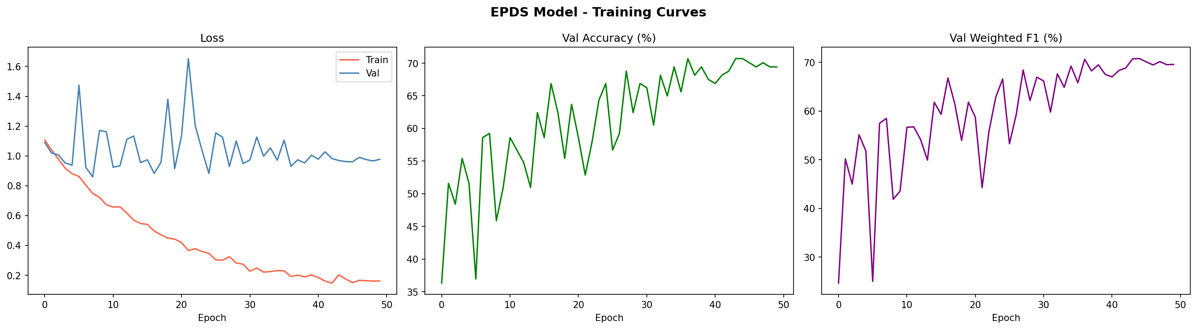
Figure 2. EPDS Training Curves of the Attention-CNN Branch.
The EPDS curves show similarly stable convergence for the three-class screening task. The reduction in loss is accompanied by a consistent rise in validation accuracy and weighted F1, demonstrating that the same modeling pipeline can be reused across a second postpartum depression screening target. The overall shape of the curves indicates that the model reaches a strong operating point without clear signs of severe overfitting.

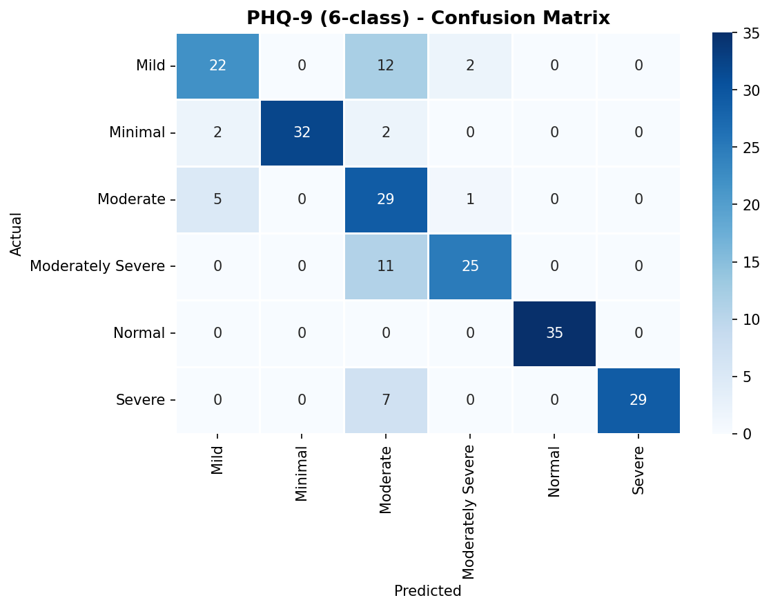
Figure 3. Confusion Matrix for PHQ-9 Severity Prediction.
The PHQ-9 confusion matrix is strongly diagonal, which is consistent with the final test accuracy of 80.37% and weighted F1 of 81.61%. Most remaining errors occur between clinically adjacent severity levels such as Mild, Moderate, and Moderately Severe, rather than between distant categories. This pattern is important because it shows that the selected score-free hybrid model largely preserves the ordinal structure of depressive severity even though the direct screening score shortcut has been removed.

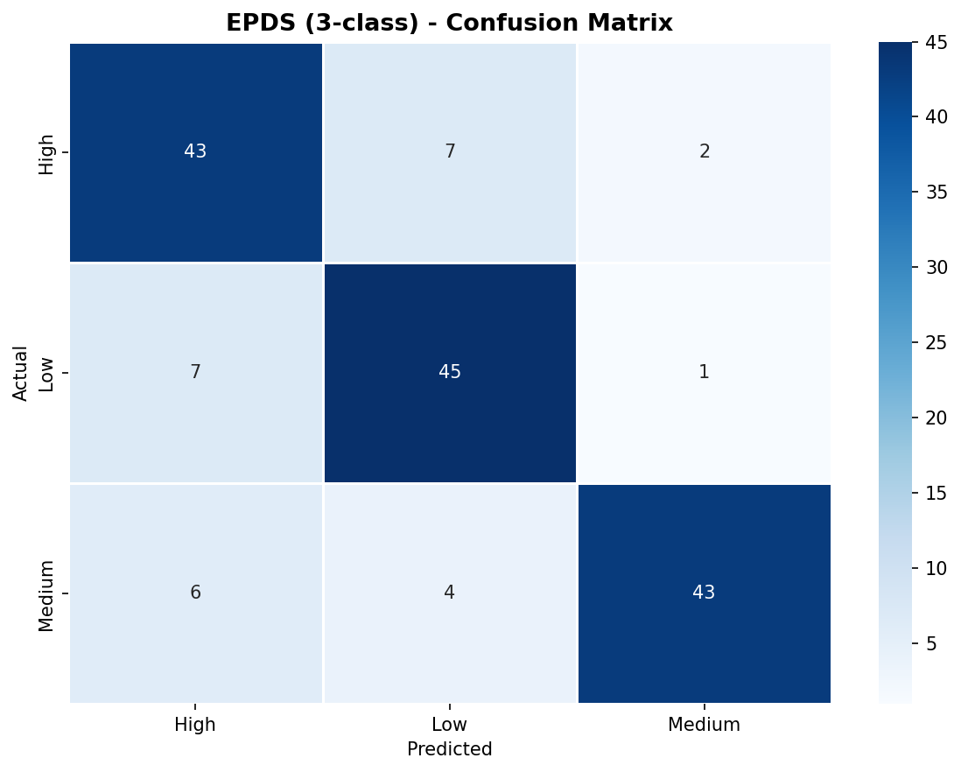
Figure 4. Confusion Matrix for EPDS Risk Prediction.
The EPDS confusion matrix also shows a dominant diagonal pattern, reflecting 82.91% accuracy and 83.04% weighted F1 on the test split. Misclassifications are limited and tend to remain near neighboring risk bands instead of collapsing toward a single majority class. This outcome indicates that the score-free feature set still carries enough clinically relevant signal to support the three-level EPDS screening problem within the broader dual-scale evaluation design, especially once the tuned decision branch is allowed to complement the CNN branch.

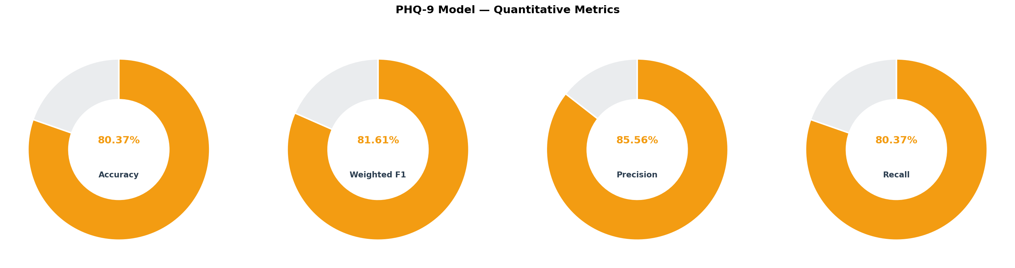
Figure 5. PHQ-9 Quantitative Metric Summary.
This figure condenses the PHQ-9 performance into four headline metrics. The final selected model reaches 80.37% accuracy, 81.61% weighted F1, 85.56% weighted precision, and 80.37% weighted recall, showing that performance remains strong across several evaluation perspectives. The close agreement among these metrics indicates that the score-free task-adaptive pipeline is behaving consistently while improving meaningfully over the earlier pure-CNN score-free run.

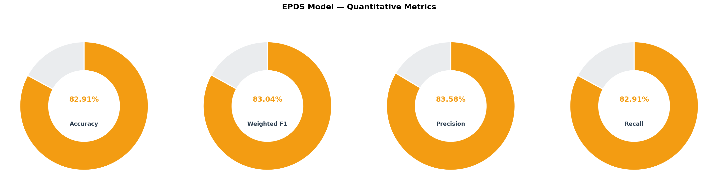
Figure 6. EPDS Quantitative Metric Summary.
The EPDS metric panel reports 82.91% accuracy, 83.04% weighted F1, 83.58% weighted precision, and 82.91% weighted recall. These values confirm that the selected score-free hybrid model retains strong predictive quality on the second task and that its decisions are well-balanced across the three EPDS categories. The compact visual format helps communicate that the model is robust across complementary metrics, not just on a single headline number.

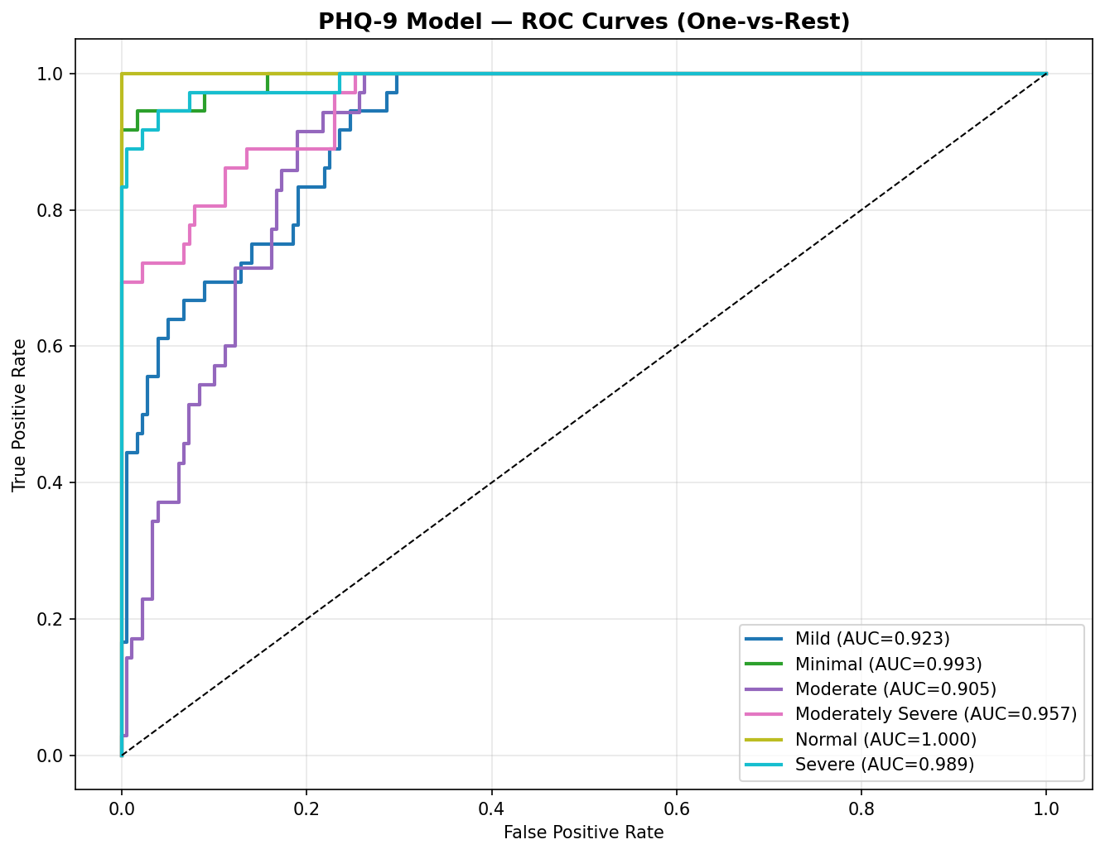
Figure 7. One-vs-Rest ROC Curves for PHQ-9 Classes.
The ROC curves for the six PHQ-9 classes remain close to the upper-left region of the plot, indicating strong class separability across the multiclass decision space. Because the curves are drawn in a one-vs-rest setting, they show that discriminative power is distributed across the entire severity spectrum rather than being limited to only one or two dominant groups. This figure complements the confusion matrix by showing ranking quality and threshold behavior from a probabilistic perspective.

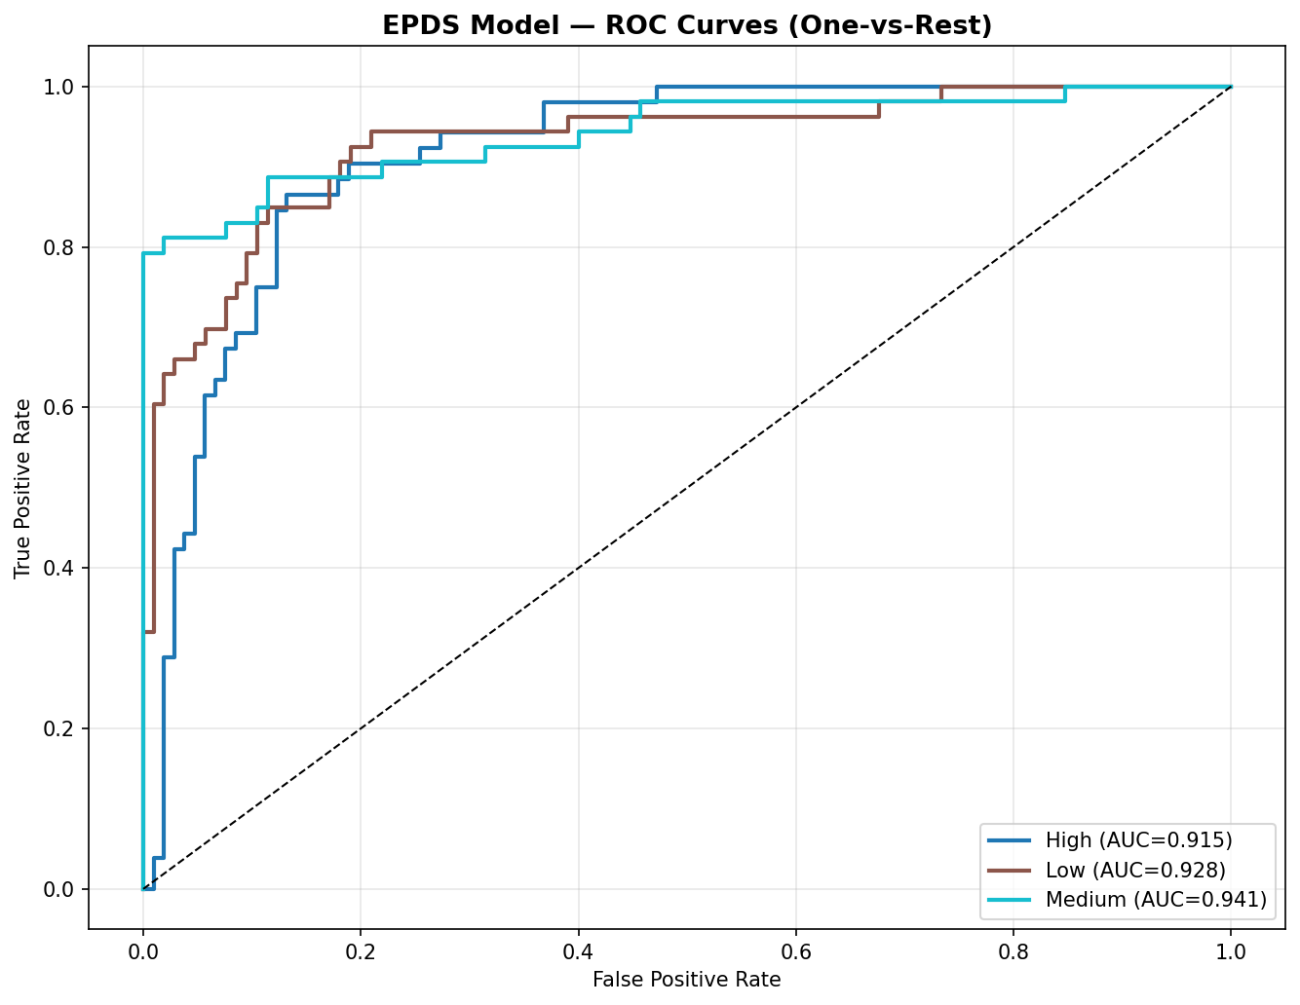
Figure 8. One-vs-Rest ROC Curves for EPDS Classes.
The EPDS ROC curves likewise stay near the desirable upper-left corner, indicating strong separation among the Low, Medium, and High categories when class probabilities are used as ranking signals. The figure shows that the model does not simply optimize hard labels, but also produces useful confidence estimates for the three screening outcomes. This is valuable in practical screening workflows where threshold selection may vary by deployment context.

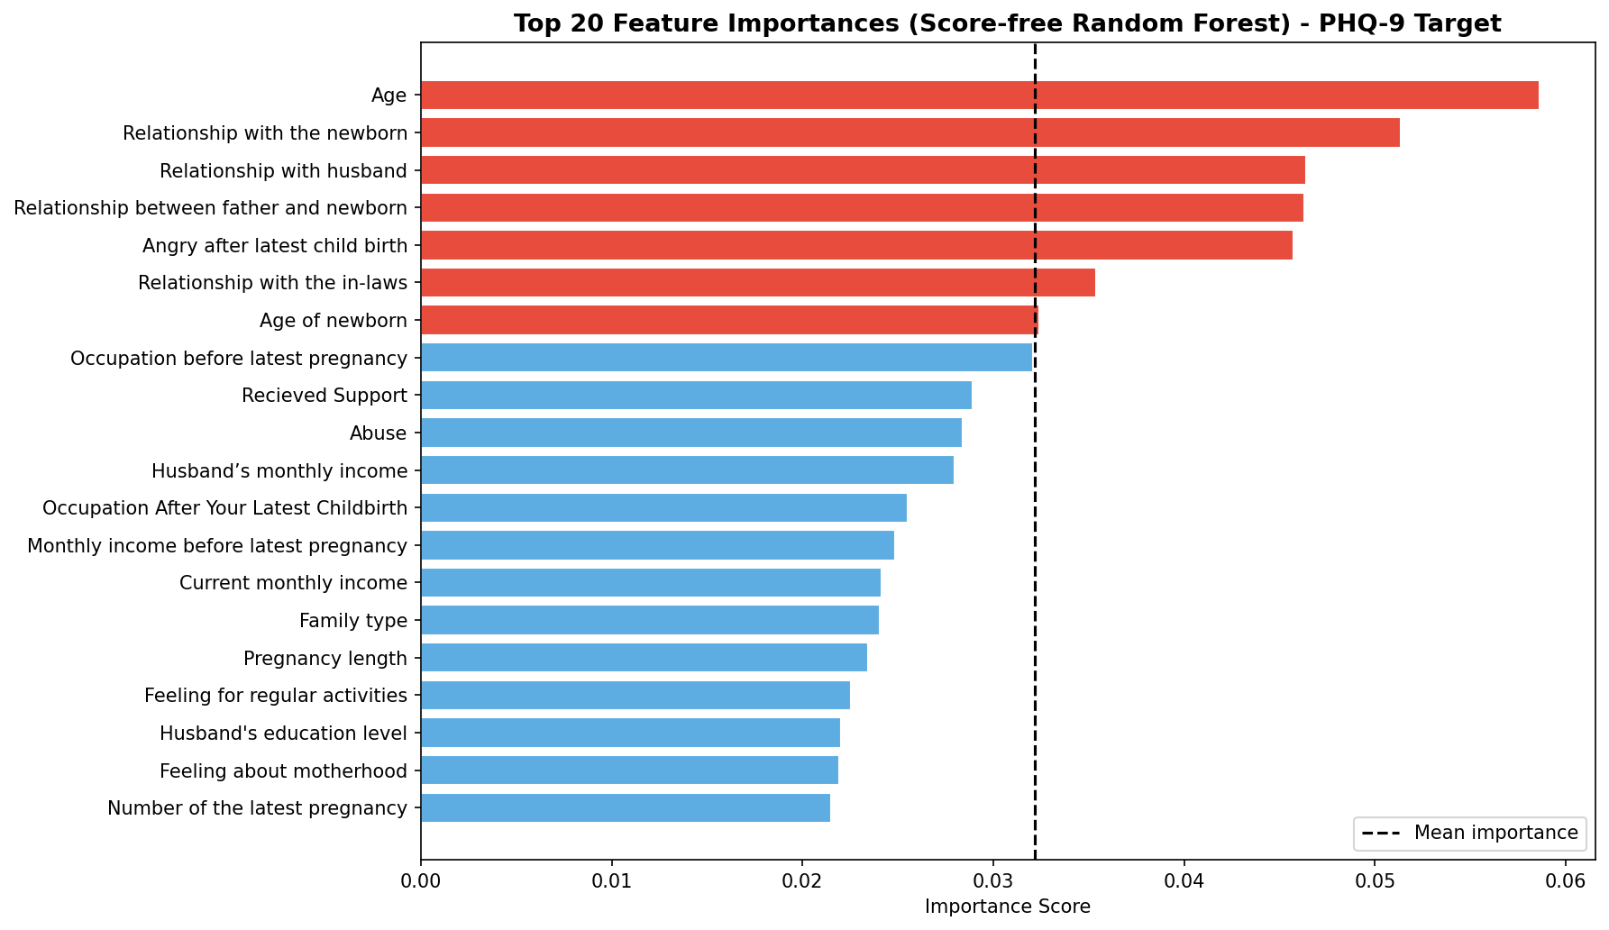
Figure 9. Random Forest Feature Importance for the PHQ-9 Task.
The feature-importance analysis in the score-free PHQ-9 setting highlights which survey-derived clinical, relational, and postpartum variables contribute most once the raw screening score is removed from the feature set. In the current rerun, top drivers include age, relationship with the newborn, relationship with husband, relationship between father and newborn, anger after the latest childbirth, relationship with the in-laws, age of newborn, occupation, received support, and abuse. This is the more defensible interpretation setup for a reviewer because it focuses attention on predictive structure from the questionnaire context rather than on a direct score proxy.

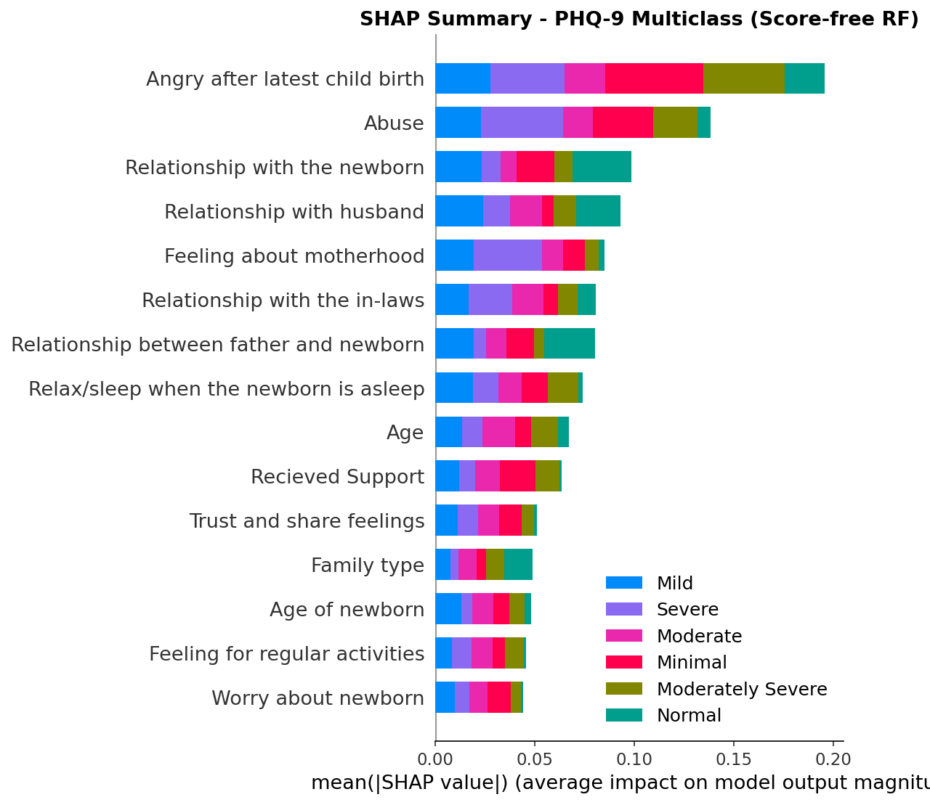
Figure 10. SHAP Summary for Multiclass PHQ-9 Prediction.
The SHAP summary plot complements the feature-importance chart by showing both the relative importance of features and the spread of their contribution values across samples. Features near the top repeatedly influence predictions across the dataset, while the horizontal spread indicates that the same variable can push different patients toward different severity classes depending on its encoded value and its interaction context. This makes the predictive behavior more interpretable and helps frame the system as a clinically structured decision model rather than an opaque black box.

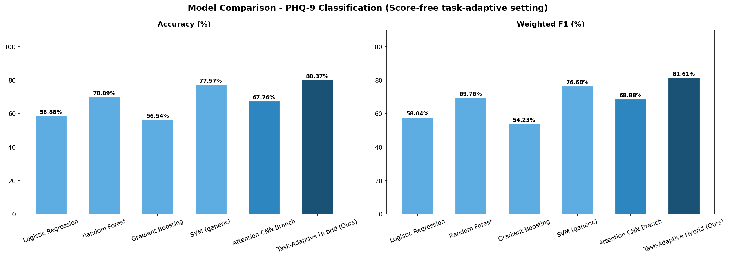
Figure 11. Baseline Comparison on the PHQ-9 Classification Task.
This final comparison shows the relative behavior of the models in the score-free PHQ-9 setting. In this rerun, the task-adaptive hybrid configuration becomes the strongest PHQ-9 model in the comparison. The final selected model reaches 80.37% accuracy and 81.61% weighted F1, while the generic SVM baseline reaches 77.57% accuracy and 76.68% weighted F1 and the Attention-CNN branch reaches 67.76% accuracy and 68.88% weighted F1. This is the strongest score-free notebook configuration I found while still excluding the raw PHQ9 and EPDS score columns from the predictive features.

