PlasmaXAI Ultra-Detailed Research, Architecture, and Equation Compendium
Thesis-style technical record covering background, methodology, layer connectivity, equations, figures, and deployment translation
This document is designed as the deepest single-file technical reference for the PlasmaXAI project. It consolidates the long-form research record, the layer-by-layer novel architecture, the mathematics of the morphology and counterfactual branches, the benchmark and ablation tables, and a figure atlas tied to the saved research outputs.

A. Executive Technical Snapshot
Item | Value
Primary problem | Malignant plasma-cell recognition from microscopy images
Final framework | CounterfactualGuidedFusionNet / PlasmaXAI
ResNet embedding dimension | 2048
DenseNet embedding dimension | 1024
Morphology feature dimension | 10
Counterfactual feature dimension | 24
Score block dimension | 3
Hidden dimension | 256
Tabular dimension | 128
Dropout | 0.25
Main novel run accuracy | 93.23%
Main novel run plasma recall | 93.39%
Deployment comparison accuracy | 93.42%
Deployment comparison AUC | 97.76%
Bootstrap accuracy mean | 93.25%
Bootstrap AUC mean | 97.77%

B. Formal Mathematical Formulation
The following equations formalize the major blocks of the PlasmaXAI research pipeline: morphology extraction, counterfactual boundary modeling, multimodal fusion, classifier scoring, and patient-level aggregation.
(1) x_s = [ p_resnet , p_densenet , p_cf ]
(2) mu_R = (1 / |Omega|) * sum_{(u,v) in Omega} I_R(u,v)
(3) mu_G = (1 / |Omega|) * sum_{(u,v) in Omega} I_G(u,v)
(4) mu_B = (1 / |Omega|) * sum_{(u,v) in Omega} I_B(u,v)
(5) I_stain = 255 - (1 / |Omega|) * sum_{(u,v) in Omega} Gray(u,v)
(6) A_nuc = |Omega_nucleus|, A_cell = |Omega_cell|, A_cyto = max(A_cell - A_nuc, 0)
(7) r_NC = A_nuc / (A_cyto + eps)
(8) G_tex = std(Gray(Omega_cell))
(9) R_shape = 4 * pi * A_cell / (P_cell^2 + eps)
(10) e_r = f_resnet(I), e_d = f_densenet(I)
(11) p_resnet = sigma(w_r^T e_r + b_r), p_densenet = sigma(w_d^T e_d + b_d)
(12) z = StandardScaler(x_m)
(13) m = w^T z + b, p_cf = sigma(m)
(14) delta_boundary = - ( max(m, 0) / ( ||w||_2^2 + eps ) ) * w
(15) delta_proto = mu_benign - z
(16) d_cf = max(m, 0) / ( ||w||_2 + eps )
(17) r_hat = Dropout( GELU( W_r * LN(e_r) + b_r ) )
(18) d_hat = Dropout( GELU( W_d * LN(e_d) + b_d ) )
(19) m_hat = Dropout( GELU( W_m * LN(x_m) + b_m ) )
(20) c_hat = Dropout( GELU( W_c * LN(x_cf) + b_c ) )
(21) s_hat = Dropout( GELU( W_s * LN(x_s) + b_s ) )
(22) g_r = sigmoid( W_cr * c_hat + b_cr ), g_d = sigmoid( W_cd * c_hat + b_cd )
(23) r_tilde = r_hat odot g_r, d_tilde = d_hat odot g_d
(24) s_tilde = Dropout( GELU( W_ms [m_hat ; c_hat] + b_ms ) ) + s_hat
(25) alpha = softmax( W_gate * LN([r_tilde ; d_tilde ; m_hat ; c_hat ; s_tilde]) + b_gate )
(26) u_modal = alpha_1 U_r(r_tilde) + alpha_2 U_d(d_tilde) + alpha_3 U_m(m_hat) + alpha_4 U_c(c_hat)
(27) u = [ u_modal ; U_s(s_tilde) ]
(28) y = W_o * Dropout( GELU( W_h * LN(u) + b_h ) ) + b_o
(29) p = softmax(y)
(30) L_CE = - sum_{i=1}^{N} sum_{k in {0,1}} w_k * 1[y_i = k] * log p_{ik}
(31) PatientMeanProb_j = (1 / n_j) * sum_{i=1}^{n_j} p_i
(32) PatientMeanCF_j = (1 / n_j^+) * sum_{i : plasma_i = 1} d_cf,i
(33) Consistency_j = mean( cosine(Delta_i, Delta_k) ) for i != k
(34) Score_patient = 0.6 * PatientMeanProb + 0.4 * PatientMeanCF

C. Layer-by-Layer Novel Architecture Summary
The table below summarizes the concrete layer stack saved in the final CounterfactualGuidedFusionNet configuration. This is based on the actual research script and saved feature dimensions rather than generic assumptions.
Module | Input dimension | Layers | Output dimension | Functional role
Res encoder | 2048 | LayerNorm -> Linear -> GELU -> Dropout | 256 | Compresses ResNet semantic embedding
Dense encoder | 1024 | LayerNorm -> Linear -> GELU -> Dropout | 256 | Compresses DenseNet texture embedding
Morph encoder | 10 | LayerNorm -> Linear -> GELU -> Dropout | 128 | Encodes handcrafted morphology vector
CF encoder | 24 | LayerNorm -> Linear -> GELU -> Dropout | 128 | Encodes counterfactual geometry
Score encoder | 3 | LayerNorm -> Linear -> GELU -> Dropout | 128 | Encodes branch-level probabilities
CF-to-Res gate | 128 | Linear -> Sigmoid | 256 | Gates ResNet latent with counterfactual evidence
CF-to-Dense gate | 128 | Linear -> Sigmoid | 256 | Gates DenseNet latent with counterfactual evidence
Morph-to-score refiner | 256 | Linear -> GELU -> Dropout | 128 | Injects morphology + CF context into score latent
Modality gate | 896 | LayerNorm -> Linear -> Softmax | 4 | Learns relative modality weights
Unification block | 256/128 | Linear projections to shared hidden space | 256 | Brings branches into common fusion space
Classifier | 512 | LayerNorm -> Linear -> GELU -> Dropout -> Linear | 2 | Produces final binary logits

D. Quantitative Tables
Model | Accuracy | Weighted F1 | Plasma precision | Plasma recall | AUC
PlasmaXAI | 93.42 | 93.43 | 91.24 | 94.63 | 97.76
ResNet50 | 91.92 | 91.93 | 89.02 | 93.80 | 97.05
Prev Hybrid | 91.73 | 91.73 | 90.91 | 90.91 | 97.12
DenseNet121 | 89.85 | 89.83 | 90.17 | 87.19 | 96.36
Morph XGBoost | 84.96 | 84.99 | 80.22 | 88.84 | 92.94
Morph Random Forest | 83.27 | 83.30 | 77.62 | 88.84 | 92.08
Morph RBF-SVM | 80.26 | 80.28 | 74.04 | 87.19 | 90.89
Morph Logistic Regression | 78.38 | 78.27 | 70.42 | 90.50 | 87.76
Ablation results are reproduced below because they provide the strongest evidence that the counterfactual path is functionally important rather than cosmetic.
Ablation | Accuracy | Weighted F1 | Plasma precision | Plasma recall | AUC
Image Only | 93.42 | 93.42 | 93.31 | 92.15 | 97.57
Without Morphology | 93.05 | 93.05 | 91.16 | 93.80 | 96.98
Without Counterfactual Path | 90.23 | 90.19 | 92.04 | 85.95 | 97.62
Full PlasmaXAI | 91.73 | 91.71 | 92.67 | 88.84 | 97.79

E. Figure and Diagram Atlas
The images below are pulled from the actual saved research outputs. Each caption explains the role of the figure in the PlasmaXAI narrative, not just its filename.
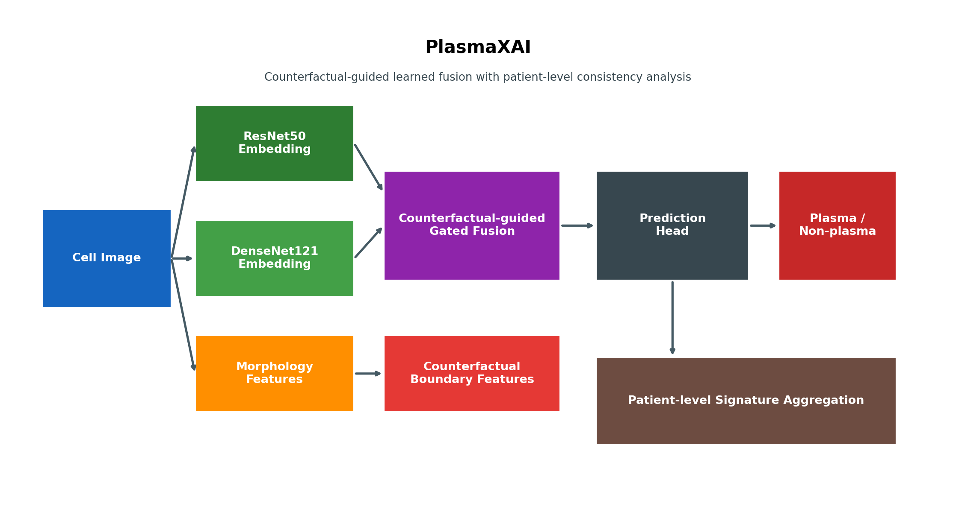
Framework Diagram
This is the high-level architecture view of PlasmaXAI. It is the best single figure for showing how microscopy input, dual deep backbones, morphology features, counterfactual features, and the learned fusion/classification path are connected end to end.
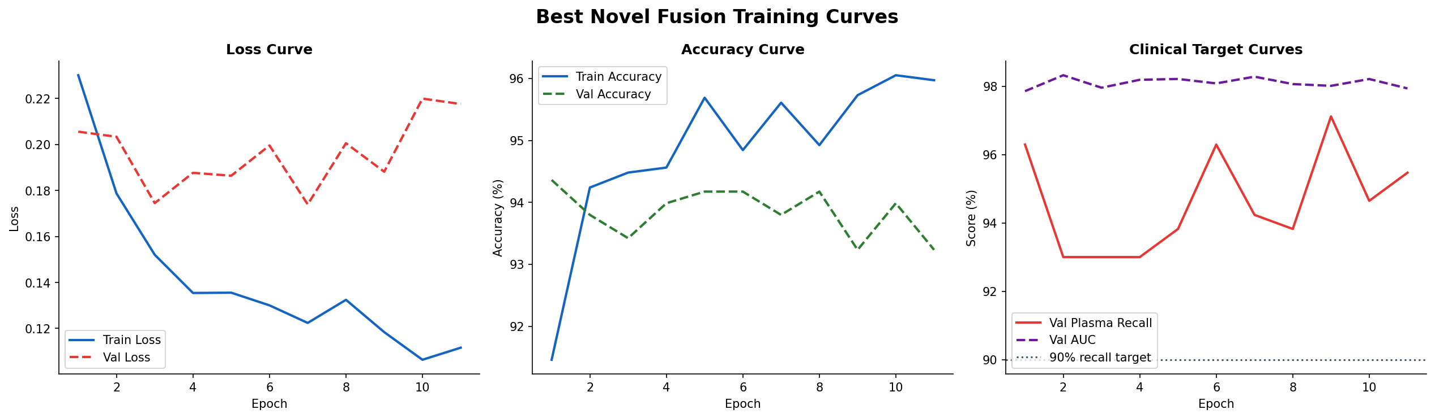
Training Curves
These curves show the optimization behavior of the novel fusion framework, including the evolution of loss, accuracy, and clinically important recall-oriented behavior across epochs.
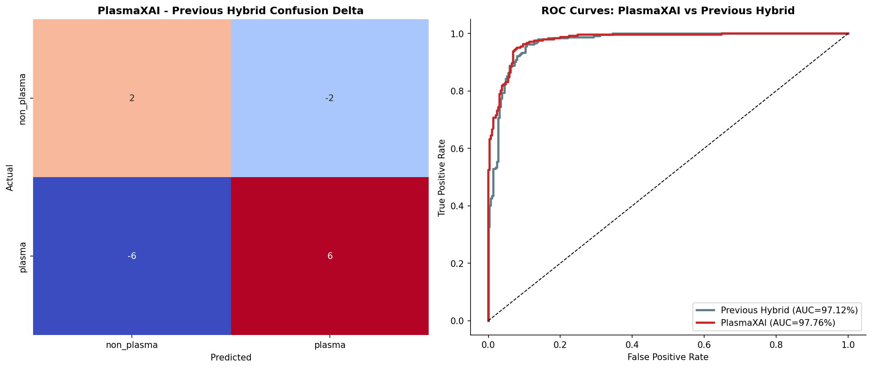
Confusion and ROC
This figure ties threshold-level performance to threshold-independent ranking quality. The confusion panel grounds the error pattern, and the ROC panel explains why the framework remains separable across operating points.
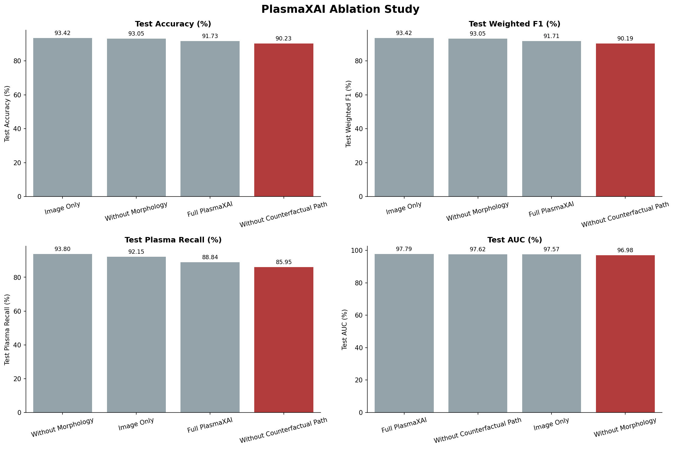
Ablation Study
This is one of the most important research figures because it demonstrates that removing the counterfactual path or morphology branch changes the performance profile. It supports the novelty claim experimentally.
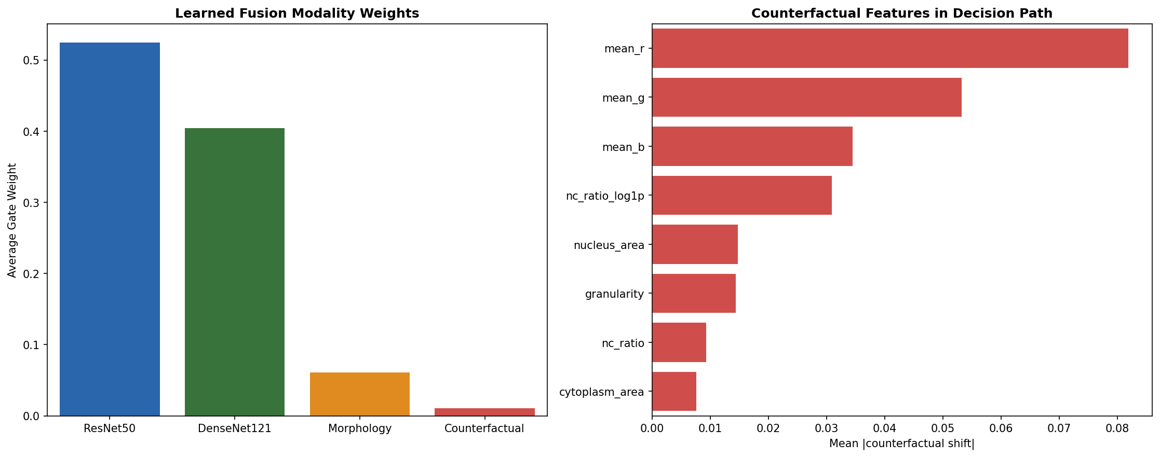
Gate and Counterfactual Analysis
This figure visualizes how the modality gates and counterfactual reasoning interact. It helps explain why the model is not just averaging branches blindly.
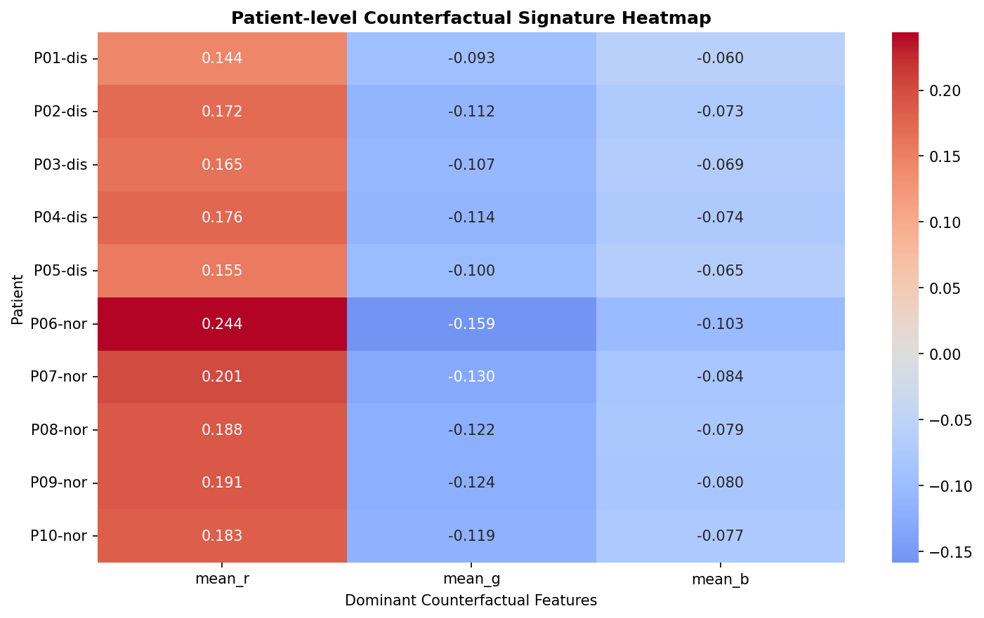
Patient Signature Heatmap
This figure summarizes patient-level consistency and cluster structure from the saved patient-level analysis. It moves the work beyond isolated cell classification.
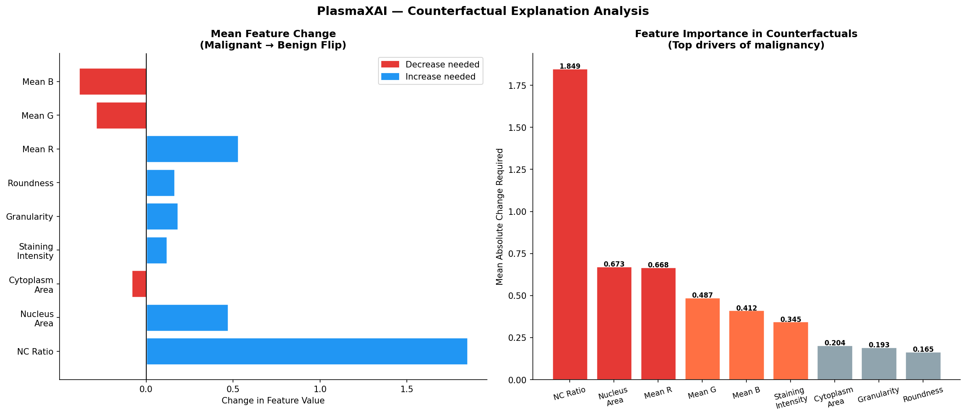
Notebook-Stage Counterfactual Analysis
This is historically important because it shows the early explainability direction before counterfactual reasoning became part of the internal model path.
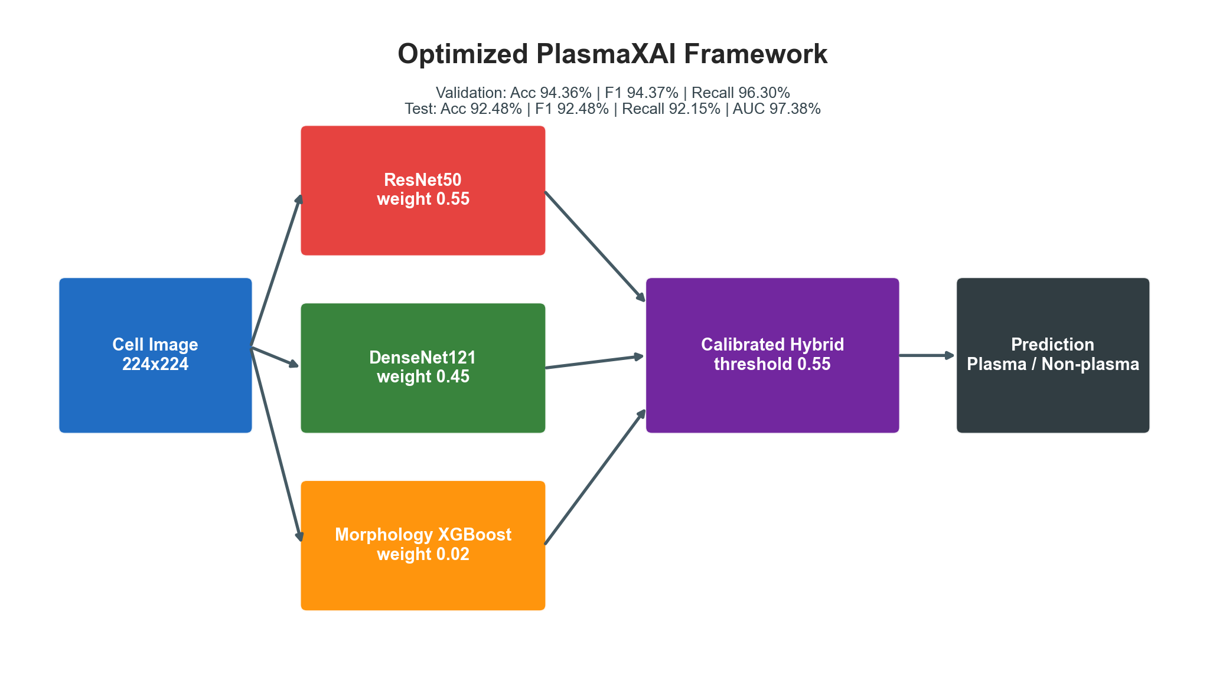
Optimization-Stage Framework Overview
This figure documents the stage between the notebook baseline and the final novel architecture. It helps show how the project matured methodologically.

F. Full Ultra-Detailed Research Record
For completeness, the complete long-form research record is reproduced below in DOCX form. This section preserves the full narrative of the project, including motivation, architecture evolution, results, packaging, deployment notes, and limitations.
PlasmaXAI Ultra-Detailed Full Research and Deployment Record

Document intent
This file is the longest and most technically detailed written record of the PlasmaXAI project. It is intentionally more exhaustive than the short competition brief and more explanatory than the standard master dossier. It documents the scientific background, problem definition, research objectives, dataset usage, architecture evolution, layer connectivity, training logic, threshold selection, results generation, robustness studies, patient-level analysis, website translation, deployment readiness, GitHub packaging, and limitations.
The purpose of this record is to answer, in one place:
- what PlasmaXAI is
- why it was built
- how it was built
- what each stage achieved
- what is genuinely novel
- what hardware/software were used
- how the final metrics were produced
- what was pushed to GitHub
- what is deployable today

1 Project identity, final name, and scope
Final preferred name: PlasmaXAI
Earlier names used during development:
- PlasmaXNet
- PLASMAXNET
Final identity: PlasmaXAI is a counterfactual-guided explainable AI framework for malignant plasma-cell recognition in multiple myeloma microscopy images. It is not only a classifier. It is a research-and-translation package consisting of:
- a notebook baseline
- an optimization-stage benchmark system
- a final learned fusion framework
- explainability assets
- patient-level exploratory analyses
- paper and diagram materials
- a doctor-facing website
- a separate inference service

2 Clinical and scientific background
Multiple myeloma is a hematologic malignancy driven by abnormal plasma-cell proliferation. Morphologic review still matters because plasma-cell appearance, burden, and organization remain relevant during diagnosis, disease monitoring, and treatment-oriented interpretation.
Why this problem matters:
- manual review is labor intensive
- interpretation depends heavily on expertise
- stain variability and morphology variation complicate consistency
- large-scale screening is difficult to scale manually
- many AI systems optimize accuracy but do not help doctors understand the
output
PlasmaXAI was designed to address that gap. The project tries to answer: "Can an explainable, high-performing plasma-cell recognition system be built that improves diagnostic support while presenting evidence in a form useful to doctors rather than only to ML developers?"

3 Research objectives
Primary objectives:

1 Build a strong malignant plasma-cell recognition framework on PCMMD.

2 Improve over the earlier notebook-stage baseline.

3 Compare against deep and morphology-based baselines.

4 Move explainability into the decision pathway itself.

5 Add patient-level consistency analysis.

6 Package the work into paper-ready figures, reports, and a doctor-facing
website.
Secondary objectives:
- improve plasma precision and recall simultaneously
- support claims with ablation and bootstrap evidence
- package the work for competition judging and deployment presentation

4 Main project locations
Root workspace: F:\BUET plasma
Main notebook: F:\BUET plasma\research\notebooks\PlasmaXAI.ipynb
Optimization script: F:\BUET plasma\research\scripts\optimize_plasmaxai.py
Final novel framework: F:\BUET plasma\research\scripts\novel_plasmaxai_pipeline.py
Website: F:\BUET plasma\apps\web
Inference service: F:\BUET plasma\apps\inference
Research package: F:\BUET plasma\research\package

5 Hardware and software environment
Verified GPU from `nvidia-smi`:
- NVIDIA GeForce RTX 3060
- 12288 MiB VRAM
- Driver version 591.86
- CUDA version 13.1
This matters because the final novel summary explicitly reports device = CUDA.
Python version verified in the local environment:
- Python 3.13.2
Relevant software used across the project:
- PyTorch
- torchvision
- timm
- OpenCV
- scikit-learn
- pandas
- NumPy
- FastAPI
- Next.js 16.2.2
- React 19.2.4
- Bun package workflow for the website
Important honesty note: CPU model and total RAM were not programmatically retrievable in the current Windows session because system info queries were access-restricted. This file therefore records the GPU and the validated software/runtime information without fabricating unavailable machine fields.

6 Dataset and split strategy
Primary dataset folder: F:\BUET plasma\data\raw\PCMMD Plasma Cells for Multiple Myeloma Diagnosis
Local related folder: F:\BUET plasma\data\raw\PCMMD_LOCAL
Usage:
- PCMMD Set 1 for model development and benchmarking
- PCMMD Set 2 for exploratory patient-level analysis
Main split:
- 70% train
- 15% validation
- 15% test
Observed counts:
- Train: 2482
- Validation: 532
- Test: 532
The split is stratified and implemented in `research/scripts/novel_plasmaxai_pipeline.py` through a two-stage `train_test_split` process:
- first split 70/30
- then split the remaining 30 into 15/15

7 Phase 1: notebook-stage baseline
Main notebook: F:\BUET plasma\research\notebooks\PlasmaXAI.ipynb
Saved baseline checkpoint: F:\BUET plasma\artifacts\models\best_plasmaxai.pth
Main notebook-stage result:
- EfficientNet test accuracy: 85.34%
- Plasma recall: 0.79
Notebook benchmark section:
- ResNet-50 benchmark accuracy: 91.92%
- ResNet-50 AUC: 0.971
- EfficientNet benchmark accuracy: 82.89%
Counterfactual stage at notebook level:
- DICE generated 60 counterfactual explanations
- prominent drivers included NC Ratio, Nucleus Area, and Mean R
Why phase 1 mattered: It established feasibility, an initial figure package, and benchmark context.
Why phase 1 was not enough:
- the main baseline was not strong enough for the intended sensitivity target
- explainability existed but was not yet inside the model’s decision pathway
- the work was still notebook-centric

8 Phase 2: optimization stage
Main optimization outputs:
- F:\BUET plasma\research\outputs\optimization\best_framework_summary.json
- F:\BUET plasma\research\outputs\optimization\best_framework_report.txt
Best optimized hybrid before the final novel extension:
- ResNet50 weight: 0.55
- DenseNet121 weight: 0.45
- Morphology contribution: 0.02
- Threshold: 0.55
Validation metrics:
- Accuracy: 94.36%
- Weighted F1: 94.37%
- Plasma recall: 96.30%
- AUC: 98.03%
Test metrics:
- Accuracy: 92.48%
- Weighted F1: 92.48%
- Plasma recall: 92.15%
- AUC: 97.38%
Best single model:
- ResNet50
- Accuracy: 92.29%
- Weighted F1: 92.31%
- Plasma recall: 94.21%
- AUC: 97.30%
Meaning of phase 2: The project clearly improved beyond the notebook baseline and showed that a hybrid design could compete strongly. However, it still looked too much like a carefully tuned ensemble of known components.

9 Why a stronger novelty step was needed
By the end of the optimization stage, the system was strong as engineering but not yet distinctive enough as a research framework. The remaining gap was:
- explainability still felt too external
- fusion was still too close to weighted blending
- there was no deeper patient-level interpretation layer
That motivated the final novel framework stage.

10 Final novel architecture overview
Main pipeline: F:\BUET plasma\research\scripts\novel_plasmaxai_pipeline.py
Main final checkpoint: F:\BUET plasma\research\outputs\novel\novel_fusion_model.pth
Supporting artifacts:
- fusion_scalers.joblib
- counterfactual_bundle.joblib
- novel_summary.json
- plasmaxai_operating_point.json
High-level idea: The final model combines:

1 ResNet50 image embeddings

2 DenseNet121 image embeddings

3 handcrafted morphology

4 counterfactual boundary descriptors

5 compact score features
These are passed through separate encoders, modulated by counterfactual signals, dynamically reweighted by a learned gate, fused, and finally classified.

11 Exact input dimensions
Using the saved feature-block definitions in `fusion_scalers.joblib`, the actual input dimensions are:
- ResNet embedding: 2048
- DenseNet embedding: 1024
- Morphology block: 10
- Counterfactual block: 24
- Score block: 3
This matters because the architecture description below is based on the real saved dimensions rather than generic assumptions.

12 Layer-by-layer novel architecture
The final architecture class is `CounterfactualGuidedFusionNet`.
Final best configuration:
- hidden_dim = 256
- tabular_dim = 128
- dropout = 0.25

12.1 ResNet encoder
Input:
- 2048-dimensional ResNet embedding
Layers:

1 LayerNorm(2048)

2 Linear(2048 -> 256)

3 GELU

4 Dropout(0.25)
Output:
- 256-dimensional ResNet latent vector

12.2 DenseNet encoder
Input:
- 1024-dimensional DenseNet embedding
Layers:

1 LayerNorm(1024)

2 Linear(1024 -> 256)

3 GELU

4 Dropout(0.25)
Output:
- 256-dimensional DenseNet latent vector

12.3 Morphology encoder
Input:
- 10-dimensional morphology vector
Layers:

1 LayerNorm(10)

2 Linear(10 -> 128)

3 GELU

4 Dropout(0.25)
Output:
- 128-dimensional morphology latent vector

12.4 Counterfactual encoder
Input:
- 24-dimensional counterfactual feature vector
Layers:

1 LayerNorm(24)

2 Linear(24 -> 128)

3 GELU

4 Dropout(0.25)
Output:
- 128-dimensional counterfactual latent vector

12.5 Score encoder
Input:
- 3-dimensional score vector:
- ResNet probability - DenseNet probability - counterfactual logistic probability
Layers:

1 LayerNorm(3)

2 Linear(3 -> 128)

3 GELU

4 Dropout(0.25)
Output:
- 128-dimensional score latent vector

12.6 Counterfactual-to-ResNet gate
Module:
- Linear(128 -> 256)
- Sigmoid
Operation: `res_feat = res_feat * cf_to_res(cf_feat)`
Meaning: The counterfactual branch directly modulates the ResNet branch. This is one of the main reasons the architecture is more than a post-hoc explanation system.

12.7 Counterfactual-to-DenseNet gate
Module:
- Linear(128 -> 256)
- Sigmoid
Operation: `den_feat = den_feat * cf_to_den(cf_feat)`
Meaning: The DenseNet latent representation is also explicitly filtered through a counterfactual gate.

12.8 Morphology-to-score refinement
Module:
- Linear(128 + 128 -> 128)
- GELU
- Dropout(0.25)
Input:
- concatenation of `morph_feat` and `cf_feat`
Operation: `score_feat = score_feat + morph_to_scores(concat(morph_feat, cf_feat))`
Meaning: The score branch does not remain a raw three-number channel. It becomes a learned, morphology-aware, counterfactual-aware signal.

12.9 Modality gate context
The gate context is the concatenation of:
- res_feat (256)
- den_feat (256)
- morph_feat (128)
- cf_feat (128)
- score_feat (128)
Total dimension:
- 896
Modality gate module:

1 LayerNorm(896)

2 Linear(896 -> 4)

3 Softmax
Output:
- four gate weights
These correspond to:
- ResNet branch
- DenseNet branch
- morphology branch
- counterfactual branch

12.10 Unification layers
To bring branch outputs into a common fusion space:
- res_unify: Linear(256 -> 256)
- den_unify: Linear(256 -> 256)
- morph_unify: Linear(128 -> 256)
- cf_unify: Linear(128 -> 256)
- score_unify: Linear(128 -> 256)

12.11 Fused modal stream
The fused modal vector is built as:
- gate_resnet * res_unify(res_feat)
- plus gate_densenet * den_unify(den_feat)
- plus gate_morph * morph_unify(morph_feat)
- plus gate_cf * cf_unify(cf_feat)
This yields one 256-dimensional fused modal representation.

12.12 Final classifier path
The unified score branch is:
- score_unify(score_feat) -> 256 dimensions
The final classifier input is:
- concat(fused_modal, score_unify(score_feat))
Total classifier input dimension:
- 512
Classifier layers:

1 LayerNorm(512)

2 Linear(512 -> 256)

3 GELU

4 Dropout(0.25)

5 Linear(256 -> 2)
Outputs:
- binary logits
- modality gates

12.13 Forward-path summary
The exact logic is:

1 encode all five input blocks

2 gate both deep image streams using counterfactual features

3 refine the score stream using morphology + counterfactual context

4 compute softmax modality weights from all streams

5 project each branch to a common 256-dimensional space

6 form a weighted modal sum across ResNet/DenseNet/Morphology/Counterfactual

7 concatenate the weighted modal sum with the score stream

8 classify into two classes
This is the central architectural novelty of PlasmaXAI.

13 Morphology feature extraction details
Each image is resized to 128 x 128 for handcrafted morphology extraction.
Computed channels:
- mean_r = average red intensity / 255
- mean_g = average green intensity / 255
- mean_b = average blue intensity / 255
Staining intensity:
- 1.0 - mean(image) / 255
Grayscale conversion:
- RGB -> grayscale
Thresholding:
- nucleus mask uses threshold 80 with binary inverse
- cell mask uses threshold 200 with binary inverse
Area quantities:
- nucleus_area = positive nucleus pixels / total pixels
- cell_area = positive cell pixels / total pixels
- cytoplasm_area = max(cell_area - nucleus_area, 0)
NC ratio:
- nucleus_area / max(cytoplasm_area, 1e-3)
- clipped at 25.0
Granularity:
- Laplacian variance / 1000
Roundness:
- computed from the largest nucleus contour using:
(4 * pi * area) / perimeter^2
The final morphology block is:
- nc_ratio
- nc_ratio_log1p
- nucleus_area
- cytoplasm_area
- staining_intensity
- granularity
- roundness
- mean_r
- mean_g
- mean_b

14 Backbone feature extraction details
Backbones used:
- ResNet50
- DenseNet121
Checkpoint sources:
- research/outputs/optimization/checkpoints/resnet50_final.pth
- research/outputs/optimization/checkpoints/densenet121_final.pth
Image preprocessing for the backbones:

1 resize to 224 x 224

2 convert to tensor

3 normalize with ImageNet statistics:
- mean [0.485, 0.456, 0.406] - std [0.229, 0.224, 0.225]
Feature extraction logic:
- `forward_features(images)`
- `forward_head(feat_map, pre_logits=True)` -> embedding
- `forward_head(feat_map)` -> logits
- softmax(logits)[:, 1] -> plasma probability
Cached embedding files:
- research/outputs/novel/cache/train_embeddings.pkl
- research/outputs/novel/cache/val_embeddings.pkl
- research/outputs/novel/cache/test_embeddings.pkl
Observed cache sizes:
- train_embeddings.pkl ~ 61.3 MB
- val_embeddings.pkl ~ 13.2 MB
- test_embeddings.pkl ~ 13.2 MB
Why caching mattered: Backbone features were expensive enough that reusing cached embeddings made the fusion search and repeated analysis stages much faster and more stable.

15 Counterfactual model and counterfactual feature construction
Counterfactual model fitting uses:
- StandardScaler
- LogisticRegression(max_iter=2000, class_weight="balanced", random_state=42)
Training morphology data:
- the training split morphology table only
Stored counterfactual bundle contents:
- scaler
- logistic regression model
- benign prototype
Counterfactual features are constructed by:

1 scaling morphology features

2 computing logistic margin

3 computing logistic plasma probability

4 reading the logistic coefficient vector

5 forming the shift-to-boundary vector `delta`

6 forming the shift-to-benign-prototype vector `proto_delta`
The final 24-dimensional counterfactual block includes:
- 10 `cf_shift_*` values
- 10 `proto_shift_*` values
- cf_margin
- cf_distance_l2
- cf_distance_l1
- cf_proto_distance
This block is one of the defining parts of the final model because it gives a mathematically structured explanation-aware representation of how far the sample lies from a lower-risk morphology region.

16 Training logic for the fusion model
Training dataset object:
- TensorDataset(res, den, morph, cf, scores, labels)
Class balancing strategy:
- inverse-frequency weights
- WeightedRandomSampler
- class-weighted CrossEntropyLoss
Optimizer:
- AdamW
Scheduler:
- CosineAnnealingLR with `T_max = epochs`
Mixed precision:
- torch.autocast used on CUDA
- torch.amp.GradScaler used on CUDA
Early stopping:
- based on validation priority
- patience from the config
Config search space:
- fusion_cfg_a
- fusion_cfg_b
- fusion_cfg_c
Best config selected:
- fusion_cfg_a
- hidden_dim = 256
- tabular_dim = 128
- dropout = 0.25
- lr = 0.001
- weight_decay = 0.0001
- epochs = 60
- batch_size = 128
- patience = 10

17 Threshold search and model selection logic
Threshold search is performed on validation probabilities using:
- `np.linspace(0.05, 0.95, 181)`
That means the threshold is scanned in 0.005 increments.
Metrics computed at each threshold:
- accuracy
- weighted F1
- plasma precision
- plasma recall
- AUC
The priority rule is not just "highest accuracy". The model selection logic first checks whether plasma recall reaches a clinical floor of 90%. The priority tuple is:

1 recall floor met or not

2 accuracy

3 weighted F1

4 AUC

5 plasma recall
This is extremely important for understanding how the final result was produced. The model was selected with a clinical screening mindset rather than with a purely academic top-1 accuracy mindset.

18 Best-history behavior and internal gate trends
Best-history file:
- research/outputs/novel/best_fusion_history.csv
Observed early epochs:
- epoch 1
- train loss: 0.2300 - train acc: 91.46 - val acc: 94.36 - val recall: 96.30 - val AUC: 97.86
- epoch 4
- train loss: 0.1354 - train acc: 94.56 - val acc: 93.98 - threshold: 0.72
- epoch 9
- train loss: 0.1184 - train acc: 95.73 - val recall: 97.12
Average gate examples over epochs show dynamic rather than fixed behavior:
- ResNet gate commonly high
- DenseNet gate fluctuates meaningfully
- morphology gate becomes non-trivial in several epochs
- counterfactual direct gate may appear numerically smaller on average, but
this understates its importance because it also modulates the image streams and refines the score branch

19 Final novel-summary result versus final preferred operating point
Original novel summary (`novel_summary.json`) reports:
- threshold: 0.76
- accuracy: 93.23%
- weighted F1: 93.24%
- plasma precision: 91.87%
- plasma recall: 93.39%
- AUC: 97.76%
Final preferred operating point (`plasmaxai_operating_point.json`) reports:
- threshold: 0.72
- accuracy: 93.42%
- weighted F1: 93.43%
- plasma precision: 91.24%
- plasma recall: 94.63%
- AUC: 97.76%
Why 0.72 became the preferred public threshold:
- it preserved the same AUC
- it kept precision strong
- it improved plasma recall
- it produced the best overall doctor-relevant balance

20 Extended model comparison
Main comparison file:
- research/outputs/novel/plasmaxai_extended_model_comparison.csv
Final comparison:
- PlasmaXAI
- 93.42 accuracy - 93.43 weighted F1 - 91.24 plasma precision - 94.63 plasma recall - 97.76 AUC
- ResNet50
- 91.92 accuracy - 89.02 plasma precision - 93.80 plasma recall - 97.05 AUC
- Prev Hybrid
- 91.73 accuracy - 90.91 plasma precision - 90.91 plasma recall - 97.12 AUC
- DenseNet121
- 89.85 accuracy - 90.17 plasma precision - 87.19 plasma recall - 96.36 AUC
- Morph XGBoost
- 84.96 accuracy - 80.22 plasma precision - 88.84 plasma recall - 92.94 AUC
- Morph Random Forest
- 83.27 accuracy - 77.62 plasma precision - 88.84 plasma recall - 92.08 AUC
- Morph RBF-SVM
- 80.26 accuracy - 74.04 plasma precision - 87.19 plasma recall - 90.89 AUC
- Morph Logistic Regression
- 78.38 accuracy - 70.42 plasma precision - 90.50 plasma recall - 87.76 AUC
Main conclusion: PlasmaXAI is the strongest overall system when the practically relevant trio of accuracy, plasma precision, and plasma recall are considered together.

21 Ablation study details
Main ablation files:
- research/outputs/novel/ablation_results.csv
- research/outputs/novel/plasmaxai_ablation_results.csv
Ablation modes:
- Image Only
- Without Morphology
- Without Counterfactual Path
- Full Novel Fusion
Main ablation test results:
- Image Only
- accuracy: 93.42 - precision: 93.31 - recall: 92.15 - AUC: 97.57
- Without Morphology
- accuracy: 93.05 - precision: 91.16 - recall: 93.80 - AUC: 96.98
- Without Counterfactual Path
- accuracy: 90.23 - precision: 92.04 - recall: 85.95 - AUC: 97.62
- Full Novel Fusion in the ablation run
- accuracy: 91.73 - precision: 92.67 - recall: 88.84 - AUC: 97.79
Most important interpretation: Removing the counterfactual path caused the clearest recall damage. That is the strongest experimental support for the claim that the counterfactual branch is functionally important, not decorative.

22 Bootstrap reliability analysis
Main file:
- research/outputs/novel/bootstrap_summary.json
The bootstrap function resamples the test set 1000 times with replacement and computes:
- accuracy
- weighted F1
- plasma recall
- AUC
Preferred operating-point bootstrap summary:
- Accuracy mean: 93.46%
- Accuracy 95% CI: 91.16 to 95.30
- Weighted F1 mean: 93.46%
- Weighted F1 95% CI: 91.17 to 95.31
- Plasma recall mean: 94.62%
- Plasma recall 95% CI: 91.30 to 97.20
- AUC mean: 97.77%
- AUC 95% CI: 96.56 to 98.63
Why this matters: These intervals demonstrate that the result is not based only on a single point estimate. The model remains strong across bootstrap resamples.

23 Patient-level analysis details
Main patient-level files:
- patient_cell_predictions.csv
- patient_counterfactual_summary.csv
- plasmaxai_patient_robustness.json
- plasmaxai_patient_lopo_auc.csv
- plasmaxai_patient_permutation_auc.csv
Patient analysis pipeline:

1 read Set 2 patient folders

2 read diagnosis.csv

3 parse YOLO-style label files

4 crop individual cells from full images

5 add 10% padding around each crop

6 map plasma to the positive class

7 extract ResNet and DenseNet embeddings for each crop

8 extract morphology features for each crop

9 compute counterfactual features for each crop

10 run fusion inference on each crop

11 aggregate crop outputs to patient summaries
Patient summary fields include:
- mean_novel_prob
- mean_plasma_prob_cells
- gt_plasma_fraction
- mean_cf_distance_plasma
- cf_consistency
- gate_cf_mean
- top_counterfactual_feature
Internal patient-level findings:
- 10 patients total
- 5 diseased
- 5 normal
- patient AUC using mean novel probability = 1.000
- one-sided exact permutation p = 0.0040
- two-sided exact permutation p = 0.0079
- leave-one-patient-out AUC mean = 1.000
- top separating features = mean_r, mean_g, mean_b
Required caution: These results are internally strong but exploratory. They are based on a very small same-source cohort and are not a substitute for external validation.

24 Explainability and doctor-facing interpretation
Explainability assets include:
- fig6_counterfactual_analysis.png
- novel_fig4_gates_counterfactuals.png
- plasmaxai_fig4_counterfactual_explanation.png
- novel_fig6_clinical_insight.png
- plasmaxai_fig6_clinical_insight.png
- clinical_insight_report.txt
Explainability design philosophy:
- do not only show developer-oriented model traces
- provide clinically interpretable counterfactual cues
- indicate what changes would lower suspicion
- support doctor review rather than replace it
One internal clinical-insight finding:
- diseased patients showed a reproducible counterfactual signature centered on
mean_r, mean_g, and mean_b
This is stated honestly as an internal, clinically interesting signal, not as final externally validated biological proof.

25 Website translation and doctor-facing workflow
Website folder:
- F:\BUET plasma\apps\web
The website includes:
- login and registration screens
- doctor dashboard
- new-case upload flow
- case review page
- patient directory
- patient profile page
- report download
- doctor notes
- patient CRUD in local mode
The intent of the website is to demonstrate that the research can be surfaced inside a clinical review interface rather than staying trapped inside notebook cells and static plots.
The website stack includes:
- Next.js 16.2.2
- React 19.2.4
- TypeScript
- Bootstrap Icons
- Framer Motion
- Recharts
- Supabase-ready auth/data/storage wiring

26 Vercel deployment readiness
To make the repository Vercel-deployment-ready, the following were added:
Website side:
- updated `apps/web/README.md`
- updated `apps/web/.env.example`
- safer hosted inference behavior in `src/lib/inference/service.ts`
Inference side:
- `apps/inference/app/app.py`
- `apps/inference/build.py`
- `apps/inference/pyproject.toml`
- updated `apps/inference/README.md`
- switched to `opencv-python-headless`
Repo-level deployment guide:
- `docs/VERCEL_DEPLOYMENT_READY.md`
- root `vercel.json`
Recommended deployment shape:
- one Vercel project from the repository root
- Framework Preset = `Services`
- `apps/web` mounted at `/`
- `apps/inference` mounted at `/api/inference`
- Supabase for auth, data, and storage
Important honesty note: This makes the repo deployment-ready from a code/configuration perspective, but PyTorch inference on serverless infrastructure can still face cold-start and runtime-size constraints. A dedicated persistent inference host may still be the better long-term production target.

27 GitHub packaging truth
Repository: https://github.com/Arnob10150/PlasmaXAI.git
Pushed website tag:
- v1.2.0
Pushed core items include:
- artifacts/models/best_plasmaxai.pth
- research/outputs/novel/novel_fusion_model.pth
- apps/web
- apps/inference
- research/package
Not literally every local file was pushed. A few large or redundant files were intentionally excluded, including:
- data/archives/PCMMD Plasma Cells for Multiple Myeloma Diagnosis.zip
- research/outputs/optimization/checkpoints/convnext_tiny_search.pth
- research/outputs/optimization/checkpoints/convnext_tiny_final.pth
This means the repo contains the main research and deployment package, but not every oversized redundant local artifact.

28 Limitations
Scientific limitations:
- no external multi-center validation
- patient-level cohort is very small
- same-source exploratory patient analysis can be optimistic
Deployment limitations:
- hosted persistence requires proper Supabase configuration
- local fallback mode is for local evaluation, not production persistence
- PyTorch inference on Vercel can still be operationally constrained
Claim boundary: The strongest honest claim is not "fully clinically proven". The strongest honest claim is: "PlasmaXAI is a high-performing, explainable, counterfactual-guided plasma-cell screening framework with a credible path toward clinician-in-the- loop deployment."

29 Key artifact checklist
Notebook baseline:
- research/notebooks/PlasmaXAI.ipynb
Optimization script:
- research/scripts/optimize_plasmaxai.py
Novel final pipeline:
- research/scripts/novel_plasmaxai_pipeline.py
Main final model:
- research/outputs/novel/novel_fusion_model.pth
Final operating point:
- research/outputs/novel/plasmaxai_operating_point.json
Main benchmark comparison:
- research/outputs/novel/plasmaxai_extended_model_comparison.csv
Bootstrap summary:
- research/outputs/novel/bootstrap_summary.json
Ablation summary:
- research/outputs/novel/ablation_results.csv
Patient summaries:
- research/outputs/novel/patient_counterfactual_summary.csv
- research/outputs/novel/plasmaxai_patient_robustness.json
Website:
- apps/web
Inference service:
- apps/inference
Short competition brief:
- research/package/PlasmaXAI_competition_master_brief.txt
Medium-length master dossier:
- research/package/PlasmaXAI_everything_master_dossier.txt
This ultra-detailed record:
- research/package/PlasmaXAI_ultra_detailed_full_record.txt

30 Final bottom line
PlasmaXAI should be understood as a full research-and-translation framework. It began as a notebook baseline, matured through benchmark optimization, and arrived at a final learned architecture that fuses ResNet50, DenseNet121, handcrafted morphology, counterfactual boundary information, and score-level signals inside one decision pipeline. The final preferred operating point achieved 93.42% accuracy, 93.43% weighted F1, 91.24% plasma precision, 94.63% plasma recall, and 97.76% AUC. The project also produced ablations, bootstrap intervals, exploratory patient-level analyses, clinician-facing explainability, paper materials, a doctor-facing website, and a deployment-ready inference service. Its strongest honest contribution is not just a metric, but an interpretable digital hematopathology framework with a credible path toward doctor-in-the-loop use.

31 References
[1] Silva, A.B., Matos, J., Costa, A., et al. PCMMD: A dataset of plasma cells for multiple myeloma diagnosis. Scientific Data 12, 543 (2025).
[2] Rajkumar, S.V. Multiple myeloma: 2022 update on diagnosis, risk-stratification, and management. American Journal of Hematology 97, 1086--1107 (2022).
[3] Litjens, G., Kooi, T., Bejnordi, B.E., et al. A survey on deep learning in medical image analysis. Medical Image Analysis 42, 60--88 (2017).
[4] Bera, K., Schalper, K.A., Rimm, D.L., Velcheti, V., Madabhushi, A. Artificial intelligence in digital pathology---new tools for diagnosis and precision oncology. Nature Reviews Clinical Oncology 16, 703--715 (2019).
[5] He, K., Zhang, X., Ren, S., Sun, J. Deep residual learning for image recognition. Proceedings of the IEEE Conference on Computer Vision and Pattern Recognition, 770--778 (2016).
[6] Huang, G., Liu, Z., van der Maaten, L., Weinberger, K.Q. Densely connected convolutional networks. Proceedings of the IEEE Conference on Computer Vision and Pattern Recognition, 4700--4708 (2017).
[7] Wachter, S., Mittelstadt, B., Russell, C. Counterfactual explanations without opening the black box: Automated decisions and the GDPR. Harvard Journal of Law and Technology 31(2), 841--887 (2018).
[8] Mothilal, R.K., Sharma, A., Tan, C. Explaining machine learning classifiers through diverse counterfactual explanations. FAT* 2020, 607--617 (2020).
[9] Guo, C., Pleiss, G., Sun, Y., Weinberger, K.Q. On calibration of modern neural networks. International Conference on Machine Learning, 1321--1330 (2017).
[10] Ribeiro, M.T., Singh, S., Guestrin, C. "Why should I trust you?": Explaining the predictions of any classifier. Proceedings of the 22nd ACM SIGKDD International Conference on Knowledge Discovery and Data Mining, 1135--1144 (2016).
[11] Selvaraju, R.R., Cogswell, M., Das, A., et al. Grad-CAM: Visual explanations from deep networks via gradient-based localization. Proceedings of the IEEE International Conference on Computer Vision, 618--626 (2017).
[12] Lundberg, S.M., Lee, S.-I. A unified approach to interpreting model predictions. Advances in Neural Information Processing Systems, 4765--4774 (2017).

32 Step-by-step walkthrough of how one final result was produced
This section explains, step by step, how a single final reported PlasmaXAI test result was actually generated in practice.
Step 1: Dataset load The pipeline starts by scanning the Set 1 folder under `data/raw/PCMMD_LOCAL/set1` and collecting file paths for the class folders defined in `CLASS_NAMES`. Every valid image path is stored together with:
- the path
- numeric label
- class name
- image_id
Step 2: Train/validation/test split The full dataframe is split with stratification. This is important because it ensures the class distribution is preserved across train, validation, and test partitions. The split uses a fixed seed, so the result is repeatable for the same environment and input data.
Step 3: Morphology extraction Every image in the full dataset has morphology features extracted and cached to `segmentation_morph_features.csv`. This cache avoids recomputing handcrafted features every time the fusion search runs.
Step 4: Counterfactual model fitting Only the training portion of the morphology table is used to fit the logistic-regression-based counterfactual boundary model. This is important for keeping the decision-boundary logic properly inside the training data regime.
Step 5: Counterfactual feature computation Counterfactual features are then computed separately for training, validation, and test. This produces per-sample boundary-distance and prototype-shift descriptors that eventually become part of the final neural input.
Step 6: Backbone embedding extraction The training, validation, and test splits are passed through ResNet50 and DenseNet121. Their pre-logit embeddings and probabilities are extracted and cached to pickle files. These features are then merged with morphology and counterfactual data.
Step 7: Fusion search The pipeline trains several candidate fusion configurations. For each epoch in each candidate configuration, it:
- trains on the training set
- evaluates on the validation set
- searches validation thresholds
- stores the epoch metrics and mean gate values
- keeps the best state according to the validation priority rule
Step 8: Best-model selection After all configurations finish, the best configuration is selected by the same clinical priority logic used during validation.
Step 9: Held-out test evaluation The best fusion model is evaluated on the held-out test set. The model outputs probabilities and gate values. The selected threshold is applied to generate class predictions and compute final metrics.
Step 10: Comparison and packaging The test metrics are then compared with baseline systems, written to JSON/CSV, used for plotting, and later refined into the final preferred threshold at 0.72.

33 Detailed explanation of the training loop and optimization dynamics
The training loop in `train_fusion_model` is worth documenting carefully because it shows how the final result was stabilized.

33.1 Weighted sampling
The class distribution of the training data is converted into inverse class weights. These weights are used twice:
- first to build `sample_weights` for the `WeightedRandomSampler`
- second to build class weights for the final `CrossEntropyLoss`
This means minority-class underrepresentation is addressed both in which examples appear during training and in how loss penalizes mistakes.

33.2 Mixed precision
Whenever CUDA is available, the training loop uses:
- `torch.autocast`
- `torch.amp.GradScaler`
This accelerates training and reduces memory pressure on the GPU. Because the project was run on an RTX 3060 with 12 GB of VRAM, mixed precision helps keep training efficient while still allowing sufficiently large batch sizes.

33.3 Optimizer choice
`AdamW` is used rather than plain SGD or vanilla Adam. This is a sensible choice for a mixed tabular-deep fusion network because:
- it is effective for dense parameter optimization
- decoupled weight decay often behaves more cleanly than naive L2 treatment
- it is widely used for transformer-like and hybrid deep architectures

33.4 Scheduler choice
`CosineAnnealingLR` is used with `T_max = epochs`. This means the learning rate gradually anneals over the full training horizon rather than stepping down at a few abrupt milestones. For compact fusion heads trained on frozen deep embeddings, this often gives a smoother optimization trajectory than a harsh piecewise schedule.

33.5 Best-state retention
The training loop does not simply keep the final epoch. Instead, it stores the state dictionary of the best validation state seen so far. That state is later reloaded into the model before returning the training result. This is important because it ensures the test set is evaluated using the validation-best fusion parameters rather than the last epoch by default.

33.6 Patience and stopping
The loop increments `bad_epochs` whenever the validation priority fails to improve. Once `bad_epochs` reaches the configured patience, training stops. In practice, this prevents wasting compute on epochs that are no longer improving the model meaningfully.

34 Exact meaning of the saved artifacts in research/outputs/novel
The `research/outputs/novel` directory contains many files, and each one has a distinct purpose. This section explains them in plain language.
`novel_fusion_model.pth`
- the final trained fusion network weights
`fusion_scalers.joblib`
- the scaling objects for morphology, counterfactual, and score features
- also contains the feature-block definitions used to recover input dimensions
`counterfactual_bundle.joblib`
- the logistic regression counterfactual model
- the scaler used before that model
- the benign prototype vector
`novel_summary.json`
- the original novel-framework summary
- contains best configuration, threshold, metrics, patient summary, and
ablation information
`plasmaxai_operating_point.json`
- the later selected preferred threshold and final preferred public metrics
`best_fusion_history.csv`
- epoch-level trace for the best fusion model
- includes train loss, train accuracy, validation metrics, threshold, and mean
gate weights
`ablation_results.csv`
- CSV representation of ablation results
`bootstrap_summary.json`
- bootstrap confidence interval summary
`patient_cell_predictions.csv`
- per-cell patient-level exploratory inference results
`patient_counterfactual_summary.csv`
- patient-level aggregated summary values
The figure files in `research/outputs/novel/figures` are not just presentation assets. They correspond to specific analytical stages of the project and can be used to defend claims made in the competition brief or the paper.

35 Detailed explanation of patient-level crop processing
The patient-level analysis is easy to misread as if it were a simple table aggregation, but there is real image processing behind it.

35.1 Patient directory structure
The pipeline expects patient folders whose names start with `patient`. Inside each patient folder, it expects:
- an `images` directory
- a `labels` directory
The labels are text files aligned with the images.

35.2 Label parsing
Each label line is interpreted as:
- class id
- x-center
- y-center
- bounding-box width
- bounding-box height
These are treated as normalized coordinates and are transformed into pixel coordinates using the image width and height.

35.3 Padding strategy
After the crop is computed from the bounding box, 10% padding is added in both the x and y directions. This is important because cell context around the bounding box may still carry useful morphology and stain information.

35.4 Crop extraction and filtering
If the crop is empty, the sample is skipped. Otherwise the crop is retained and stored as an RGB array. This means the patient-level inference stage runs on true extracted cell crops rather than on metadata only.

35.5 Consistency analysis
For plasma-positive cells within a patient, the code computes pairwise cosine similarity of the counterfactual-shift vectors. This creates a patient-level consistency value that summarizes whether malignant-like counterfactual movements are coherent across plasma cells in the same patient.
That is one of the reasons the patient-level analysis is scientifically interesting despite being exploratory.

36 Detailed explanation of the doctor-facing PDF/report generation path
The reporting logic is another important part of the translation story.

36.1 Why reports matter
A model result on its own is not enough in a clinical context. A doctor often needs:
- the prediction
- the confidence
- the supporting interpretation
- the case identity
- an image or reference to the reviewed material
- a document that can be retained or shared

36.2 Report generation in the website
The website’s report builder uses `pdf-lib` and the project’s own `buildCaseReportPdf` logic. That means a newly created case can produce a real downloadable PDF rather than only a web card.

36.3 Report content style
The reports are intentionally more clinician-facing than developer-facing. They include:
- the case code and patient code
- the title
- the doctor identity context
- the prediction summary
- confidence-related information
- the clinical note
- explainability text
- image/analysis visuals where available

36.4 Why this matters for competition scoring
This strengthens both:
- impact and real-world application
- methodology and implementation logic
because it demonstrates that the project is not only a training script but a review-support system with documentation output.

37 Doctor-facing website architecture in more depth
The website is not a simple static landing page. It is organized as a workspace application.

37.1 Core route groups
The application contains:
- landing page
- login page
- register page
- dashboard
- new case page
- case detail page
- history
- patient list
- patient detail
- reports
- profile
- settings

37.2 Local versus cloud modes
The site can operate in two broad modes:
Local mode:
- uses local doctor accounts
- uses local JSON-backed case and patient storage
- supports offline/local evaluation
- can fall back to local Python inference
Cloud-ready mode:
- uses Supabase auth
- uses Supabase database tables
- uses Supabase storage buckets
- expects a real inference API URL

37.3 Why both modes exist
The local mode made it possible to keep iterating on the interface while the full deployment stack was still being prepared. The cloud-ready mode makes the site translatable to real hosting instead of remaining a purely local demo.

37.4 Patient CRUD
Patient create, update, and delete were added to the local workspace so the doctor-facing flow would feel more like a real review system and less like a developer-only prototype.

38 Vercel deployment implementation details
The Vercel readiness work was not only a documentation change; it required code changes to make hosting behavior honest and safer.

38.1 Website-side hosted inference behavior
Originally, the website could fall back to running the local Python inference script. That is useful for local development but not appropriate for a hosted Vercel deployment. The website inference service helper was therefore changed to:
- use `INFERENCE_API_URL` when provided
- allow local fallback only outside hosted deployment
- return a clean "not configured" reason if hosted inference is unavailable

38.2 Inference-service Vercel entrypoint
Vercel’s FastAPI support expects a supported entrypoint. An explicit `app/app.py` wrapper was therefore added so the service exposes its FastAPI app in a Vercel-compatible location.

38.3 Model-asset staging
Because the model artifacts live outside the inference folder in the repo, `build.py` was added to stage the required files into `model_assets/` during a hosted build. This is a practical deployment step, not just a documentation note.

38.4 Function limits
The root `vercel.json` now defines the `inference` service with an increased memory and duration budget. This does not solve every production constraint, but it makes the hosted deployment more realistic than leaving the Python service completely unbounded or implicit.

39 Competition-oriented interpretation of the whole project
PlasmaXAI scores well conceptually because it addresses multiple judging axes at once.
Clarity of problem:
- medically relevant problem
- clear need for explainable support
- clear difference between notebook baseline and final framework
Impact and real-world application:
- useful in review-heavy workflows
- can support documentation and patient follow-up
- website strengthens translational credibility
Methodology:
- combined deep image features and handcrafted morphology
- used a learned fusion architecture
- embedded counterfactual reasoning inside the model path
- supported claims with ablation and bootstrap
Originality:
- not just a static ensemble
- counterfactual path is functionally integrated
- patient-level exploratory analysis extends beyond standard image
classification
Expected outcomes:
- strong test metrics
- good precision/recall balance
- clear benchmark improvement
Domain relevance:
- AI in medicine
- explainable AI
- digital pathology / hematology
- clinically meaningful deployment framing

40 Why PlasmaXAI should be described as a framework, not just a model
The word "framework" is appropriate here because the project includes:
- multi-stage development
- multiple data modalities
- explicit threshold-selection logic
- explainability integration
- ablation and robustness logic
- patient-level aggregation
- diagram and report infrastructure
- a doctor-facing web interface
- a deployable inference service
If the work had ended at a single trained `.pth` file and one ROC curve, it would be more accurate to call it a model. Because it includes the broader design, interpretability, and translation layer, "framework" is the right word.

