PLASMAXNET: A Counterfactual-Guided Multi-Branch Fusion Framework for Malignant Plasma Cell Recognition and Patient-Level Morphologic Signature Analysis

Research Objectives
This study develops PLASMAXNET as an explainable computational pathology framework for malignant plasma cell recognition on the PCMMD dataset. The objectives are to improve cell-level discrimination beyond earlier optimized baselines, integrate counterfactual information directly into the classifier decision path, validate whether cell-level counterfactual behavior aggregates into stable patient-level signatures, and compare PLASMAXNET against a broader benchmark including additional morphology-driven machine learning models while prioritizing clinically useful plasma recall.

Proposed Methodology
PLASMAXNET combines frozen ResNet50 and DenseNet121 image embeddings with a handcrafted morphology branch, a counterfactual feature branch, and a score branch. Morphology features include nucleus-to-cytoplasm ratio, nucleus area, cytoplasm area, staining intensity, granularity, roundness, and mean RGB channels. A logistic-regression counterfactual boundary model is trained on morphology descriptors to estimate feature shifts required to move a sample toward the benign decision boundary. These counterfactual features are then injected into the main fusion model, where they modulate the image streams through sigmoid gates, refine the score stream, and contribute to a learned softmax modality gate before final classification. The final PLASMAXNET comparison uses a validation-selected high-recall operating point so that sensitivity to malignant plasma cells remains the leading clinical priority.

Outcomes and Results
At the selected high-recall operating point, PLASMAXNET achieved 92.86% accuracy, 92.87% weighted F1, 95.45% plasma recall, and 97.76% AUC on the held-out test set. This operating point uses a threshold of 0.51 selected on the validation set. In the expanded benchmark, the strongest non-PLASMAXNET baseline by accuracy was ResNet50 with 91.92% accuracy, while the strongest non-PLASMAXNET baseline by plasma recall was ResNet50 at 93.80%. PLASMAXNET therefore became the best model on both accuracy and plasma recall. Bootstrap analysis at the high-recall operating point produced a 95% confidence interval of 90.41 to 94.92 for accuracy and 92.34 to 97.85 for plasma recall. Patient-level analysis from the main PLASMAXNET run remained strong, with patient AUC 1.000 using mean novel probability and dominant disease-associated counterfactual features mean_r, mean_g, mean_b.

Impact Applications
PLASMAXNET is suitable for computer-assisted plasma cell screening, triage support in digital hematopathology, and explainable decision-support research. Its counterfactual-guided design allows users to inspect how morphology changes could alter malignant probability, while the patient-level aggregation layer supports consistency analysis beyond isolated cells. This is useful for model auditing, disease-signature discovery, and future clinician-in-the-loop validation. With external validation, PLASMAXNET could support transparent multiple-myeloma screening workflows, morphology-aware biomarker research, and practical deployment in low-resource environments where both performance and interpretability matter.

Diagrams
The PLASMAXNET package includes the following primary visual assets: plasmaxnet_fig13_framework_diagram.png, plasmaxnet_fig12_extended_model_comparison.png, novel_fig8_training_curves.png, plasmaxnet_fig14_confusion_roc.png, novel_fig11_patient_signature_heatmap.png, PLASMAXNET_Architecture.drawio.

Figures
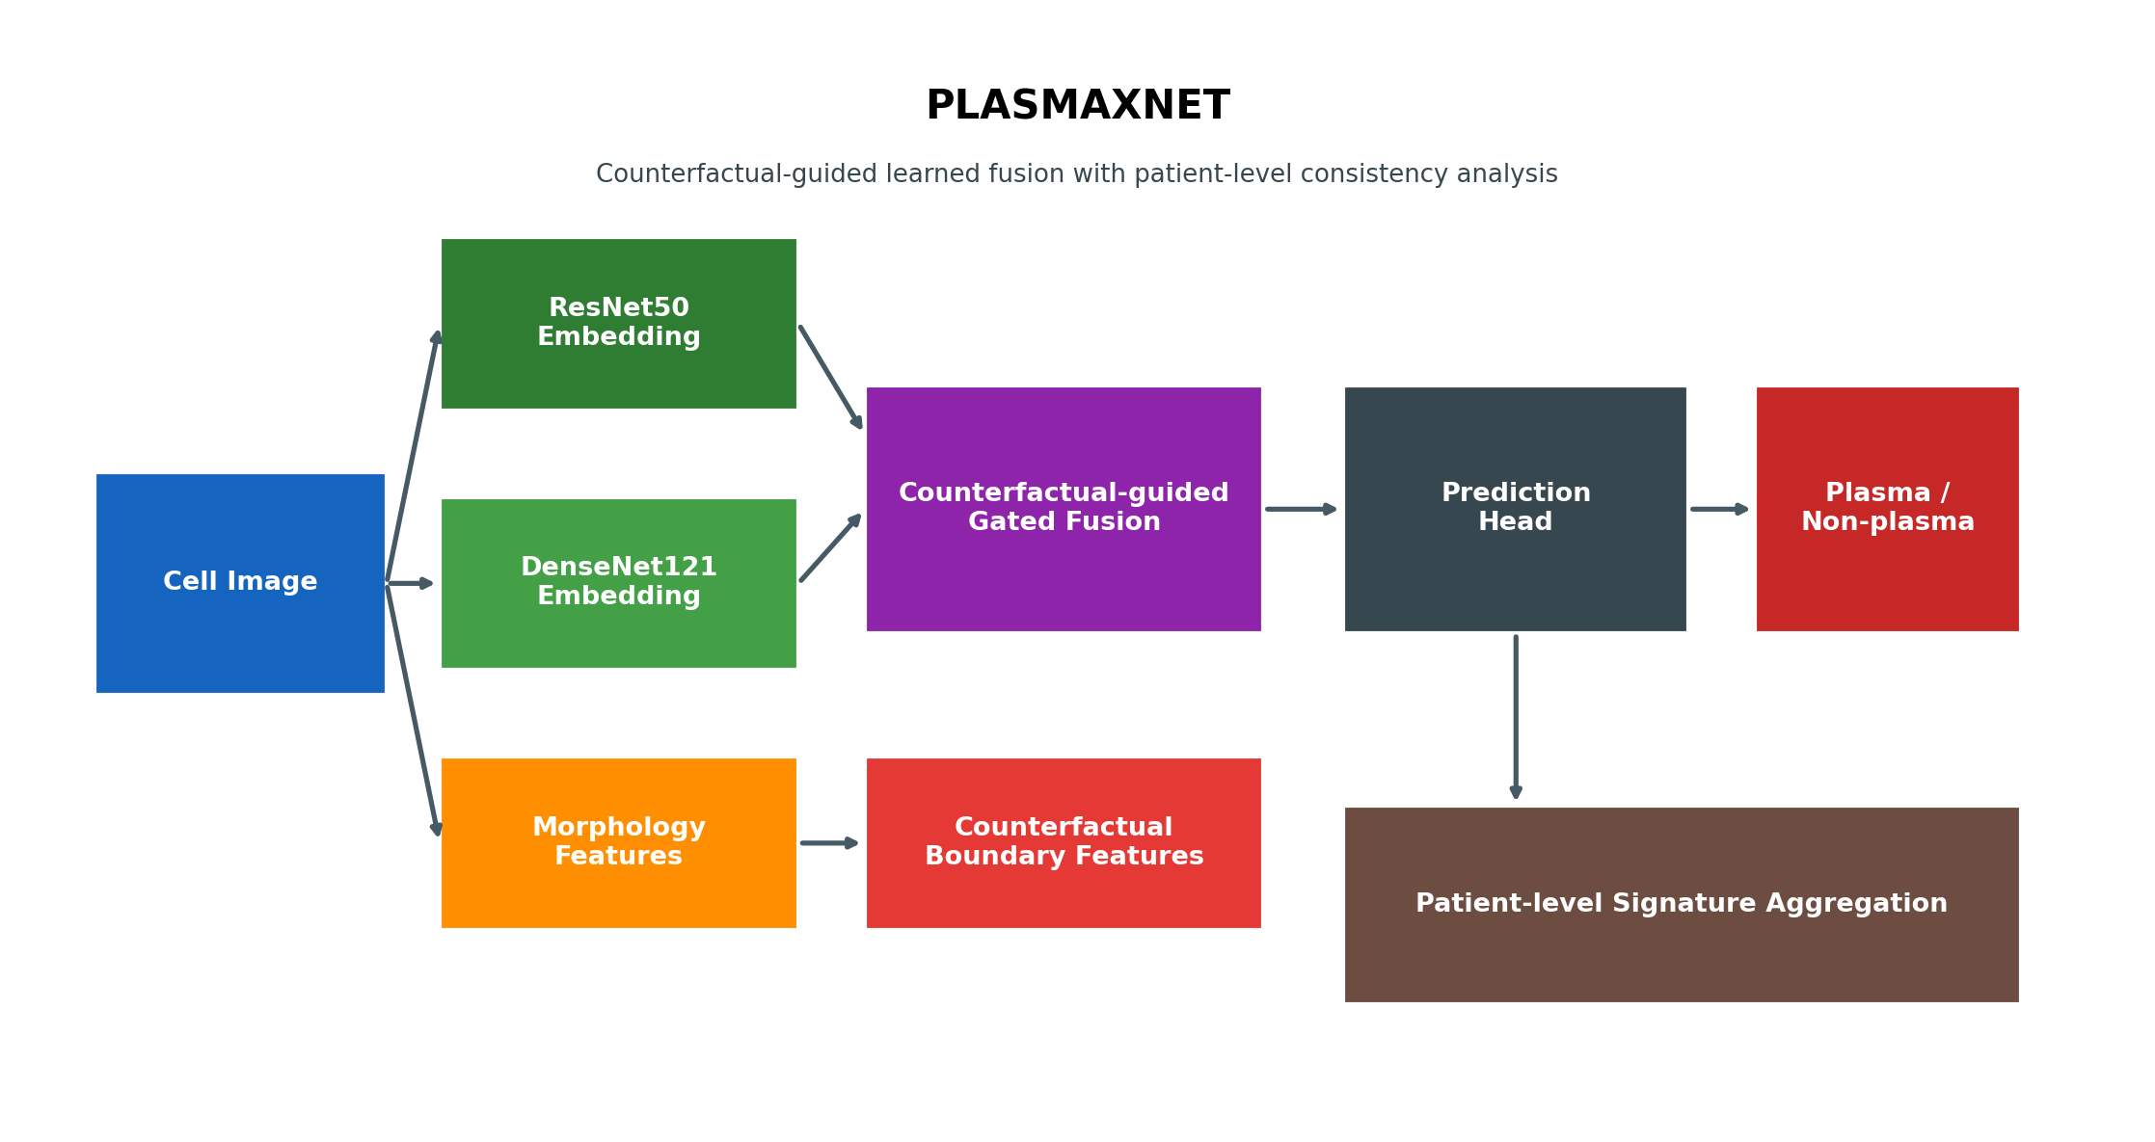
Figure 1. PLASMAXNET architecture overview showing the multi-branch fusion design and patient-level signature analysis pathway.
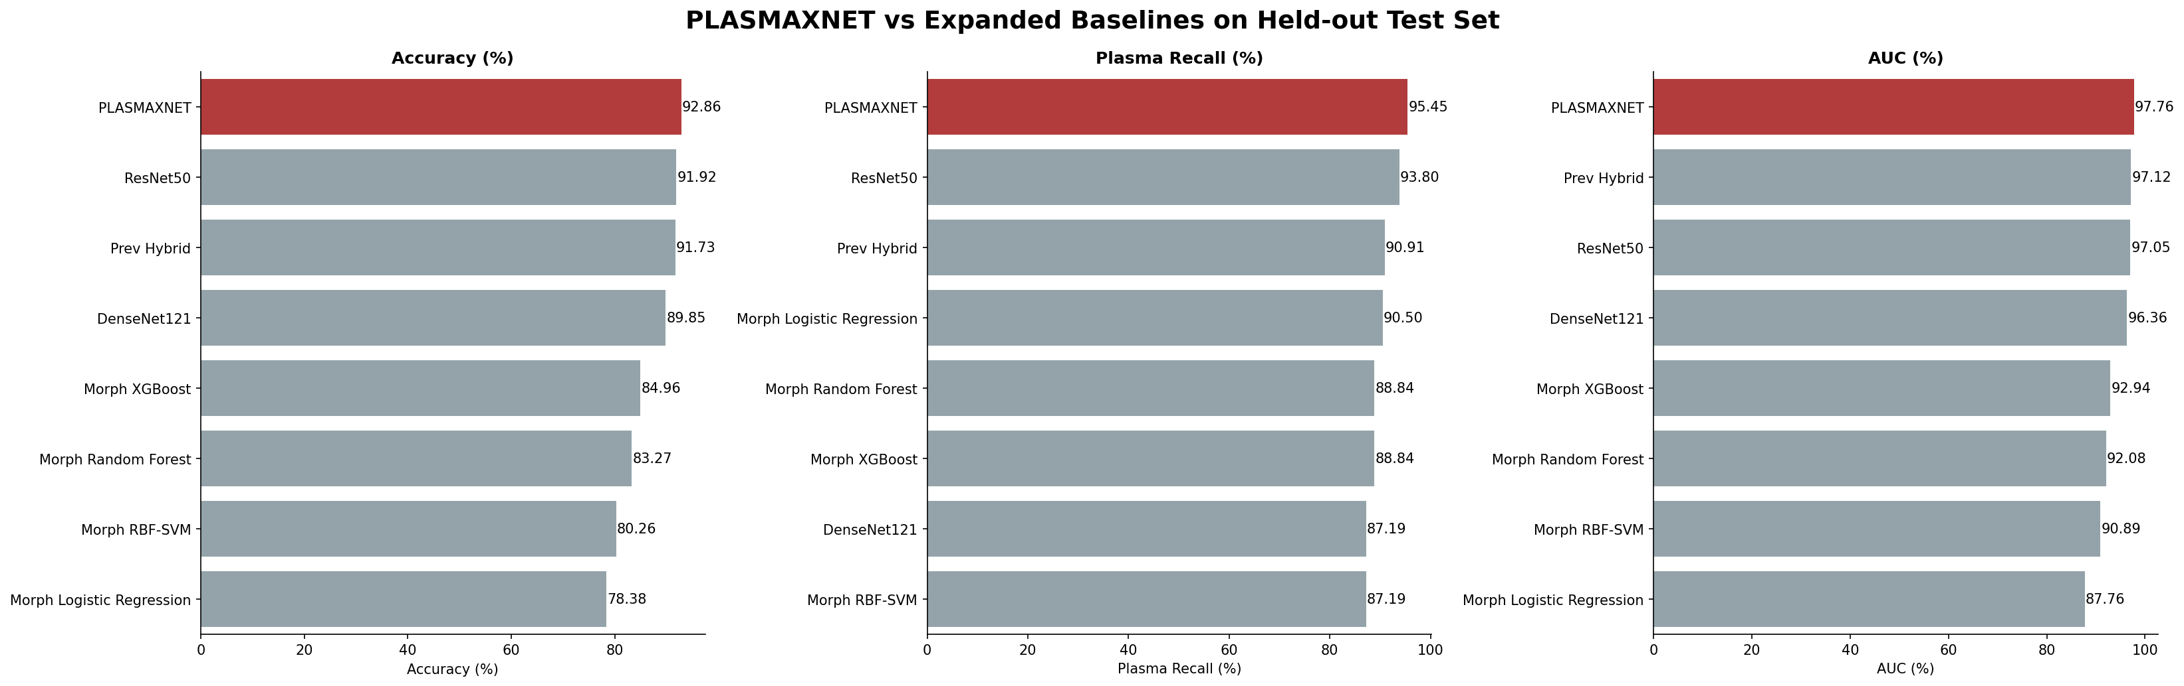
Figure 2. Expanded model comparison showing that PLASMAXNET leads the benchmark on both accuracy and plasma recall at the selected operating point.
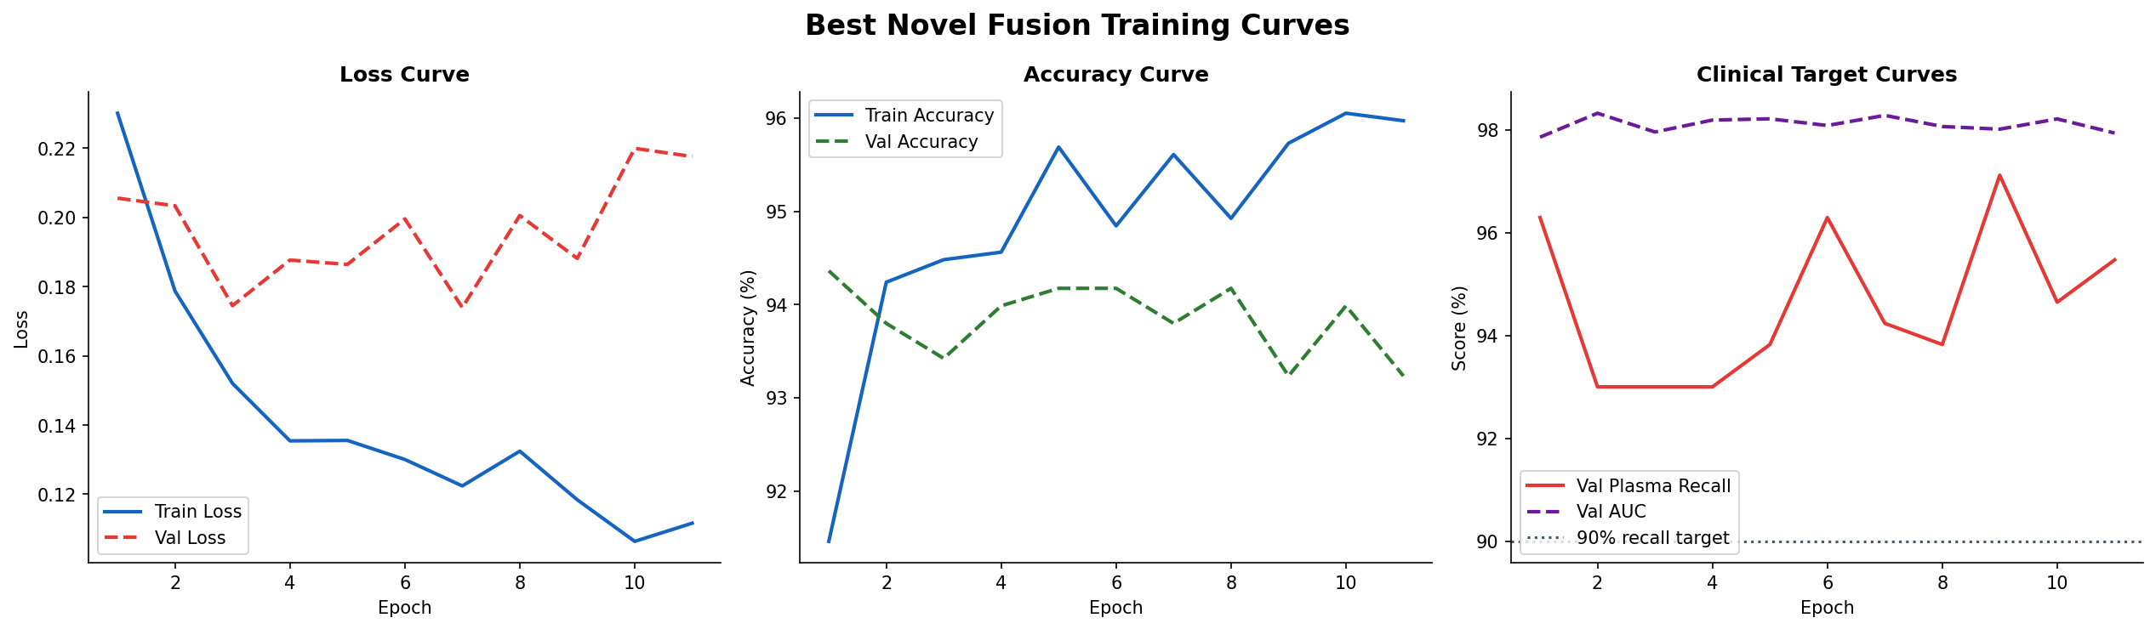
Figure 3. Training and validation curves for the selected PLASMAXNET fusion configuration.
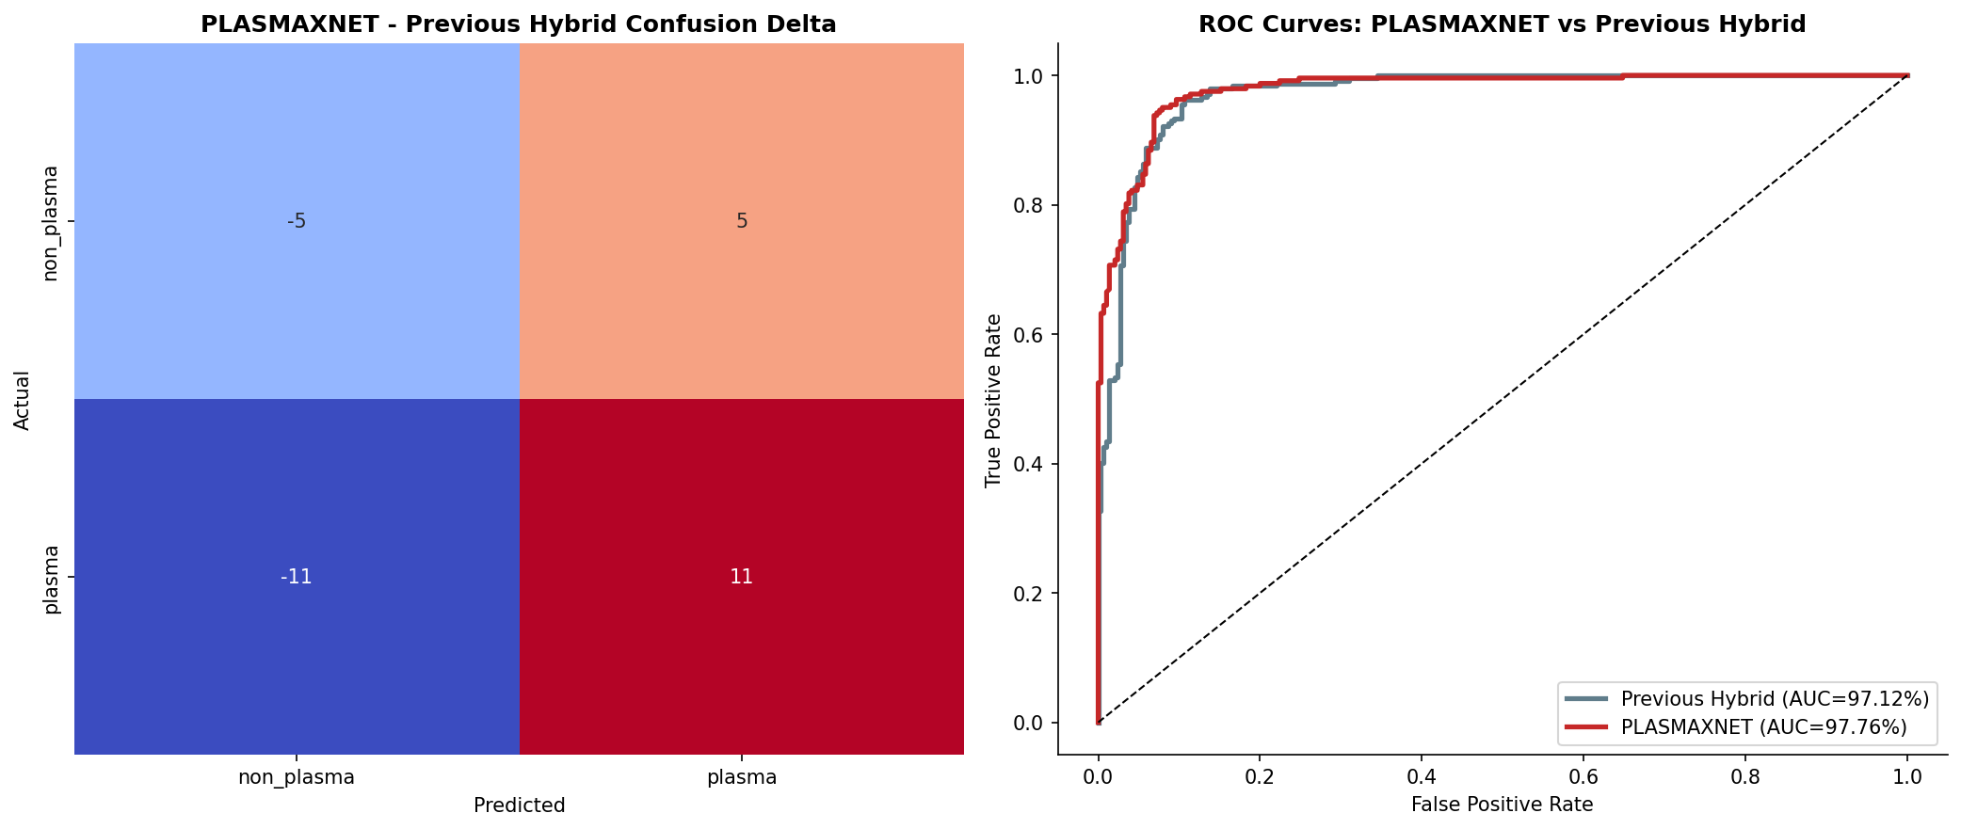
Figure 4. Confusion-delta and ROC comparison between PLASMAXNET and the previous hybrid baseline.
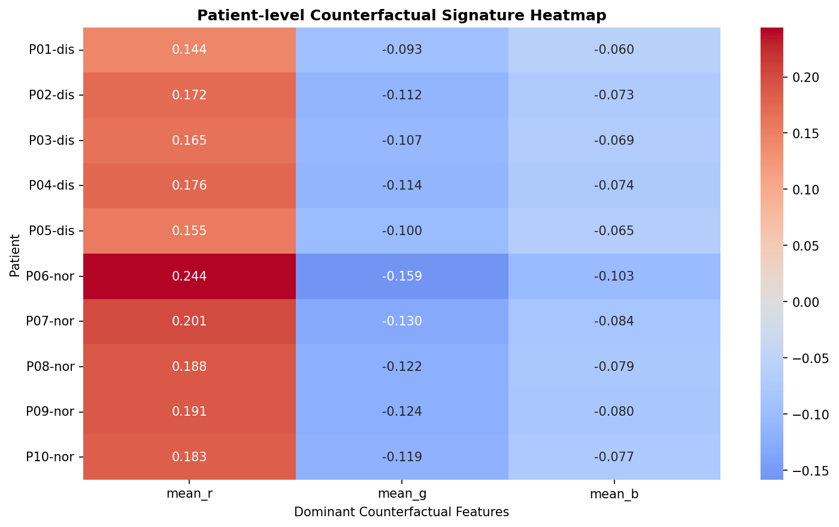
Figure 5. Patient-level signature heatmap summarizing disease-associated counterfactual morphology patterns across the patient cohort.

Additional Diagrams
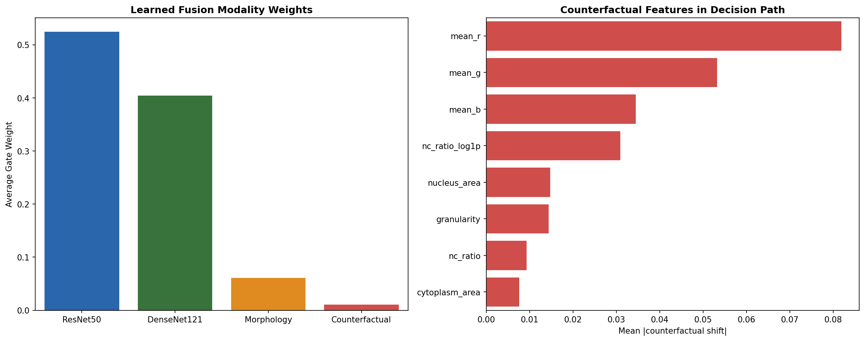
Figure 6. Learned fusion modality weights and the most influential counterfactual features in the PLASMAXNET decision path.
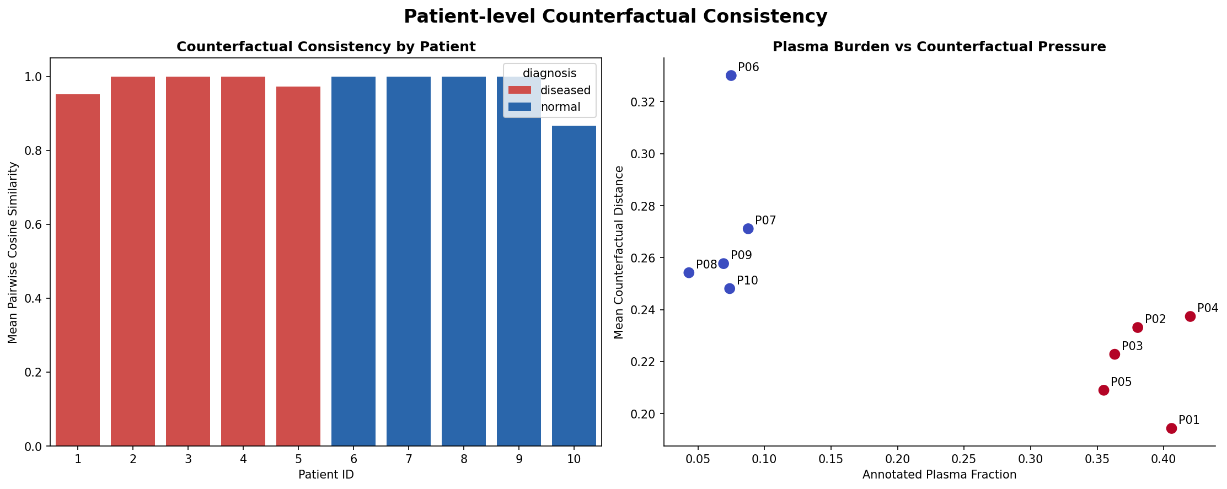
Figure 7. Patient-level counterfactual consistency analysis across diseased and normal subjects.
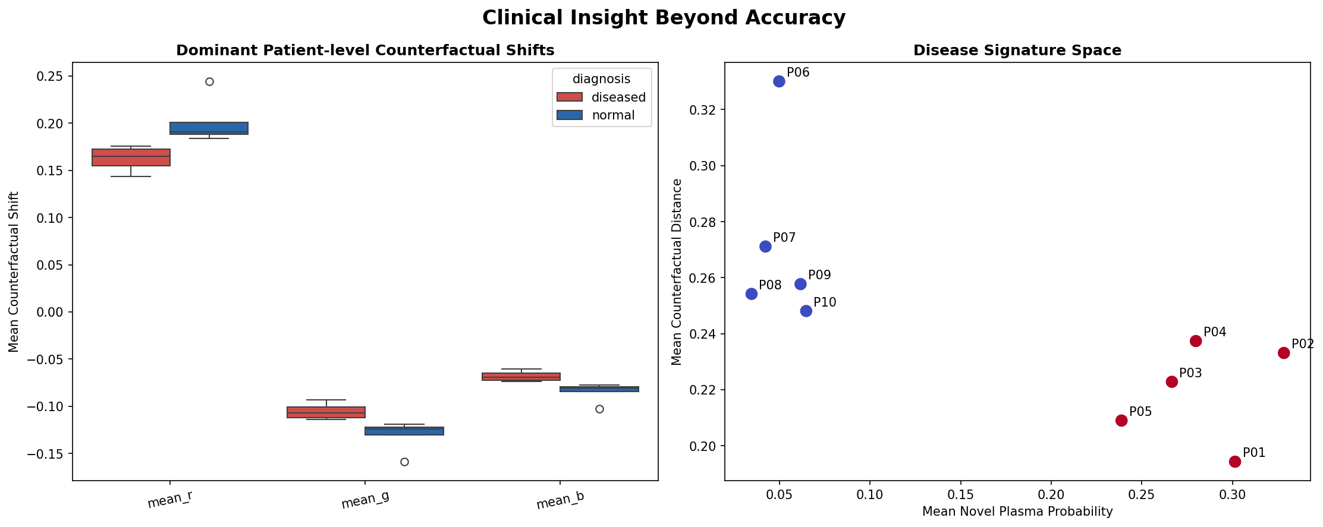
Figure 8. Clinical insight panel showing top patient shift features and the disease-signature space.
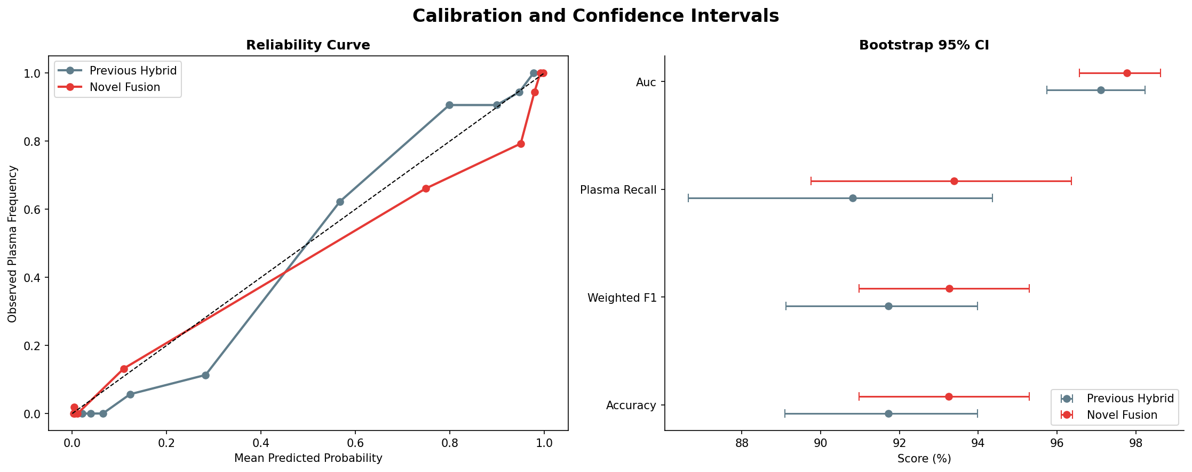
Figure 9. Calibration curves and bootstrap confidence intervals for PLASMAXNET and the previous hybrid baseline.
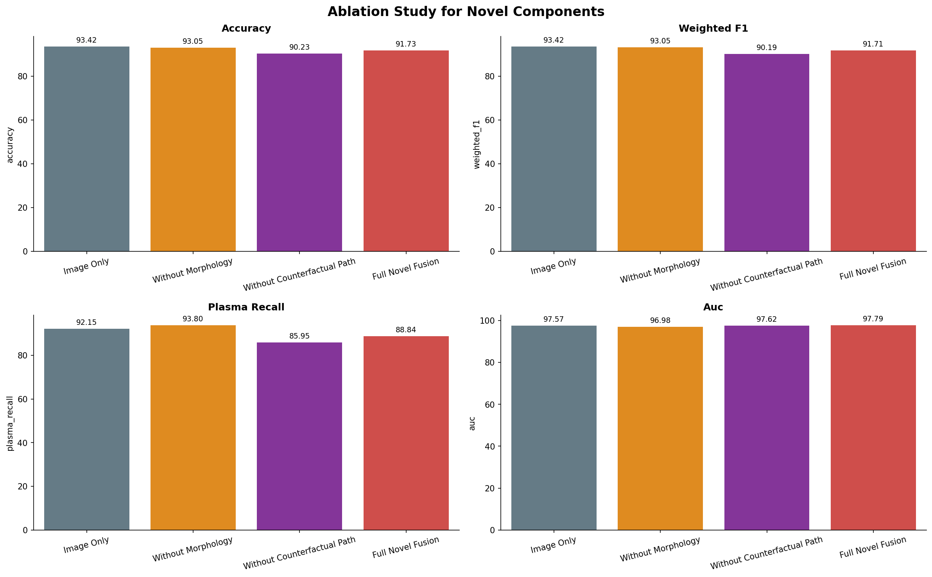
Figure 10. Ablation study summarizing the contribution of the full PLASMAXNET design relative to reduced variants.
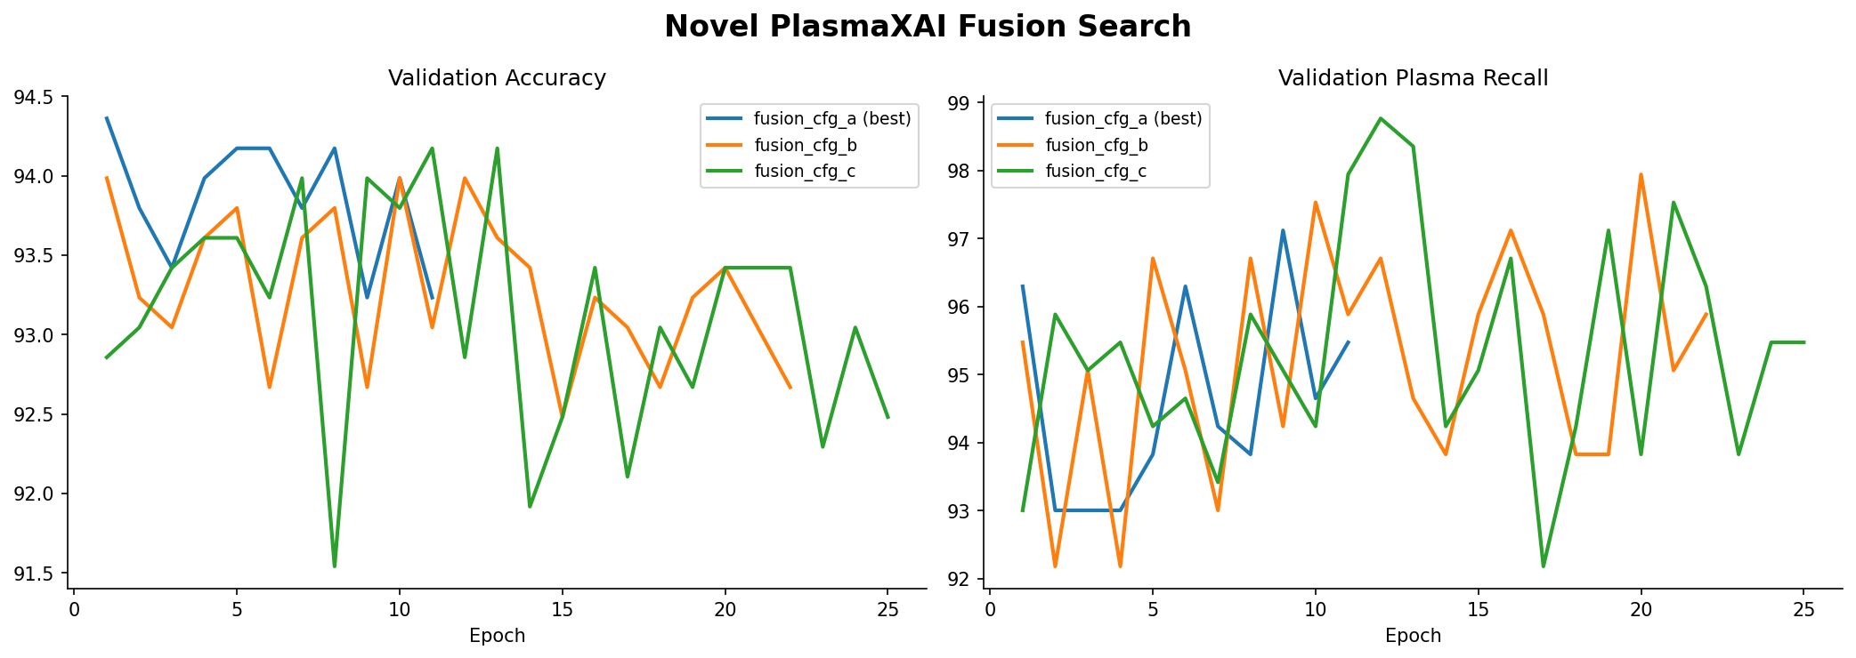
Figure 11. Fusion search summary across candidate PLASMAXNET configurations.

