PlasmaXAI: Counterfactual-Guided Fusion for Explainable Malignant Plasma Cell Recognition and Patient-Level Morphologic Consistency Analysis

Research Objectives
Multiple myeloma diagnosis depends heavily on recognizing malignant plasma cells, yet manual microscopic screening is time-consuming, experience-dependent, and difficult to scale. This study aims to develop PlasmaXAI as an explainable computational pathology framework that improves malignant plasma cell recognition on the PCMMD dataset while remaining clinically interpretable. The first objective is to outperform strong deep-learning and classical morphology-based baselines on the held-out test set. The second objective is to move explainability inside the prediction pathway by using counterfactual morphology signals as direct model inputs rather than only as a post-hoc explanation layer. The third objective is to evaluate whether cell-level explainability patterns can be aggregated into patient-level consistency signatures. The fourth objective is to produce a deployment-oriented operating point that balances high plasma recall with stronger precision so the model is useful for practical screening workflows.

Proposed Methodology
PlasmaXAI uses a multi-branch learned fusion architecture instead of a fixed weighted ensemble. Images from PCMMD Set 1 are divided into stratified training, validation, and test splits, while PCMMD Set 2 is used for exploratory patient-level analysis. Each cell image is resized to 224 x 224 and normalized for CNN processing. Two frozen image backbones, ResNet50 and DenseNet121, provide high-level feature embeddings that capture complementary visual patterns. In parallel, a handcrafted morphology pipeline extracts nucleus-to-cytoplasm ratio, nucleus area, cytoplasm area, staining intensity, granularity, roundness, and mean RGB channels, together with a log-transformed ratio feature. A morphology-based logistic counterfactual boundary model is then trained to estimate how far each sample lies from the benign decision boundary and what feature shifts would move it toward that boundary. These counterfactual outputs are not only visualized later; they are injected directly into the main classifier. Inside PlasmaXAI, separate encoders transform the ResNet, DenseNet, morphology, counterfactual, and score streams. Counterfactual features modulate the image streams through sigmoid gates, refine the score branch, and contribute to a learned softmax modality gate that determines the relative contribution of each branch before final classification. Training uses AdamW, cosine annealing, weighted sampling, early stopping, and validation-based threshold selection. Additional benchmarking is performed against ResNet50, DenseNet121, the previous optimized hybrid model, Morph Logistic Regression, Morph RBF-SVM, Morph Random Forest, and Morph XGBoost.

Outcomes
At the selected precision-recall balanced operating point with threshold 0.72, PlasmaXAI achieved 93.42% accuracy, 93.43% weighted F1, 91.24% plasma precision, 94.63% plasma recall, and 97.76% AUC on the held-out test set. This made PlasmaXAI the strongest model in the expanded benchmark across the three practically important classification measures: accuracy, precision, and recall. The best non-PlasmaXAI baseline by accuracy was ResNet50 at 91.92%, the best baseline by precision was Prev Hybrid at 90.91%, and the best baseline by recall was ResNet50 at 93.80%. Bootstrap analysis further supported the stability of the final operating point, with a 95% confidence interval of 91.16-95.30 for accuracy, 91.30-97.20 for plasma recall, and 96.56-98.63 for AUC. Explainability outputs showed that counterfactual morphology signals and modality gates were actively involved in the prediction path rather than being disconnected visual add-ons. At the patient level, mean novel probability achieved an internal AUC of 1.000 on a ten-patient exploratory cohort, with exact permutation p-values of 0.0040 one-sided and 0.0079 two-sided, while leave-one-patient-out AUC remained 1.000. These findings are encouraging, but the patient-level result is still exploratory because the cohort is small and comes from the same source domain. The dominant disease-associated shift features were mean_r, mean_g, mean_b.

Impact and Applications
The practical value of PlasmaXAI is that it combines strong predictive performance with transparent decision support. In digital hematopathology, the framework can assist plasma cell screening, triage suspicious cells for review, and reduce the burden of manually examining large numbers of images. Its counterfactual pathway can help users understand what morphologic changes increase or decrease malignant probability, which is useful for model auditing, quality control, and clinician-in-the-loop validation. The patient-level aggregation layer also makes the framework useful for exploratory morphology-signature discovery rather than only single-cell classification. Beyond direct laboratory support, the framework can contribute to explainable AI research in medical imaging, low-resource deployment scenarios, and future biomarker studies, provided that broader external validation is performed before any strong clinical claims are made.

Visual Support
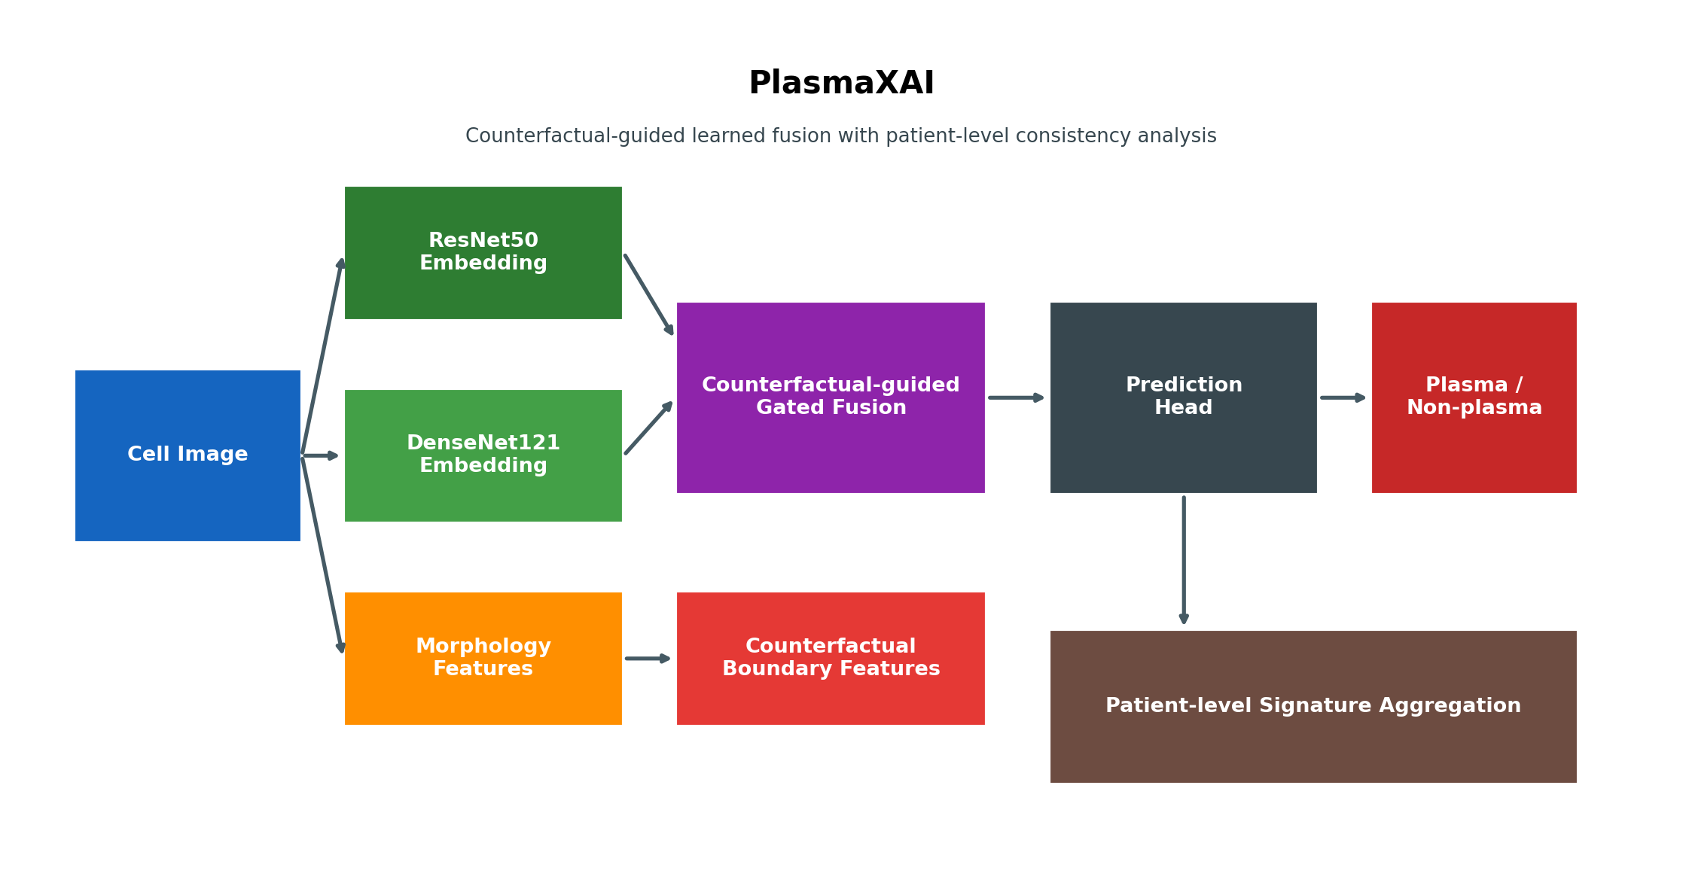
Figure 1. PlasmaXAI architecture overview showing the multi-branch fusion design and the explainability pathway.
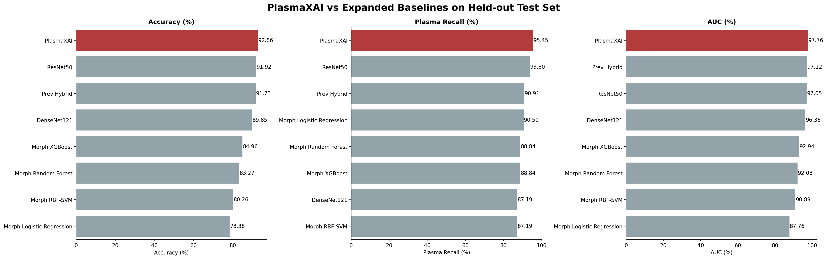
Figure 2. Expanded model comparison showing PlasmaXAI against deep-learning and morphology-based baselines.
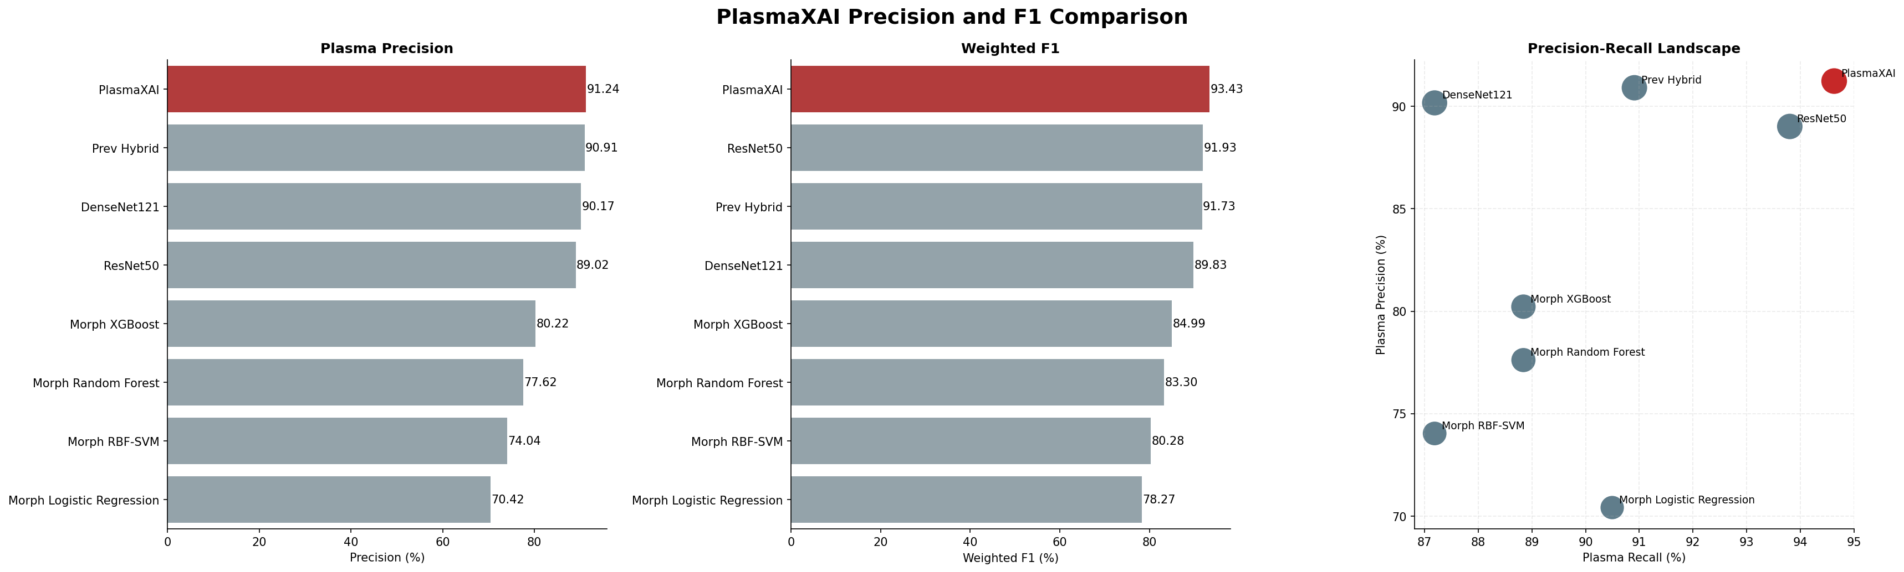
Figure 3. Precision and weighted-F1 comparison across the full benchmark.
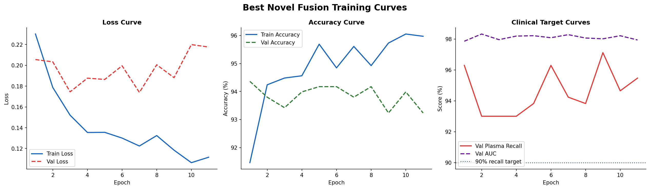
Figure 4. Training and validation curves for the selected PlasmaXAI fusion configuration.
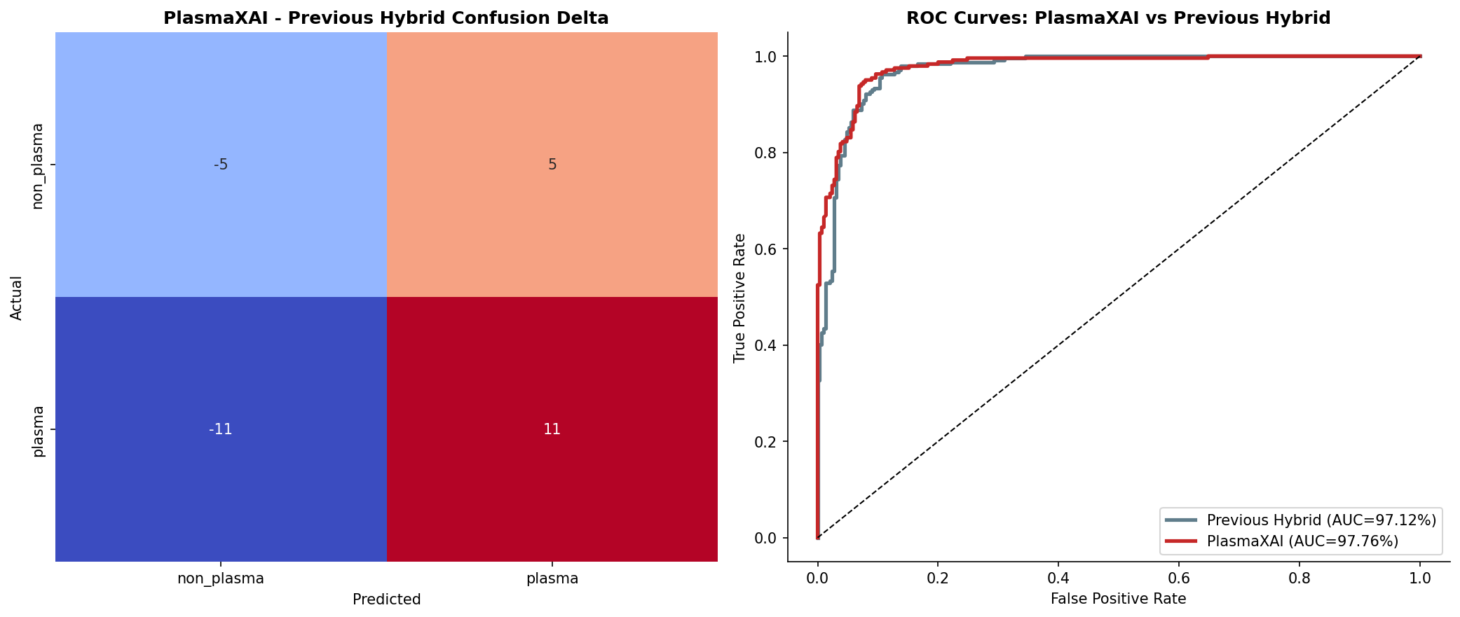
Figure 5. Confusion-delta and ROC comparison between PlasmaXAI and the previous hybrid baseline.
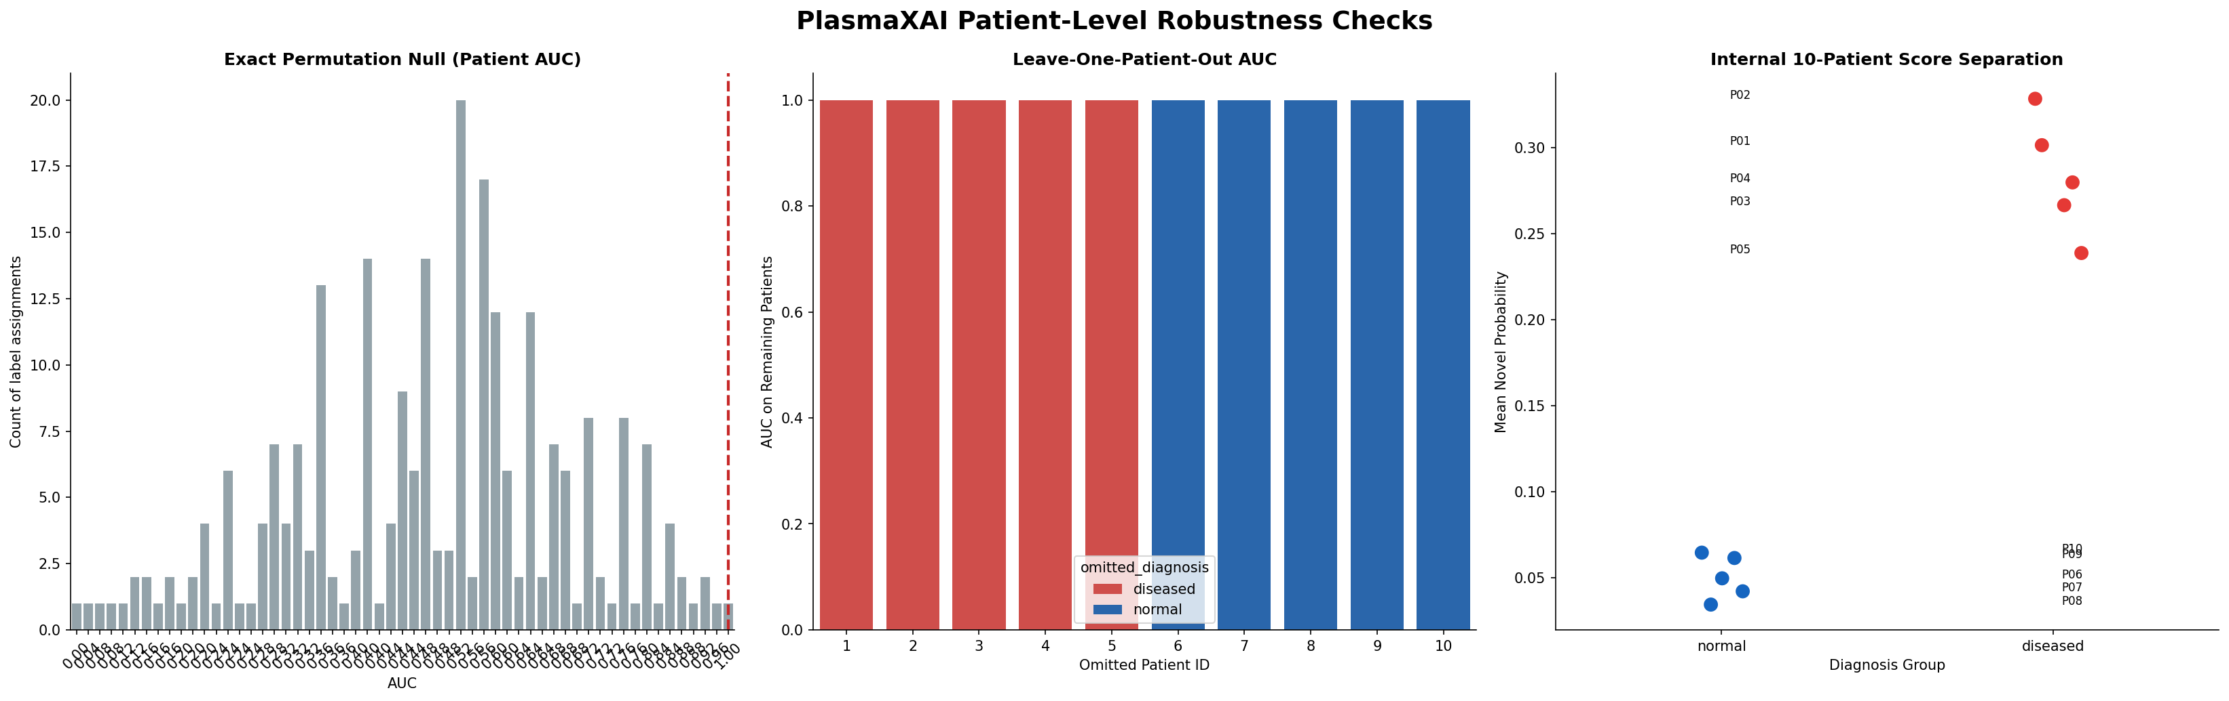
Figure 6. Patient-level robustness analysis with permutation testing and leave-one-patient-out stability.
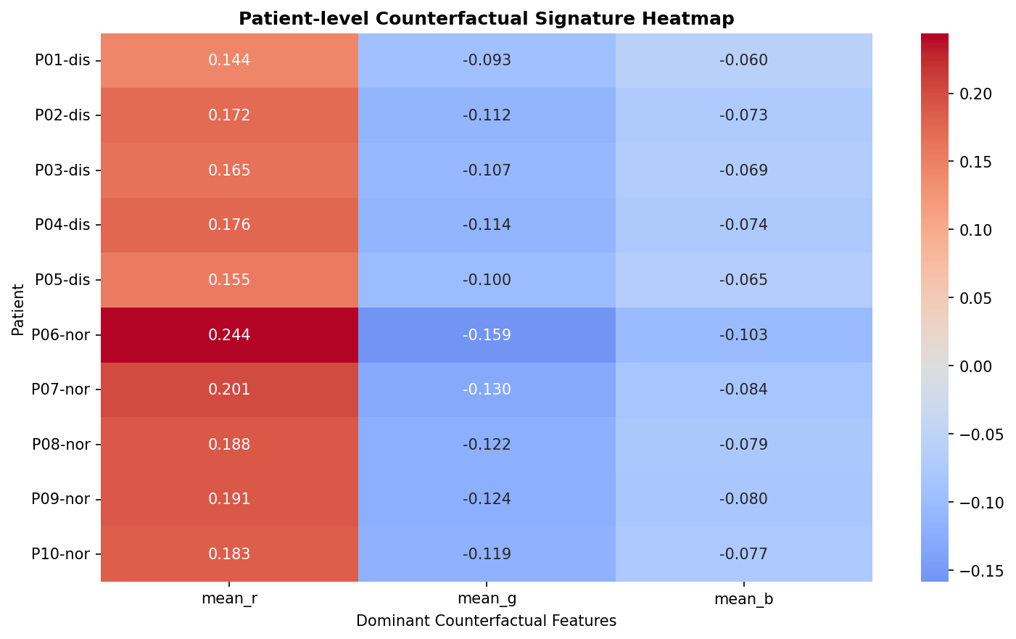
Figure 7. Patient-level signature heatmap for disease-associated counterfactual morphology patterns.

