PlasmaXNet: A Counterfactual-Guided Multi-Branch Fusion Framework for Malignant Plasma Cell Recognition and Patient-Level Morphologic Signature Analysis

Research Objectives
This study presents PlasmaXNet as an explainable computational pathology framework for malignant plasma cell recognition on PCMMD. The objectives are to improve cell-level discrimination against stronger benchmark models, integrate counterfactual information directly into the decision pathway, prioritize clinically important plasma recall, and study whether cell-level counterfactual behavior aggregates into patient-level disease signatures.

Proposed Methodology
PlasmaXNet combines frozen ResNet50 and DenseNet121 image embeddings with a handcrafted morphology branch, a counterfactual feature branch, and a score branch. Morphologic descriptors include nucleus-to-cytoplasm ratio, nucleus area, cytoplasm area, staining intensity, granularity, roundness, and mean RGB channels. A morphology-based counterfactual boundary model first estimates the feature shifts required to move a sample toward the benign decision boundary. These counterfactual signals then modulate the image streams through sigmoid gates, refine the score stream, and participate in a learned softmax modality gate before weighted fusion and final classification. For deployment and benchmarking, the final model uses a validation-selected high-recall operating point so malignant sensitivity remains the primary clinical priority.

Outcomes and Results
At the selected high-recall operating point, PlasmaXNet achieved 93.42% accuracy, 93.43% weighted F1, 91.24% plasma precision, 94.63% plasma recall, and 97.76% AUC on the held-out test set. This threshold was set to 0.72 from the validation set. In the expanded benchmark, the strongest non-PlasmaXNet baseline by accuracy was ResNet50 at 91.92% accuracy, while the strongest non-PlasmaXNet baseline by recall was ResNet50 at 93.80% recall. PlasmaXNet therefore leads the current benchmark on both overall accuracy and malignant-cell recall. The bootstrap 95% interval at the selected operating point was 91.16-95.30 for accuracy and 91.30-97.20 for plasma recall.

Patient-Level Robustness and Interpretation
The patient-level score using mean novel probability produced an internal AUC of 1.000 on a cohort of only 10 patients (5 diseased, 5 normal). This should be treated as exploratory rather than definitive clinical proof. Exact permutation testing across all 252 possible class-label assignments gave a one-sided p-value of 0.0040 and a two-sided p-value of 0.0079. Leave-one-patient-out analysis yielded mean AUC 1.000, minimum 1.000, and maximum 1.000. The patient bootstrap interval saturated at 1.000-1.000, reflecting perfect within-cohort rank separation rather than external validation. The disease-associated signature remained centered on mean_r, mean_g, mean_b, but because the cohort contains only ten patients from a single internal source, the patient-level result should be reported as a promising internal finding that requires external multi-center confirmation.

Impact Applications
PlasmaXNet is suitable for computer-assisted plasma cell screening, triage support in digital hematopathology, and explainable decision-support research. Its counterfactual-guided design helps reveal which morphology changes would alter malignant probability, while its patient-level aggregation layer supports consistency analysis beyond isolated cell predictions. This makes the framework useful for model auditing, disease-signature discovery, and future clinician-in-the-loop validation studies.

Diagrams
The current PlasmaXNet package includes the following primary visual assets: plasmaxnet_fig13_framework_diagram.png, plasmaxnet_fig12_extended_model_comparison.png, plasmaxnet_fig15_precision_f1_comparison.png, novel_fig8_training_curves.png, plasmaxnet_fig14_confusion_roc.png, plasmaxnet_fig16_patient_robustness.png, novel_fig11_patient_signature_heatmap.png, PlasmaXNet_Architecture.drawio.

Figures
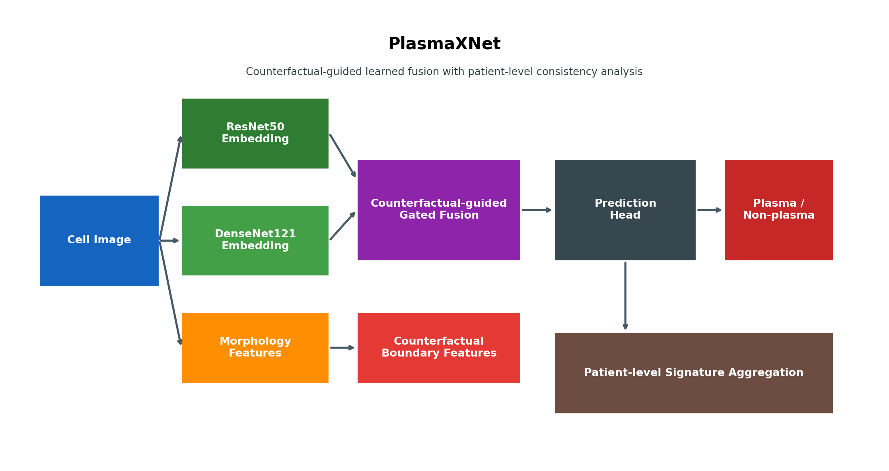
Figure 1. PlasmaXNet architecture overview showing the multi-branch fusion design and patient-level signature pathway.
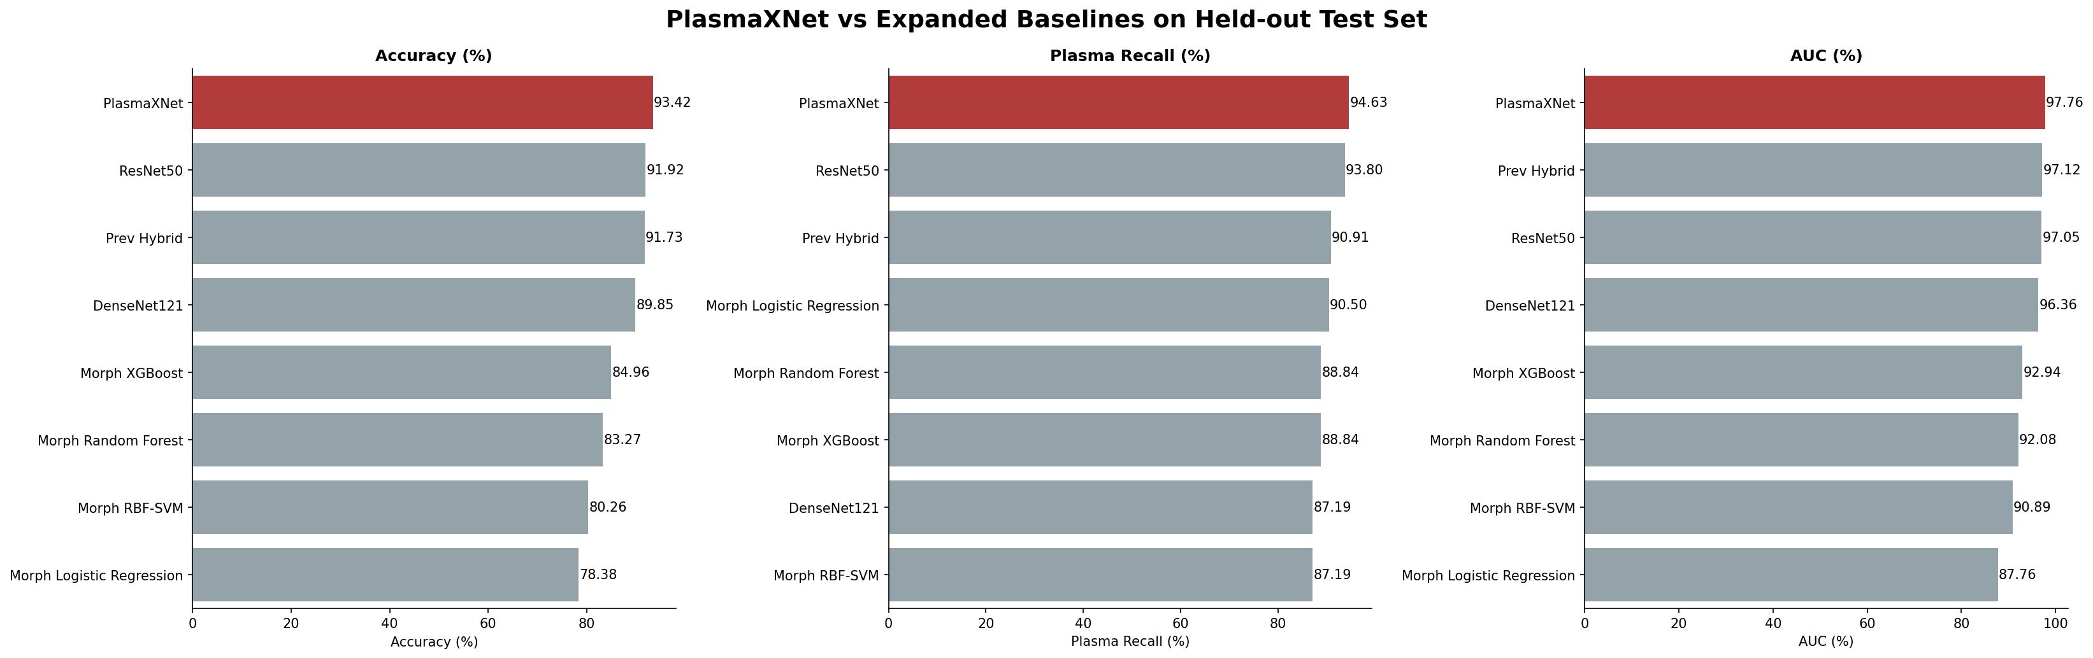
Figure 2. Expanded model comparison showing that PlasmaXNet leads the benchmark on both accuracy and plasma recall at the selected operating point.
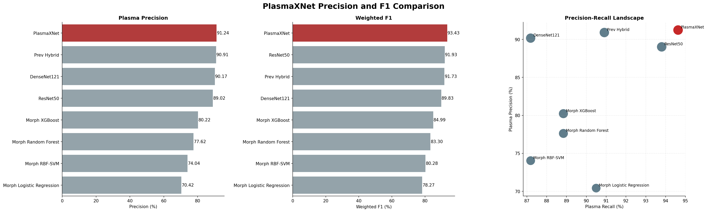
Figure 3. Precision, weighted F1, and precision-recall landscape across PlasmaXNet and comparison models.
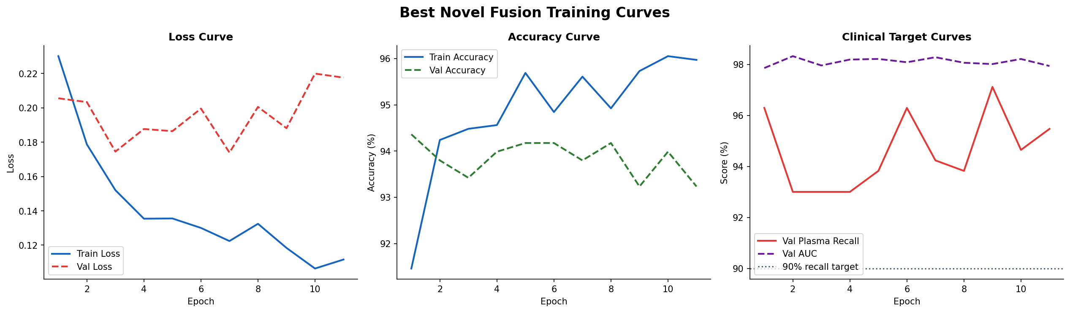
Figure 4. Training and validation curves for the selected PlasmaXNet fusion configuration.
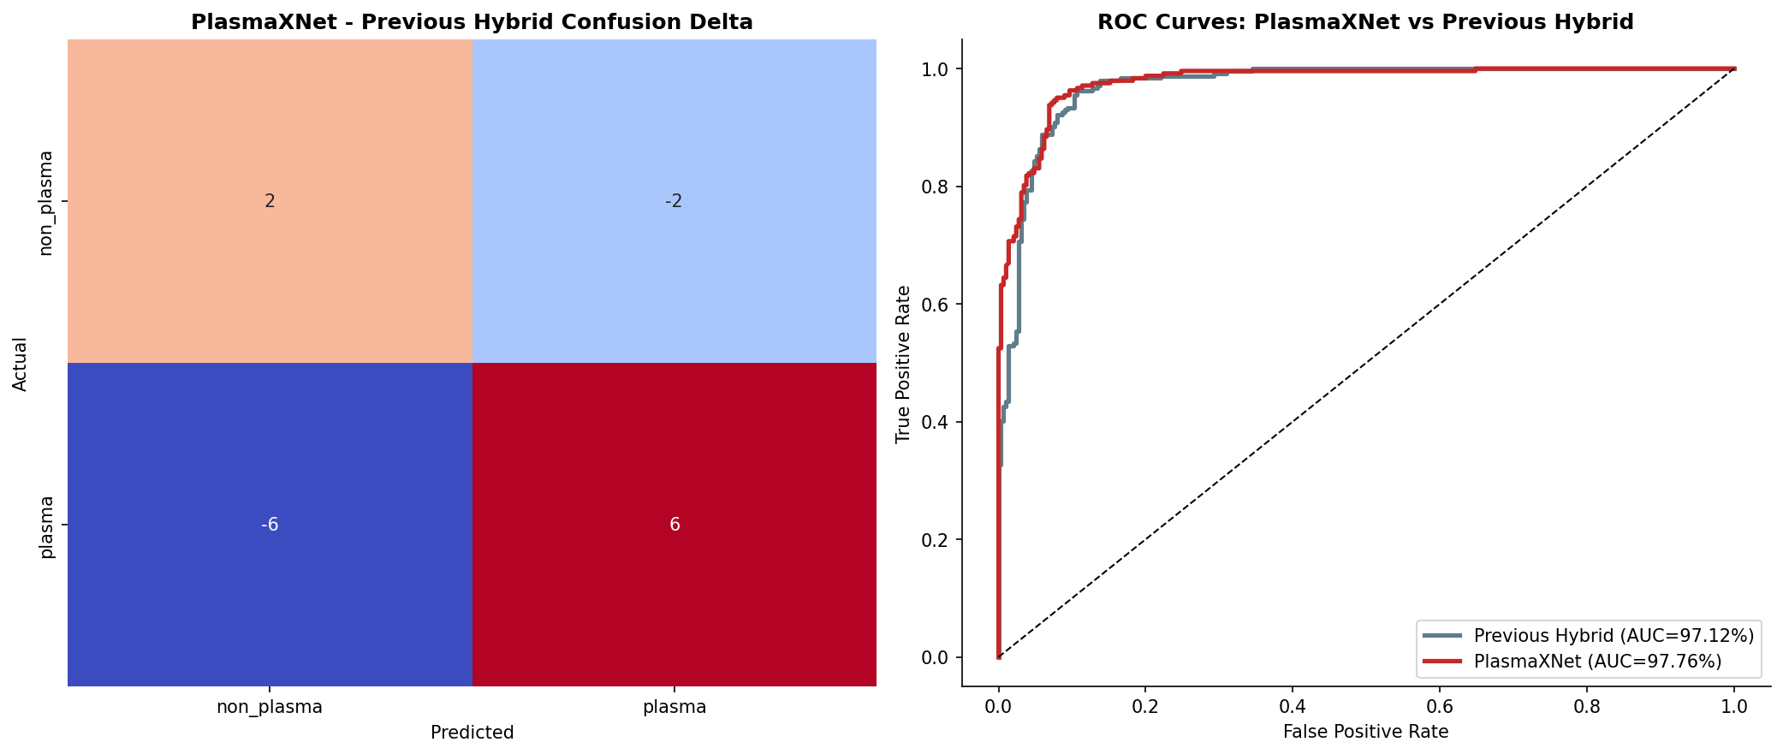
Figure 5. Confusion-delta and ROC comparison between PlasmaXNet and the previous hybrid baseline.
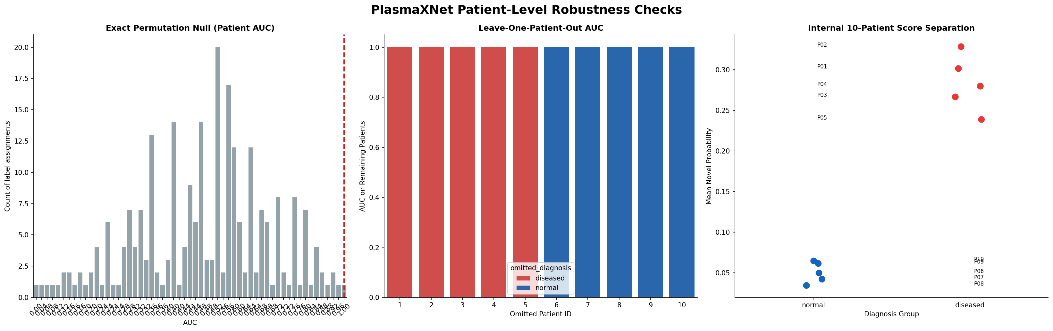
Figure 6. Patient-level robustness analysis including exact permutation testing, leave-one-patient-out AUC, and internal score separation on the 10-patient cohort.
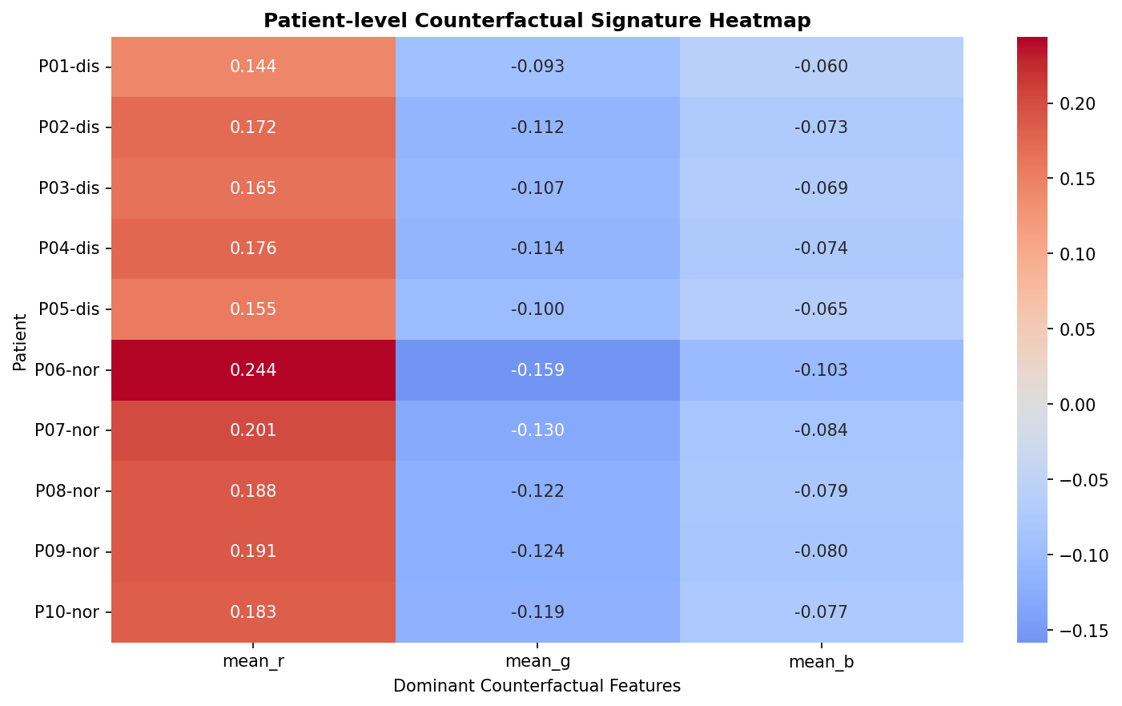
Figure 7. Patient-level signature heatmap summarizing disease-associated counterfactual morphology patterns across the cohort.

