Malware Detection Using Artificial Intelligence: A Survey
Arnob Chakrobortty
Student ID: M.sc 260227



Computer Science and Engineering Discipline Khulna University, Khulna - 9208, Bangladesh
April, 2026

Abstract
Malware has emerged as one of the most critical cyber security threats in the digital era, causing significant financial and data losses worldwide. Traditional malware detection techniques, such as signature-based and heuristic-based methods, are increasingly ineffective against modern threats like polymorphic and zero-day malware. Artificial Intelligence (AI), particularly Machine Learning (ML) and Deep Learning (DL), offers a promising solution by enabling systems to automatically learn patterns and detect unknown threats. This paper provides a comprehensive survey of AI-based malware detection techniques. It explores various ML and DL approaches, including supervised, unsupervised, and hybrid models. Additionally, the paper discusses feature engineering techniques, datasets, evaluation metrics, and real-world applications. The challenges of AI-based detection, such as adversarial attacks and data imbalance, are also analyzed. Finally, future research directions, including explainable AI and federated learning, are presented.

i

Table of Contents

Abstract................................................................................................................................i

Chapter I: Background ....................................................................................................1

1.1 Introduction .................................................................................................................1

1.2 Background and Related Work………......................................................................1

1.3 Types of Malware ........................................................................................................2

Chapter II: Machine Learning in Malware Detection.................................................. 3

2.1 Literature Review ...................................................................................................... 3

2.2 Machine Learning Techniques ..................................................................................3

2.3 Machine Learning-Based Malware Detection...........................................................4

2.3.1 Supervised Learning ............................................................................................4

2.3.2 Unsupervised Learning .......................................................................................4

2.3.3 Advantages and Limitations ...............................................................................4

2.4 Deep Learning-Based Malware Detection ................................................................5

2.5 Feature Engineering ...................................................................................................5

Chapter III: Experiments and Discussions ....................................................................6

3.1 Datasets ........................................................................................................................6

3.2 System Architecture ....................................................................................................6

3.2.1 Architecture Components ...................................................................................6

3.3 Proposed Framework .................................................................................................7

3.3.1 Key Features .........................................................................................................7

3.3.2 Framework Steps .................................................................................................7

3.3.3 Advantages ...........................................................................................................7

3.4 Algorithm for Malware Detection .............................................................................8

3.5 Experimental Setup ....................................................................................................9

3.6 Case Study ...................................................................................................................9

3.7 Adversarial Attacks ..................................................................................................10

3.8 Explainable AI ...........................................................................................................10

3.9 Federated Learning ..................................................................................................10

3.10 Edge AI ....................................................................................................................10

3.11 Ethical Considerations ...........................................................................................11

Chapter IV: Results and Discussion ..............................................................................12

4.1 Performance Analysis ...............................................................................................12

4.2 Comparative Analysis ...............................................................................................12

4.3 Neural Network Model .............................................................................................13

4.4 Evaluation Metrics ....................................................................................................14

4.5 Challenges and Limitations ......................................................................................14

Chapter V: Conclusion and Future Work ....................................................................15

5.1 Conclusion .................................................................................................................15

5.2 Future Directions ......................................................................................................15

Bibliography ....................................................................................................................16

ii

List of Tables

Table 2.1: Machine Learning Algorithms for Malware Detection………................. 4

Table 3.1: Pseudo-Code for Malware Detection ............................................................8

Table 4.1: Comparative Analysis of Methods ..............................................................12

iii

List of Figures

Figure 1.1: Definition of Malware ...................................................................................2

Figure 3.1: Architecture Diagram of AI-based Hybrid Framework by the researchers……………………………..............................................................................6

Figure 4.1: Traditional vs AI-Based Approach ............................................................12

Figure 4.2: Neural Network Model Diagram ...............................................................13

Figure 4.3: Evaluation Metrics ......................................................................................14

iv

Chapter I
Background

1.1 Introduction

The rapid growth of information technology and internet-based systems has significantly increased the risk of cyber threats. Among these threats, malware is one of the most dangerous and widely discussed problems. Malware refers to malicious software designed to infiltrate, damage, or disrupt systems without user consent. [7]
Traditional malware detection systems rely heavily on signature-based techniques, where known malware patterns are stored in a database. [7] Although effective for known threats, these systems fail to detect new and unknown malware variants. With the rise of sophisticated attacks such as zero-day exploits and polymorphic malware, traditional methods are no longer sufficient. [8]
Artificial Intelligence (AI) has introduced a paradigm shift in malware detection. [3][4] AI-based systems can learn from data, identify patterns, and adapt to new threats. Machine Learning (ML) algorithms can classify malicious and benign files based on extracted features, while Deep Learning (DL) models can automatically learn complex representations from raw data. This paper aims to provide a detailed survey of AI-based malware detection techniques, highlighting their effectiveness, limitations, and future potential.

1.2 Background and Related Work
Malware detection has evolved significantly over the past decades. Initially, antivirus systems used signature-based detection, which involved matching files against a database of known malware signatures. However, this approach proved ineffective against unknown threats. Heuristic-based methods were introduced to detect suspicious behavior, but they often produced high false positives. To overcome these limitations, researchers exploring Machine Learning techniques.
Several studies have demonstrated the effectiveness of ML algorithms such as Support Vector Machines (SVM), Decision Trees, and Random Forests in malware classification. [8] More recently, Deep Learning models like Convolutional Neural Networks (CNN) and Recurrent Neural Networks (RNN) have shown superior performance by automatically extracting features from raw data. [3][12]

1
Despite these advancements, challenges such as dataset imbalance, adversarial attacks, and computational complexity remain significant concerns. [18]

1.3 Types of Malware
Malware can be classified into several categories based on behavior and functionality: [7]
- Virus: Attaches itself to legitimate files and spreads when executed
- Worm: Self-replicates and spreads across networks without user interaction
- Trojan Horse: Disguised as legitimate software but performs malicious actions
- Ransom ware: Encrypts user data and demands payment for decryption
- Spyware: Collects sensitive user information without consent
- Adware: Displays unwanted advertisements
- Rootkits: Provide unauthorized access while hiding their presence
Understanding these categories is essential for designing effective AI-based detection systems.



Figure 1.1: Definition of Malware [7]

2

Chapter II

Machine Learning in Malware Detection

2.1 Literature Review
Recent studies highlight the effectiveness of AI in malware detection.
Kolter and Maloof used machine learning for detecting malicious executable, showing improved detection accuracy. [8] Saxe and Berlin applied deep neural networks for malware classification using binary features. [2]
Raff et al. proposed feeding raw executable files into deep learning models, eliminating manual feature engineering. [11] Arp et al. introduced the DREBIN system for Android malware detection. [16]
Hardy et al. proposed DL4MD, a deep learning framework for intelligent malware detection. [14]
Overall, literature shows:
- Deep Learning > Machine Learning
- Hybrid models = best performance

2.2 Machine Learning Techniques
- SVM
- Decision Tree
- Random Forest
- Naïve Bayes
Used for classification based on extracted features. [10]

3

2.3 Machine Learning-Based Malware Detection
Machine Learning plays a crucial role in malware detection by enabling systems to learn patterns from data. [15]

2.3.1 Supervised Learning
Supervised learning algorithms require labeled datasets. [7][8] Common techniques include:
- Support Vector Machine (SVM)
- Decision Tree
- Random Forest
- Naïve Bayes
These models classify files as malicious or benign based on extracted features. [13]

2.3.2 Unsupervised Learning
Unsupervised learning is used when labeled data is unavailable. [16] Techniques include:
- Clustering
- Anomaly detection
These methods identify unusual patterns that may indicate malware. [16]

2.3.3 Advantages and Limitations
Advantages:
- High accuracy [16]
- Ability to detect unknown malware
Limitations:
- Requires large labeled datasets
- Sensitive to feature selection [16]

4
Table 2.1: Machine Learning Algorithms for Malware Detection:
Algorithm | Type | Use of Performance | Case
SVM | Supervised | Binary classification | High
Decision Tree | Supervised | Rule-based classification | Medium
Random Forest | Ensemble | Large dataset classification | High
Naïve Bayes | Probabilistic | Fast classification | Medium
KNN | Instance-Based | Similarity detection | Low

2.4 Deep Learning-Based Malware Detection
Deep Learning has gained popularity due to its ability to automatically extract features. [3][4]

Techniques:
- CNN: Converts binary files into images and detects patterns [11]
- RNN/LSTM: Analyzes sequential data such as API calls [6]

Advantages:
- No manual feature engineering
- High performance on complex datasets [6]

Limitations:
- High computational cost [11]
- Requires large datasets

2.5. Feature Engineering
Feature engineering is a critical step in malware detection. Good feature selection improves model performance significantly. [5]

Types of Features:
- Static features (opcode, binary signatures) and
- Dynamic features (runtime behavior, API calls) [17]
- Hybrid features [6]
5
Chapter III
Experiments and Discussions Conducted By Researchers

3.1 Datasets
Common datasets used in malware detection include:
- EMBER Dataset [10]
- VirusShare [12]
- CICIDS [19]
- Microsoft Malware Dataset [14]
Challenges:
- Imbalanced data
- Lack of standard datasets

3.2 System Architecture for AI-Based Malware Detection
An AI-based malware detection system typically consists of several interconnected components that work together to identify malicious software efficiently. [9]

3.2.1 Architecture Components:
- Data Collection Module: Collects raw data such as executable files, network traffic, and system logs. [9]
- Preprocessing Module:
  - Data cleaning
  - Noise removal
  - Normalization
- Feature Extraction Module: Extracts relevant features such as:
  - API call sequences
  - Opcode frequencies
  - File metadata

6
- Model Training Module: Machine Learning and Deep Learning models are trained using labeled datasets. [9]
- Detection Engine: Classifies incoming files as:
  - Benign
  - Malicious
- Response Module: Takes action such as:
  - Blocking file
  - Alerting user
  - Logging attack

Workflow:
Input → Preprocessing → Feature Extraction → Model → Detection → Action

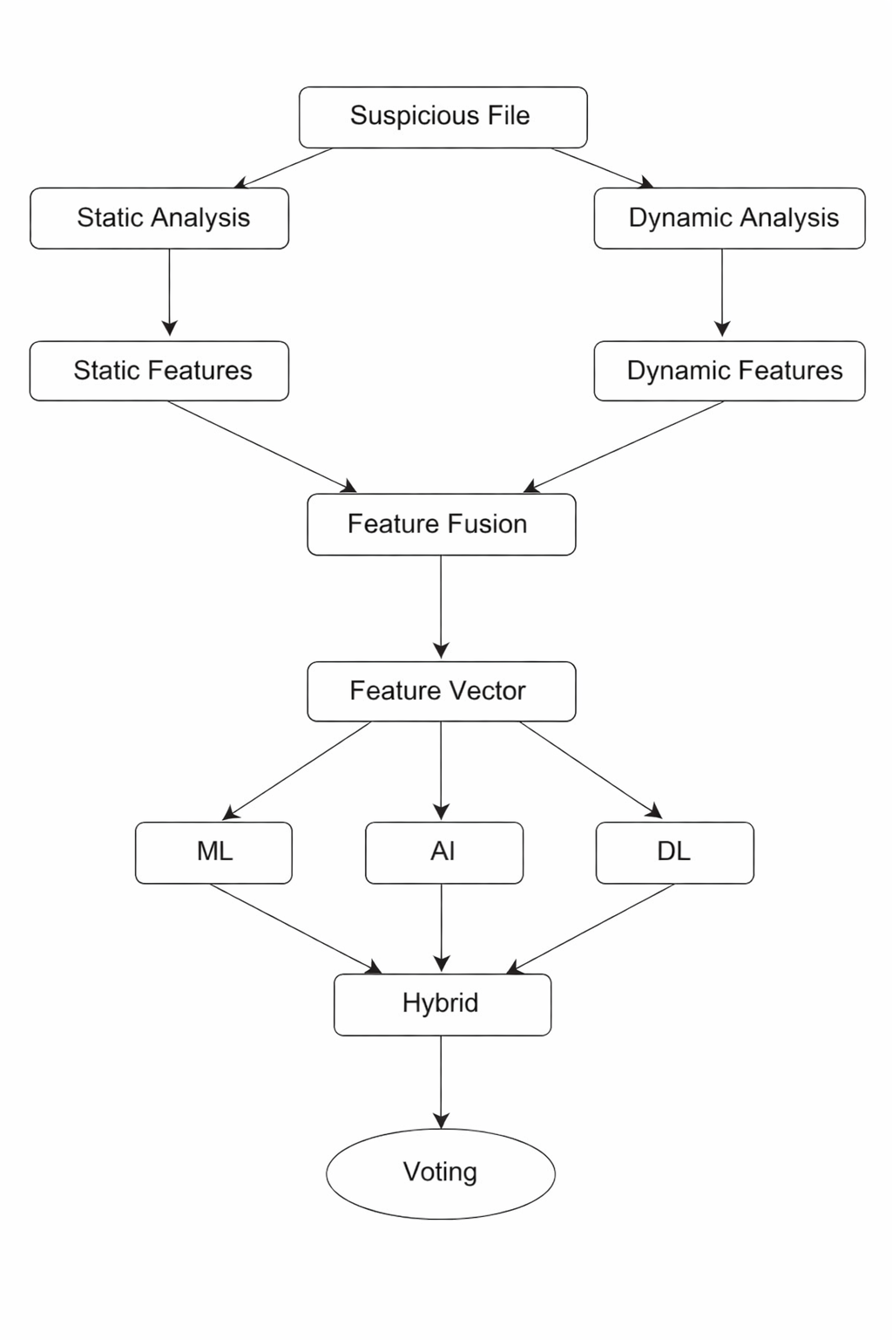
Figure 3.1: Architecture Diagram of AI-based Hybrid Framework by Researchers

7

3.3 Proposed AI-Based Malware Detection Framework by Researchers
A hybrid AI-based framework is proposed and performed by the researchers combining both static and dynamic analysis. [17]

3.3.1 Key Features:
- Combines Machine Learning + Deep Learning [17]
- Uses hybrid feature extraction
- Supports real-time detection

3.3.2 Framework Steps:
- Static analysis (file scanning)
- Dynamic analysis (sandbox execution) [19]
- Feature fusion and classification using ensemble model

3.3.3 Advantages:
- Improved accuracy
- Reduced false positives [14]
- Robust against obfuscation

3.4 Algorithm for Malware Detection

Table 3.1: Pseudo-Code for Malware Detection [12]
Input: Dataset D
Output: Trained Malware Detection Model

Step 1: Load dataset D
Step 2: Preprocess data (cleaning, normalization)
Step 3: Extract features F from D
Step 4: Split dataset into training and testing sets
Step 5: Train ML/DL model using training data and AI
Step 6: Evaluate model using testing data
Step 7: If accuracy < threshold:
Tune hyper-parameters
Repeat Step 5
Step 8: Deploy trained model

8

3.5 Experimental Setup
To evaluate the effectiveness of the proposed system, experiments are conducted using benchmark datasets. [12][17]

3.5.1 Environment:
- Programming Language: Python [12]
- Tools: TensorFlow, Scikit-learn [17]
- Hardware: GPU-enabled system

3.5.2 Dataset Split:
- Training: 70%
- Testing: 30%

3.5.3 Models Used:
- Random Forest
- Support Vector Machine
- CNN and ANN

3.6 Case Study: Real-World Malware Detection
A real-world case study involves detecting ransom-ware using AI models. [9]

Process:
- Dataset collected from infected systems
- Features extracted from behavior logs
- Model trained using supervised learning

Outcome:
- Detection accuracy improved significantly
- Early detection prevented data encryption

9

3.7 Adversarial Attacks on AI Models
Attackers can manipulate AI models using adversarial techniques. [18][19]

Types:
- Evasion attacks
- Poisoning attacks

Impact and Mitigation:
- Reduced model accuracy
- Misclassification of malware [20]
- Adversarial training
- Robust feature selection

3.8 Explainable AI in Malware Detection
AI models often act as black boxes. Explainable AI (XAI) improves transparency. [4]

Techniques:
- SHAP (SHapley Additive exPlanations) [4]
- LIME (Local Interpretable Model-agnostic Explanations) [4]

Benefits:
- Better trust
- Easier debugging
- Regulatory compliance

3.9 Federated Learning for Malware Detection
Federated Learning allows multiple systems to collaborate without sharing raw data. [6]

Advantages:
- Data privacy
- Distributed learning
- Scalability

10

3.10 Edge AI for Real-Time Detection
Deploying AI models on edge devices enables faster detection.

Benefits:
- Low latency
- Real-time response
- Reduced cloud dependency

3.11 Ethical and Security Considerations
AI-based systems must address:
- Privacy concerns
- Misuse of AI
- Bias in datasets

11

Chapter IV

Results and Discussions Regarding AI-Based Models

4.1 Results and Performance Analysis
The experimental results demonstrate that AI-based models outperform traditional methods.

Observations:
- Deep Learning models achieve higher accuracy [3][12]
- Hybrid models reduce false positives
- Feature quality significantly impacts performance

4.2 Comparative Analysis
The comparative analysis demonstrates the accuracy, advantages and the limitations of these methods focusing on the comparison. [14]
Table 4.1: Comparative Analysis of the Methods:
Method | Accuracy | Advantages | Limitations
Signature-Based | Low | Fast | Cannot detect new malware
Machine Learning | Medium | Detects unknown threats | Feature dependent
Deep Learning | High | Automatic feature learning | High computation cost
Hybrid Approach | Very High | Best performance | Complex implementation

12

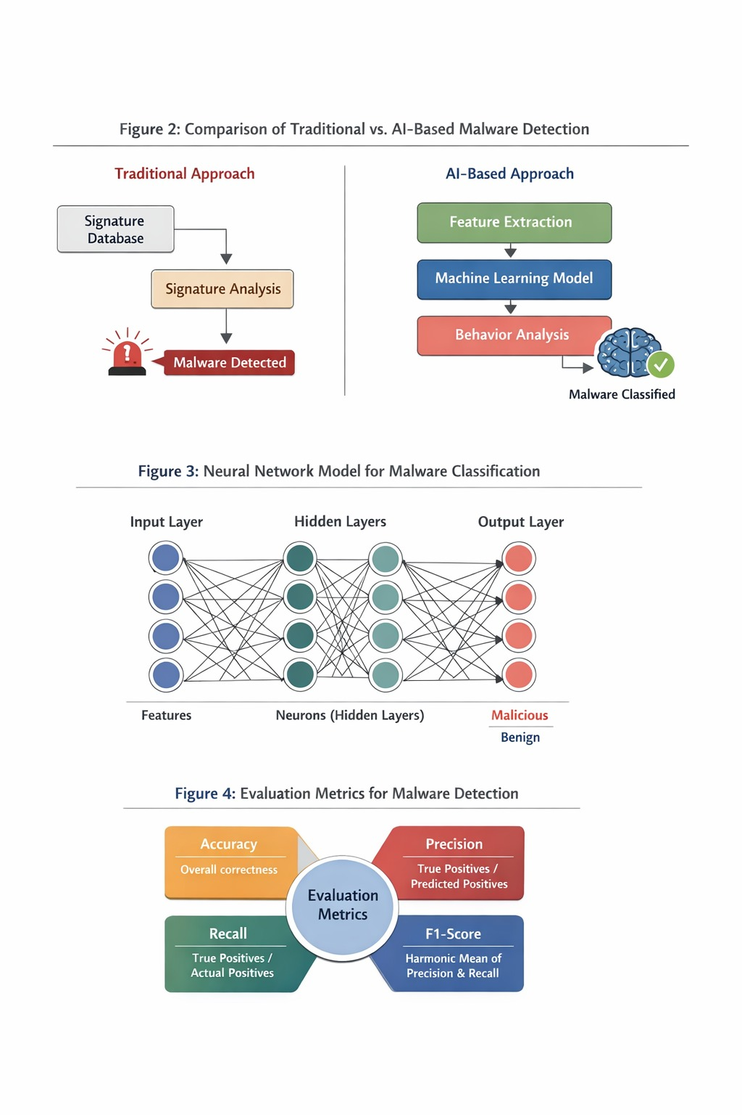

Figure 4.1: Traditional Approach vs AI-Based Approach

The figure describes the steps of both approaches simultaneously through comparison. [14]

4.3 Neural Network Model

Figure 4.2: Neural Network Model Diagram

The neural network model perfectly describes the input layer, hidden layers and the output layer. [14]

13

4.4 Evaluation Metrics
Performance is measured using:
- Accuracy [7]
- Precision [7]
- Recall [7]
- F1-score
- ROC-AUC
- False Positive Rate

Figure 4.3: Evaluation Metrics [7]

4.5 Challenges and Limitations
AI-based malware detection faces several challenges:
- Data imbalance
- High computational cost
- Limited dataset availability
- High computational requirements
- Model generalization issues
- Lack of Explainability [7]

14
Chapter V
Future Works Suggested By Researchers

5.1 Conclusion
Artificial Intelligence has significantly improved malware detection capabilities. [3][4] Machine Learning and Deep Learning techniques outperform traditional methods. It is possible by detecting unknown and evolving threats. However, challenges such as adversarial attacks and computational complexity must be addressed to ensure robust and reliable systems. [10]

5.2 Future Directions
Future research should focus on:
- Explainable AI [18]
- Real-time detection
- Federated learning [18]
- Edge AI security

15

Bibliography

1. U. Bayer, P. Milani Comparetti, C. Hlauschek, C. Kruegel and E. Kirda, “Scalable, Behavior-Based Malware Clustering,” Proc. Network and Distributed System Security Symposium (NDSS), 2009.
2. R. Saxe and K. Berlin, “Deep Neural Network Based Malware Detection Using Two Dimensional Binary Program Features,” Proc. 10th Int. Conf. on Malicious and Unwanted Software (MALWARE), IEEE, 2015.
3. Y. LeCun, Y. Bengio and G. Hinton, “Deep Learning,” Nature, vol. 521, no. 7553, pp. 436–444, 2015.
4. I. Goodfellow, Y. Bengio and A. Courville, Deep Learning, MIT Press, 2016.
5. M. Yousefi-Azar, L. G. C. Hamey, V. Varadharajan, “Autoencoder-Based Feature Learning for Cybersecurity Applications,” Proc. Int. Joint Conf. on Neural Networks (IJCNN), IEEE, 2017.
6. A. Kolosnjaji, A. Zarras, G. Webster and C. Eckert, “Deep Learning for Classification of Malware System Call Sequences,” Australasian Joint Conf. on Artificial Intelligence, 2016.
7. M. Schultz, E. Eskin, E. Zadok and S. Stolfo, “Data Mining Methods for Detection of New Malicious Executables,” Proc. IEEE Symposium on Security and Privacy, 2001.
8. J. Z. Kolter and M. A. Maloof, “Learning to Detect and Classify Malicious Executables in the Wild,” Journal of Machine Learning Research, vol. 7, 2006.
9. B. Anderson and D. McGrew, “Machine Learning for Encrypted Malware Traffic Classification,” Proc. ACM CCS Workshop, 2016.
10. H. S. Anderson, A. Kharkar, B. Filar et al., “EMBER: An Open Dataset for Training Static PE Malware Machine Learning Models,” arXiv preprint arXiv:1804.04637, 2018.
11. S. Raff, J. Barker, J. Sylvester et al., “Malware Detection by Eating a Whole EXE,”
Workshops at AAAI Conference on Artificial Intelligence, 2018.
12. A. Krizhevsky, I. Sutskever and G. Hinton, “ImageNet Classification with Deep Convolutional Neural Networks,” NIPS, 2012.

16
13. K. He, X. Zhang, S. Ren and J. Sun, “Deep Residual Learning for Image Recognition,” IEEE CVPR, 2016.
14. W. Hardy, L. Chen, S. Hou, Y. Ye and X. Li, “DL4MD: A Deep Learning Framework for Intelligent Malware Detection,” Proc. Int. Conf. on Data Mining (DMIN), 2016.
15. N. McLaughlin, J. Martinez del Rincon, B. Kang et al., “Deep Android Malware Detection,” Proc. ACM CODASPY, 2017.
16. D. Arp, M. Spreitzenbarth, M. Hübner et al., “DREBIN: Effective and Explainable Detection of Android Malware,” NDSS, 2014.
17. S. Hou, Y. Ye, Y. Song and M. Abdulhayoglu, “Hindroid: An Intelligent Android Malware Detection System,” Proc. ACM SIGKDD, 2016.
18. B. Biggio and F. Roli, “Wild Patterns: Ten Years After the Rise of Adversarial Machine Learning,” Pattern Recognition, 2018.
19. N. Papernot, P. McDaniel, I. Goodfellow et al., “Practical Black-Box Attacks Against Machine Learning,” Proc. ACM AsiaCCS, 2017.
20. M. Rigaki and S. Garcia, “Bringing a GAN to a Knife-Fight: Adapting Malware Communication to Avoid Detection,” IEEE Security Workshops, 2018.

17

