Malware Detection Using Artificial Intelligence: A Survey
Arnob Chakrobortty
Student ID: M.Sc 260227
Computer Science and Engineering Discipline
Khulna University, Khulna-9208, Bangladesh
April 2026

Abstract
Malware remains one of the most critical cyber security threats, causing significant financial and data losses worldwide. Traditional detection techniques such as the signature-based and the heuristic-based approaches are increasingly ineffective against advanced threats including polymorphic and zero-day malware. Artificial Intelligence (AI), particularly Machine Learning (ML) and Deep Learning (DL), has emerged as a powerful solution by enabling systems to learn patterns and detect previously unseen attacks. This paper presents a comprehensive survey of AI-based malware detection techniques, including supervised, unsupervised, and hybrid models. It also discusses feature engineering, datasets, evaluation metrics, and real-world applications. Key challenges such as adversarial attacks and data imbalance are analyzed, followed by future research directions including explainable AI and federated learning.
Index Terms— Hybrid Model, Malware Detection, Artificial Intelligence, Machine Learning, Deep Learning, Cyber security.

1
I. Introduction
The rapid expansion of internet-based systems has significantly increased exposure to cyber threats. [7] Malware, defined as malicious software designed to disrupt or exploit systems, is among the most severe threats. Traditional detection systems rely on signature databases, making them ineffective against unknown malware variants such as zero-day and polymorphic attacks. [8] AI has introduced a paradigm shift by enabling adaptive and intelligent detection systems. ML models classify files using extracted features, while DL models automatically learn representations from raw data. This survey explores AI-driven malware detection techniques, their credibility, effectiveness, and limitations. [3] [4]
II. Background
A. Related Work
Early malware detection relied on signature matching, which failed against new threats. Heuristic methods improved detection but suffered from high false positives. [3]

ML techniques such as Support Vector Machines (SVM), Decision Trees, and Random Forests improved classification accuracy. More recently, DL models such as Convolutional Neural Networks (CNN) and Recurrent Neural Networks (RNN) [12] demonstrated superior performance through automated feature extraction. Despite progress, challenges such as dataset imbalance, adversarial manipulation, and computational complexity remain unresolved. [18]
B. Literature Review
Recent studies highlight the effectiveness of AI in malware detection. Kolter and Maloof used machine learning for detecting malicious executable, showing improved detection accuracy. [8] Saxe and Berlin applied deep neural networks for malware classification using binary features. [2] Raff et al. proposed feeding raw executable files into deep learning models, eliminating manual feature engineering. [11] Arp et al. introduced the DREBIN system for Android malware detection. [16] Hardy et al. proposed DL4MD, a deep learning framework for intelligent malware detection. [14]
III. Types of Malware
Malware can be categorized as follows:
- Virus: Attaches to files and spreads upon execution
- Worm: Self-replicates across networks
- Trojan Horse: Disguised malicious software

2
- Ransom-ware: Encrypts data for ransom
- Spyware: Steals user information
- Adware: Displays unwanted ads
- Rootkits: Hide unauthorized access
Understanding these types is essential for designing detection systems. [7]
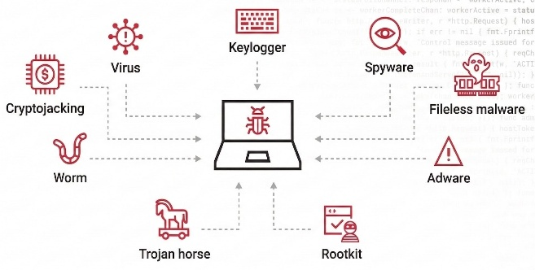
Figure 1: Types of Malware [7]
IV. Machine Learning in Malware Detection
A. Machine Learning Techniques
Common ML algorithms include:
- Support Vector Machine (SVM)
- Decision Tree
- Random Forest
- Naïve Bayes
- K-Nearest Neighbors (KNN)
These models classify software as malicious or benign based on extracted features. [10]
B. Supervised and Unsupervised Learning
Supervised Learning: Requires labeled datasets and includes SVM, Decision Trees, and Random Forest. [15]

Unsupervised Learning: Used when labels are unavailable; includes clustering and anomaly detection. [7] [8]
Advantages:
- High accuracy
- Detection of unknown malware [13]
Limitations:
- Requires large datasets [16]
- Sensitive to feature selection
C. Deep Learning-Based Detection
DL techniques include:
- CNN: Converts binaries into images [3]
- RNN/LSTM: Processes sequential data like API calls [4] [11]
Advantages:
- Automatic feature extraction [6]
- High accuracy
Limitations:
- High computational cost [11]
- Requires large datasets
D. Feature Engineering
Feature engineering significantly impacts performance. [5] Types include:
- Static features (opcode, signatures)
- Dynamic features (runtime behavior)
- Hybrid features [6]

3
V. Datasets and Experimental Setup
A. Common Datasets
- EMBER [10]
- VirusShare [12]
- CICIDS [19]
- Microsoft Malware Dataset [14]
Challenges:
- Data imbalance [17]
- Lack of standardization
B. System Architecture
Typical architecture includes:
- Data Collection
- Preprocessing
- Feature Extraction
- Model Training
- Detection Engine
- Response Module
C. AI-based Hybrid Framework
The hybrid framework combines static and dynamic analysis:
- Feature fusion
- Ensemble classification [9]
- Real-time detection
Advantages:
- Higher accuracy
- Reduced false positives [16]

- Robustness against obfuscation
D. Algorithm Overview
- Load dataset and preprocess data
- Extract features
- Split dataset
- Train model
- Evaluate performance
- Tune if necessary
- Deploy model

The workflow is: Input → Pre-processing → Feature Extraction → Model → Detection → Action
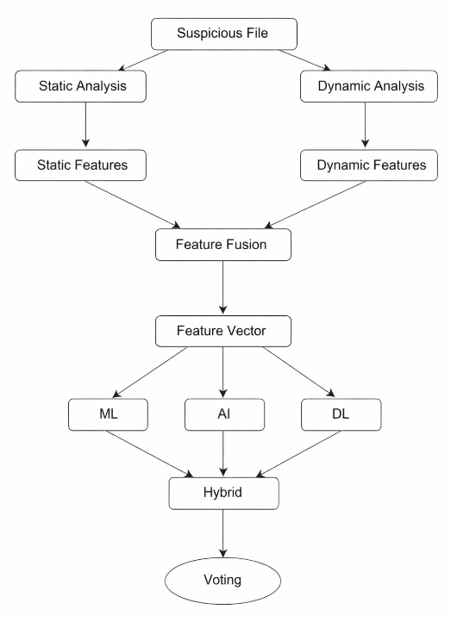
Figure 2: AI-based Hybrid Framework

4
E. Algorithm for Malware Detection
Input: Dataset D
Output: Trained Malware Detection Model

Step 1: Load dataset D
Step 2: Preprocess data (cleaning, normalization)
Step 3: Extract features F from D
Step 4: Split dataset into training and testing sets
Step 5: Train ML/DL model using training data and AI
Step 6: Evaluate model using testing data
Step 7: If accuracy < threshold:
Tune hyper-parameters
Repeat Step 5
Step 8: Deploy trained model
Table 2: Algorithm for Malware Detection [12]
F. Experimental Setup
To evaluate the effectiveness of the proposed system, experiments are conducted using benchmark datasets. [12][17]
Environment:
- Programming Language: Python [12]
- Tools: TensorFlow, Scikit-learn [17]
- Hardware: GPU-enabled system

Dataset Split:
- Training: 70%
- Testing: 30%

Models Used:
- Random Forest
- Support Vector Machine
- CNN and ANN

VI. Advanced Topics
A. Adversarial Attacks
Types include:
- Evasion attacks
- Poisoning attacks
Mitigation techniques:
- Adversarial training [18] [19]
- Robust feature selection
B. Explainable AI (XAI)
Techniques such as SHAP and LIME improve transparency and trust. [20]
C. Federated Learning
Enables collaborative training without sharing raw data, ensuring privacy. [4]
D. Edge AI
Provides real-time detection with low latency and reduced cloud dependency. [6]
E. Ethical Considerations
- Privacy concerns
- Bias in datasets
- Misuse of AI [11] [13] [15]
VII. Results and Discussion
A. Performance Analysis
- DL models outperform ML models
- Hybrid models provide best performance
- Feature quality is critical

5
B. Comparative Analysis
Method | Accuracy | Advantages | Limitations
Signature-Based | Low | Fast | Cannot detect new malware
Machine Learning | Medium | Detects unknown threats | Feature dependent
Deep Learning | High | Automatic learning | High cost
Hybrid | Very High | Best performance | Complex

Table 3: Comparative Analysis of the Models
C. Evaluation Metrics
- Accuracy
- Precision [3]
- Recall
- F1-score [12]
- ROC-AUC
- False Positive Rate [14]
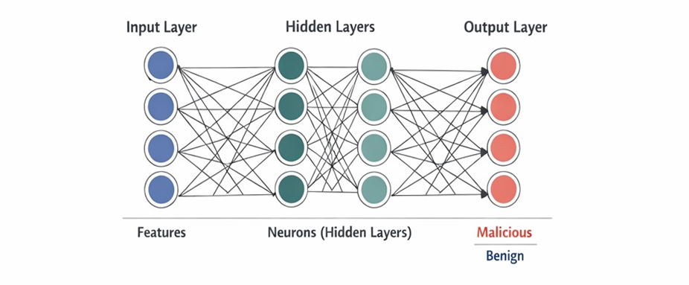
Figure 3: Neural Network Model Diagram

D. Challenges
- Data imbalance
- Computational cost
- Limited datasets
- Lack of explain-ability

E. Case Study: The Real-World Malware Detection
A real-world case study involves detecting ransom-ware using AI models. [9]

Process:
- Dataset collected from infected systems
- Features extracted from behavior logs
- Model trained using supervised learning
Outcome:
- Detection accuracy improved significantly
- Early detection prevented data encryption
VIII. Conclusion and Future Work
A. Conclusion
AI significantly enhances malware detection by identifying unknown threats. ML and DL outperform traditional methods, though challenges such as adversarial attacks and computational complexity remain.
B. Future Directions
- Explainable AI
- Federated learning

6
- Real-time detection
- Edge AI security
Bibliography
1. U. Bayer, P. Milani Comparetti, C. Hlauschek, C. Kruegel and E. Kirda, “Scalable, Behavior-Based Malware Clustering,” Proc. Network and Distributed System Security Symposium (NDSS), 2009.
2. R. Saxe and K. Berlin, “Deep Neural Network Based Malware Detection Using Two Dimensional Binary Program Features,” Proc. 10th Int. Conf. on Malicious and Unwanted Software (MALWARE), IEEE, 2015.
3. Y. LeCun, Y. Bengio and G. Hinton, “Deep Learning,” Nature, vol. 521, no. 7553, pp. 436–444, 2015.
4. I. Goodfellow, Y. Bengio and A. Courville, Deep Learning, MIT Press, 2016.
5. M. Yousefi-Azar, L. G. C. Hamey, V. Varadharajan, “Autoencoder-Based Feature Learning for Cybersecurity Applications,” Proc. Int. Joint Conf. on Neural Networks (IJCNN), IEEE, 2017.
6. A. Kolosnjaji, A. Zarras, G. Webster and C. Eckert, “Deep Learning for Classification of Malware System Call Sequences,” Australasian Joint Conf. on Artificial Intelligence, 2016.
7. M. Schultz, E. Eskin, E. Zadok and S. Stolfo, “Data Mining Methods for Detection of New Malicious Executables,” Proc. IEEE Symposium on Security and Privacy, 2001.
8. J. Z. Kolter and M. A. Maloof, “Learning to Detect and Classify Malicious Executables in the Wild,” Journal of Machine Learning Research, vol. 7, 2006.

9. B. Anderson and D. McGrew, “Machine Learning for Encrypted Malware Traffic Classification,” Proc. ACM CCS Workshop, 2016.
10. H. S. Anderson, A. Kharkar, B. Filar et al., “EMBER: An Open Dataset for Training Static PE Malware Machine Learning Models,” arXiv preprint arXiv:1804.04637, 2018.
11. S. Raff, J. Barker, J. Sylvester et al., “Malware Detection by Eating a Whole EXE,”
Workshops at AAAI Conference on Artificial Intelligence, 2018.
12. A. Krizhevsky, I. Sutskever and G. Hinton, “ImageNet Classification with Deep Convolutional Neural Networks,” NIPS, 2012.
13. K. He, X. Zhang, S. Ren and J. Sun, “Deep Residual Learning for Image Recognition,” IEEE CVPR, 2016.
14. W. Hardy, L. Chen, S. Hou, Y. Ye and X. Li, “DL4MD: A Deep Learning Framework for Intelligent Malware Detection,” Proc. Int. Conf. on Data Mining (DMIN), 2016.
15. N. McLaughlin, J. Martinez del Rincon, B. Kang et al., “Deep Android Malware Detection,” Proc. ACM CODASPY, 2017.
16. D. Arp, M. Spreitzenbarth, M. Hübner et al., “DREBIN: Effective and Explainable Detection of Android Malware,” NDSS, 2014.

7

17. S. Hou, Y. Ye, Y. Song and M. Abdulhayoglu, “Hindroid: An Intelligent Android Malware Detection System,” Proc. ACM SIGKDD, 2016.
18. B. Biggio and F. Roli, “Wild Patterns: Ten Years After the Rise of Adversarial Machine Learning,” Pattern Recognition, 2018.
19. N. Papernot, P. McDaniel, I. Goodfellow et al., “Practical Black-Box Attacks Against Machine Learning,” Proc. ACM AsiaCCS, 2017.
20. M. Rigaki and S. Garcia, “Bringing a GAN to a Knife-Fight: Adapting Malware Communication to Avoid Detection,” IEEE Security Workshops, 2018.

