**1: Visibility of System Status**

**Scenario:** You have been removed from a Confluence site. Just as social media apps like Facebook will not notify if someone unfriended you, Confluence would not notify (most likely for good reasons) that you have been removed. We know how to find out if someone unfriended us on Facebook (let’s not go through the details of that) but how intuitive is it to find out on Confluence?

**Heuristic violated:** To find that you have been removed from the site (refreshing the browser will not help) you will have to log out of Confluence and log back in to find the image below:

**2: Match Between the System and the Real World**

**Scenario:** To understand why the previous heuristic was violated, let us see if Atlassian made any documentation for us. Let us read the developer’s guide.

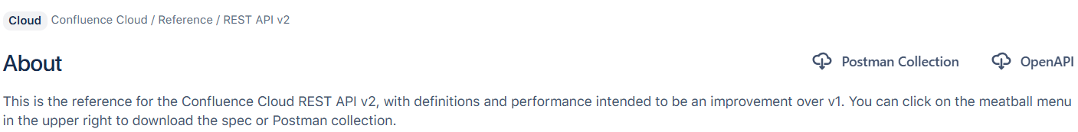

**Heuristic violated:** Now, since this is a developers’ guide, we shall allow developers’ jargons like “REST API”, “Cloud” etc. However, notice the line, “You can click on the meatball menu in the upper right to download the spec or Postman collection”. The “meatball menu” seems more of an internal jargon than developers’ because in developers’ vocabulary, a meatball menu looks like an ellipsis, but they are referring to the “Postman Collection” and “OpenAPI”, on the upper right in the above image, by “meatball menu”.

In case anyone is wondering, the menus in the Actions column in the above image are examples of a meatball menu in developers’ vocabulary.

**3: User Control and Freedom**

**4: Consistency and Standards**

**Scenario:** You are the admin of a Confluence site. You want to know the email address of one of the users in your site. Based on your experience of any app that involves one user getting information about another user, what is your intuition for getting the email address?

**Heuristic violated:** Here is how Confluence site looks like:

As you can see, there is a user named Arnob, you want to see his email address. Intuitively we shall expect to see their email address in their profile. To go to their profile, we should probably click on their name, right? No, clicking on the name will take you to the file “edit korlum” instead of the profile. No problem, let us try with clicking on the profile picture/logo:

Something like this pops up. Not the most standard thing because we would expect to directly go to their profile when we click on the profile logo but now let us click on the “View profile" button. This takes us to a completely different page. Before, we were in <https://arnavaclab.atlassian.net/wiki/home> and now we have been directed to – you can see the url highlighted in the below image. Below is how the profile page looks:

Any sign of his email address? My experience with other apps is no longer helping me but let us keep clicking here and there. When we click “Manage access”:

As seen, in the above image, we are again taken to a different page with a completely different url (meaning we had to go through three different web apps?). We can now see his email address but after hopping over two pages. Moreover, given that we just wanted his email address, clicking on “Manage access” was not very intuitive.

**5: Error Prevention**

**6: Recognition Rather than Recall**

**7: Flexibility and Efficiency of Use**

**8: Aesthetic and Minimalist Design**

**9: Help Users Recognize, Diagnose, and Recover from Errors**

**10: Help and Documentation**