Arnob Bhattacharjee, e2401827
Lizhe Huang, e2401837
Nasrin Priya, e2404244

- Stakeholders
Customers: Customers should be able to search and reserve hotel rooms, can get clear room information and prices, accurate room availability, secure handling of payments.
Hotel staffs: Hotel staffs should be able t o manage rooms, reservations, customers check in and check out.
Hotel management: Hotel managements should be able to monitor rooms, reservation and make sure if the room is occupied or not.
System Administrator: He should be able to manage users and maintain the system.
Payment service: The Administrator could see the details about customer’s paid , and the details of their status of payments. And if their booking is due .

- Overall requirements:
Functional requirements:
- Users should be able to register and log in without any problem.
- Customers can search available rooms by dates and number of guests.
- Customers should be able to view room details and prices.
- Staffs should be able to manage rooms and reservation.
- Administrators can manage users and system settings.
Performance: Operation should be fast and smooth and they should be responded within 3 seconds.
Usability: The interface should be simple and easy to use.
Reliability: The system should avoid losing reservation data.
Security: Personal data and password of the users must be protected.
Maintainability: The system should have a modular structure so that features can be changed or added easily.
Compatibility: The application should work on modern web browsers and different screen size.
Constraints: The application must follow applicable data-protection requirements such as GDPR.

- Logical subsystem:
Subsystem | Main Responsibility | Inputs/outputs
User & Authentication | Registration, login and roles | Login data → authentication result
Room Management | Manage rooms and availability | Dates/room data → available rooms
Reservation |  | Booking details → reservation
  Create, view and cancel bookings
Payment | Process payments
  Payment details → payment status
Customer Management | Manage customer information | Customer data → profile
Administration | Manage users and hotel operations | Staff actions → updated system data

- Quality Function Deployment:
Customer Need | Importance | Related Technical Requirements
Easy room search | 5 | Fast and simple search
Fast response | 5 | Response time ≤ 3 seconds
Simple reservation | 5 | Easy reservation interface
Accurate availability | 5 | Database consistency and double-booking prevention
Secure information | 5 | Authentication, authorization and encryption
Easy cancellation | 4 | Simple cancellation process
Reliable system | 5 | Error handling and database backups

5.

Use case diagram:
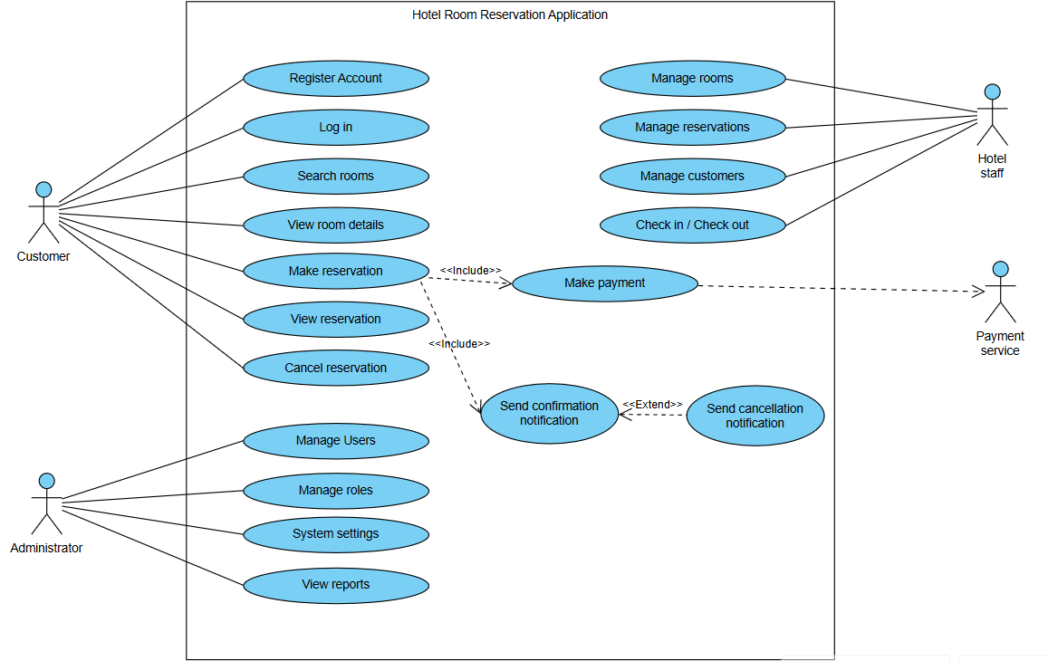

Sequence diagram:
