Software Engineering and Project

Software Design Document

PG5

Sai Dheeraj Reddy Pallavolu

Xuankai Feng

Junjie Zhao

Sharon Khate Damaso

Kalpana Parvathaneni

Ying Wang

Yuedong Wang

Lantian Cai

1.0

2/09/2019

Table of Contents

**Version History** **1**

**Introduction** **2**

Overview 2

Intended audience 2

References 2

Glossary 2

**Components Design** **3**

Component Decomposition Description 3

**Human Interface Design** **4**

Overview of the User Interface 4

Detailed Design of the User Interface 4

**Appendix A** **5**

# Version History

|  |  |  |  |
| --- | --- | --- | --- |
| Date | Version | Changer | Description |
| 29/09/2019 | 0.1 | Pallavolu Sai  Dheeraj Reddy | Finalized section introduction. Waiting for final document review |
| 30/09/2019 | 0.2 | Kalpana Parvathineni | Finalized the Component Design |
| 1/09/2019 | 0.3 | Pallavolu Sai Dheeraj Reddy | Finalized the Human Interface Design |
| 1/09/2019 | 0.4 | Pallavolu Sai Dheeraj Reddy | Merged three sections into smooth report, organized structure |
| 1/09/2019 | 0.5 | Kalpana Parvathineni | Modify and added the images |
| 2/09/2019 | 1.0 | Pallavolu Sai Dheeraj Reddy | Add flowcharts and Modified |

# Introduction

## Overview

This document primarily introduces the software design of the Hire Me Coder. The main purpose of this document is to deliver a comprehensive and detailed description of the software design of Hire Me Coder. It is expected to produce a baseline for software development as it elaborates the process of building the system and understand the software components are to be built. This document provides necessary information.

## Intended audience

This document can be read by all related stakeholders.

All the development team members are intended audiences. This Document can be viewed for all members to comply with design principle and follow the procedure. Moreover, both scope part and process part are helpful for developer to ensure all requirements can meet the expectation of client

Clients from Map tek are audiences of this report. Clients will be interested in all sections of this document they can understand our design document plan of Hire Me Coder.

## References

Software Project and Management Plan Draft

Software Design Documents Draft

System Requirement Specification Draft

The interview with clients of project specification

## Glossary

|  |  |
| --- | --- |
| **Agile Methodology** | A software development approach that promotes continues iteration of development and testing throughout the software development life cycle |
| **GitHub** | Software Development version control |
| **MapTek** | A leading provider of innovative software, hardware and services for the mining industry |
| **Scrum** | An agile process framework |
| **Slack** | Communication Tool |
| **SPMP** | Software Project Management Plan |
| **Trello** | Web-based list-making application |
| **QA** | Quality Assurance |

# Components Design

## Component Decomposition Description

**Login Page:**

The login system is used by administrators and interviewees to login into system. It has two mode i.e., admin mode and candidate mode. Admin will manage the test to interviewee, whereas the interviewee will update their task according to their extension file.

**Register:**

In this the candidate will register the account with their details after registering the details they would receive a link activation to their email account with temporary password.

**Link Activation:**

The link activation is which authorized by admin and generate the link and send to the candidate the link would have expiration time in limited time. Candidate would click on the link with generated temporary password.

**Creating Questionnaire:**

Admin would authorize the creating the question for test to the candidate. Admin will release the question in pdf format to candidate.

**View Assignment:**

Assignment can be viewed by candidate after they receive the link, they can click on it view the assignment.

**Uploading Code File:**

The candidate would upload the file depends on their extension the question is asked in the question paper. So, candidate need to upload the file this function should co-operate with the link activation.

# Human Interface Design

## Overview of the User Interface

The user interactive interface includes login page where admin and candidates can login into the account. Whereas the candidate should register their account. After registering the account, the candidate receives an activation link to their personal email. Admin will upload a test questionnaire, and candidate can login and solve the questionnaire and upload the file according to the extension file given.

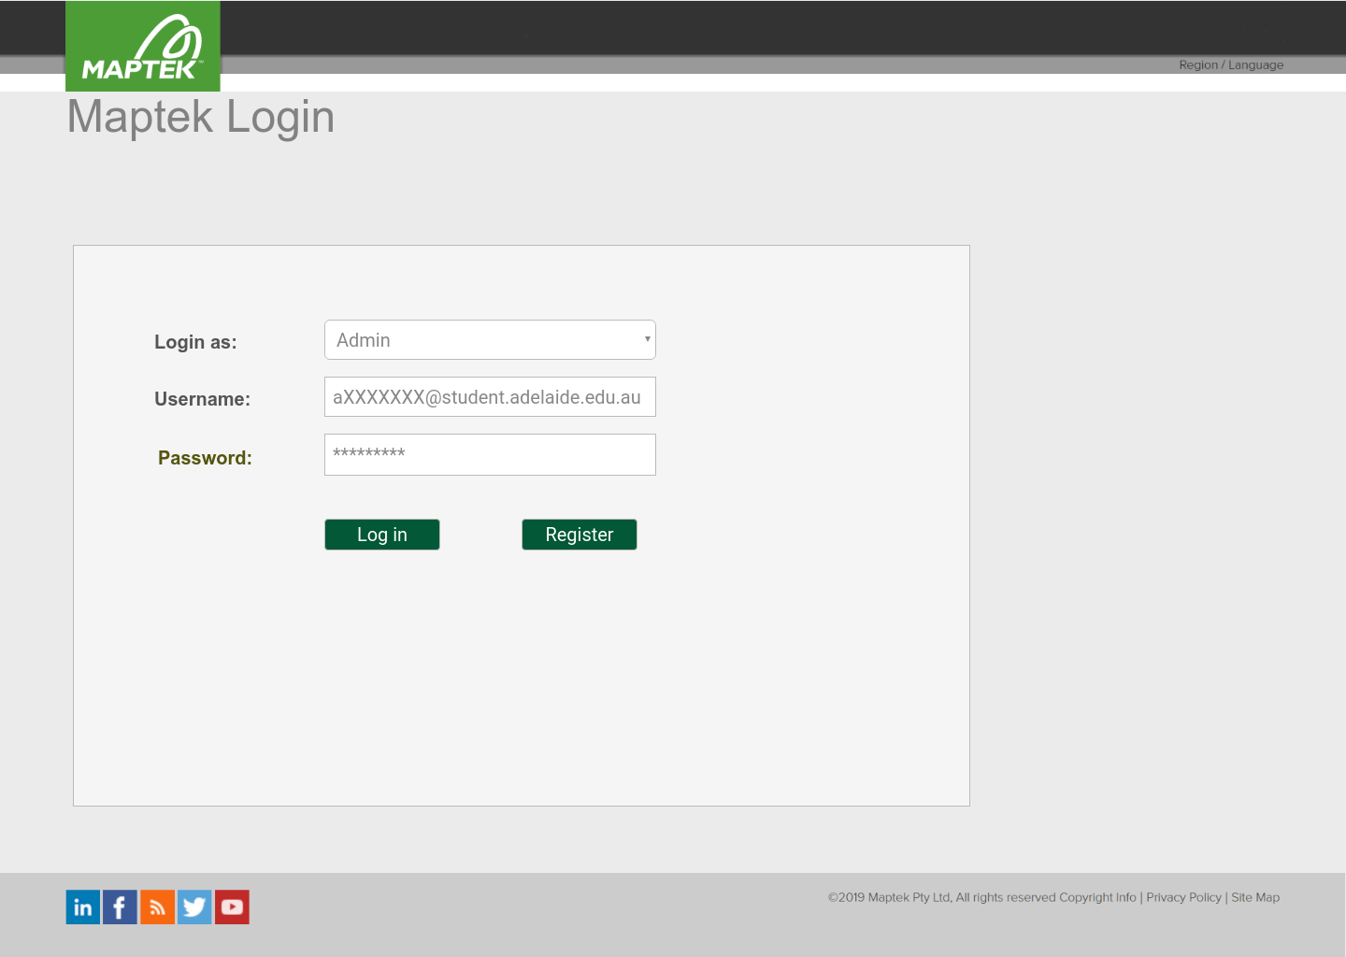

Figure 1 Main Screen of UI

## Detailed Design of the User Interface

**Admin Page:**

This Function only admin can view it, where admin can update the details. Admin can send the test to the candidate, check the coding file of the candidate. And view the database of the assignment for this page

.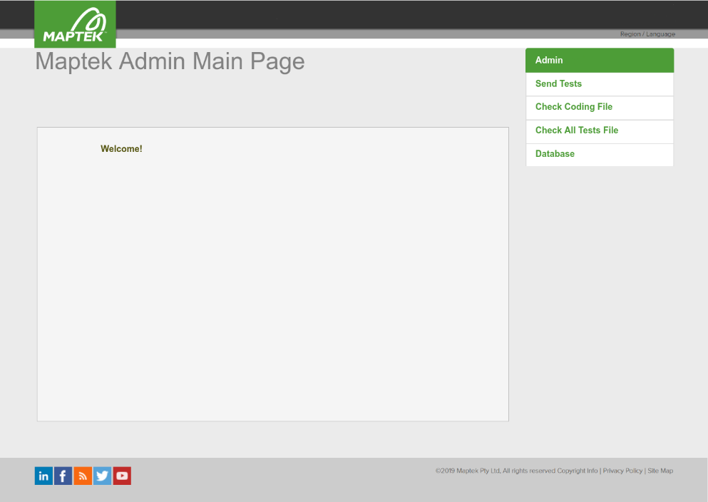

Figure 2 Admin Page

**Register Page:**

The Candidate can register their details as asked in the register form like name, email, mobile number and some other info. After validating the details candidate can register their account.

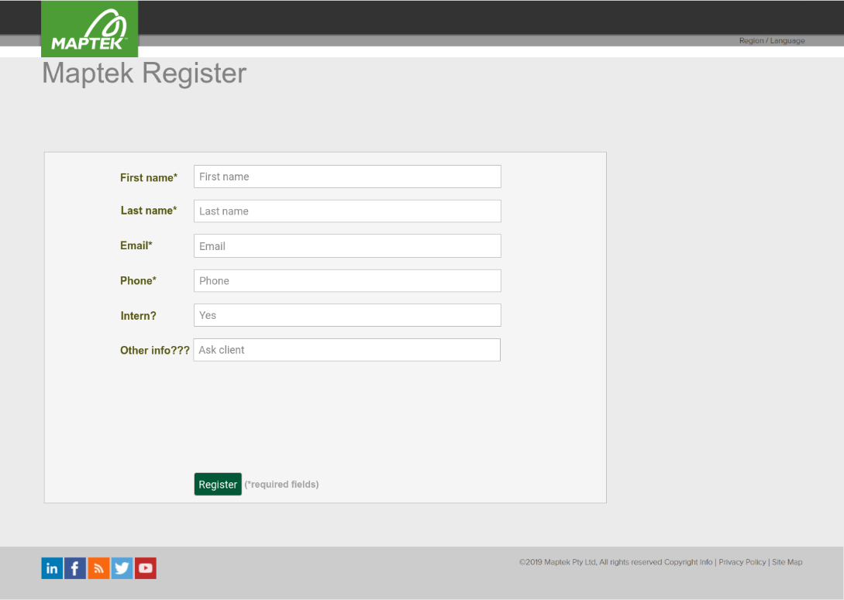

Figure 3 Register Page

**Candidate Welcome page:**

This function is for the Candidate welcome page, where candidate can login with their credentials and can view the test and submit it in online.

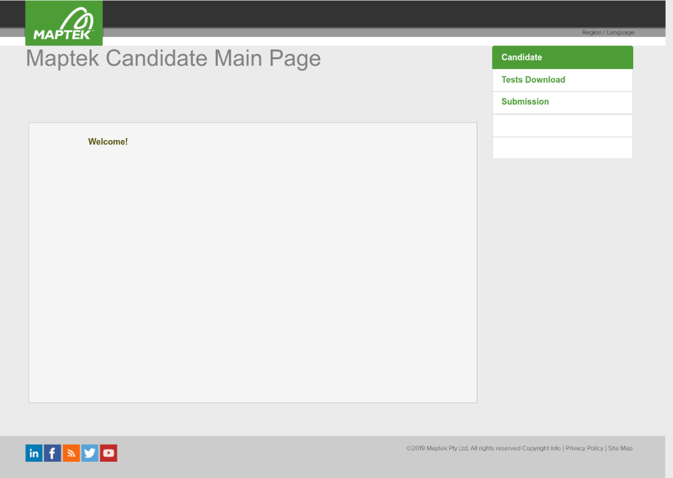

Figure 4 Candidate Welcome page

**Send Test:**

In this function the Send test is viewed by Admin only. Admin can send the test with the attached file to candidate.



Figure 5 Send Test page

**Checking Code File:**

This function is handled by the admin user only because the admin can view the code file whether the candidate has uploaded the file or not.

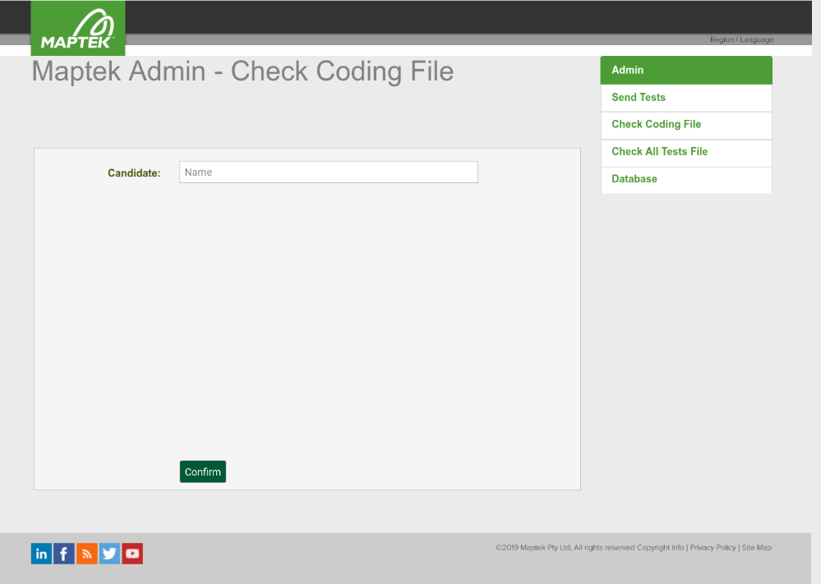

Figure 6 Checking code file page

**Candidate Test File:**

This is function is viewed by the admin user only the admin can check the file whether the candidate has done in correct format.

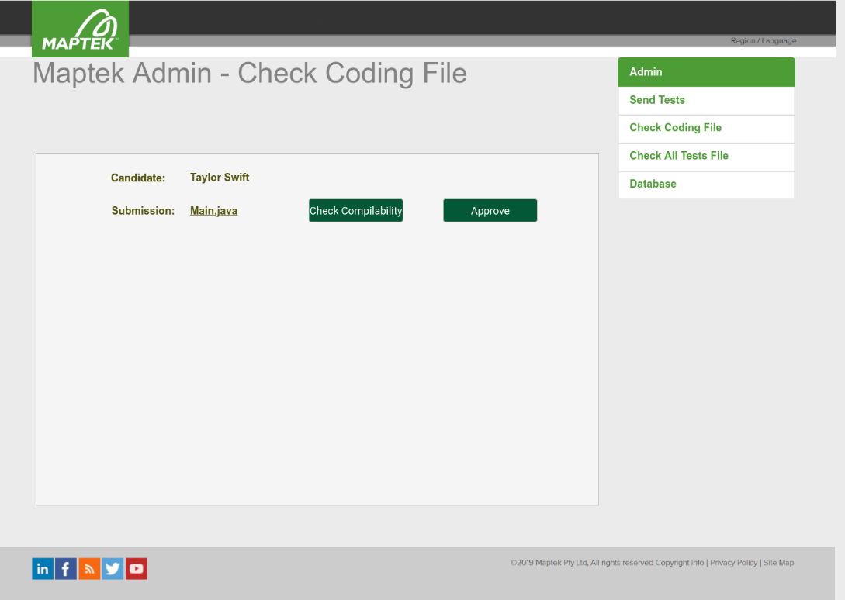

Figure 7 Candidate Test File Page

**Check All File:**

This function is viewed by the admin user, can check all the files of all the candidate whoever has submitted their test.

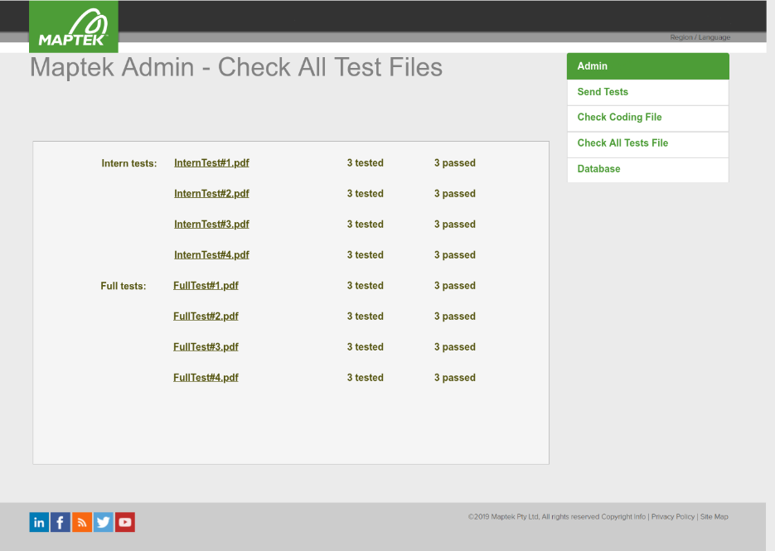

Figure 8 Check all file page

**Submission:**

This Function is viewed in candidate page. Candidate can submit the test file uploading according to their extension file.

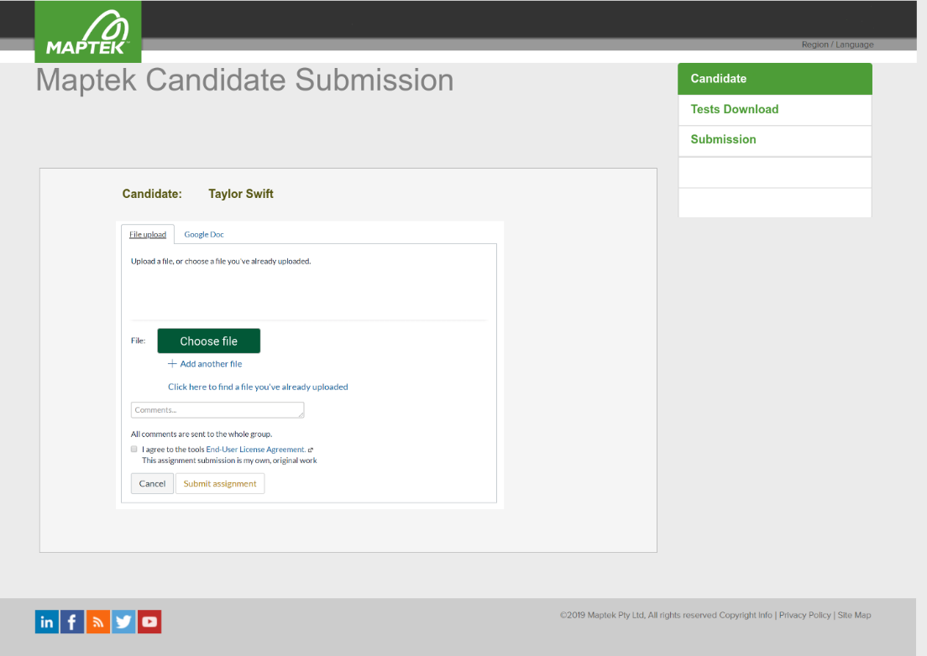

Figure 9 Submission

# Appendix A

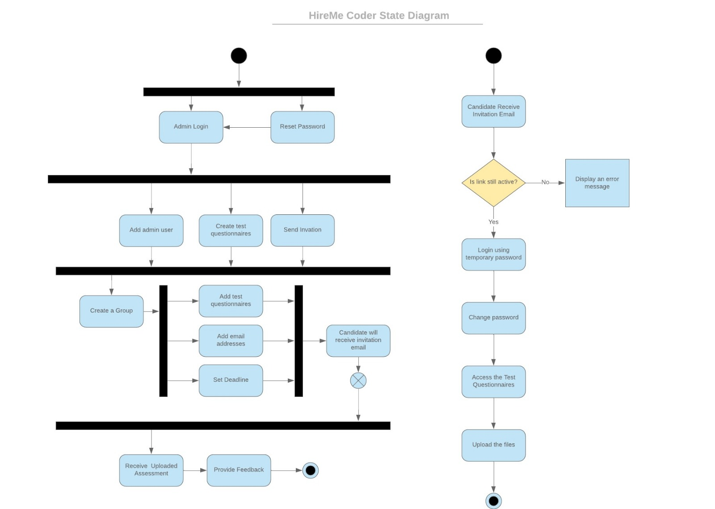

Figure 10 State Diagram of Hire Me Coder

Figure 1 Main Screen of UI

Figure 2 Admin Page

Figure 3 Register Page

Figure 4 Candidate Welcome Page

Figure 5 Send Test page

Figure 6 Checking code file page

Figure 7 Candidate Test File Page

Figure 8 Check all file page

Figure 9 Submission

Figure 10 State Diagram of Hire Me Coder