Software Engineering and Project

Software Project Management Plan

PG5

Xuankai Feng

Sharon Khate Damaso

Junjie Zhao

Sai Dheeraj Reddy Pallavolu

Kalpana Parvathaneni

Ying Wang

Yuedong Wang

Lantian Cai

1.7

21/10/2019

Table of Contents

Version History 1

Introduction 3

Scope 3

Intended audience 3

References 4

Glossary 4

Process 5

Process Model 5

Overview 8

Supporting Plan 9

Documentation 9

Git configuration - structure & branching 9

Naming conventions 10

Versioning 10

Task estimation 10

Task tracking 10

Quality Assurance 10

Risk Management 11

Meetings (internal and external) 11

**Appendix A 12**

# Version History

|  |  |  |  |
| --- | --- | --- | --- |
| Date | Version | Changer | Description |
| 13/8/2019 | 0.1 | Xuankai Feng | Initialized the structure and deciding supporting involved. |
| 15/8/2019 | 0.2 | Junjie Zhao | Finished the scope part |
| 16/8/2019 | 0.3 | Xuankai Feng | Finished the draft of supporting plans, included overview of specific activities |
| 16/8/2019 | 0.4 | Junjie Zhao | Finished the intended audience, reference and glossary parts |
| 18/8/2019 | 0.5 | Xuankai Feng | Finished supporting plan part, written description of each supporting activities with details |
| 19/8/2019 | 0.6 | Sai Dheeraj Reddy Pallavolu | Finished process part with an overview of the whole process |
| 19/8/2019 | 0.7 | Xuankai Feng | Combine three parts of the draft SPMP plan, and reorganize the structure and logic |
| 20/8/2019 | 1.0 | Xuankai Feng | Review the whole plan and correct errors |
| 13/9/2019 | 1.1 | Xuankai Feng | Change reference style into IEEE style |
| 14/9/2019 | 1.2 | Xunakai Feng | Modify the scope part and intended audience part |
| 15/10/2019 | 1.3 | Xuankai Feng | Add Gantt chart as project timetable |
| 17/10/2019 | 1.4 | Xuankai Feng | Modify details of timetable |
| 20/10/2019 | 1.5 | Xuankai Feng | Separate the schedule into time frames |
| 21/10/2019 | 1.6 | Xuankai Feng | Add specification of tests |
| 21/10/2019 | 1.7 | Xuankai Feng | Add details of confliction avoidance to supporting plan |

# Introduction

## Scope

The main purpose of this project is to develop a system to help MapTek test their candidates’ programming skills and abilities. Hence, MapTek can screen qualified software engineers to match their requirements. The system which called “Hire-me Coder” is a web-based facility, both MapTek staff who is regarded as the administrator and the invited candidates can visit it but with different authority. In the perspective of administrators, they have the permission of creating and managing all questions and tests for the candidates in the system. Moreover, the system provides a function to administrators to send invitations to candidates. After invited candidates finishing their allocated tests, administrators will take advantage of the system to evaluate and make assessment. On the other hand, candidates can visit the system only if they have received an invitation from MapTek with temporary username and password. Candidates are expected to finish a test based on their preferred programming languages within required time. Assessment results and feedback from MapTek will be given after they had handed in their tests on time.

In terms of this project, our group will take the responsibility of developing two major modules of “Hire-me Coder” system, the user module and the test module. The user module can be divided into two parts, administrator part and candidate part. The objective of administrator part is to develop functions for administrators to log in and manage personal information. Moreover, administrators can manage all candidate accounts in this system. For candidates, they can change their passwords and basic information. The test module is regarded as the core module of the system, administrators can create, edit or delete both questions and tests in the system. Besides, administrators will receive candidates’ tests answers and provide feedbacks. However, our group will not involve in the development of on-line compiler and embedded mail system.

## Intended audience

The intended audience of this document are all stakeholders of this project. In other words, both the clients from MapTek and all developers in our group have the authority to read this document. This document which refers to a management plan can be a guide for all group members to comply with the management principles and follow the schedule so that the project can be finished and delivered on time with quality and quantity guaranteed. Moreover, both the scope part and the process part are helpful for developers to ensure all functions that they build can meet the requirements and expectation of the client to a great extent. And supporting plans included in this document will be favorable for group members to finish further documents with guarantee that all processes are catching up with the timetable.

Clients from MapTek are intended audiences of this report as well. Clients will be interested in all sections of this document since they need to understand our management plan that can help the project get success. Specifically, they may focus on the process section because this part introduces the process model this project will apply and the time frame of this project. Therefore, they can supervise the whole project.

## References

## *Software Engineering and project- software plan and management plan template*. Adelaide: University of Adelaide, 2019. "The interview with clients of project specification", University of Adelaide, 2019. "Scrum - Framework - Tutorialspoint", *Tutorialspoint.com*, 2019. [Online]. Available: https://www.tutorialspoint.com/scrum/scrum_framework. [Accessed: 13- Aug- 2019].

## Glossary

|  |  |
| --- | --- |
| **Agile Methodology** | A software development approach that promotes continues iteration of development and testing throughout the software development life cycle |
| **GitHub** | Software Development version control |
| **MapTek** | A leading provider of innovative software, hardware and services for the mining industry |
| **Scrum** | An agile process framework |
| **Slack** | Communication Tool |
| **SPMP** | Software Project Management Plan |
| **Trello** | Web-based list-making application |
| **QA** | Quality Assurance |

# Process

## Process Model

## The process model we are following is SCRUM. SCRUM is an implementation of Agile methodology which consists of more complex set of development principles. Our clients will associate with the development team to collect and harness the function of system throughout the whole development period and maintain communications. A product backlog will be determined by the clients in the early stage, then the development team will finish the workload estimation and allocation. In this project, the whole development period will be divided into several sprints and each sprint refers to two weeks. Both group sprint report and individual sprint report are helpful document to show all stakeholders’ the current status of this project after finishing each sprint. Further to this, those reports are useful when the stakeholders need to make a review of this project. Certainly, a sprint retrospective meeting will be held to discuss about previous performance and problems met in last sprint, all group members will participate in and share ideas of the next sprint.

## 

Figure 1. Scrum process model

In this project, there are four sprints divided by two milestones. The first sprint will last from the first week to the third week. Three weeks will be used to finish preliminary work which includes project allocation and briefing, group allocation and the early research. After this first sprint, the development team has been completed built and begun to work on developing the system of Hire-me Coder. Moreover, all team members will discuss about the scope and goal settings of this project during this sprint, and the draft of the Software Project Management Plan will be finished as well.

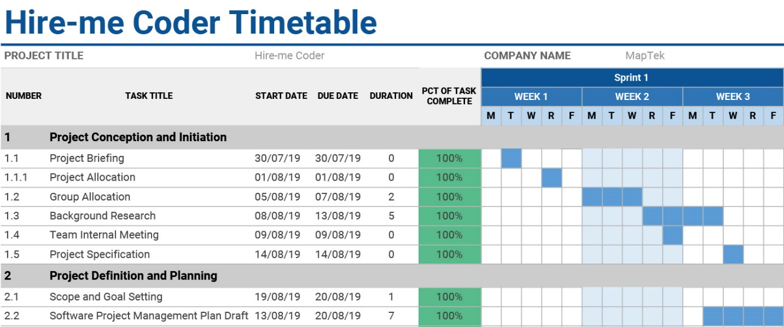

Figure 2. 1st Sprint Schedule

As for the second sprint which will take place from the fourth week to the sixth week, the project will be enter the stage of planning. Various documents which guide the development team to complete the development in the right track. Further to this, both Software Design Document and Software Requirement Specification are necessary to figure out the requirements and expectation from the client. On the other hand, the development team will begin to consider developing tools such as programming and system framework.

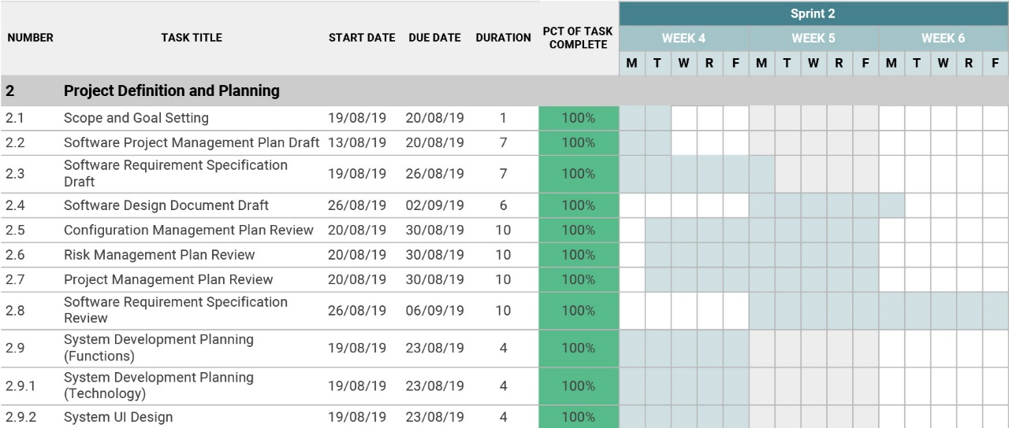

Figure 3. 2nd Sprint Schedule

One of the most important tasks in this project, the first milestone will take place in the third sprint. Before the milestone 1 presentation, the development team had finished most of the documents review so that everyone can focus on the system development. In this stage, the frontend UI design had been finalized and the major functions had been implemented in both frontend and backend. In the meantime, testers from the team are working on designing testing cases to conduct the function tests on both user module and test module. In general, a rough shape of the “Hire-me Coder” system had been developed with required functions by the milestone 2.

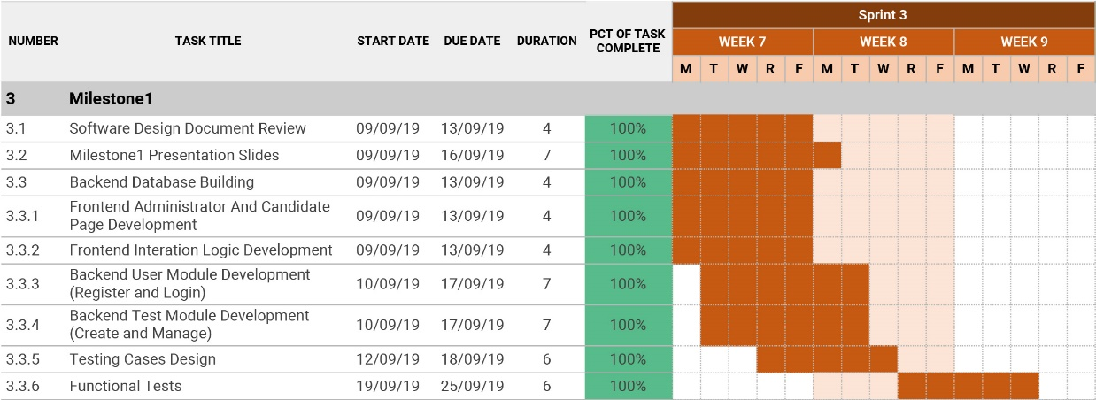

Figure 4. 3rd Sprint Schedule

During the fourth sprint which can be regarded as the final stage of this project, all functions that required by the customers will be finished. Both functional tests and integration tests had been passed so that the system can work well. Specifically, the “Hire-me Coder” system can send assessment to invited candidates and provide tests to them. On the other hand, administrators from MapTek can manage all tests and review the candidates’ submissions. As for the documentation, all plans and related documents had been organized for the client to review.

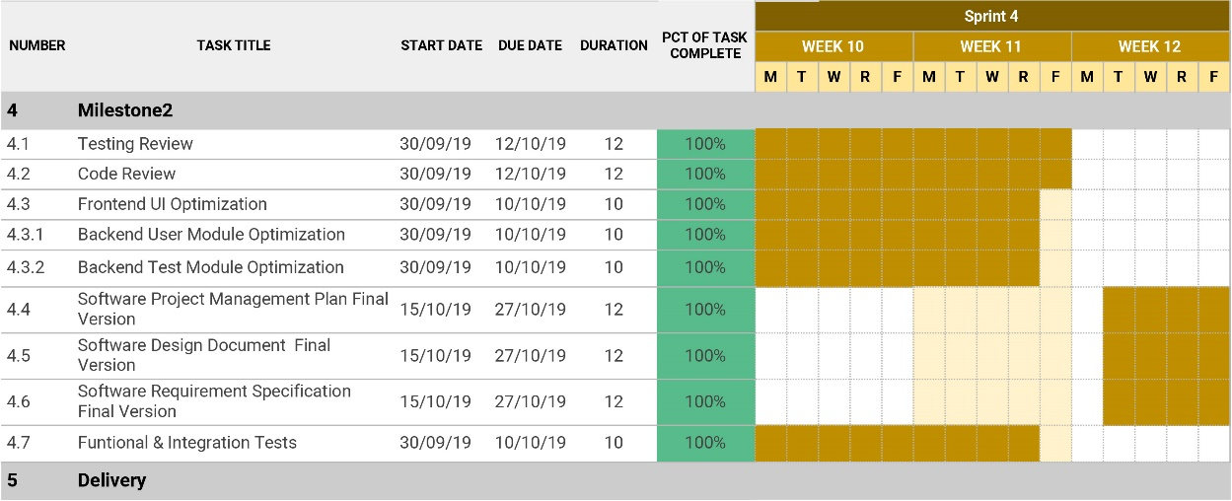

Figure 5. 4th Sprint Schedule

## Overview

This project uses the Object-oriented Programming for designing the project. Aim of the project is to develop the software to hire the developer to satisfy the requirements of MapTek. Every Wednesday there will be a weekly client meeting to achieve these goals and discuss the requirements of the projects and progress of the project. The task is assigned to each member in a team, we have three groups i.e., developer, documentation and testing groups. After the client meeting there is an internal group meeting and one extra meeting if needed per week. In addition to meetings, Slack and Trello used to follow up online for collaboration. Each task is tested and validated.

# Supporting Plan

In order to achieve an effective and smooth development of this project, there are various plans and activities set up to support the development throughout the whole process. A certain portion of supporting plans are common in other developments that we had experienced, and some of them are designed to be suitable for our process model, Scrum model which is an implementation of Agile methodology. In the following part, all supporting plans and activities will be conducted during our development will be introduced with details.

## Documentation

The documentation refers to all documents finished during the project development period. These documents aim at sharing the planning and actual progress to both stakeholders and group members. Therefore, stakeholders and group members can know the current progress and discuss about further steps. Each document will be finished by group members who are allocated to finish it. Then the draft will be uploaded to our GitHub repository before submission. This activity will run through the whole development process, started with the software project management plan and ended with a final presentation as well as demonstration.

## Git configuration - structure & branching

In this project of Hire-me Coder, GitHub is the tool we use to store both project documents and program codes. The repositories on GitHub will be divided into two sections, one section named “doc” which used to store documents including group sprint reports and project plans, and another one named “code” to store both front-end and back-end programming codes.

As for the branching of git configuration, we will have a master branch to ensure all documents and finished codes. For each group member, they should have their own branches to store their work. Specifically, there will be two subordinate branches which refer to QA branch and development branch. For instance, developers will work on codes that they are responsible, and each of them will have a different development branch, after finishing development periodically, they will merge their branches into the master branch. This activity will be a persistent one during this project development.

To specific, the steps to avoid confliction occurring during development are mentioned as following. Firstly, a team member should use “git clone” to download the master branch to his local disk. Then he shall create a new personal branch locally so that he can work on his own branch and have no influence on the master branch. Thirdly, when a team member needs to submit his work to the master branch, he needs to use “git pull origin master” to update the latest master branch then use “git merge” to submit his work. If a team member has influence the origin master branch by mistake, he can use “git reset” command to back to the last version.

## Naming conventions

Camel-Case is the naming convention will be implemented in this project’s development, since it is easy for both developers and testers to distinguish different variables as well as functions.

And for the naming convention of GitHub, all repositories will be named in lower cases.

## Versioning

Documents of this project will be started from version 0.1 which indicates an internal version. Then for the public version, it will be started with version 1.0 and so on.

## Task estimation

In each internal weekly meeting, all group members will share the latest progress of each part and discuss about the next step. So, we will estimate the workload and the next stage’s tasks on every Wednesday when our weekly meeting will be held.

## Task tracking

Trello is used for tracking tasks’ processes throughout the development. Once a new task has been created and allocated, we will upload it to our Trello panel. Task owners will take responsibility for updating the status of tasks in cycles.

## Quality Assurance

There are a code leader and a documentation leader in this project. In terms of documents, each member of documentation group will finish their part, then send to the documentation leader for a review. After that, the combined and modified document will be shared to the whole group for an internal review before submitting. As for the programming part, the code leader will be responsible that all developers are working on the correct functions. Besides, there are two testers in this project, and they will conduct various tests including function test and performance test before releasing new functions.

## Risk Management

The risk management is a vital part of project process management, because there may be some emergencies occurring. We will prepare alternative scheme to each task in terms of different aspects of this project. Programming codes of the system will be stored in the GitHub repository and backup in developers and testers’ computers. If someone delete some codes by mistake, we can easily roll-back to previous status with the feature of GitHub or from other branches.

Possible risks will be listed, and each risk will assign an owner, who will help solve when it does happen. And the probable influence on project will be discusses among group members before starting a new stage of development.

## Meetings (internal and external)

The external meeting with our supervisor who can be regarded as our client occurs on Wednesday morning with all team members. The meeting is used to share project progresses with the supervisor and gain advices and feedback, then the group can make adjustments or conduct further development. Any actions to be made from the meeting will be followed up offline after the meeting, and corresponding minutes of meeting will be written and uploaded to the GitHub repository.

The internal meeting occurs on Wednesday after the external meeting. Each team members will come into discussion about the feedback from the supervisor and allocate tasks to each group member. Furthermore, members can put forward problems they met during previous tasks and share experiences, which is helpful to provoke the progress of this project. Similarly, a minute of meeting will be finished and uploaded to the GitHub so that everyone knows the current situation of this project.

## Appendix A

Figure 1. Scrum process model

Figure 2. 1st Sprint Schedule

Figure 3. 2nd Sprint Schedule

Figure 4. 3rd Sprint Schedule

Figure 5. 4th Sprint Schedule