

Participant user manual
Step-by-step reference for ICT, HR and Finance
One-Day Practical Training Programme | Mutoko, Zimbabwe | 2 ICT · 3 HR · 2 Finance
Prepared from the approved discovery baseline. Training delivery, attendance, competence and Council acceptance remain unrecorded until conducted.

How to use this manual
Use W1–W17 below. Public screenshots show actual read-only website captures, not training records. Every authenticated screen is pending until approved training access is provided. Follow the numbered sequence only where authorized; stop at any missing permission. Browser completion with each participant role has not yet been verified.
Required before hands-on work: G1 isolated training URL, G2 tested role access, G3 controlled mail/no external AI, G4 supplied fictional files. Organizational approval and software publication are separate.

Workflow contents
W1 — Find information on the public website (All)
W2 — Sign in, recover access and protect your account (All)
W3 — Navigate the administration panel (All)
W4 — Create and edit a managed Page draft (Authorized authors)
W5 — Create news or a notice (Authorized authors)
W6 — Upload an image or PDF safely (Authorized authors)
W7 — Create a financial or governance document (Finance / authorized authors)
W8 — Replace a document and preserve history (Finance / authorized document editors)
W9 — Review, publish, withdraw and check visibility (Authorized verifier/publisher)
W10 — Manage a vacancy with authorized HR access (HR)
W11 — Maintain approved department and staff information (HR if assigned)
W12 — Handle procurement publications safely (Procurement-authorized Finance / ICT)
W13 — Handle enquiries, feedback and complaints privately (Assigned officers)
W14 — Review users, scopes, audit and MFA safely (ICT)
W15 — Monitor, troubleshoot and escalate (ICT; basic triage for all)
W16 — Verify backups, recovery and release readiness (ICT demonstration / tabletop)
W17 — Manage translations, galleries and other public modules (Authorized content owners)

W1 | Find information on the public website

Purpose
Locate authoritative Council information before editing or responding.

Required permissions and prerequisites
No CMS permission for public reading
Use only an approved training fixture and address for changes. Confirm named responsibility and role/scope with ICT before opening Create or changing state.

Navigation path
Public website → navigation / search

Numbered instructions
1. Open https://www.mutokordc.co.zw/en for read-only orientation. Use the approved separate training address for exercises.
2. Use Services, Documents, Vacancies or another relevant menu. Read the title, dates and status before relying on a record.
3. In Documents, filter by category/year/department or search. Open a record detail page; distinguish the publication year from its upload date.
4. Use the language selector for English, Shona or Ndebele. Missing translated content may remain English.
5. Try the available text-size/contrast controls and keyboard navigation. Report a barrier rather than claiming full accessibility.
6. Record the exact URL and date checked. Do not submit forms or register tender downloads on production during training.

Actual screen or pending evidence
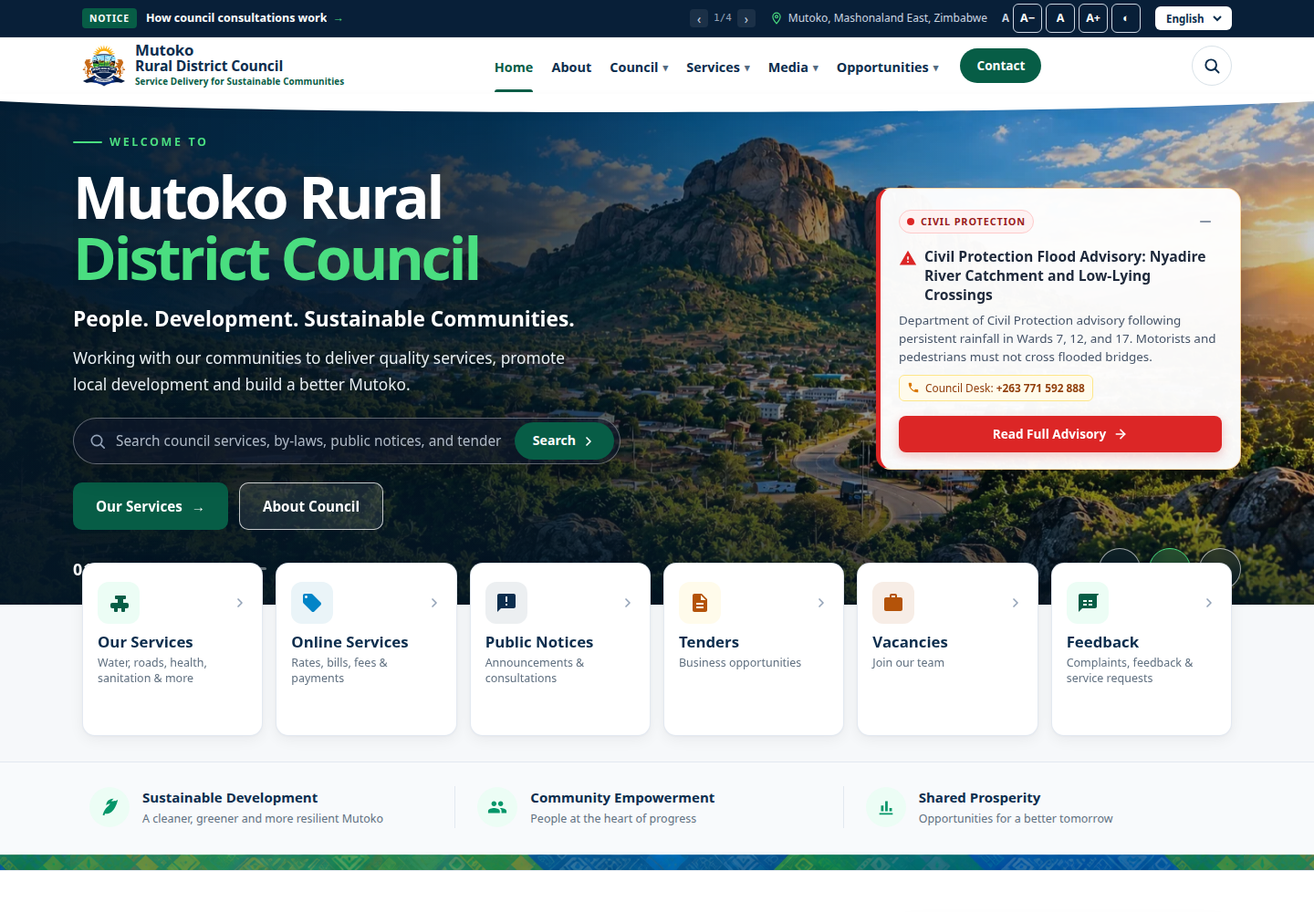
Verified public screenshot home: https://www.mutokordc.co.zw/en | 2026-11-12T02:26:18.341Z | 1440 × 1000

Expected result
Participant locates a service, a vacancy and a document and can cite their URLs.

Common errors and troubleshooting
An empty category can mean no published content. A 200 response does not prove accurate wording, file integrity or complete translation.

Security and governance
Public names and contact details may be viewed; do not reproduce private complaint details.

W2 | Sign in, recover access and protect your account

Purpose
Access the permitted CMS without sharing credentials.

Required permissions and prerequisites
Active account + admin.access + valid scope
Use only an approved training fixture and address for changes. Confirm named responsibility and role/scope with ICT before opening Create or changing state.

Navigation path
/admin/login → profile / Forgot password?

Numbered instructions
1. Check the approved training URL with the facilitator. Open /admin/login and enter your own assigned account credentials.
2. If prompted for an authenticator code, use your enrolled device. MFA is supported; enrollment is not proven mandatory for every account.
3. If access fails, check the address and typing, then contact ICT. A disabled account or missing scope cannot be fixed by repeatedly retrying.
4. For password recovery use Forgot password? and the registered mailbox. Do not forward a reset link. Training recovery requires a controlled mail sink.
5. Open your user menu and profile. Use its password fields if available; choose a long unique password. Exact authenticated profile screenshot is pending.
6. Store MFA recovery codes in the approved secure location, never in the CMS or a training screenshot. Lost codes/device require verified ICT identity recovery.
7. Log out after use and lock the workstation during breaks.

Actual screen or pending evidence
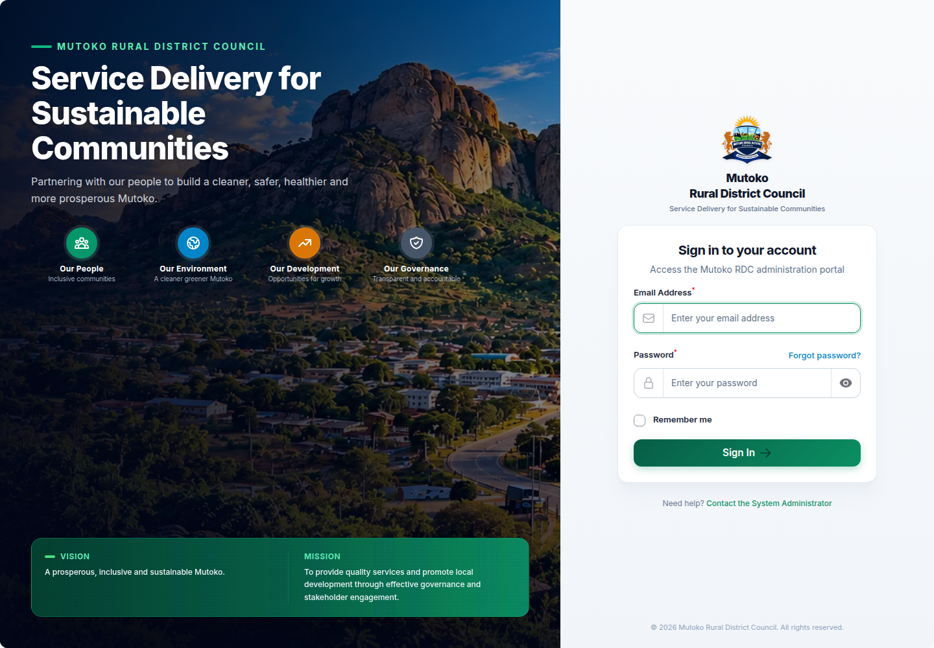
Verified public screenshot login: https://www.mutokordc.co.zw/admin/login | 2026-11-12T02:26:28.838Z | 1440 × 1000

Expected result
Authorized participant sees only permitted navigation; account secrets remain private.

Common errors and troubleshooting
No email: report to ICT for SMTP/sink checks. MFA loss: use secured recovery codes or ICT; no verified universal MFA-reset button is claimed.

Security and governance
Never use another officer’s account or include passwords/recovery codes on attendance sheets.

W3 | Navigate the administration panel

Purpose
Find the correct resource and help for your role.

Required permissions and prerequisites
Per-module view permission plus scope
Use only an approved training fixture and address for changes. Confirm named responsibility and role/scope with ICT before opening Create or changing state.

Navigation path
/admin → relevant cluster → module

Numbered instructions
1. Open the dashboard. Identify Public Enquiries, Content, Council, Services & Development, Reports & Monitoring and Administration where visible.
2. Open your permitted module: News and notices and Documents are in Content; Vacancies is in Services & Development.
3. Locate search, record title/status columns and row actions. Actions depend on permission, record state and scope.
4. Open System Walkthrough at /admin/system-guide when available. Use this manual’s workflow ID when requesting support.
5. If Create or a row action is missing, record the exact module and task and ask ICT to review authorized access. Do not borrow credentials.

Actual screen or pending evidence
SCREENSHOT PENDING — admin-pending. Capture from approved training build with the intended role; do not substitute a sample dashboard.

Expected result
Participant locates a permitted resource and explains at least one access limitation.

Common errors and troubleshooting
Department-only create checks may deny entry even with create permission. Role names do not establish all rights.

Security and governance
System Administrator rights are not a prerequisite for ordinary authorship.

W4 | Create and edit a managed Page draft

Purpose
Maintain supported informational content while preserving a reviewable draft.

Required permissions and prerequisites
pages.view/create/update with matching scope; verify/publish separately
Use only an approved training fixture and address for changes. Confirm named responsibility and role/scope with ICT before opening Create or changing state.

Navigation path
Content → Pages → Create / Edit

Numbered instructions
1. Confirm permission and an assigned disposable record. Choose Create or open the assigned draft with Edit.
2. Enter TRAINING ONLY – Participant [ID] page, a unique lowercase-hyphen slug, a short summary and the approved department.
3. Add heading, paragraph and optional CTA blocks. CTA links must be internal paths beginning with a single slash.
4. Save with the form’s Create/Save action. Confirm draft status. Record its ID/slug on the workbook.
5. Edit a paragraph and save again. Core Page editing returns the record to draft; public availability may stop until republication.
6. Do not assume all About sections are controlled here. Vision/mission use code-managed translation keys and the district map is bundled.
7. When authorized, open Restore revision and inspect the snapshot before confirming. Restoration produces a draft and needs review again.

Actual screen or pending evidence
SCREENSHOT PENDING — admin-pending. Capture from approved training build with the intended role; do not substitute a sample dashboard.

Expected result
A clearly labelled draft contains the intended blocks; edits are saved without premature publication.

Common errors and troubleshooting
Duplicate slug: choose a unique participant suffix. Invalid CTA: use a permitted internal path. Restore denied: stop and record access.

Security and governance
Never change a production slug casually; external links may depend on it. Page visibility gates differ from Documents.

W5 | Create news or a notice

Purpose
Prepare a factual announcement and distinguish a notice’s expiry from a news item.

Required permissions and prerequisites
editorial.view/create/update; media rights if uploading; verify/publish separately
Use only an approved training fixture and address for changes. Confirm named responsibility and role/scope with ICT before opening Create or changing state.

Navigation path
Content → News and notices → Create

Numbered instructions
1. Choose type News or Notice. Enter a TRAINING ONLY title, summary, body and a unique slug.
2. Choose the correct department/category. Use clear paragraphs or lists; avoid pasted scripts, embeds or private information.
3. For Notice, set an expiry no earlier than today; the public query includes the expiry day. Set Urgent only when organizationally approved.
4. If adding an image, use the supplied training image and meaningful Image alt text, or pick permitted active library media.
5. Attach only intended Documents; each document has its own approval/public visibility conditions.
6. Save draft; edit and save again to confirm changes. Arrange separate review before an authorized Verify/Publish action.
7. Do not look for a verified future scheduling button; publication currently sets its timestamp to now.

Actual screen or pending evidence
SCREENSHOT PENDING — admin-pending. Capture from approved training build with the intended role; do not substitute a sample dashboard.

Expected result
News/Notice is correctly classified and saved as a draft; expiry and urgency are intentional.

Common errors and troubleshooting
Past expiry rejected on save; duplicate slug or inaccessible media can fail validation. Missing buttons require permission review.

Security and governance
Verify & Publish exists for authorized editorial users; it does not establish an independent second-officer approval.

W6 | Upload an image or PDF safely

Purpose
Use allowed file formats and descriptive alternatives.

Required permissions and prerequisites
media.view/create; media.update for metadata changes
Use only an approved training fixture and address for changes. Confirm named responsibility and role/scope with ICT before opening Create or changing state.

Navigation path
Content → Media → Create / Edit

Numbered instructions
1. Open the supplied file locally and confirm it is the intended fictional image/PDF. Check there is no personal or confidential information.
2. In Media choose Create; select JPEG/JPG, PNG, WebP or PDF. Default application limit is 10,240 KB; hosting may impose a lower limit.
3. Enter a descriptive title, caption where helpful, and the correct department. For an informative image add meaningful Alt text.
4. Save and open Preview; check image/file and metadata. Uploaded files are library items, not automatically approved public Documents.
5. For a metadata correction use Edit only if authorized. Use Archive cautiously: linked public content may depend on the media being active.

Actual screen or pending evidence
SCREENSHOT PENDING — admin-pending. Capture from approved training build with the intended role; do not substitute a sample dashboard.

Expected result
Valid media is active in the permitted library; image alt text describes its purpose.

Common errors and troubleshooting
Extension/MIME mismatch or invalid image is rejected. A renamed executable is not a PDF. For storage/size failures report the exact non-sensitive error.

Security and governance
Alt text is good practice and a ToR requirement even where validation allows it to be blank. Do not bypass upload rejection.

W7 | Create a financial or governance document

Purpose
Publish the correct approved PDF with searchable classification and reporting year.

Required permissions and prerequisites
documents.view/create and permitted media.view/create; matching scopes
Use only an approved training fixture and address for changes. Confirm named responsibility and role/scope with ICT before opening Create or changing state.

Navigation path
Content → Documents → Create

Numbered instructions
1. Use only the supplied TRAINING ONLY sample budget in the isolated environment. Enter a unique title and slug with participant ID.
2. Select Category: Budget for the sample budget, not a financial report merely because both concern Finance.
3. Choose Department and Visibility deliberately. Public means eligible after approval/publication; Private must not be treated as public disclosure.
4. Set Reference date to 2099-01-01 for this fictional budget. Its reference year is derived from that date, not the upload timestamp.
5. Use Upload PDF document or select an active permitted PDF from the library. The saved document must have an active PDF media reference.
6. Save draft. Verify metadata and PDF before requesting organizational review and authorized Verify/Publish.
7. After permitted training publication, check the separate training Documents/Transparency page, year/category and actual opened file.

Actual screen or pending evidence
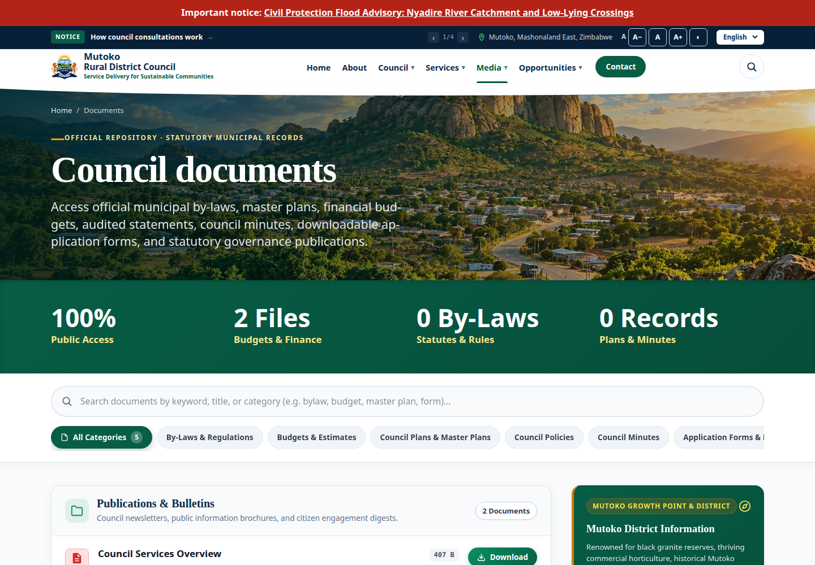
Verified public screenshot documents: https://www.mutokordc.co.zw/en/documents | 2026-11-12T02:26:20.400Z | 1440 × 1000

Expected result
Correct draft links to the intended PDF and reporting year; only approved public publication appears to citizens.

Common errors and troubleshooting
Category/year mismatch: correct metadata. Missing PDF or media visibility rights: stop. Default Department Content Owner lacks update/replace.

Security and governance
Never publish payroll, bank statements with private transactions, ratepayer lists or unapproved financial figures.

W8 | Replace a document and preserve history

Purpose
Supersede the same publication without losing the previous version.

Required permissions and prerequisites
documents.update + scoped document/media view; verify/publish separately
Use only an approved training fixture and address for changes. Confirm named responsibility and role/scope with ICT before opening Create or changing state.

Navigation path
Content → Documents → row action Replace file

Numbered instructions
1. Confirm this is a corrected version of the same publication; a different year/publication may require a new record.
2. Upload the supplied corrected sample PDF to Media with a distinct title, if authorized. Inspect the file first.
3. In Documents locate your assigned record and note current version. Choose Replace file, then the replacement active PDF.
4. Confirm the action. Record the new version: it increments; the old media is preserved in DocumentVersion; the record returns to draft.
5. Review the replacement, then ask an authorized verifier/publisher to repeat approval/publication in training.
6. Open the training public document/download and confirm corrected content, category/year and filename. Never use ordinary edit to claim version history was preserved.

Actual screen or pending evidence
SCREENSHOT PENDING — admin-pending. Capture from approved training build with the intended role; do not substitute a sample dashboard.

Expected result
Version increases, previous media is retained, draft is re-reviewed and the current approved file is verified.

Common errors and troubleshooting
Same media selected again: choose the corrected file. Action absent: Finance replacement rights have not been established; record pending.

Security and governance
Do not delete/recreate to hide an error. No universal recycle bin or delete audit guarantee is claimed.

W9 | Review, publish, withdraw and check visibility

Purpose
Apply system visibility controls after organizational approval.

Required permissions and prerequisites
Module-specific verify/publish rights and scope; vacancy verify uses vacancies.update
Use only an approved training fixture and address for changes. Confirm named responsibility and role/scope with ICT before opening Create or changing state.

Navigation path
Resource row → Verify / Mark publishable → Publish

Numbered instructions
1. Review accuracy, dates, attachments, personal information, department, category/year, alt text and approved wording.
2. Record organizational approval in the Council-approved location. The application does not enforce a different person for every review.
3. Use Verify or Mark publishable as offered by the resource, then Publish with an authorized account. Editorial Verify & Publish combines these actions.
4. In a separate anonymous training browser/tab open the expected citizen URL. Check text, links, file and status, not only a success message.
5. For a correction, edit the record and expect core content to return to draft. Review and publish again before announcing availability.
6. Use Unpublish or Archive for withdrawal where available. Avoid destructive Delete unless an approved retention process permits it.
7. Remember exceptions: FAQs use is_published; bank accounts use active + published status; settings apply on save; slides/statistics have distinct controls.

Actual screen or pending evidence
SCREENSHOT PENDING — admin-pending. Capture from approved training build with the intended role; do not substitute a sample dashboard.

Expected result
Only intended content is publicly accessible, or its withdrawal is verified.

Common errors and troubleshooting
Draft/private/unverified/inactive-media/expired records can be absent. Page verification checks are not uniform; never rely on a universal gate.

Security and governance
System verification is not legal approval. Account sharing to obtain a publish button is prohibited.

W10 | Manage a vacancy with authorized HR access

Purpose
Prepare an accurate vacancy with a controlled closing date and advert.

Required permissions and prerequisites
vacancies.view/create/update; vacancies.publish separately; advert document rights
Use only an approved training fixture and address for changes. Confirm named responsibility and role/scope with ICT before opening Create or changing state.

Navigation path
Services & Development → Vacancies → Create / Edit

Numbered instructions
1. Confirm HR vacancy access is specifically configured and tested. The default Department Content Owner role does not grant these rights.
2. Create TRAINING ONLY – Records Assistant [ID]. Use a unique fictional reference and slug; enter grade/employment type if needed.
3. Enter description, responsibilities and requirements. Use one item per line where the form requests it; use approved application instructions.
4. Choose the HR department, display order 0, opening date equal to training day and closing date seven days later. Confirm closing is not before opening.
5. Attach the assigned advert Document if available; its public eligibility is separate. Save draft and record ID/reference.
6. Edit one requirement, save and inspect draft state. Vacancy Verify uses update permission; publication requires vacancies.publish.
7. Observe the authorized training publisher and check the public training vacancy. It remains Open on its closing day and reads Closed after that day; it can remain listed.

Actual screen or pending evidence
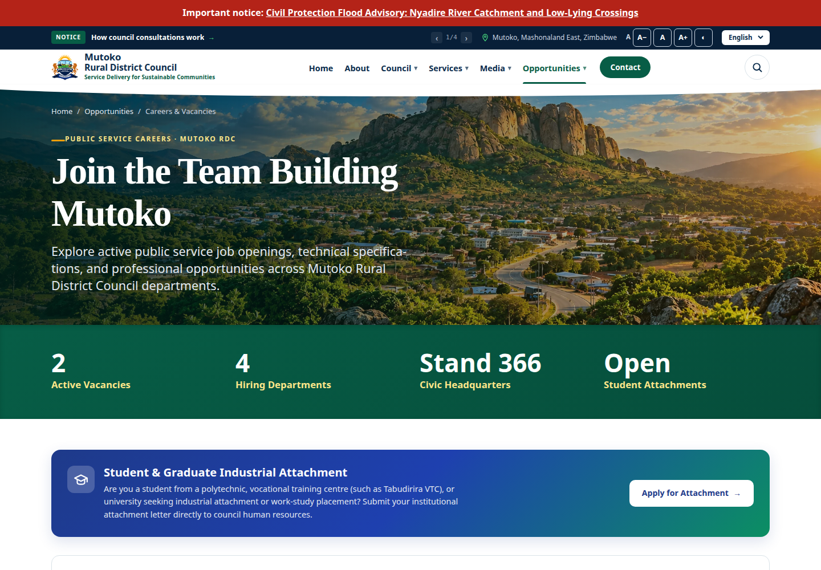
Verified public screenshot vacancies: https://www.mutokordc.co.zw/en/vacancies | 2026-11-12T02:26:22.069Z | 1440 × 1000

Expected result
Draft vacancy has correct dates, instructions and attachment; publication occurs only through authorized training access.

Common errors and troubleshooting
Missing menu/Create/action: pending access, not participant failure. Missing advert does not establish a live online application facility.

Security and governance
No real applicant CVs, personal employee records or production vacancy edits in exercises.

W11 | Maintain approved department and staff information

Purpose
Keep approved public profiles current while separating internal and public status.

Required permissions and prerequisites
departments.update/verify/publish; officials.create/update/verify/publish as applicable
Use only an approved training fixture and address for changes. Confirm named responsibility and role/scope with ICT before opening Create or changing state.

Navigation path
Council → Departments / Officials

Numbered instructions
1. Confirm the Council has assigned this responsibility and the account has the required rights; default HR role rights are insufficient.
2. In Departments open the assigned training record. Check internal name/code and public name/summary/description/responsibilities.
3. Edit only the assigned public text; preserve internal department identity and correct display order. Save and follow public verification/publication actions.
4. For Officials enter only an approved public name/title/biography and permitted image with alt text. Confirm category, department and head-of-department flag.
5. After authorized training publication check the public profile and linked department page. Do not assume the bundled About content changes.

Actual screen or pending evidence
SCREENSHOT PENDING — admin-pending. Capture from approved training build with the intended role; do not substitute a sample dashboard.

Expected result
Approved public information matches the relevant department/official and related pages.

Common errors and troubleshooting
Department activation is not the same as publishing its profile. Linked officials/documents each have their own visibility.

Security and governance
Keep private phone numbers, medical, salary and disciplinary information out of public profiles.

W12 | Handle procurement publications safely

Purpose
Recognize procurement responsibilities without assuming Finance job title grants authority.

Required permissions and prerequisites
tenders.view/create/update/verify/publish; tenders.award for awards
Use only an approved training fixture and address for changes. Confirm named responsibility and role/scope with ICT before opening Create or changing state.

Navigation path
Services & Development → Tenders / Tender compliance

Numbered instructions
1. Confirm procurement responsibility and rights. Use a preassigned training tender; do not create a production download registration.
2. Check reference/title, description, lifecycle, opening/closing dates, department and advert Document before seeking publication.
3. Compare public date-derived status with stored lifecycle and Tender compliance indicators. An indicator is not statutory certification.
4. If authorized to record an award, use the award action with fictional contractor and award date. Publish an amount only if organizationally cleared.
5. Treat bidder company/email/IP data as personal/business data. Download registration can create records; demonstrate it only on isolated training fixtures.

Actual screen or pending evidence
SCREENSHOT PENDING — admin-pending. Capture from approved training build with the intended role; do not substitute a sample dashboard.

Expected result
Officer distinguishes publication, tender lifecycle, award approval and download registration.

Common errors and troubleshooting
Awarded status needs contractor and award date. Document download checks are weaker than the general public-document scope; focused QA is pending.

Security and governance
Do not demonstrate real bidder submissions, evaluation records or external email.

W13 | Handle enquiries, feedback and complaints privately

Purpose
Route correspondence and keep notes separate from a citizen response.

Required permissions and prerequisites
enquiries.view/update/route/assign individually; matching scope
Use only an approved training fixture and address for changes. Confirm named responsibility and role/scope with ICT before opening Create or changing state.

Navigation path
Public Enquiries → Enquiries → View

Numbered instructions
1. Open only the preassigned fictional training enquiry and confirm reference, department, status and origin.
2. If authorized, Route to department, then Assign staff in that department. View permission alone does not grant these actions.
3. Use Add internal note for factual staff-only notes. New can move to In progress or Closed; In progress can move to Resolved or Closed.
4. Resolved or Closed may reopen to In progress through permitted transitions. The default SLA is five days; escalation requires the host scheduler.
5. AI Draft Reply can produce an internal draft; do not send real data to AI services during training. Review any draft before use.
6. Send Update to Citizen is an explicit email action; use only a controlled training recipient and mail sink. Do not confuse it with an internal note.

Actual screen or pending evidence
SCREENSHOT PENDING — admin-pending. Capture from approved training build with the intended role; do not substitute a sample dashboard.

Expected result
Private record is correctly routed/updated with traceable, appropriate text; no real message is sent.

Common errors and troubleshooting
Stale/invalid transition: refresh and inspect status. No mail: ICT investigates transport/worker; a success notification is not inbox-delivery proof.

Security and governance
Never copy a complaint or its attachments into a public Page/News/Document record.

W14 | Review users, scopes, audit and MFA safely

Purpose
Explain safe account administration without performing unauthorized changes.

Required permissions and prerequisites
users.view; changes require separately approved users.*; audit.view/export
Use only an approved training fixture and address for changes. Confirm named responsibility and role/scope with ICT before opening Create or changing state.

Navigation path
Administration → Users / Roles; Reports & Monitoring → Audit events / Audit report

Numbered instructions
1. Use an approved isolated account or redacted evidence. Locate active/disabled status, department, role and its global/department/own scope.
2. Compare the requested duties to current permissions; missing actions become access requests, not permission grants during this document-development task.
3. Describe approved user creation: name/email/active department; reset-link delivery requires secure mail. Explain disable/reactivate and leaver controls.
4. Explain protections: no self-disable, no disabling/removing the final System Administrator, System Administrator requires global scope; custom role policy protects its permissions.
5. Locate Audit events/report and filter to the assigned fictional event. Explain actor/action/time/subject and keep export recipients authorized.
6. Record coverage limits: not all direct saves/deletes are audited; Shield super-admin interactions need review. Do not claim audit proves every read or write.
7. Explain optional authenticator MFA and secured recovery codes; no real secret is displayed. Record any recovery request for identity verification.

Actual screen or pending evidence
SCREENSHOT PENDING — admin-pending. Capture from approved training build with the intended role; do not substitute a sample dashboard.

Expected result
ICT identifies permissions/scopes and one audit event or records the evidence as pending.

Common errors and troubleshooting
Unavailable scoped create/action: inspect the actual policy, permission and role-associated scope. Never edit production roles as a demonstration.

Security and governance
Approval to develop training is not authorization to change application users, permissions or hosting.

W15 | Monitor, troubleshoot and escalate

Purpose
Gather useful evidence and avoid misleading health conclusions.

Required permissions and prerequisites
analytics.view, system-health.view, mail_operations.view or audit.view as needed
Use only an approved training fixture and address for changes. Confirm named responsibility and role/scope with ICT before opening Create or changing state.

Navigation path
Reports & Monitoring → System health / M&E dashboard / Email operations

Numbered instructions
1. For missing content, first check draft/publication, dates, visibility, media/attachment status and account permissions. Record URL/time/error.
2. For infrastructure symptoms review approved read-only reports. /up returning 200 is liveness, not proof that email, DB, jobs and backups work.
3. System health always pings Redis and reads jobs/failed_jobs counts. Check selected drivers; an irrelevant Redis failure can mislead on database-backed hosting.
4. Ask ICT/hosting for actual worker progress and recent cron execution, not only queue counts or schedule:list. A stopped worker can still show Healthy.
5. Inspect email operations with view-only rights. Retry may send messages; do not retry a production message during training.
6. Review M&E counts as approximate usage; public audit traffic can affect counts. Export only as authorized.
7. Escalate content to owner, access to ICT, application defects to software support, infrastructure/TLS to hosting, suspected disclosure immediately to ICT and privacy lead.

Actual screen or pending evidence
SCREENSHOT PENDING — admin-pending. Capture from approved training build with the intended role; do not substitute a sample dashboard.

Expected result
A support ticket identifies symptom, environment, URL/time, safe evidence, owner and action needed.

Common errors and troubleshooting
Do not expose .env, passwords, cookies or real citizen data in screenshots/log exports. Record any current operational evidence that is missing.

Security and governance
For a suspected breach preserve evidence and report immediately; do not erase logs or independently notify the public.

W16 | Verify backups, recovery and release readiness

Purpose
Understand evidence needed before accepting ongoing operations.

Required permissions and prerequisites
Approved host access only; not provided by this package
Use only an approved training fixture and address for changes. Confirm named responsibility and role/scope with ICT before opening Create or changing state.

Navigation path
ICT runbooks → backup evidence / scratch recovery plan

Numbered instructions
1. Request latest authorized backup evidence: creation time, successful database dump, managed-files archive and manifest.
2. Check every configured storage disk is covered. backup:create supports the MySQL driver and archives storage/app; remote/custom disks require explicit coverage.
3. Confirm retention, encryption controls and an off-server copy. Compression is not encryption. This command does not schedule itself.
4. Explain restore into a disposable scratch database/files area first, verify record/file access, then plan approved cutover. No restore is executed in this course.
5. Before a release require approved code/version, backup, compatible assets, reviewed migrations, cache steps, actual workers and smoke checks. Never run migrate:fresh in production.
6. Rollback should use the approved runbook; data rollback/cutover requires separate authority. RPO 24h and RTO four business hours remain proposed, not accepted service levels.

Actual screen or pending evidence
SCREENSHOT PENDING — admin-pending. Capture from approved training build with the intended role; do not substitute a sample dashboard.

Expected result
ICT can explain DB/files/manifest/off-server/restore evidence and identify the responsible owner.

Common errors and troubleshooting
Missing cron/backup/off-server evidence remains pending. A historical restoration record is not proof of current recoverability.

Security and governance
Keep secrets inventory sealed separately; no terminal production changes are part of the exercise.

W17 | Manage translations, galleries and other public modules

Purpose
Recognize secondary modules and use the right publication dependencies.

Required permissions and prerequisites
Each module view/create/update plus any verify/publish permissions
Use only an approved training fixture and address for changes. Confirm named responsibility and role/scope with ICT before opening Create or changing state.

Navigation path
Content → Translation status / Galleries; Council → Wards / Council meetings; Services & Development → Council projects / Project updates / Investment opportunities

Numbered instructions
1. In Translation status identify missing/partial/complete values where pages.view permits. Complete means populated fields, not approved linguistic quality.
2. On a permitted record enter Council-approved Shona/Ndebele text in Translations. Empty fields use English fallback; preserve line/block alignment.
3. For Galleries use a draft title/slug, cover and active library images/captions; then follow that module’s verification/publication workflow.
4. For Wards use authoritative names/boundary text and approved map links only. For meetings set date/time/venue/status and independently approved agenda/minutes Documents.
5. For projects link correct wards/documents/image and approved progress. Add a dated Project update and publish it through its own control. Progress is manually maintained.
6. For investment use approved sector/location/requirements/opportunity status and related document. Investor contact uses ordinary contextual enquiries.
7. Preview and verify citizen-facing results in the isolated environment. If a form or permission has not been rehearsed, record the task as pending instead of improvising.

Actual screen or pending evidence
SCREENSHOT PENDING — admin-pending. Capture from approved training build with the intended role; do not substitute a sample dashboard.

Expected result
Officer identifies the managing module, dependency and source of approved information.

Common errors and troubleshooting
Missing media/documents/translations can cause fallback or hidden content. Navigation depends on role and record state.

Security and governance
This is reference coverage; secondary modules are not all practical assessment requirements in the one-day timetable.

Glossary
Term | Plain-English meaning
CMS | The administration system used to maintain website content.
Resource | A CMS module such as Documents or Vacancies.
Draft | Saved content awaiting review/publication; normally not public.
Publishable | Verification state allowing publication where the module requires it.
Published | Publication state; dates, visibility and dependencies can still affect public availability.
Scope | The global, department or own-record boundary attached to a role.
Slug | The readable part of a URL; changing it may break links.
Alt text | A useful text alternative describing an image’s information.
Media | Uploaded image/PDF and its stored metadata.
Reference date | Document date from which the reporting year is derived.
Version | A retained predecessor when Replace file supersedes a document.
MFA | Multi-factor authentication; authenticator plus password, where enrolled.
Queue | Stored work waiting for a worker; a count does not prove progress.
Scheduler | Laravel’s planned tasks, requiring actual host cron execution.
SMTP | The email transport used to deliver messages.
Audit event | Recorded actor/action/time/subject; coverage is not universal.
RPO / RTO | Proposed recovery-data-loss/time targets requiring approval.
TLS / HTTPS | Encrypted web connection; certificate renewal still needs ownership.
Pending | Not yet verified or assessed, not proof of success.

Evidence limits that must remain visible
- Authenticated administration walkthroughs and screenshots remain pending. Instructions are source-verified; per-role browser completion is not certified.
- HR vacancy rights and Finance document update/replacement rights are not assumed. ICT must test separately authorized training accounts; this package grants no permissions.
- Department-only create-policy entry checks may block creation even when a department role grants create. Stop and record the access blocker; do not grant blanket administrator access.
- Production PHP/database versions, cPanel application path, effective queue/cache/session drivers, worker supervision, cron execution, SMTP and hosting ownership remain unverified.
- Current backup scheduling, off-server copies, encryption, restoration rehearsal, external monitoring and delivery of alerts remain unverified. Historical rehearsal is not current evidence.
- Full mobile, keyboard, screen-reader and WCAG conformance checks, download integrity, all Shona/Ndebele pages and linguistic approvals remain outstanding.
- Publication gates vary: FAQs, bank accounts, settings, slides and statistics do not all use the standard lifecycle. Page verification filters are inconsistent; author/reviewer separation is recommended governance, not enforced independence.
- Generic delete/direct-save audit coverage, procurement attachment eligibility and Shield super-admin/custom-policy interactions need focused QA. No universal audit trail, recycle bin or exploitability is claimed.
- Announcement scheduling is not an available verified CMS workflow. Vacancy/tender public closure is date-derived; stored lifecycle may need reconciliation. Alt text is not universally enforced.
- AI/SMTP external services, complete legal compliance, approved privacy wording, support contacts, Council content acceptance and production role assignments are not verified.
- The approved audit describes a working tree with pre-existing changes, not a clean deployed release. No production edits, submissions, permission changes or hosting changes are authorized here.

Source references
Approved system discovery | ../SYSTEM-DISCOVERY-TRAINING-AUDIT.md | Approved baseline dated 12 November 2026; copy included in evidence.
Original contractual ToR | ../ToRs for Mutoko RDC websitev2.pdf | Sections 3.5 and 5: four subjects; 2 ICT, 3 HR, 2 Finance; one day in Mutoko.
Existing administrator guide | ../ADMIN-USER-GUIDE.md | Use only where reconciled to current code; deletion/lifecycle exceptions override historical claims.
Role permission source | ../../database/seeders/SecuritySeeder.php | Actual seed baseline; production assignments unverified.
Workflow source | ../../app/Domain/Cms and ../../app/Filament | Managers, forms, policies and publication conditions; no application edits made.
Operational handover | ../TECHNICAL-HANDOVER.md; ../MAINTENANCE-SOP.md; ../DEPLOYMENT-RUNBOOK.md; ../DISASTER-RECOVERY.md | Historical Redis/hosting assumptions and proposed RPO/RTO retained as limitations.
Zimbabwe legislation | https://zimlii.org/akn/zw/act/2021/5/eng%402022-03-11 | Act 5/2021; sections 7–19 support quality, lawful handling, security and prompt breach escalation. Checked by web search 12 November 2026; page fetch restricted.
POTRAZ implementation guidance | https://www.veritaszim.net/node/7966 | POTRAZ-issued 2025 implementation guidance listed by Veritas. Full page fetch restricted; Council privacy/legal lead must confirm current detail before delivery.

