WIZYFI BRIDGE — MASTER DOCUMENTATION INDEX
Documentation architecture, dependencies, traceability and completion control
Wizyfi Bridge • Comprehensive Round 1 Specification • September 2026

1. Purpose and governing role
This document is the control layer for the Wizyfi Bridge specification set. It defines what documentation must exist, how the documents depend on one another, how requirements are traced from business intent to implementation and testing, and what must be true before the package is considered implementation-ready.

2. Product boundary
Wizyfi Bridge is a unified network-management and scalable access-control platform serving four related experiences: the public website, provider/agent platform, captive portal, and an independently operated Hard Logout management system.
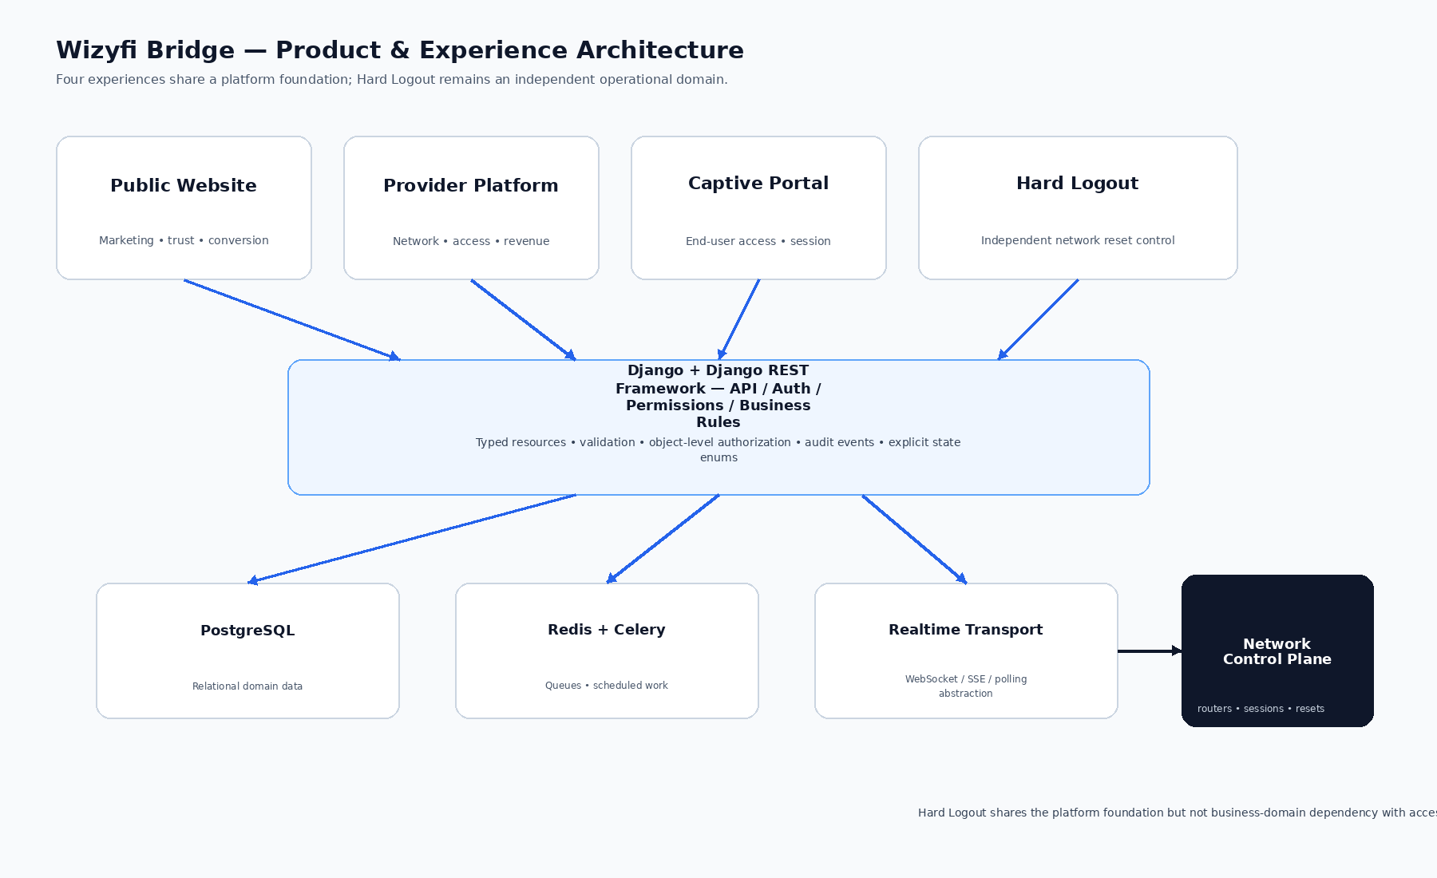
Figure 1 — Product and experience architecture.

3. Documentation hierarchy
ID | Area | Primary purpose | Depends on / informs
00 | Master Index | Governance, map, traceability, completion gate | All documents
01 | Product | Vision, scope, personas, requirements, success criteria | UX, architecture, testing
02 | UX | IA, flows, states, responsive rules | UI, frontend, API
03 | UI | Tokens, components, themes, accessibility | Figma, frontend
04 | Screen Specifications | Page-by-page content and interaction contracts | UX, frontend, QA
05 | Network Systems | Router/session/access/cycle/Hard Logout behavior | Backend, API, testing
06 | Architecture | System, frontend, backend, realtime, deployment | Engineering
07 | Data | Domain model, schema, state/audit/data lifecycle | Backend, API
08 | API | Endpoint/resource/validation/error conventions | Frontend, backend, QA
09 | Security | Threat model, authorization, secrets, audit, incident response | Backend, deployment, testing
10 | Engineering | Repository, coding standards, environments, workflow | Developers
11 | Testing | Unit/integration/UI/network/security/acceptance | All implementation
12 | Deployment | Environments, CI/CD, database, workers, monitoring, recovery | Operations
13 | Figma | File structure, naming, variants, prototypes, handoff | Design/engineering
14 | Diagrams | Canonical visual architecture and flow diagrams | All stakeholders
15 | Final Review | Traceability and implementation-readiness audit | Release gate

4. Non-negotiable product rules
- Provider operations follow the mental model Places → Routers → Devices → Users/Sessions → Access → Revenue → Control.
- Hard Logout is a separate operational subsystem. It may use shared authentication, API infrastructure and network adapters, but it must not become an implicit child process of Access Plans, Vouchers, Network Cycles, Sales, Transactions, Users/Sessions or Router Management.
- Backend state is authoritative for operational status. The UI never invents network state, completion percentage or execution results.
- Every destructive or network-affecting action identifies target, scope, timing and consequence before confirmation.
- Light and dark themes are equal design targets and are reviewed independently.
- Operational tables must remain usable at scale; mobile transforms information rather than merely shrinking desktop tables.
- Financial Transactions are evidentiary/ledger-like records; Sales is analytical.
- Captive Portal optimizes for connection and session continuity, not administration.

5. Requirements traceability chain
Every material requirement should be traceable through the following chain:
Business Requirement → Product Requirement → UX Flow → Screen → Component → API → Data → Security → Test → Acceptance Criterion

6. Core terminology
Term | Canonical meaning
Place | A physical or logical service location containing one or more managed routers/networks.
Router | A managed network gateway/control point associated with a place.
Device | An endpoint observed on the managed network.
User | An end-user identity associated with access/session activity.
Session / Connection | A time-bounded network access state for a device/user.
Access Plan | A product defining duration, price and access limits.
Voucher | A redeemable access credential associated with an access plan.
Network Cycle | A scheduled access/network operating period with explicit scope and behavior.
Sale | Analytical commercial event used to understand performance.
Transaction | Immutable/evidentiary financial or payment record.
Hard Logout Event | An independently scheduled network reset/disconnect operation.

7. Round-1 completion gate
- Master index exists and defines document ownership and dependencies.
- Product requirements include explicit functional/non-functional requirements and measurable acceptance criteria.
- UX architecture defines information architecture, primary flows and global state behavior.
- Network specification defines router/session behavior and an independent Hard Logout lifecycle.
- Canonical diagrams are supplied as actual visual assets, not text-only pseudo-diagrams.
- Every subsequent document must preserve terminology and independence boundaries established here.

