WIZYFI BRIDGE — PRODUCT REQUIREMENTS DOCUMENT
Comprehensive product definition, requirements, roles, journeys, success measures and acceptance criteria
Wizyfi Bridge • Comprehensive Round 1 Specification • September 2026

1. Executive product definition
Wizyfi Bridge centralizes the operational work required to run managed Wi-Fi and access networks across multiple places. A provider should be able to understand network health, inspect routers and connected devices, manage users and access products, monitor live sessions, understand sales and transactions, and execute explicit network-control actions without moving between unrelated systems.

2. Product promise
Primary promise: one operational platform for unified network management, scalable access and intelligent control. Brand direction: “Bridging Networks. Connecting People. Empowering Communities.”

3. Problem statement
- Providers operating multiple locations lack a single operational view of routers, connections, users and access.
- Network actions are often disconnected from the business context that explains why a network is being operated.
- Access products, vouchers, sales and transactions become difficult to reconcile when operational and commercial data live in separate tools.
- End users need a simple captive experience while operators need a high-information control console.
- Scheduled network resets require explicit timing, scope, consequence awareness and auditability.

4. Goals
- Centralize multi-place and multi-router network visibility.
- Make live connection and device state understandable and actionable.
- Provide first-class access-plan, voucher, cycle, sales and transaction workflows.
- Provide an independent Hard Logout system with deterministic lifecycle and audit trail.
- Deliver a professional, accessible and responsive experience with equal light/dark theme quality.
- Expose backend capabilities through a typed, maintainable API contract.

5. Non-goals
- Do not turn the provider console into a generic CRM.
- Do not make Hard Logout a side effect of an access plan, voucher, network cycle, sale or transaction.
- Do not rely on frontend-only authorization for sensitive actions.
- Do not present simulated operational telemetry as real network state.
- Do not make the captive portal a miniature provider dashboard.

6. Experience architecture
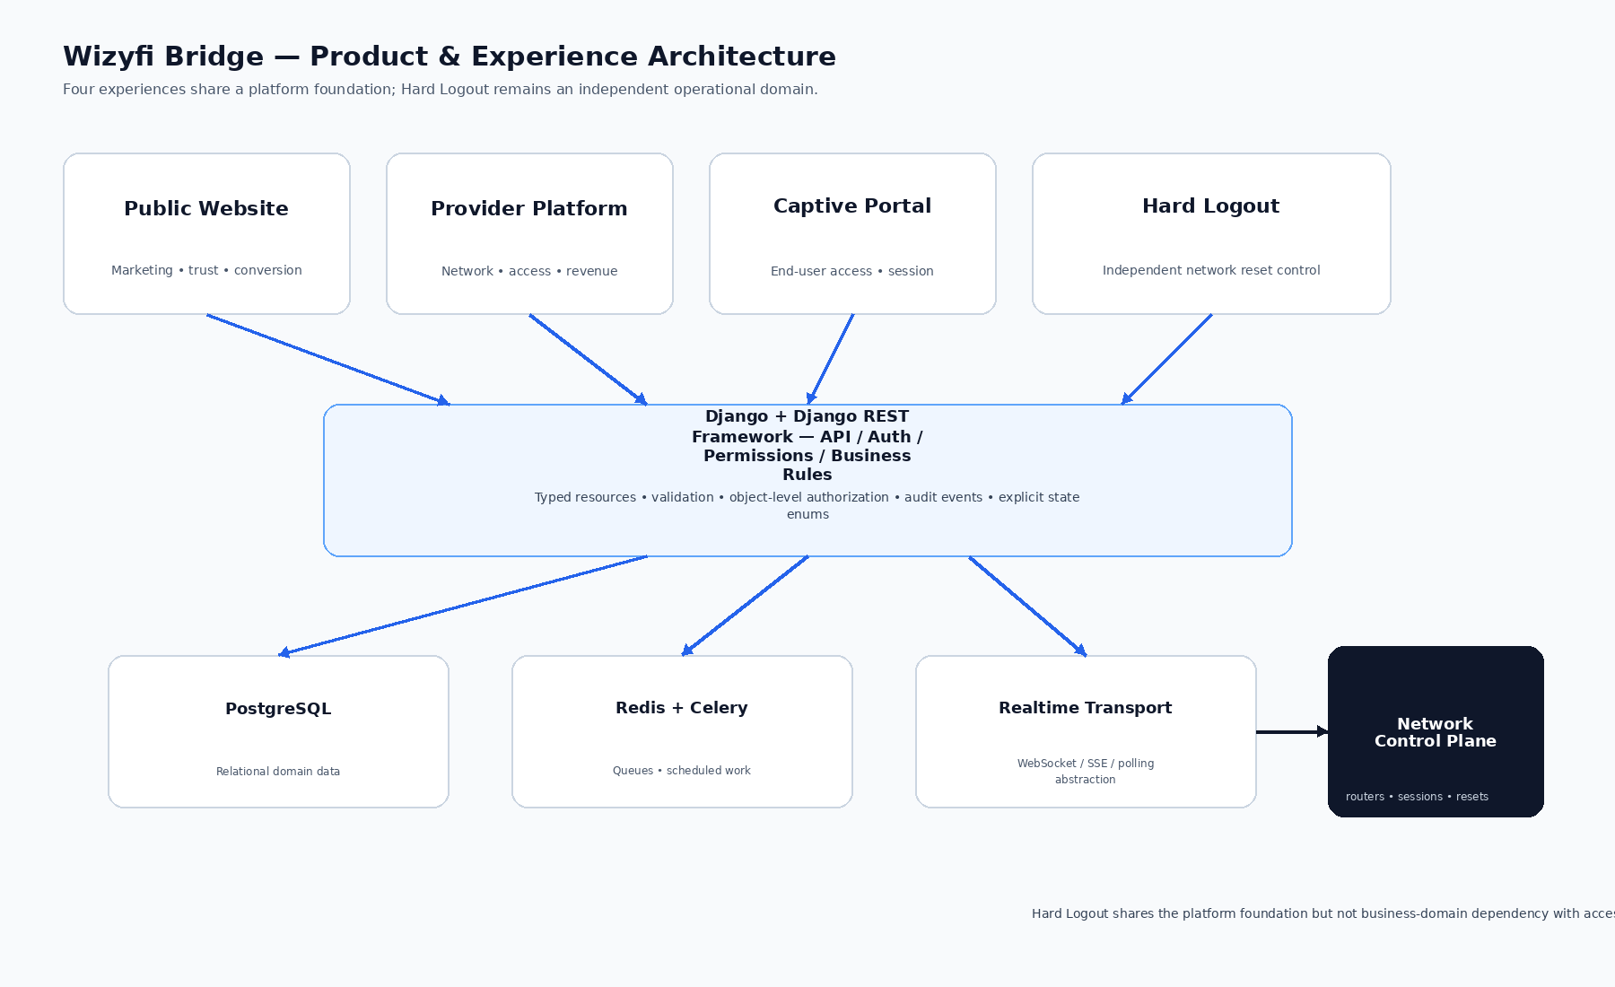
Figure 1 — Four experiences over a shared platform foundation.

7. Users and jobs-to-be-done
Persona | Primary jobs | Critical needs
Provider / Owner | Operate multiple places; understand business and network performance | Fast overview, permissions, audit, revenue and network control
Agent / Operator | Handle daily network operations and customers | Live status, connections, vouchers, safe actions
Network-focused Operator | Diagnose routers/devices and execute control actions | Health, heartbeat, scope, event history, explicit consequences
End User | Connect and maintain access | Fast captive flow, clear plan/session state, recovery guidance
Administrator | Govern accounts, roles and platform configuration | Strong authorization, audit, configuration and support tools

8. Core functional requirements
ID | Requirement | Acceptance intent
FR-001 | Multi-place management | Provider can create, view, update and archive places according to permissions.
FR-002 | Router management | Provider can associate routers with places and view health, heartbeat, status and connected counts.
FR-003 | Device visibility | Provider can inspect device identity, associated user/session and relevant history.
FR-004 | Live connections | Provider can search/filter active sessions and perform authorized disconnect actions.
FR-005 | User management | Provider can inspect user identity, sessions, access history and permitted commercial associations.
FR-006 | Access plans | Provider can define price, duration, limits, availability and lifecycle.
FR-007 | Vouchers | Provider can issue/bulk-generate, inspect lifecycle and associate vouchers with plans.
FR-008 | Network cycles | Provider can view, schedule and review cycles with explicit scope and effective time.
FR-009 | Sales analytics | Provider can analyze sales by time, place, plan and other supported dimensions.
FR-010 | Transactions | Provider can inspect immutable transaction records, status and event relationships.
FR-011 | Hard Logout | Authorized operator can schedule, observe, cancel where allowed and audit independent reset events.
FR-012 | Captive access | End user can select access, redeem voucher or authenticate through a concise flow.
FR-013 | Authentication | Users can sign in, recover access and maintain secure sessions.
FR-014 | Notifications | System communicates important success, warning, failure and operational conditions.
FR-015 | Auditability | Material network-affecting and administrative actions produce attributable audit/event records.

9. Non-functional requirements
ID | Area | Requirement
NFR-001 | Security | Authorization enforced server-side; sensitive mutations require explicit permission checks.
NFR-002 | Reliability | Operational state transitions are persisted and recoverable; scheduled events cannot depend on a browser remaining open.
NFR-003 | Performance | Large operational lists use server-side pagination/filtering; UI avoids unbounded rendering.
NFR-004 | Observability | Network and background operations expose timestamps, result state and useful diagnostic events.
NFR-005 | Accessibility | Keyboard navigation, labels, focus states, contrast and non-color status communication are supported.
NFR-006 | Responsive behavior | Provider workflows remain usable on desktop, tablet and mobile through intentional transformations.
NFR-007 | Maintainability | Domain logic remains in services/backend layers rather than being scattered through presentation components.
NFR-008 | Consistency | Terminology, status enums, route naming and visual tokens remain consistent across surfaces.

10. Provider operational mental model
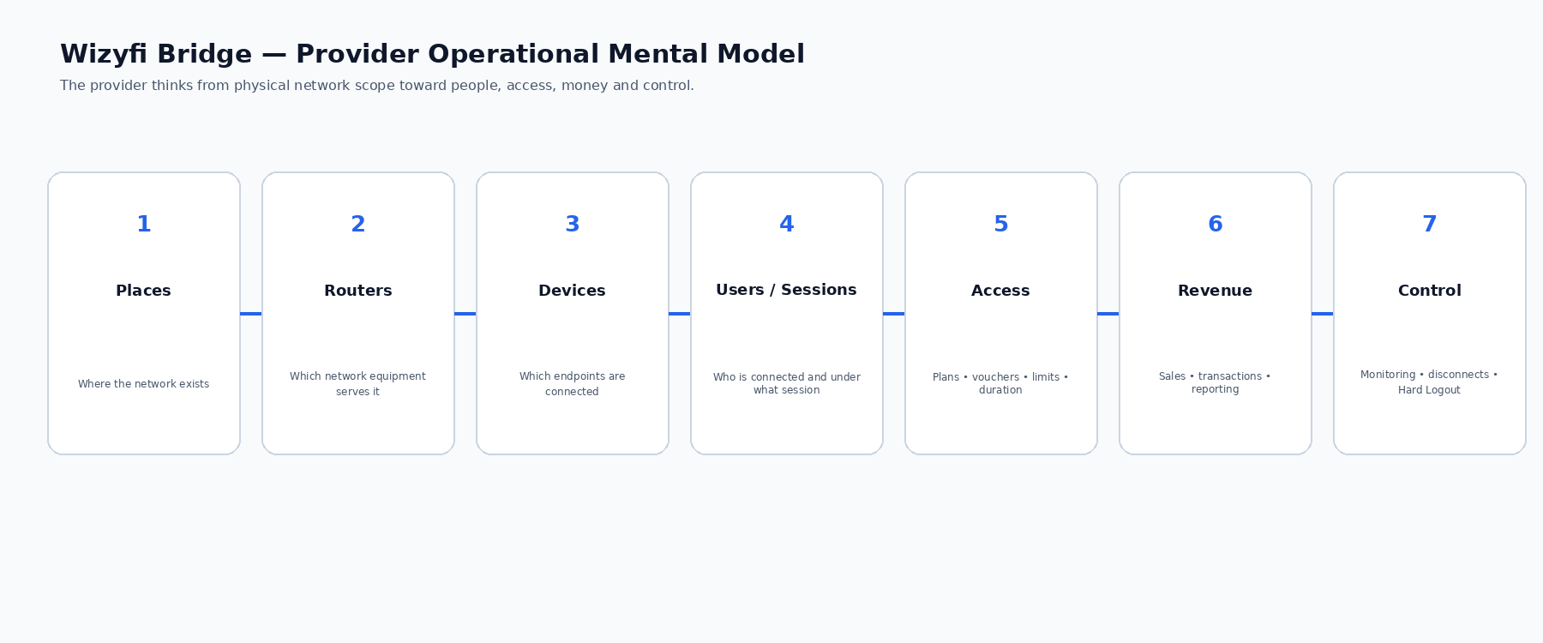
Figure 2 — Provider operational mental model.

11. Key user journeys
Journey | Happy path | Failure / recovery expectations
Onboard provider | Register → verify/recover → initial place → router → dashboard | Validation errors mapped to fields; incomplete setup remains recoverable
Monitor network | Dashboard → place → router → health/events | Degraded/offline state explains freshness and next action
Handle connection | Live Connections → inspect → disconnect → confirmation → result | Exact session/scope/consequence shown; failed mutation remains visible
Issue access | Access Plans → choose plan → issue voucher → confirmation | Duplicate/invalid constraints handled explicitly
Analyze business | Sales → filter period/place/plan → inspect trend | Empty data explains timeframe; transactions remain separate
Schedule reset | Hard Logout → scope → time/timezone → impact → review → schedule | No ambiguous scope/time; backend persists event
End-user connect | Portal → access/voucher → authentication → connecting → connected | Duplicate submission prevented; error has recovery path

12. Product success metrics
Metric | Definition | Why it matters
Time to network overview | Time from provider sign-in to trustworthy view of place/router/session state | Measures operational clarity
Connection action completion | Successful completion rate of authorized connection workflows | Measures daily usability
Voucher issuance success | Valid voucher creation rate without support intervention | Measures access workflow quality
Hard Logout execution integrity | Percentage of scheduled events reaching accurate terminal state with complete audit | Measures control reliability
State freshness | Age of latest trustworthy operational update | Prevents stale data being mistaken for live state
Task error recovery | Percentage of errors with successful recovery without leaving workflow | Measures resilience

13. Product acceptance criteria
- Provider can navigate from a place to its routers, then to connected devices/users/sessions without losing context.
- Operational status is always accompanied by a textual state and meaningful timestamp/freshness information where applicable.
- Network-affecting actions identify exact target and consequence before confirmation.
- Hard Logout can be scheduled independently and produces a persistent lifecycle event.
- Access Plans, Vouchers, Network Cycles, Sales and Transactions cannot silently create a Hard Logout event.
- Captive portal exposes only the information necessary for connection and session management.

