WIZYFI BRIDGE — NETWORK SYSTEMS & HARD LOGOUT
Comprehensive operational model, lifecycles, safety rules, state machine and event contract
Wizyfi Bridge • Comprehensive Round 1 Specification • September 2026

1. Scope
This specification defines the network-facing operational concepts used by Wizyfi Bridge: places, routers, devices, connections/sessions, access interaction points and the independent Hard Logout control system. It is intentionally implementation-aware without binding the product to a single router vendor or network protocol.

2. Operational topology
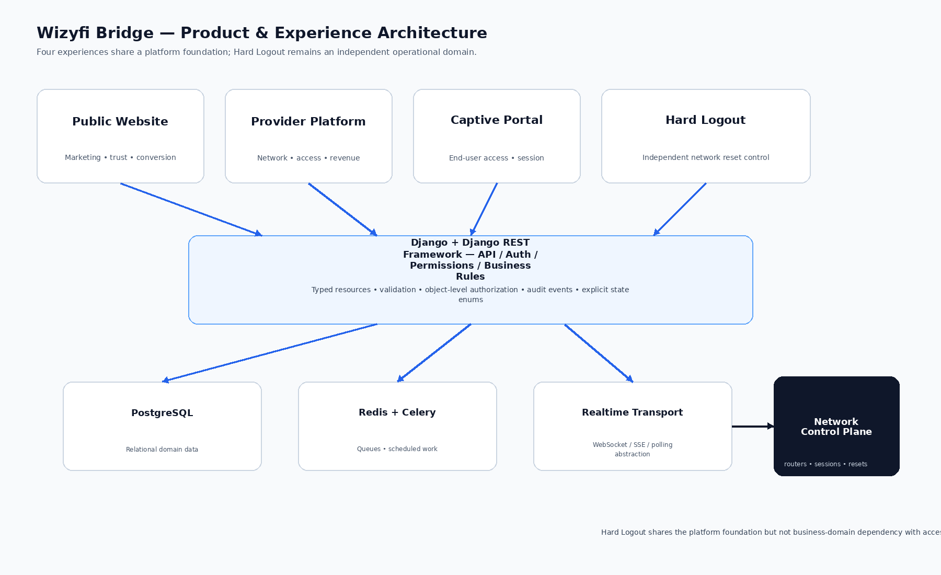
Figure 1 — Platform-to-network operational architecture.

3. Domain model
Domain object | Responsibility | Key state / data
Place | Network/service location | Identity, status, routers, metrics
Router | Managed gateway/control point | Status, heartbeat, capabilities, place, events
Device | Observed endpoint | Identifier, router, user/session, freshness
User | End-user identity | Identity, sessions, access history
Session | Time-bounded access relationship | Start, expiry, status, user/device/router/place
Access Plan | Commercial access definition | Price, duration, limits, availability
Network Cycle | Scheduled operating/access period | Scope, start/end, status, history
Hard Logout Event | Independent reset operation | Scope, schedule, execution, result, audit

4. Router lifecycle
State | Meaning | Operator response
Provisioning | Router record exists but operational readiness is not confirmed | Complete configuration/verification
Online | Expected heartbeat/health signals are available | Normal monitoring
Degraded | Some health signals or capabilities are impaired | Inspect events and diagnostics
Offline | Expected communication unavailable | Inspect last heartbeat and connectivity
Disabled | Operator intentionally disabled the router | Review reason and enable if authorized

5. Connection/session lifecycle
State | Meaning | UI expectation
Pending | Connection/access is being established | Show processing; prevent duplicate submission
Active | Session currently has access | Show remaining time and scope
Expiring | Session is near configured expiry threshold where supported | Make remaining time prominent
Expired | Access period ended | Explain expiry and available next path
Disconnected | Session was terminated | Show reason/source where available
Failed | Session establishment or mutation failed | Show actionable error

6. Operational freshness
- Every live network resource should expose a last-updated/heartbeat timestamp where the backend can provide one.
- Realtime transport is an optimization, not a replacement for persisted truth.
- Polling intervals should be appropriate to operational importance and backend capacity.
- Stale data must be visually distinguishable from confirmed current data.

7. Independent Hard Logout definition
Hard Logout is a dedicated network-management capability that lets an authorized operator schedule a reset at an exact future date/time. At execution, the targeted active connections are disconnected according to the supported network adapter/control mechanism, and affected users must complete a fresh sign-in/access flow according to the network policy.
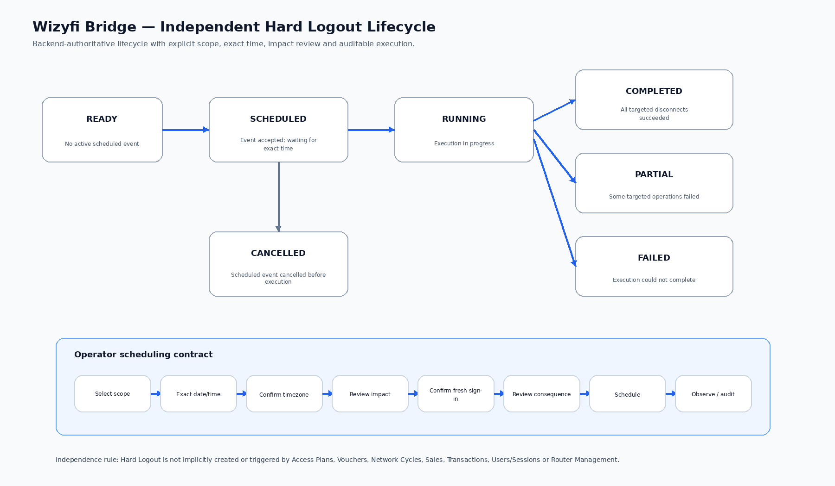
Figure 2 — Hard Logout lifecycle and operator scheduling contract.

8. Hard Logout lifecycle
State | Entry condition | Required persisted information | Allowed transitions
READY | No active scheduled event for the relevant control context | System availability/status | SCHEDULED
SCHEDULED | Valid event created and committed | Event ID, scope, scheduled timestamp/timezone, creator, impact estimate | RUNNING, CANCELLED
RUNNING | Execution worker/control operation begins | Started timestamp, event stream, counts/results | COMPLETED, PARTIAL, FAILED
COMPLETED | All targeted operations succeed | Completed timestamp, affected count, result | Terminal
PARTIAL | Some targeted operations succeed and some fail | Succeeded/failed scope, reasons | Terminal
FAILED | Execution cannot complete as required | Failure reason, diagnostics, affected scope if known | Terminal
CANCELLED | Operator cancels before execution where policy permits | Cancelled timestamp, actor, reason | Terminal

9. Hard Logout scheduling contract
- Scope: one router, selected routers, a place or another explicitly supported network scope.
- Time: exact date/time and explicit timezone.
- Impact: estimated connected users/devices and scope; estimates must be labelled as estimates.
- Consequence: explicitly state that affected users will need a fresh sign-in/access flow.
- Authorization: server validates permissions against the selected scope.
- Persistence: the schedule must be stored server-side and must execute without an open browser.
- Audit: creation, changes, cancellation, start, progress events and terminal result are attributable.

10. Safety rules
Rule | Reason
No implicit triggers | Prevents commercial/access workflows from unexpectedly resetting users.
Exact scope confirmation | Prevents broad unintended disconnects.
Exact time + timezone | Prevents schedule ambiguity.
Server-side authorization | Prevents client-side privilege escalation.
Idempotent execution design | Prevents retries from producing uncontrolled duplicate effects.
Explicit partial failure | Preserves operational truth and supports remediation.
Immutable event history | Supports audit, troubleshooting and accountability.
No fake progress | Avoids misleading operators when exact progress cannot be measured.

11. Event model
Event | Minimum fields
HardLogoutCreated | event_id, actor, scope, scheduled_at, timezone, created_at
HardLogoutCancelled | event_id, actor, cancelled_at, reason
HardLogoutStarted | event_id, started_at, execution_context
HardLogoutTargetAttempted | event_id, target_id, attempted_at, target_type
HardLogoutTargetSucceeded | event_id, target_id, completed_at
HardLogoutTargetFailed | event_id, target_id, failed_at, error_code/message
HardLogoutCompleted | event_id, completed_at, counts, result

12. Failure and recovery
- If the worker crashes during execution, the persisted lifecycle must permit safe recovery/reconciliation.
- If a target becomes unavailable, mark that target as failed rather than falsely completing it.
- If execution partially succeeds, preserve successful and failed target sets.
- If a scheduled event is cancelled, record actor and reason and prevent later execution.
- If a user refreshes or returns later, the event page reconstructs state from the backend rather than browser state.

13. Independence boundary
The following modules may share infrastructure and references but must not create a Hard Logout event implicitly: Access Plans, Vouchers, Network Cycles, Sales, Transactions, Users/Sessions and Router Management. A direct Hard Logout command is required.

14. Network-system acceptance criteria
- Router status is backend-authoritative and includes meaningful freshness information.
- Connection actions identify exact session/device and associated place/router.
- Hard Logout persists its own event and lifecycle independent of browser state.
- Hard Logout supports explicit terminal outcomes: Completed, Partial, Failed or Cancelled.
- Operational events are attributable and auditable.

