07 — Wizyfi Bridge System Architecture Specification
Wizyfi Bridge • Round 3 • Architecture, Data, API & Engineering

Purpose
Implementation-ready logical architecture for separating experience, application, network-control, data, realtime, background work and observability while preserving the independent Hard Logout boundary.

Architecture Principles
- Django/DRF is the authoritative application/API backend; React never owns business truth.
- Network-affecting operations are server-authoritative and auditable.
- Hard Logout is an independent operational subsystem with explicit boundaries.
- PostgreSQL is the durable source of record; Redis is not the system of record.
- Background jobs must be idempotent and retry-aware.
- Realtime delivery improves visibility but cannot be the authority for committed state.
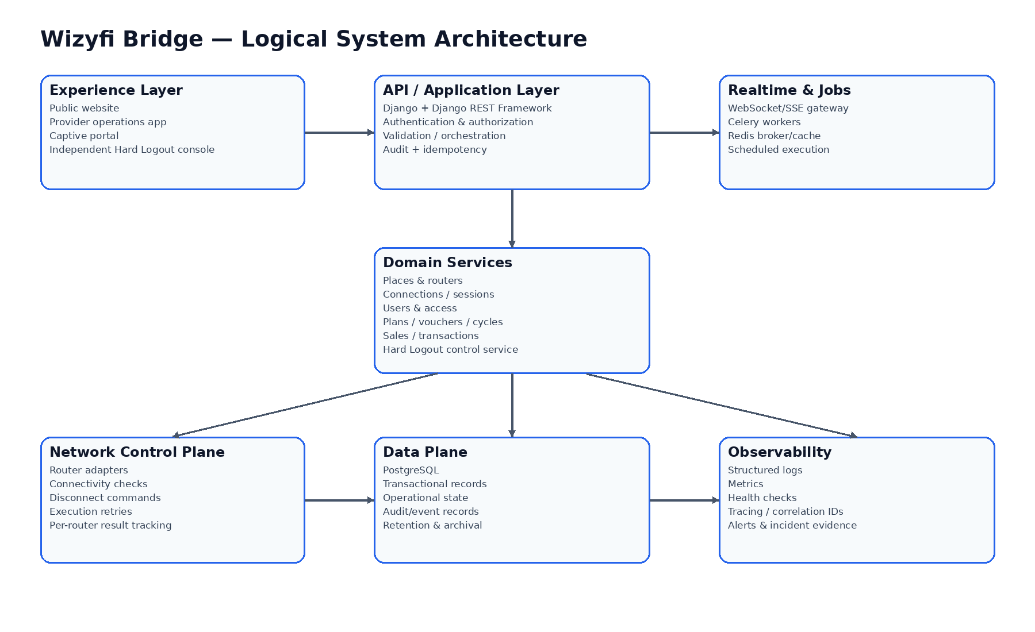

Logical Layers
Layer | Responsibility | Primary implementation | Failure boundary
Experience | Rendering, navigation, interaction, local UI state | React + Vite + TypeScript | Browser/network failure
API | Auth, validation, orchestration, domain commands | Django + DRF | HTTP/API failure
Domain | Business rules and state transitions | Django service modules | Transaction/business failure
Network control | Router communication and command execution | Adapter/service layer | Per-router/per-command failure
Async/realtime | Schedules, retries, notifications, live updates | Celery + Redis + WebSocket/SSE | Worker/broker failure
Data | Durable state and audit evidence | PostgreSQL | DB failure
Observability | Logs, metrics, traces, alerts | Structured telemetry + monitoring stack | Telemetry failure must not block core operations

Failure Boundaries & Recovery
Every external network action should have a correlation ID, target identifier, timeout, retry policy, terminal outcome and persisted result. A worker restart must resume from durable state rather than infer progress from memory.

Authentication & Authorization
Authenticate the principal at the API boundary, resolve provider/tenant context, then authorize every object-level action. Frontend route guards are UX controls only; backend permission checks remain mandatory.

Realtime Contract
Realtime messages are event notifications keyed by resource/event IDs. Clients reconcile with authoritative GET endpoints after reconnect. Events may be duplicated or arrive out of order; clients must tolerate both.

