08 — Wizyfi Bridge Data Architecture & PostgreSQL Specification
Wizyfi Bridge • Round 3 • Architecture, Data, API & Engineering

Data Design Goals
Use normalized transactional data for durable business state, explicit status fields for operational state, immutable audit/event evidence, and indexed foreign keys plus time fields for operational queries.
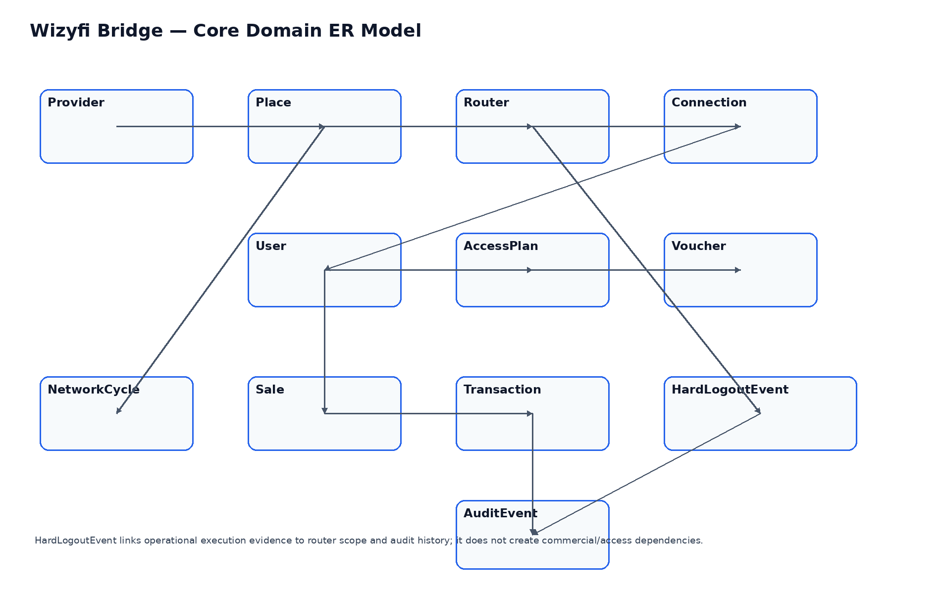

Core Entities
Entity | Purpose | Key relationships | Critical fields
Provider | Tenant/account boundary | 1→many Places | id, name, status
Place | Physical/logical deployment location | Provider→Routers | provider_id, name, timezone, status
Router | Managed network endpoint | Place→Connections; HardLogout scope | place_id, identity, status, last_seen
Connection | Active/historical network connection | Router→User | router_id, user_id, state, started_at, ended_at
User | Subscriber/portal identity | Connections, sales | provider_id, identity, status
AccessPlan | Commercial access definition | Provider; vouchers | name, duration, quota, price, status
Voucher | Credential/access artifact | AccessPlan | code_hash, status, issued_at, expires_at
NetworkCycle | Planned operational cycle | Place | place_id, starts_at, ends_at, status
Sale | Commercial sale record | User/AccessPlan | provider_id, user_id, total, status
Transaction | Payment/accounting event | Sale | sale_id, amount, currency, status, reference
HardLogoutEvent | Independent reset event | Router scope; Audit | scope, scheduled_at, state, execution metadata
AuditEvent | Immutable operational evidence | Actor + resource | actor_id, action, resource, timestamp, metadata

Constraints & Indexing
- Foreign keys must be enforced for durable relationships.
- Unique constraints should exist for provider-scoped natural identifiers where required.
- Index every frequent filter/sort field: provider_id, place_id, router_id, state/status, created_at, scheduled_at.
- Store timestamps in UTC and retain the relevant IANA timezone on scheduled operational objects.
- Do not hard-delete audit evidence. Use archival/retention workflows where policy permits.
- Credential-like voucher secrets should be stored as hashes when plaintext recovery is not required.

Hard Logout Data Boundary
HardLogoutEvent may reference provider/place/router scope needed to execute the event and audit it, but it must not contain foreign-key dependencies that make it a child of AccessPlan, Voucher, NetworkCycle, Sale, Transaction or User lifecycle.

State Models
Object | States | Transition authority
Router | ONLINE / DEGRADED / OFFLINE / DISABLED | Network health/service
Connection | ACTIVE / DISCONNECTING / DISCONNECTED / UNKNOWN | Connection service
Voucher | AVAILABLE / ISSUED / REDEEMED / EXPIRED / REVOKED | Access service
HardLogoutEvent | READY / SCHEDULED / RUNNING / COMPLETED / PARTIAL / FAILED / CANCELLED | Hard Logout service

