11 — Wizyfi Bridge Security & Threat Model Specification
Wizyfi Bridge • Round 4 • Security, Testing, Deployment & Operations

Security Objectives
- Protect provider, subscriber and operational data from unauthorized access.
- Prevent unauthorized network-affecting actions.
- Maintain trustworthy audit evidence for sensitive operations.
- Reduce blast radius through tenant isolation and least privilege.
- Make failure and security events observable and recoverable.
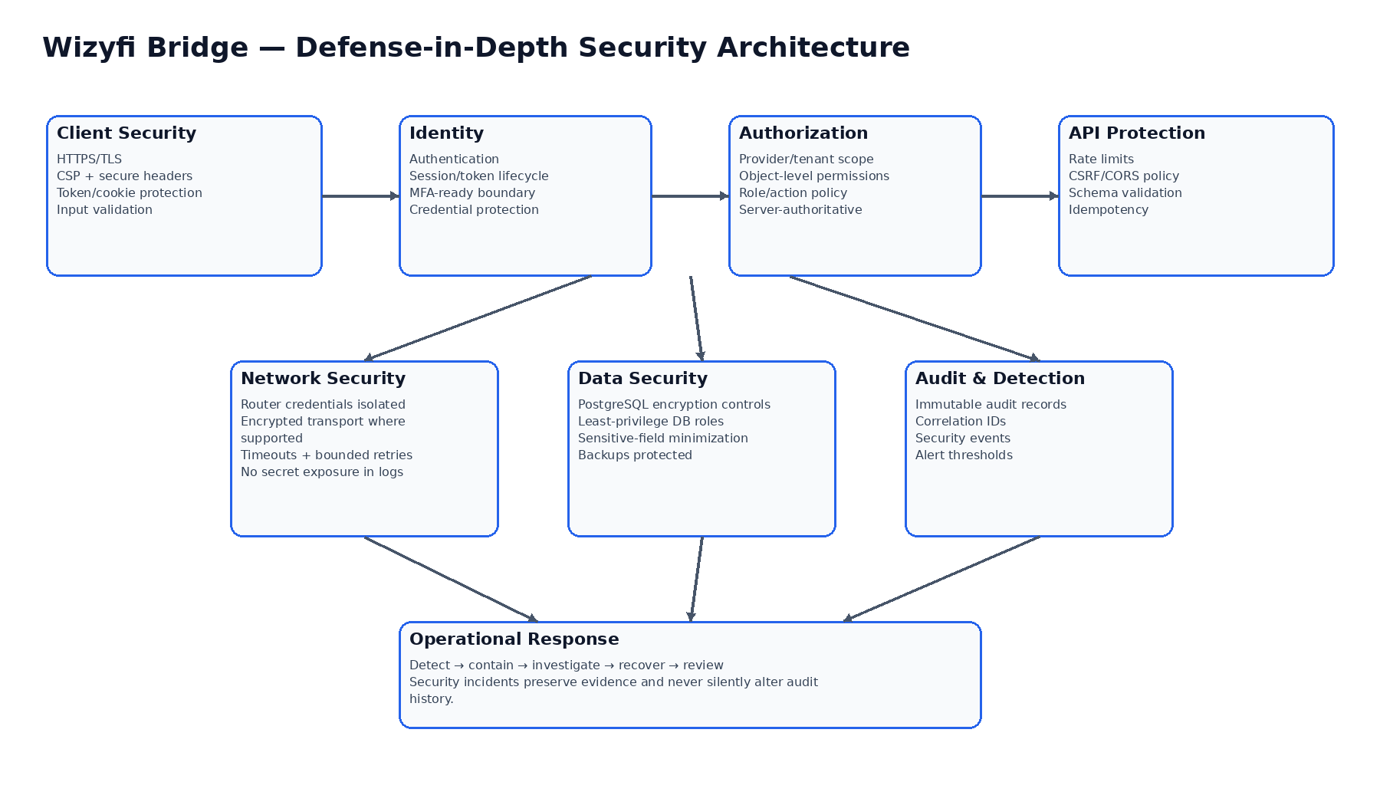

Threat Model
Threat | Control | Verification
Credential theft | Secure cookies/tokens, rotation, rate limits, login monitoring | Auth/security tests
Broken tenant isolation | Provider-scoped queries + object permissions | Cross-tenant authorization tests
Privilege escalation | Explicit role/action matrix; deny by default | Permission matrix tests
CSRF/CORS abuse | Strict origin policy + CSRF controls where cookie auth is used | Browser/API tests
Replay/duplicate command | Idempotency keys + state transitions | Concurrency tests
Unauthorized router action | Server authorization + scoped adapter credentials | Network control tests
Secret leakage | Secret manager/env injection; redacted logs | Secret scanning/log tests
Audit tampering | Append-oriented audit model + restricted writes | Audit integrity tests
Worker failure | Durable event state + retry/recovery | Worker restart tests
DoS/rate abuse | Rate limits, bounded queries, pagination | Load/security tests

Authorization Model
Role capability | Expected rule
Provider owner/admin | Full provider-scoped administration subject to destructive-action confirmation
Operations agent | Operational actions allowed by assigned permissions
Read-only operator | No mutation/network-control commands
Portal user | Only portal-scoped access actions; never provider administration
System worker | Only narrowly scoped internal execution permissions; no interactive login

Hard Logout Security Invariants
- Scope is explicit, validated and permission-filtered.
- Scheduled execution is server-side and survives browser closure.
- Cancellation is state-dependent and permission-checked.
- Every execution has a stable event ID and audit trail.
- Per-target outcomes are persisted; partial execution is visible.
- No access, sales, voucher or cycle event may implicitly trigger Hard Logout.

Security Incident Workflow
Detect → contain affected credentials/services → preserve evidence → assess scope → remediate → validate recovery → document root cause and preventive action. Security logging must avoid passwords, tokens and unnecessary personal data.

