12 — Wizyfi Bridge Testing & Acceptance Specification
Wizyfi Bridge • Round 4 • Security, Testing, Deployment & Operations

Test Strategy
Testing follows the risk profile: most logic is covered cheaply at unit level; integration tests validate database/queue/network boundaries; end-to-end tests cover critical journeys; controlled live-network tests validate adapter behavior.
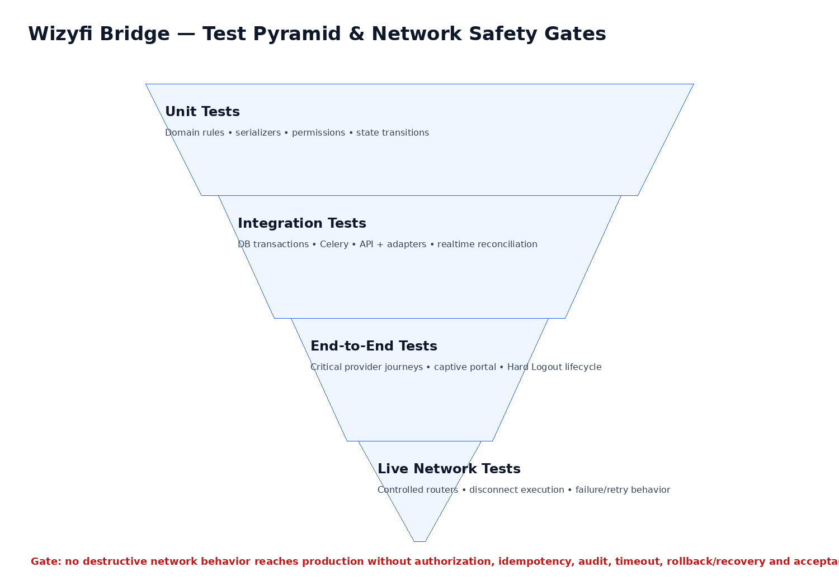

Test Domains
Domain | Required coverage
Frontend | Routes, permissions UX, forms, validation, loading/error states, responsive behavior, theme parity
Backend | Services, serializers, permissions, transactions, filtering, pagination, error contracts
Data | Migrations, constraints, indexes, transaction rollback, retention/archive behavior
Network | Adapter commands, timeout, retry, disconnect outcomes, router offline/degraded behavior
Realtime | Reconnect, duplicate/out-of-order events, stale state reconciliation
Hard Logout | Schedule/cancel/execute/partial/failure/retry/idempotency/audit
Security | Auth, authorization, tenant isolation, rate limits, injection, secret leakage
Deployment | Health checks, migrations, worker startup, backup/restore, rollback

Hard Logout Acceptance Tests
ID | Scenario | Expected result
HL-01 | Unauthorized operator schedules event | 403; no event created
HL-02 | Valid schedule with explicit timezone | SCHEDULED event persisted
HL-03 | Browser closes after scheduling | Event still executes at server time
HL-04 | Duplicate create with same idempotency key | Same committed result; no duplicate event
HL-05 | Cancel before execution | CANCELLED; no network command
HL-06 | Worker restarts during execution | Recovery resumes from durable state
HL-07 | Some routers succeed and others fail | PARTIAL with per-target evidence
HL-08 | All targets succeed | COMPLETED with audit evidence
HL-09 | Repeated execution request | Already-completed targets are not blindly repeated
HL-10 | Access plan changes around scheduled event | Hard Logout event remains independent

Definition of Done
- All acceptance tests pass in staging.
- Critical security findings are resolved or formally accepted.
- Migrations apply cleanly from a fresh database.
- Production configuration contains no development secrets.
- Network-affecting operations have audit evidence and recovery behavior.
- UX states match the documented design system in light and dark themes.

