13 — Wizyfi Bridge Deployment, Monitoring & Disaster Recovery
Wizyfi Bridge • Round 4 • Security, Testing, Deployment & Operations

Environment Model
Environment | Purpose | Isolation
Development | Local feature work | Local DB/Redis; simulated routers
Staging | Production-like validation | Separate DB, Redis, secrets and test routers
Production | Live operations | Dedicated secrets, DB, workers, router credentials and monitoring
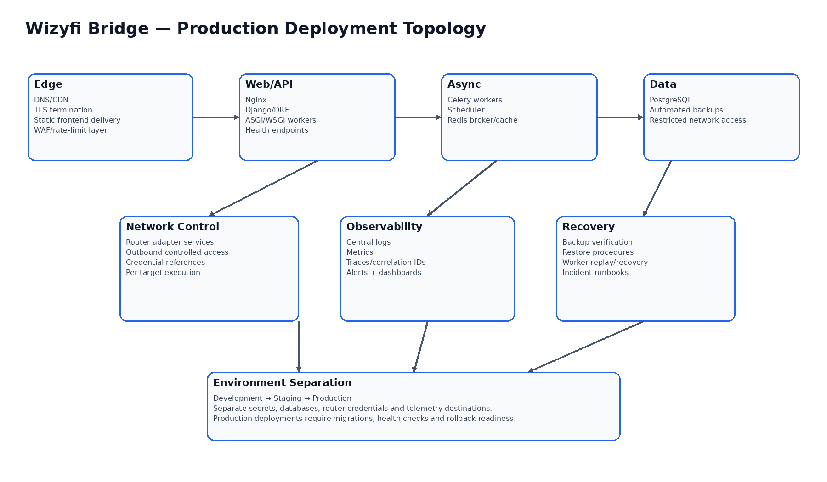

Deployment Pipeline
1. Pull request checks: frontend build/type/lint/tests; backend tests/lint/migrations.
2. Build immutable versioned artifacts/containers.
3. Deploy to staging; apply migrations; run smoke and acceptance tests.
4. Require approval for production deployment.
5. Run migrations with rollback-aware procedure.
6. Deploy API/web/workers; verify health and queue readiness.
7. Run post-deploy smoke tests and monitor error/latency metrics.
8. Roll back application version when safe; use forward migrations for irreversible schema changes.

Monitoring
Signal | Examples | Action
Availability | HTTP health, DB health, Redis/worker health | Page on sustained outage
API | 5xx rate, latency, request volume | Investigate service/resource issue
Network | Router reachability, command failures, disconnect latency | Investigate adapter/router failures
Hard Logout | Scheduled backlog, execution age, partial/failed rate | Operational alert
Workers | Queue depth, task age, retry count | Scale/investigate
Database | Connections, latency, storage, backup status | Capacity/recovery action
Security | Auth failures, forbidden spikes, suspicious commands | Security investigation

Backup & Disaster Recovery
- Automated PostgreSQL backups with retention appropriate to business requirements.
- Regular restore tests; a backup is not considered valid until restoration is demonstrated.
- Document RPO and RTO targets before production launch.
- Keep production secrets and backup access separately controlled.
- Maintain runbooks for DB restore, worker recovery, API rollback and router-control incident handling.

Operational Runbooks Required
- API outage
- Database unavailable
- Redis/Celery outage
- Router fleet degraded
- Hard Logout stuck/partial
- Credential compromise
- Unexpected destructive network action
- Backup restore
- Production rollback

