WIZYFI BRIDGE — VISUAL DIAGRAM ATLAS
Canonical diagrams for architecture, provider workflow and Hard Logout lifecycle
Wizyfi Bridge • Comprehensive Round 1 Specification • September 2026

1. Purpose
This atlas contains the canonical visual diagrams that should be reused in the master documentation, architecture reviews, implementation onboarding and stakeholder presentations. The diagrams are rendered as actual visual assets so that structure, boundaries and flow are visible at a glance.

2. Product & experience architecture
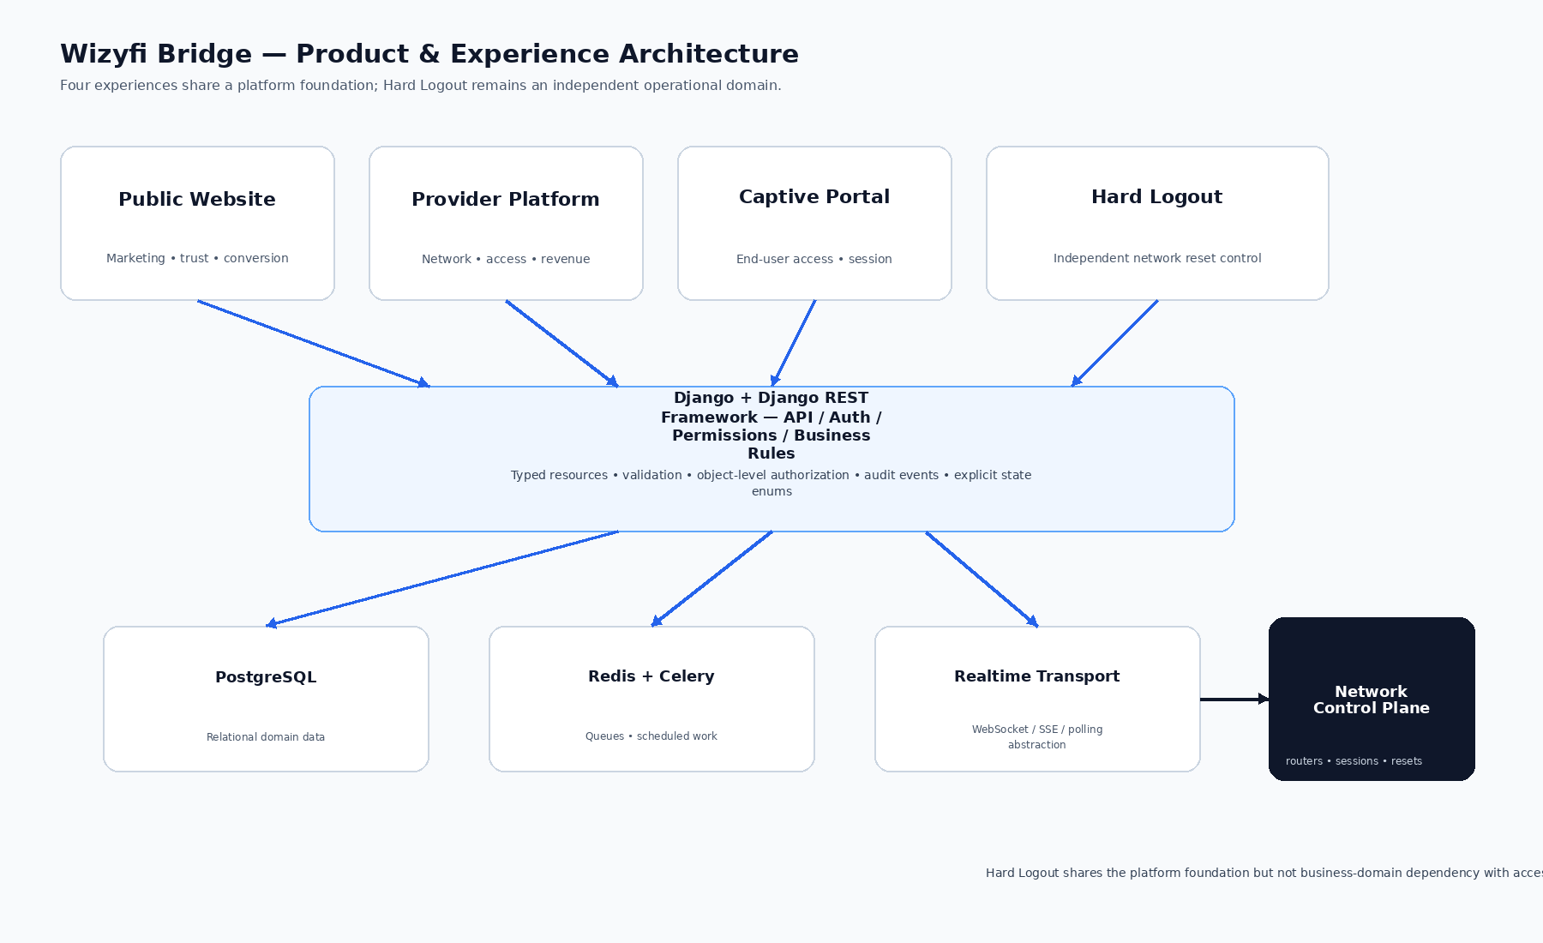
Canonical architecture diagram.

3. Provider operational mental model
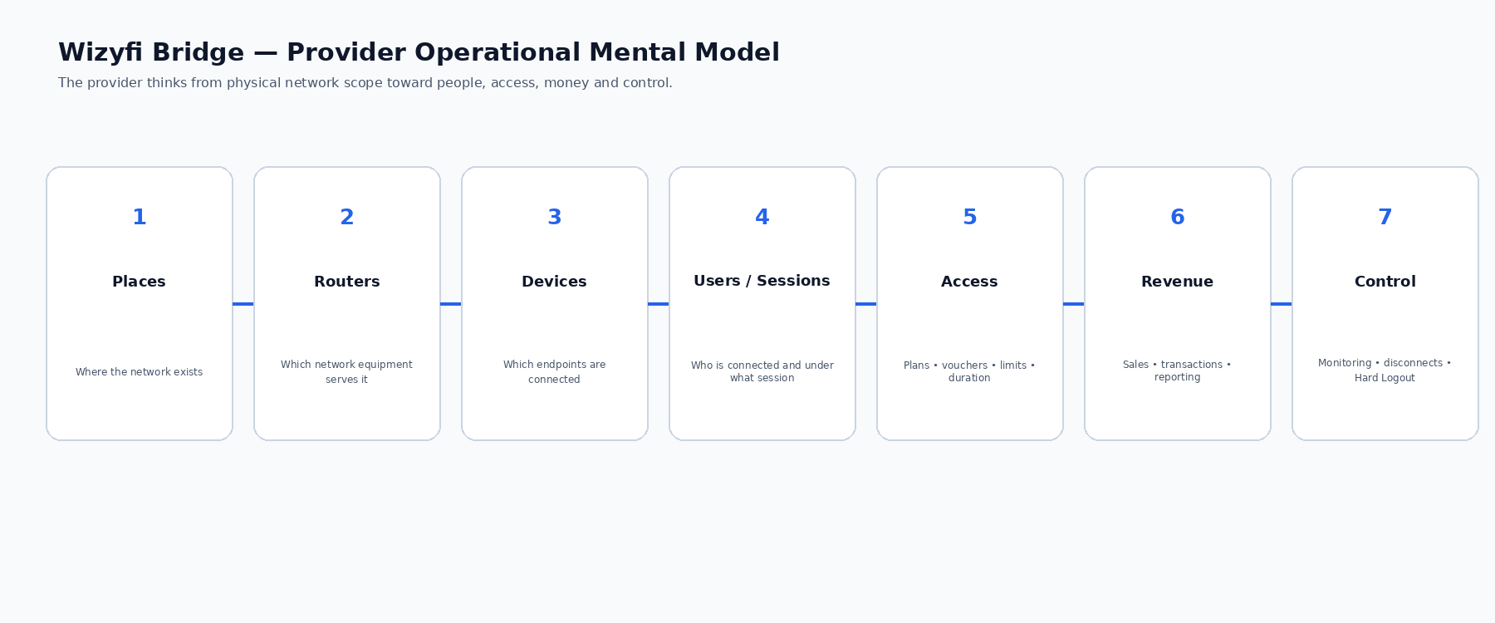
Canonical provider journey diagram.

4. Independent Hard Logout lifecycle
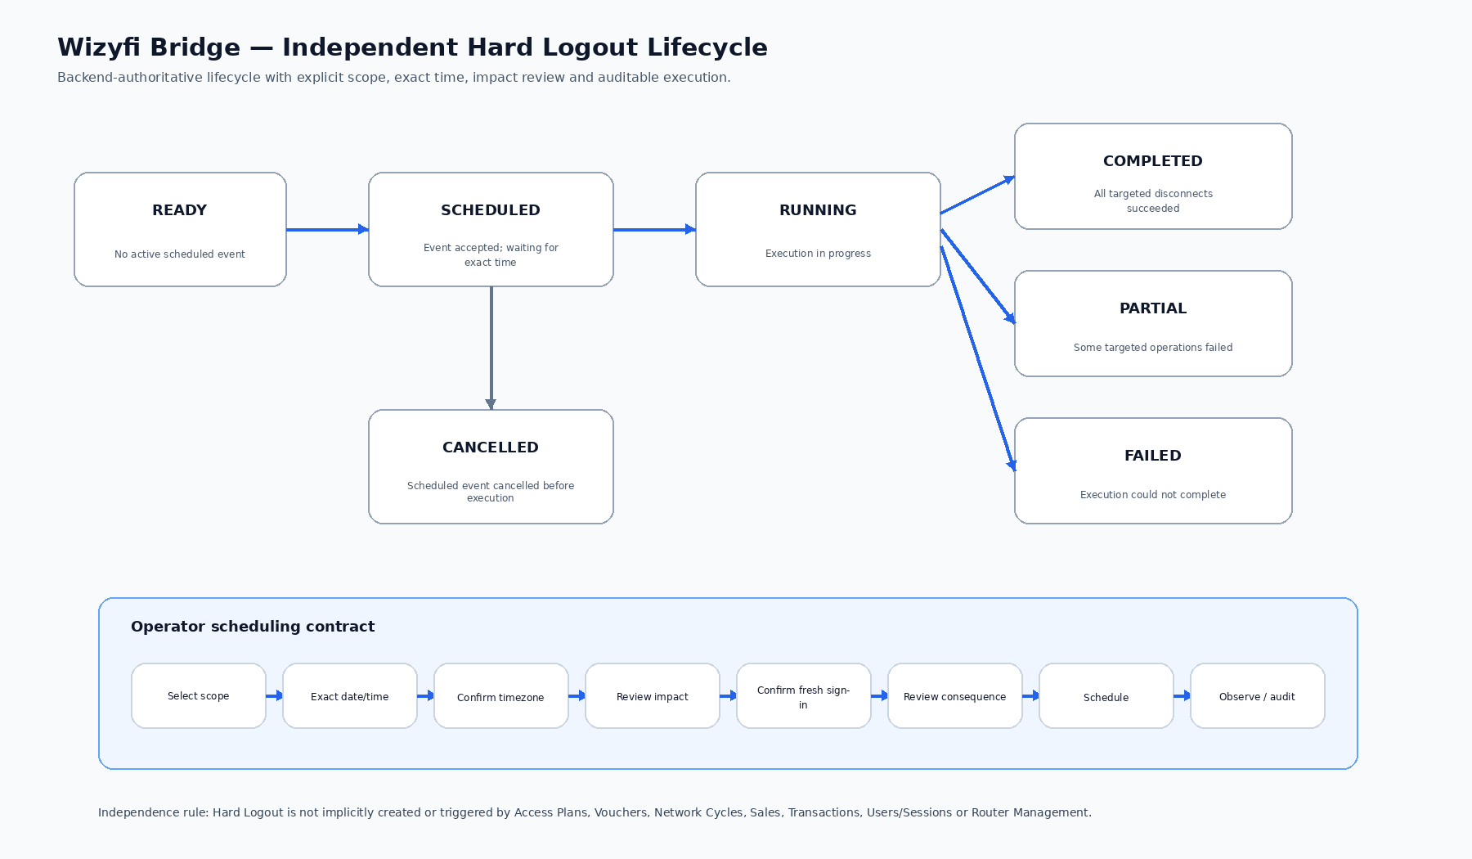
Canonical Hard Logout state/lifecycle diagram.

5. Diagram usage rules
- Do not replace these diagrams with ASCII/text arrows in final stakeholder documents.
- Keep the Hard Logout boundary visually distinct whenever architecture is discussed.
- Any future architecture change must update the source diagram and all dependent documentation.
- Diagram labels must use the canonical terminology from the Master Documentation Index.

