# Contents

1. **Introduction** **1**
   1. Problem Definition 1
   2. Background Study 1
   3. Significance and Objectives 2
   4. Organization of the Report 2
2. **Literature Review 3**
   1. Existing Solutions 3
   2. IoT Applications in Transportation 3
   3. Challenges and Opportunities 4
3. **Methodology 4**
   1. Components Used 4
      1. IR Sensors 4
      2. Arduino UNO 4
      3. LCD with I2C Module 5
      4. Node MCU 5
   2. Software Used 6
      1. Arduino IDE 6
      2. IFTTT Services 6
4. **System Design 7**
   1. Overall Architecture 7
   2. Block Diagram of the Sensor System 8
   3. Working Principles 9
5. **Summary and Conclusion 11**
   1. Key Findings 11
   2. Contributions to the Field 11
   3. Potential for Future Development 11
   4. Overall Significance 11

# Chapter 1

## Introduction

The project aims to address the critical issue of head-to-head collisions on single-track railways by implementing an IoT-based velocity detection system for trains. The system utilizes a combination of IR sensors, Arduino Uno, LCD display, NodeMCU, and IFTTT services to monitor train speed and direction, providing real-time information and triggering notifications to prevent potential collisions.

#### Problem Definition

Railway systems face a persistent challenge of ensuring the safety of operations, especially in scenarios where trains share a single track. Head-to-head collisions pose a significant threat, requiring the development of advanced monitoring systems to detect and prevent such incidents. Traditional methods fall short in providing real-time data on train velocity and direction, necessitating the implementation of an intelligent solution that leverages the Internet of Things (IoT). This project seeks to address the critical issue of head-to-head collisions on single-track railways through the development and implementation of an IoT-based velocity detection system.

#### Background Study

The integration of the Internet of Things (IoT) into transportation systems has become crucial for real-time monitoring and decision-making. Train velocity monitoring is a key aspect of ensuring safe and efficient railway operations. This project addresses the need for an intelligent system that can detect train speed and direction to mitigate the risk of collisions.

#### Significance and Objectives

With the increasing complexity of railway systems, ensuring safety is paramount. This project seeks to contribute to the enhancement of railway safety by preventing collisions on single tracks. The primary objectives include developing a reliable velocity detection system and establishing a wireless communication infrastructure for timely alerts.

#### Organization of the Report

#### Chapter 2:

Explores existing solutions and technologies in train monitoring and IoT applications, examining strengths, limitations, and opportunities.

#### Chapter 3:

Details components, power supply, sensor calibration, data processing, wireless security, testing, integration, user interaction, safety, and scalability considerations.

#### Chapter 4:

Illustrates the overall architecture using circuit diagrams and flowcharts, showcasing how components are connected.

#### Chapter 5:

Conclusion and future development of the project are explained.

# Chapter 2

## Literature Review

#### Existing Solutions

Traditional train monitoring methods, reliant on track signaling, have limitations in providing real-time data and proactive collision prevention. The adoption of IoT technologies has introduced more sophisticated approaches to address these challenges.

In the realm of train detection, infrared (IR) sensors, as utilized in this project, have proven effective in offering accurate and reliable data on train movements. These sensors are known for their low power consumption and high sensitivity, making them suitable for diverse environmental conditions.

#### IoT Applications in Transportation

The integration of IoT in transportation systems has revolutionized data collection and decision-making processes. Wireless communication modules, exemplified by the NodeMCU in this project, enable seamless connectivity between onboard systems and central servers, facilitating the transmission of critical data such as train velocity and location.

Cloud computing plays a crucial role in IoT-based transportation systems by providing efficient data storage and processing capabilities. This allows for real-time monitoring, analysis, and the implementation of predictive maintenance strategies, contributing to overall system reliability.

#### Challenges and Opportunities

Despite advancements, challenges persist in scalability, signal interference, and integration with existing infrastructure. Opportunities for improvement include the exploration of machine learning algorithms for predictive analysis, enabling proactive safety measures based on historical data.

In summary, existing solutions highlight the need for advanced monitoring systems in railway safety. The proposed project, utilizing IoT technologies and IR sensors, aims to contribute to this field by creating a robust velocity detection system with potential applications for enhancing safety in railway operations.

# Chapter 3

## Methodology

#### Components Used

##### **3.1.1 IR Sensors:**

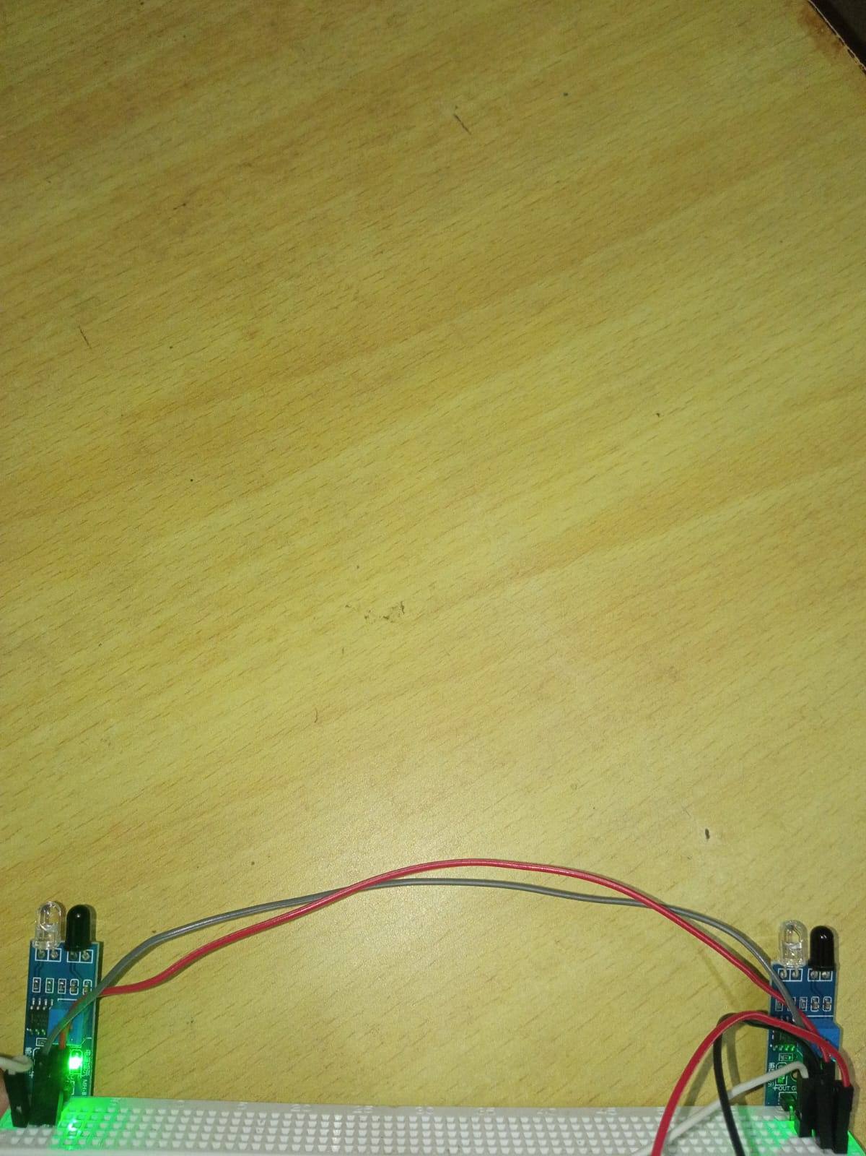

Two Infrared (IR) sensors, known for their accuracy and reliability, are strategically placed along the railway track to detect the presence of trains. These sensors act as the primary input for calculating train velocity.

##### **3.1.2 Arduino Uno:**

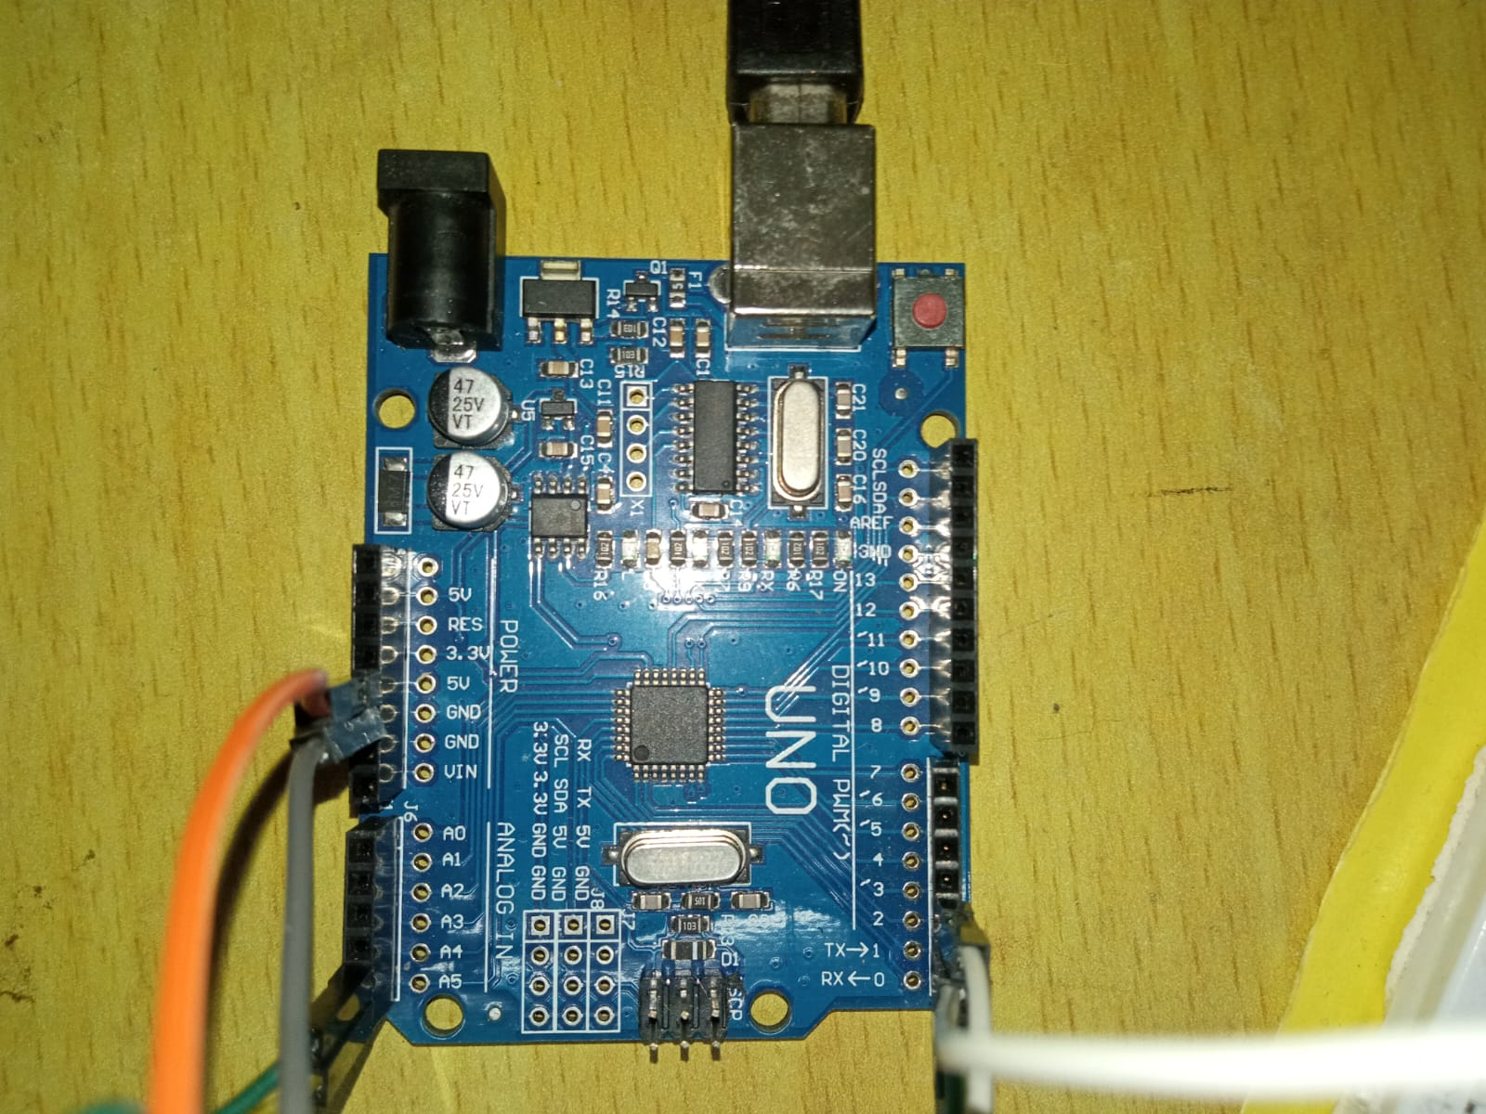

Arduino Uno, a versatile microcontroller, serves as the central processing unit. It collects data from IR sensors, calculates train speed and direction, and controls the overall system. Its flexibility and ease of programming make it an ideal choice for this application.

##### **3.1.3 LCD with I2C module:**

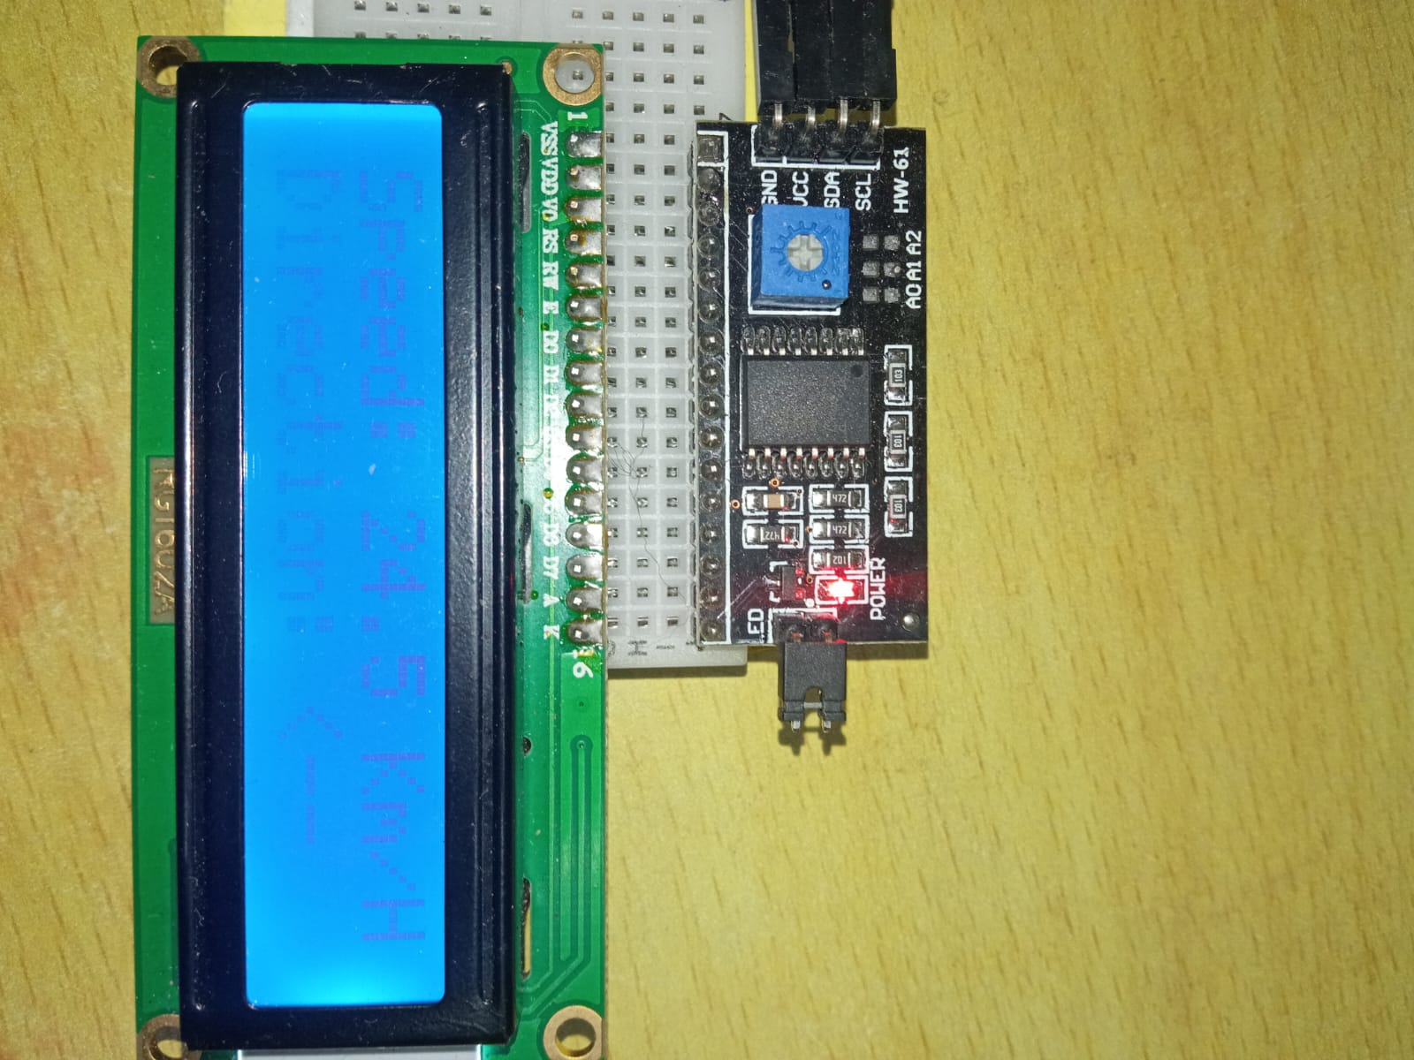

An LCD display with I2C module is integrated to provide real-time feedback on the speed and direction of moving trains. This visual output enhances situational awareness for operators, and the I2C module simplifies the wiring complexity, allowing for efficient communication between the display and Arduino Uno.

##### **3.1.4 NodeMCU:**

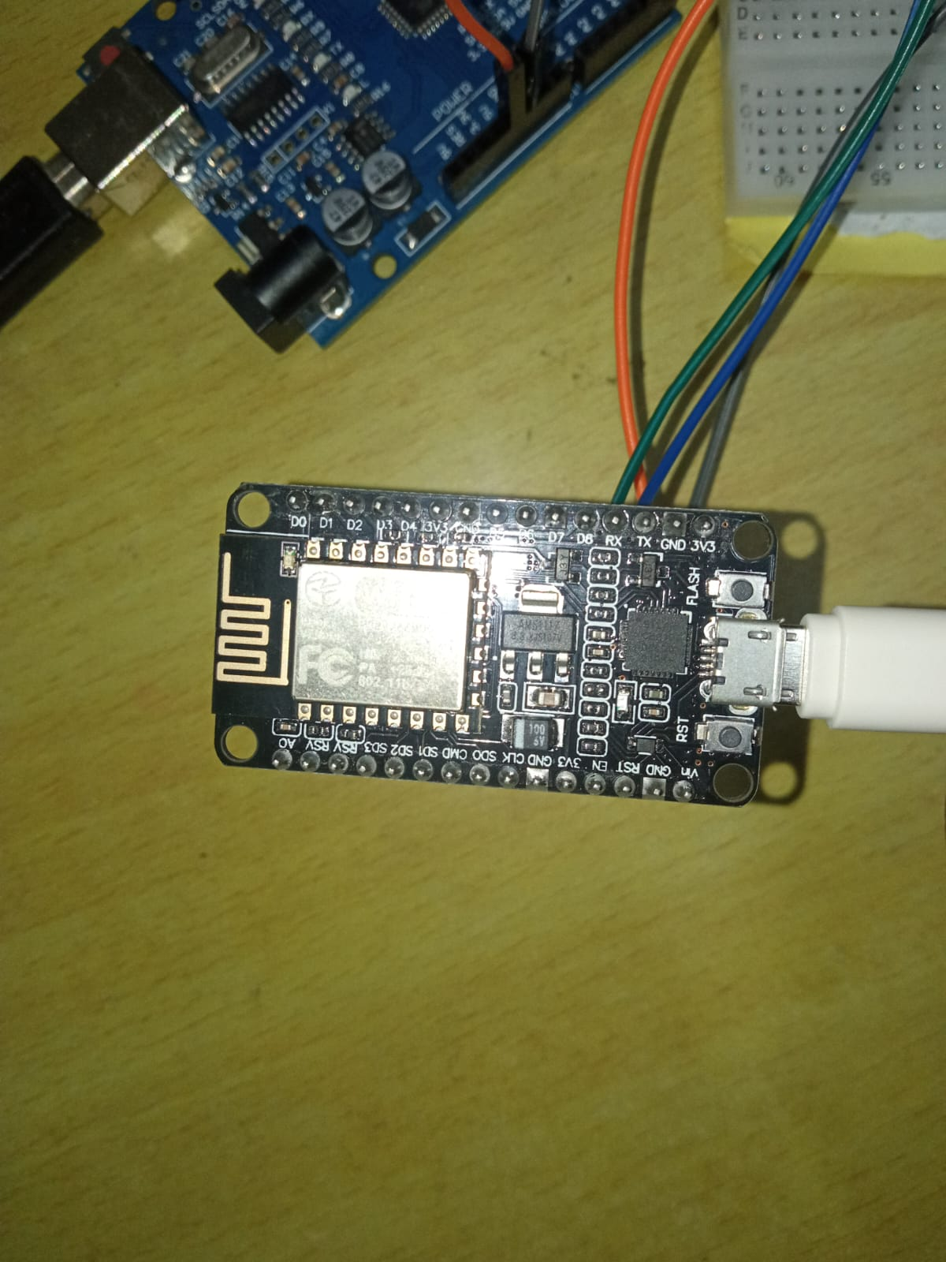

NodeMCU, based on the ESP8266 Wi-Fi module, facilitates wireless communication. It communicates with the Arduino Uno to retrieve train data and transmits this information to a designated server using Wi-Fi.

#### Software Used

##### **ARDUINO IDE:**

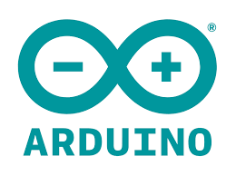

Arduino IDE is a user-friendly software platform designed for programming Arduino microcontrollers. It provides a simple yet powerful environment for writing, compiling, and uploading code to Arduino boards. Key features include a text editor for writing code, a compiler to convert code into machine-readable language, and a bootloader for transferring the compiled code to the Arduino board. With its open-source nature, extensive community support, and a vast library of pre-written code (sketches), Arduino IDE is widely used for developing projects across various domains, from simple electronics to complex IoT applications.

##### **IFTTT Services:**

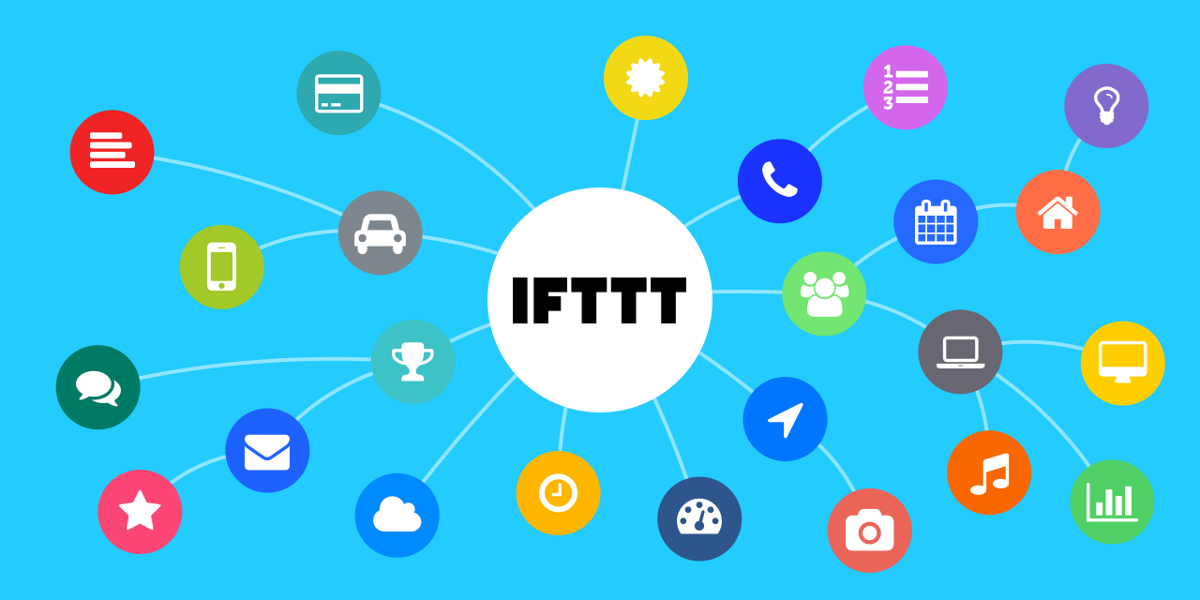

IFTTT (If This Then That) services are employed to trigger notifications based on predefined conditions. IFTTT services are configured to activate VoIP calls and webhooks based on predefined thresholds, ensuring timely alerts and automated responses in the event of potential collisions.

# Chapter 4

## System Design

#### Overall Architecture

#### 

#### IR Sensor Connections:

Connect the VCC (power) and GND (ground) pins of each IR sensor to the corresponding pins on the Arduino Uno.

Connect the signal pins (output) of the IR sensors to digital input pins on the Arduino Uno.

#### Arduino Uno and LCD Display Connections:

Connect the VCC and GND pins of the LCD display with I2C module to the corresponding pins on the Arduino Uno.

Connect the SDA (data line) and SCL (clock line) pins of the LCD display with I2C module to the corresponding pins on the Arduino Uno.

#### NodeMCU Connections:

Connect the VCC and GND pins of the NodeMCU to the corresponding pins on the breadboard.

Connect the TXD pin of the NodeMCU to the RXD pin on the Arduino Uno.

Connect the RXD pin of the NodeMCU to the TXD pin on the Arduino Uno.

#### Block Diagram of the Sensor Syst

#### Working Principles

#### 

#### IR Sensor Detection:

Function: Infrared (IR) sensors are strategically placed along the railway track.

Working Principle: IR sensors detect the presence of a train by measuring the infrared light reflected off the train. The interruption of the infrared beam triggers the sensor.

#### Arduino Uno Processing:

Function: Arduino Uno serves as the central processing unit.

Working Principle: Arduino Uno collects data from IR sensors, including the time taken for the interruption to occur. Using this information, it calculates the speed and direction of the moving train.

#### LCD Display Output:

Function: LCD display with I2C module provides real-time feedback.

Working Principle: Arduino Uno communicates with the LCD display to output the calculated train speed and direction. This visual feedback enhances real-time monitoring for operators.

#### NodeMCU Wireless Communication:

Function: NodeMCU facilitates wireless communication.

Working Principle: NodeMCU retrieves train data from Arduino Uno and transmits it wirelessly to a remote server using Wi-Fi. This ensures real-time monitoring and data storage.

#### IFTTT Services Integration:

Function: IFTTT services are used for notifications.

Working Principle: IFTTT is configured to trigger notifications (VoIP call and webhook) based on predefined conditions. When the train speed exceeds a specified threshold, IFTTT sends notifications to alert relevant personnel.

#### Server-Side Processing:

Function: The remote server processes and responds to incoming data.

Working Principle: The server receives the train data transmitted by NodeMCU, potentially storing it for future analysis. It acts as an intermediary for IFTTT notifications, ensuring timely alerts.

#### Collision Prevention:

Function: The system aims to prevent head-to-head collisions.

Working Principle: By continuously monitoring train speed and triggering notifications when it exceeds a safe threshold, the system provides an early warning mechanism, helping prevent potential collisions on single-track railways.

# Chapter 5

## Conclusion

In conclusion, this project lays a foundation for a comprehensive IoT-based railway safety system designed to prevent head-to-head collisions on single-track railways. The primary focus was on the initial stages of calculating train speed and direction and implementing a notification mechanism through IFTTT services.

#### 5.1 Key Findings

The successful implementation allowed for accurate speed and direction calculations using IR sensors and Arduino Uno. The integration of IFTTT services proved effective in triggering notifications when the train's speed surpassed a predefined threshold.

#### 5.2 Contributions to the Field

While the current scope addresses a simplified scenario, the project marks a crucial step in the development of a larger-scale IoT architecture for railway safety. The emphasis on speed detection and notification triggers showcases the potential of technology in preventing collisions and enhancing rail safety.

#### 5.3 Potential for Further Development

This project serves as a stepping stone for future developments. The envisioned expansion involves a more intricate IoT architecture with multiple devices, creating a robust system for detecting potential head-on collisions. Future work may include refining algorithms, integrating machine learning for predictive analysis, and exploring scalability for diverse railway environments.

#### 5.4 Overall Significance

The project's significance lies in its demonstration of IoT's potential to contribute to railway safety. By successfully implementing a speed detection and notification system, it provides insights into how technology can be harnessed to prevent accidents and improve the overall security of railway operations.

In summary, while the current project focuses on fundamental aspects, it paves the way for a more sophisticated and comprehensive IoT solution for railway safety. The envisioned real-world application involving multiple devices reflects the project's commitment to addressing critical challenges in transportation infrastructure.