RESILIENT APPROACHES IN NATURAL RANGELAND ECOSYSTEMS (RANGE).
Quarterly Progress Report.
Reporting Period. January – March 2026 (Q1-2026)
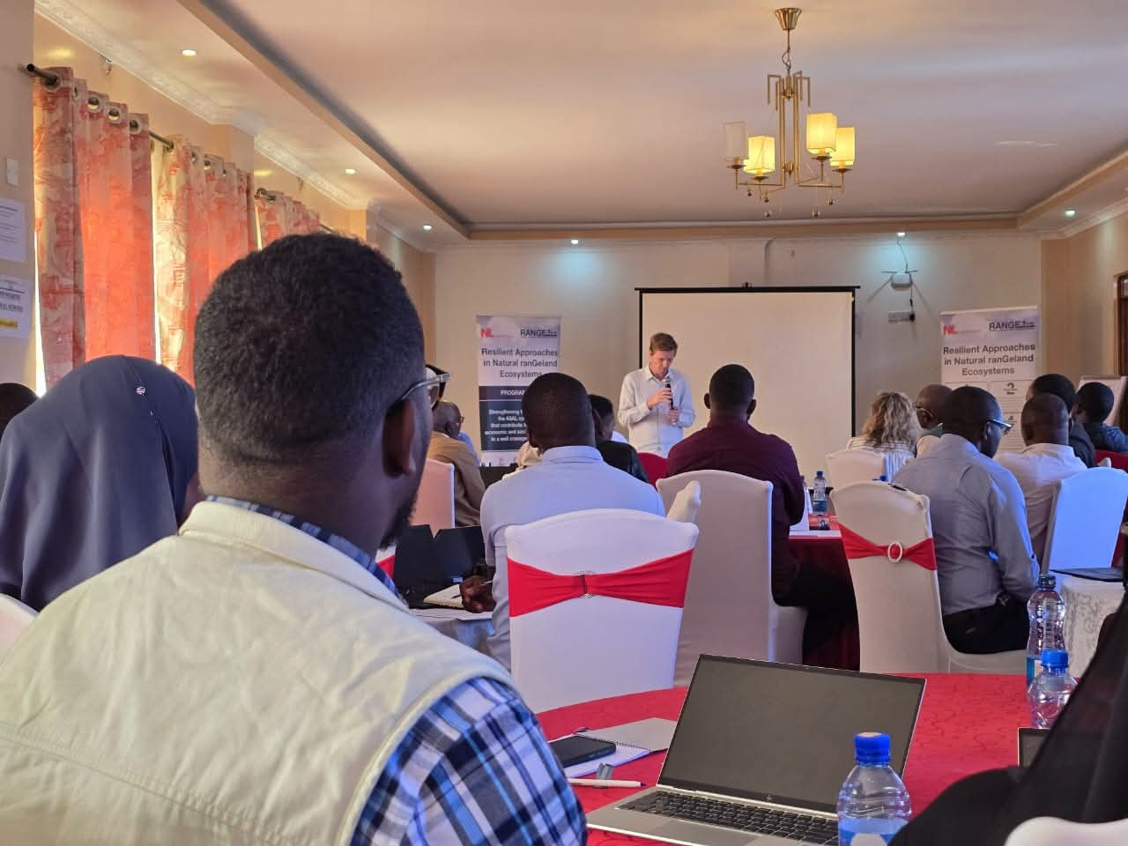
Mercy corps Kenya country Director Mr. Wills Barron. Welcoming the RANGE team consortium members and local partners to the joint Annual review meeting at Seasons Hotel Maralal Samburu County on 28th January 2026
- Executive Summary
During the January to March 2026 reporting period, Strategies for Northern Development (SND), under the Resilient Approaches in Natural Rangeland Ecosystems (RANGE) program, implemented targeted activities across Sagante/Jaldesa and Golbo wards in Marsabit County focused on strengthening rangeland governance and enhancing community preparedness for sustainable natural resource management.
In January 2026, the project team actively participated in the County Steering Group (CSG) meeting, a technical field visit to the Dololo Dokhatu water infrastructure, and the RANGE program year two annual review meeting in Maralal Samburu County. In February 2026. A one-day cross learning and exchange visit was organized, bringing together 23 (15M, 8F) participants. Additionally, SND RANGE team participated in the Regional Climate Outlook Forum from 10 to 12 February 2026, held at the Koket Borena hotel in Moyale Ethiopia linking Marsabit County (Kenya) and Borana Zone (Ethiopia). In March 2026, the SND RANGE team undertook a needs assessment for fodder groups in both Golbo and Sagante/Jaldesa wards, in collaboration with the Ward Development Committees (WDCs) and the Office of the Ward Administrators.
Progress and Planned Activities
Outcome 1: Improved rangeland management repairs ecosystem health and increases food, nutrition and water security.
Progress against Indicators/Activities.
All activities planned within the January – March 2026 reporting period were not implemented as scheduled as some of the activities were carried over to the subsequent quarter.Mainly delays in cash disbursement and competing timelines arising from parallel RANGE activities. Additional time was also required for joint planning and coordination with partners such as the FCDC to ensure alignment and effective implementation
In Q1 2026, activity implemented under Outcome 1 is, 1.1.5 Support a one-day cross-learning and exchange visit for 30 WDC members across wards and counties to share best practices and strengthen inter-ward collaboration on participatory governance. This activity contributes directly to Output 1.1: Formal and informal governance systems of land management, protection and restoration are strengthened.
Progress under this output is measured through the indicator: Number of Ward Development Committees (WDCs) with enhanced inclusive representation, trained on governance and planning and formally integrated with traditional governance systems. The target for this indicator is 30(15M, 15F).
During the quarter, 23 WDC members (15 men, 8 women, including 11 youth) from Golbo and Sagante/Jaldesa wards participated in a one-day peer-to-peer learning and exchange visit at the Kenya Agricultural and Livestock Research Organization (KALRO) Marsabit Centre. The visit provided practical skills in farming, fodder production, apiculture, value addition, and land management techniques for rangeland regeneration.
Following the visit, farmers will receive farm tools and participate in cash-for-work activities to apply their learning, including clearing invasive species and planting Cenchrus ciliaris (African foxtail) to expand fodder areas. These actions are expected to enhance year-round fodder availability, rehabilitate degraded land, improve livestock productivity, and create income opportunities, contributing directly to Outcome 1 of the RANGE program while strengthening community resilience and self-reliance.

Carryover activities to the next quarter.
Under outcome 1, Activity 1.1.04. Facilitate a two-day policy dialogue with 30 participants (15 from each of two wards), bringing together strengthened Ward Development Committees (WDCs) and county government representatives to anchor inclusive governance models in county policies. Will be carried over to Quarter 2 because this activity requires co-implementation with FCDC due the involvement of the county assembly which is policy making organ in the county.
Deviations from Expected Progress.
During the quarter, there were no major deviations in the delivery of activities, with most planned interventions successfully implemented within the reporting period. A few activities were carried over to the next quarter due to minor operational constraints, mainly delays in cash disbursement and competing timelines arising from parallel RANGE activities. Additional time was also required for joint planning and coordination with partners such as the FCDC to ensure alignment and effective implementation. Despite this, implementation remained largely on track and contributed effectively to the intended outcomes of strengthening rangeland governance, enhancing coordination mechanisms and promoting inclusive decision making, thereby supporting improved food, nutrition and water security.
Outcome 2: Sustainable livestock and alternative livelihood production and competitiveness of markets strengthened within an improved policy environment.
Progress against Indicators/Activities.

During the reporting period, no direct activities were implemented under this outcome. However, interventions under other outputs laid a strong foundation for its achievement in subsequent quarters. For example, engagement of farmers in an exchange visit under the activity 1.1.05, will form a basis for the implementation of activity 1.2.3 which is all about Implementing specific sustainable land management practices in priority degraded areas identified through mapping. Farmers who participated in the exchange visit were supported with tools for fodder production and other farming activities. The farmers will be part of community members engaged in the activity 1.2.3 in cash-for-work to use the tools for land management practices in degraded areas. Sustainable land management practices in priority degraded areas restores rangeland vegetation, improves soil fertility, and enhances water retention, strengthening overall ecosystem health. Healthier rangelands provide more reliable forage for livestock, boosting food and nutrition security for pastoral households. Improved soil and water management increases water availability for both livestock and domestic use.
In addition, water infrastructure assessments and coordination platforms conducted within the quarter, improved the enabling environment for livestock and livelihood activities. Rehabilitation of the water structures will make water readily available for farming activities, fodder production and rangeland management activities. This will then support sustainable livestock production, alternative livelihoods and improved market competitiveness.
Planned activities under Outcome 2 for the April-June 2026 quarter include;
- 1.2.03 Implement specific sustainable land management practices in priority degraded areas identified through mapping
- 1.2.04 Support 10 members of WDCs and NRM committees for 3 days per ward in exposure visit and knowledge exchange on rangeland management practices through structured learning approaches
- 1.2.06 Develop and implement Quarterly review for the drought contingency plan integrated with rangeland management practices targeting 30 WDC, NRM and WRUA committee members per ward.

Deviations from Expected Progress.
Although activities under this outcome have not yet been implemented during the reporting period, proactive measures have been established to minimize any potential deviation from the targeted results. Key preparatory steps, including stakeholder engagement, coordination with the county and community structures have been established to ensure timely and effective execution in the subsequent quarter.
- Risks and Bottlenecks
The project operates within a complex and rapidly evolving risk environment in Marsabit County, particularly in Golbo and Sagante/Jaldesa wards, where climate variability, socio-political dynamics, institutional capacity gaps and market limitations intersect to exacerbate community vulnerability. During the reporting period, the onset of the long rainy period (MAM) rains across Golbo and Sagante/Jaldesa wards introduced a different set of climatic challenges. While the rains contributed to some level of pasture regeneration, they also rendered key access roads largely impassable, disrupting movement, service delivery and market access.
Overview of Risk Management.
Uneven distribution of the MAM rains is likely to trigger livestock migration into Golbo and Sagante/Jaldesa wards, leading to overgrazing, increased pressure on rangelands and heightened risks of destocking and disease outbreaks. These risks were monitored during the quarter, with plans to implement head management training, grazing plans and IPLRM execution and climate smart rangeland management and livelihood diversification interventions in subsequent phases.
Marsabit County continues to face resource-based tensions, with both humans and livestock heavily relying on boreholes despite adequate MAM rains. The project maintained conflict sensitive engagement and plans to strengthen peace committees, while highlighting the need for rangeland mega dams to reduce pressure on boreholes and improve water access.
Weak institutional capacity and fragmented local governance structures remain a key risk affecting service delivery and coordinated natural resource management. In response, the project emphasized strengthening Ward Development Committees (WDCs) and related governance structures through targeted capacity strengthening, mentorship and coordination support during the quarter. These efforts aim to improve institutional effectiveness, enhance coordination with county departments and support inclusive decision making within the two targeted wards.
Economic risks related to limited and unstable market access for livestock and alternative livelihoods were also observed, particularly in the context of declining livestock body conditions and fluctuating market prices. To address this, the project continued to apply a Market Systems Development (MSD) approach, laying the groundwork for strengthened private sector linkages and market-oriented interventions in subsequent quarters.
During the reporting period, insecurity risks within and across communities were observed. A number of cattle rustling incidents have been reported in both Golbo and Sagante/Jaldesa wards, reflecting increased mobility and competition over recovering grazing areas. A recent night raid in neighboring Marsabit Central ward, which resulted in the loss of four lives and multiple injuries, underscores the volatility of the security situation. With the 2027 general elections approaching, there is a risk that such incidents may increase, as heightened political activity and shifting alliances influence local dynamics. In this context, insecurity may undermine community cohesion, disrupt livelihoods, and pose challenges to inclusive governance processes and negotiated resource-sharing arrangements.
Risks of social exclusion, particularly affecting women, youth and persons with disabilities, were proactively addressed through deliberate application of the project’s Gender, Equity and Social Inclusion (GESI) policy. During the quarter, inclusive participation thresholds were upheld across governance and planning activities, ensuring broader representation and meaningful engagement of special interest groups in project processes.
Materialization of Risks
During this reporting period, uneven MAM rainfall was observed across Marsabit County, affecting pasture and water availability in Golbo and Sagante/Jaldesa wards. These conditions prompted increased livestock mobility in search of grazing areas, heightening competition and tensions over shared resources. Livestock body condition improved in some areas, while farmers withheld their livestock from the market, reflecting cautious herd management and limiting market supply, which continues to shape pastoralist livelihoods. In-migration of livestock from neighbouring counties, including Mandera and Wajir, added additional pressure on the limited rangeland resources, and coupled with the 2027 electioneering period, has heightened the project’s risk environment.

Adjustments to Risk Analysis.
No major revisions were made to the project’s risk matrix during the quarter. However, the early signs of political realignments ahead of the 2027 elections were noted. To address these, the project will strengthen and promote conflict-sensitive engagement and enhance coordination with county authorities to safeguard interrupted implementation of the project.
- Project Spin-offs
During the reporting period, SND implemented complementary interventions through Ecosystem restoration project implemented by SND in partnership with WFP in Golbo Ward that strategically layer, sequence and integrate with the RANGE program. These spin offs include
- Water infrastructure. SND supported the sinking of a strategic borehole in Dirdima, enhancing water availability for communities, livestock and rangeland restoration activities.
- Horticulture support. The project distributed ten 10,000 liter plastic water tanks to local horticulture groups, improving water storage and supporting climate-resilient crop production.
- Agroforestry and tree planting.SND facilitated the establishment of three shade nets and ten tree seedling nurseries, promoting climate-resilient livelihoods, improving soil cover, and complementing rangeland restoration efforts.
By intentionally sequencing and layering these activities with RANGE program interventions, SND strengthened ecosystem restoration, diversified livelihoods and provided practical platforms for community learning. These interventions reinforce sustainable natural resource management, enhance household food and water security, and create integrated pathways for achieving the long-term objectives of the RANGE program.
Other complementary activities implemented within the quarter include
In January 2026, the SND project team participated in key planning and coordination engagements that informed implementation for the quarter, including the County Steering Group (CSG) meeting, a technical field visit to the Dololo Dokatu water infrastructure in Sagante/Jaldesa ward, and the Year Two Annual Review Meeting in Maralal, Samburu County. These engagements provided critical insights on program performance, stakeholder coordination and infrastructure status, strengthening adaptive planning, alignment with county priorities and evidence-based decision-making.
The field visit to the Dololo Dokatu Borehole, conducted jointly with the Mercy Corps team, was particularly strategic. Key milestones included identification of the site for water kiosk construction, mapping of the pipeline extension route, community engagement and confirmation of their contributions, as well as introduction of the contractor and official site handover. This was done in the presence of county leadership, including the Director of Water Services, the Ward Administrator for Sagante/Jaldesa ward and the area chief, reinforcing local ownership and accountability.
Additionally, SND RANGE team participated in the Regional Climate Outlook Forum from 10 to 12 February 2026, held at the Koket Borena hotel in Moyale Ethiopia linking Marsabit County (Kenya) and Borana Zone (Ethiopia). The forum, organized by IGAD Climate Prediction and Applications Centre (ICPAC) in collaboration with IGAD Centre for Pastoral Areas and Livestock Development (ICPALD), brought together cross-border stakeholders to jointly develop seasonal climate advisories for October November December 2025 and March April May 2026. A key achievement was the harmonization of Indigenous Knowledge forecasts with scientific predictions, enhancing confidence in the climate outlooks. Multi-stakeholders including government officials, community leaders, traditional forecasters, women, youth and persons with disabilities, researchers, media and NGOs participated in participatory scenario planning. The integration of Indigenous Knowledge with scientific forecasts improves the accuracy, trust and use of climate information, enabling farmers and pastoralists to make better planning decisions. Inclusive participatory scenario planning also strengthens coordination, ownership and timely action among stakeholders, ultimately enhancing resilience and supporting sustainable livelihoods under the RANGE program.
In March 2026, the SND RANGE team undertook a needs assessment for fodder groups in both Golbo and Sagante/Jaldesa wards, in collaboration with the Ward Development Committees (WDCs) and the Office of the Ward Administrators. Through this process, two promising groups were identified. Danicha Fodder Group in Golbo Ward with 15 members (10M. 5F) and Biftu Cultural Fodder Group in Sagante/Jaldesa Ward with 75 members (15 M, 60F). Following the assessment, the RANGE project plans to support these groups with essential farm tools and facilitate the expansion of fodder production areas through a Cash for Work approach.
Additionally, joint water infrastructure assessments in Golbo conducted with the Mercy Corps team strengthened planning for rehabilitation and improved access to water services. Qoloba and Godoma boreholes were assessed, and water samples collected for laboratory testing. Based on the test results and identified community needs, one facility will be selected for targeted support to enhance reliable water access for both domestic and productive us
- Cross-cutting Interventions
Gender
Gender mainstreaming across all project activities, ensuring equitable participation and benefits for both youth, women and men. Gender considerations were integrated at every stage from planning to implementation through targeted mobilization, inclusive selection criteria and gender-sensitive facilitation approaches. Women’s participation was actively promoted in Ward Development Committee (WDC) engagements in both wards. As a result, women made up a significant proportion of participants in training sessions, community consultations and decision-making forums.
In addition, sessions on leadership, financial literacy and climate change placed special emphasis on empowering women to take up leadership roles and improve their economic resilience. The project also ensured that meeting venues, timing and facilitation styles were sensitive to the needs of both women and men, fostering an inclusive learning environment.
Furthermore, gender-disaggregated data was collected and analyzed to monitor participation trends and inform future interventions. This has helped the project identify areas needing improvement particularly in enhancing youth and women’s representation in technical and governance structures at the community level.
Climate Change
Climate change was mainstreamed as a cross cutting theme in all project engagement (WDC) during this reporting period. While implementation of specific climate-smart agricultural interventions is planned for subsequent quarters, the foundational capacity building and training conducted this quarter strengthened awareness on Sustainable rangeland management, drought preparedness and Ecosystem conservation. These initial efforts have positioned WDCs and local governance structures to integrate climate adaptation and environmental stewardship into ward level planning and decision-making processes. By embedding climate considerations early, the project has laid the groundwork for more targeted, community driven climate resilience actions in the coming phases of the RANGE program.
- SEAH (Safeguarding)
During January –March 2026, SND implemented robust safeguarding measures across all RANGE program activities. Participants were provided with a toll-free reporting line and clear procedures emphasizing confidentiality and non-retaliation. Community safeguarding was further strengthened through CRFM clinics and a Gender Help Desk and informed consent was obtained for all photos, videos, or personal stories. No safeguarding cases were reported during the quarter, continuous sensitization for new participants was identified as a priority to maintain awareness and effective application of safeguarding measures.
- Sustainability
Sustainability of the RANGE program was strengthened through farmer capacity building, improved access to resources and enhanced climate preparedness. Practical learning visits equipped farmers with skills in farming, apiculture, fodder production and value addition, supporting year-round production. The planned distribution of farm tools will further enable continuous agricultural activities and improve self-reliance.
Engagement with IGAD climate outlook processes has enhanced access to early warning information, allowing farmers to better prepare for climatic shocks. Additionally, the pipeline extension of the Dololo Dokatu Borehole will improve access to water for domestic use and fodder production, supporting sustained livelihoods and increased resilience.
- Lessons Learned
Project sustainability is significantly enhanced when communities are actively involved from the outset, including during planning, site selection and implementation. The engagement of Ward Development Committees (WDCs) and local leaders strengthens legitimacy, trust and acceptance of interventions. Locally agreed rules such as grazing plans and water point management have proven effective in improving compliance and collective responsibility.
Pastoralist communities possess strong indigenous rangeland management systems, including seasonal grazing patterns and mobility strategies. Combining these with modern approaches such as enclosure systems, reseeding and water harvesting enhances the overall effectiveness, relevance, and adoption of rangeland restoration interventions.
- Annexes
- Annex 2: Participant Lists
- Annex 3: IATI Report
- Annex 4: Quarterly Participant Data

